South Dakota Pulse Crops Council - 116 N. Euclid Ave. Pierre SD
Conference Call Minutes – March 13, 2020

Roll Call was taken at 9:00 am – Present members Chairman David Neuharth, Tyrel Eiesenbraun, Brad Karlen, Raymond Roghair and Terry Ness were in attendance. Staff attending was Caren Assman. Guest Dr.Clifford Hall, Professor SDSU.

Agenda
The agenda with one item, to receive information about a specialty crops block grant, was approved.

Guest Speaker
Dr. Hall from SDSU, shared his ideas about what topics of science and food that might work to be submitted for a specialty crops block grant. They included protein increase for varieties, use of peas and chickpeas for sourdough bread, additional use of the starch byproduct and presenting outcomes of the research at specific pulse meetings and or Ag Horizons.

Dr Hall will provide addition information and a grant proposal to the Council on Monday, March 16th.

Adjournment - Motion to adjourn 9:45 am.

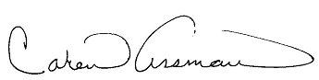
Respectfully submitted,
Caren Assman, Recorder

