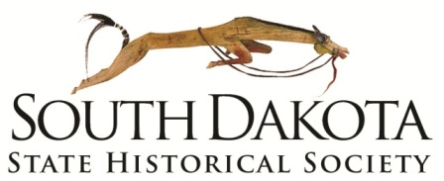

Museum of the South Dakota State Historical Society

900 Governors Drive

Pierre SD 57501

Ph. 605.773.3458

Fax. 605.773.6041

**Record of Deaccession**

**Accession Number:** See attached spreadsheet

**Catalog Number:** See attached spreadsheet

**Description:**

See attached spreadsheet

**Reason for Deaccession:**

These dresses are being deaccessioned for three reasons: they are either in poor condition, or the bride that wore it was not married in South Dakota, or they are redundant to the collection. See the attached spreadsheet for detailed reasons.

**Disposition:**

___x__**Transfer:** to an appropriate museum, see spreadsheet for details

_____**Sell:**

_____**Exchange:**

_____**Return to Donor:**

_____**Destroy:**

_____**Other:**

_____**Additional Notes Attached**

**Requested By**: _________________________________________________ Date: ____________

Museum Director

**Authorized By**: _________________________________________________ Date: _____________

Director, South Dakota State Historical Society

_________________________________________________ Date: _____________

President, Board of Trustees