**Education and Telecommunications Board Report**

**September 2022**

**Twyla Olson**

**Director of Content & Assistant General Manager**

After three amazing years of change and growth, I left Friends of SDPB as VP of Membership in late December and was warmly welcomed to the “other side” at the SDPB network on January 3rd.  Larry Rohrer stayed on to introduce me to important partners and the staff and showed me the ropes through early April. Those first three months were primarily watching, listening, and learning as Larry wrapped up his tenure and we celebrated his long career and copious contributions to SDPB. We also negotiated Larry’s retirement contract, as he agreed to stay on as the host of Dakota Life, the voice of radio underwriting, and continue to contribute content to In the Moment. Larry also continues to help Friends of SDPB with some fundraising.

We began our Strategic Planning meetings with consultant Ted Krichels in mid-February and continued our meetings with him through mid-May. We have already begun implementing portions of our new Strategic Plan in the following ways.

**DIGITAL**

Realizing that digital is the future of media distribution, Julie Overgaard created a new Digital Department and Heather Benson was named Digital Strategy Manager in April. Heather hired a Digital Content Curator, Brent Duerre, who starts on Sept. 26th.  Heather and her team will lead SDPB’s effort to streamline our content onto one CMS platform, Grove, which is hosted by NPR, lead our content team in data-based decisions, and lead us into future social media platforms.

**DEI Training**

SDPB is dedicated to employing and serving our diverse communities in South Dakota. We have identified two tracks of DEI (Diversity, Equity and Inclusion) training for staff and board members. Brad Van Osdel has completed intensive training course in DEI through Public Media Diversity Leaders Initiative (PDMLI) and he will assist me with in-service training for all staff and board members.

Fritz Miller is currently enrolled in the PDMLI training course. All other managers will attend the quarterly training throughout the next 2-3 years.

Here is a list of DEI projects that are underway:

* Working with Red Cloud in Pine Ridge on adding videography to the SDPB Boutique studio and attending their buffalo hunt in November as a videography training exercise for Red Cloud students and staff.
* Working with the Spanish-speaking population in Sioux Falls to develop newscasts and hosting interpreters who will be live streamed during the live debates in our studios.
* Working with the Spanish-speaking community in Sioux Falls and various communities in Rapid City during the launch of PBS Kids “Rosie’s Rules”, a new, bi-lingual kids program
* Assisting in the launch of a Spanish speaking radio station in Sioux Falls
* Working with independent documentary team on finishing Lakota Language project

* In talks with Sinte Gleska re: setting up an internship program in their journalism program
* Dakota Life Premiere in Mission on November 1st.
* Meeting with filmmakers from Flandreau to discuss a documentary on the Flandreau Pow Wow.
* Filming the Young Composers Program in partnership with the South Dakota Symphony Orchestra in Oelrichs with Native American youth participating

**Education**

SDPB is a trusted source for educational resources in South Dakota, and Marcy Drew and her team have been all over the state these past several months visiting with educators from pre-school through high school. They also interacted with hundreds of kids and families at several Summer events. Marcy and Kevin Nelson traveled to Sisseton last week to visit with teachers and provide resources, and they plan on traveling to other communities featured in the Dakota Life series this year. Science Steve continues to be a huge hit with students and teachers throughout the state. Marcy and Steven are working with a team producing a documentary about the life of Badger Clark. They will create curriculum based on Badger Clark’s work and life once the documentary is completed.

**Outreach**

To fulfill SDPB’s commitment to growing audience and members, Friends of SDPB brought on Nathan Hofer as Outreach and Experiences manager in Spring of 2021. Since that time, Nathan has worked to create a system to track events and projects, as well as expanding our reach to South Dakotans through Community Conversations and live Premieres of Dakota Life. The momentum for these events is growing and the recent season Premiere of Dakota Life’s “Greetings from Sisseton” achieved record-breaking attendance, with approximately 65 community members attending at Rosalie’s Restaurant Bakery & Lounge. Here they are, enjoying the show. You can watch the program at this link   <https://watch.sdpb.org/video/greetings-from-sisseton-fwhmz9/>

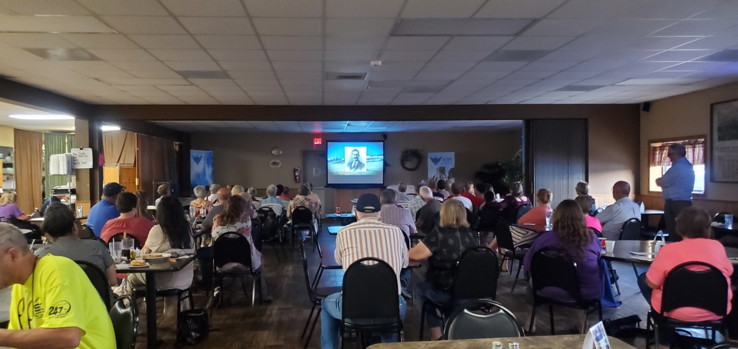

Here is a snapshot of the next month’s activities. As you can see, it is action packed and covers all corners of the state.

|  |  |  |  |
| --- | --- | --- | --- |
| ItMo Live - Festival of Books | 23-Sep | Oscar Larson Performing Arts Center | Brookings |
| [SD Festival of Books](https://stateofsouthdakota.sharepoint.com/:f:/s/bit/telecommunications/SDPB/mp/Eh4WuXQ0ADxLtfRGpV8-awEB2l9TWvwI-rouTAI2NHuKUQ?e=MZWlh0) | 23-Sep | Oscar Larson Performing Arts Center | Brookings |
| Rock & Roll Hall of Fame | 23-Sep | Ramkota Exhibit Hall | Sioux Falls |
| Rock & Roll Hall of Fame | 24-Sep | Ramkota Exhibit Hall | Sioux Falls |
| [SD Festival of Books](https://stateofsouthdakota.sharepoint.com/:f:/s/bit/telecommunications/SDPB/mp/Eh4WuXQ0ADxLtfRGpV8-awEB2l9TWvwI-rouTAI2NHuKUQ?e=MZWlh0) | 24-Sep | Oscar Larson Performing Arts Center | Brookings |
| Daschle Dialogues | 25-Sep | South Dakota State University | Brookings |
| [Siouxpercon](https://tasks.office.com/stateofsouthdakota.onmicrosoft.com/Home/PlanViews/1Uk8W7q95ki0W4e_USNzK4IAD2bp?Type=PlanLink&Channel=Link&CreatedTime=637853722837120000) | 30-Sep | Sioux Falls Convention Center | Sioux Falls |
| SD Board of Ed Telecommunications mtg | 30-Sep | Vermillion |  |
| Buffalo Roundup | 30-Sep | Custer State Park | Custer |
| Siouxpercon | 1-Oct | Sioux Falls Convention Center | Sioux Falls |
| Siouxpercon | 2-Oct | Sioux Falls Convention Center | Sioux Falls |
| SDHSAA Class A Boys Golf Championships | 3-Oct |  | Aberdeen |
| SDHSAA Class AA Boys Golf Championships | 3-Oct |  | Mitchell |
| Radio Membership Drive | 3-Oct | SFS/BHS/VERM | Statewide |
| Leola Dakota Life Premiere | 4-Oct | Leola HS Auditorium | Leola |
| SDHSAA Class A Boys Golf Championships | 4-Oct |  | Aberdeen |
| SDHSAA Class AA Boys Golf Championships | 4-Oct |  | Mitchell |
| SDHSAA Class A Girl Tennis Championships | 4-Oct |  | Rapid City |
| SDHSAA Class A Girl Tennis Championships | 4-Oct |  | Rapid City |
| Radio Membership Drive | 4-Oct | SFS/BHS/VERM | Statewide |
| Radio Membership Drive | 5-Oct | SFS/BHS/VERM | Statewide |
| SDHSAA Class AA Girl Tennis Championships | 6-Oct |  | Rapid City |
| Radio Membership Drive | 6-Oct | SFS/BHS/VERM | Statewide |
| SDHSAA Class AA Girl Tennis Championships | 7-Oct |  | Rapid City |
| Radio Membership Drive | 7-Oct | SFS/BHS/VERM | Statewide |
| DTSF Art & Wine Walk | 7-Oct | Sioux Falls Studio | Sioux Falls |
| SDSO: Conrad Tao Plays Tchaikovsky | 8-Oct | Washington Pavillion | Sioux Falls |
| Cheers! SD | 13-Oct | The Underground | Sioux Falls |
| Friends Board | 14-Oct | TBD | TBD |
| Prairie Songs | 14-Oct | Orpheum Theater | Sioux Falls |
| SDHSAA Class A & AA Boys & Girls Soccer Champs | 15-Oct |  | Tea |
| Prairie Songs | 15-Oct | Performing Arts Center of RC | Rapid City |
| SDHSAA Journalism Event | 17-Oct |  | Vermillion |
| Pride of the Dakotas SF Premiere | 18-Oct | State Theater | Sioux Falls |
| Girls Got Game Screening | 19-Oct | Sioux Falls Studio | Sioux Falls |
| Election 2022 US House Debate | 20-Oct | Sioux Falls Studio | Sioux Falls |
| SDHSAA Class A & AA Cheer & Dance Competition | 21-Oct |  | Watertown |
| SDHSAA Class A & AA Cheer & Dance Competition | 22-Oct |  | Watertown |
| SDHSAA All Class XC Championships | 22-Oct |  | Huron |
| Election 2022 Gubernatorial Debate | 24-Oct | Sioux Falls Studio | Sioux Falls |
| Election 2022 Ballot Initiatives/PUC/Sec of State | 27-Oct | Recorded Programming |  |
| SDHSAA All-State Chorus & Orchestra Grand Concert | 29-Oct | Premier Center | Sioux Falls |
| SDSO: Bolero & Yi-Chun Lin | 29-Oct | Washington Pavillion | Sioux Falls |
| Pride of the Dakotas Documentary Premiere (SDSU) | 29-Oct | Oscar Larson Performing Arts Center (SDSU) | Brookings |

**Open Government**

SDPB continues its commitment to open government through our SD.net coverage of all legislative sessions and is expanding that coverage with cameras being installed in all convening rooms at the Capital for the coming session.

We are interviewing all candidates for the Fall election through our Meet the Candidates coverage, and we are hosting three debates in our Sioux Falls Studio.

**High School Activities**

SDPB continues our commitment to serving all South Dakotans through our strong partnership with the South Dakota High School Activities Association, covering all activities with the addition of the Girls Softball Championships in Spring of 2023. Brad Van Osdel and I attended their annual board meeting in May.   We will host two in-studio screenings and panel discussions of the Title IX documentary “Girls Got Game” with Jo Auch and Nate Wek in October.  <https://watch.sdpb.org/video/girls-got-game-zu0ctf/>

There is much more to share, but I will end here with kudos to our incredibly talented team and the recent recognition they have received from their peers. ***Congratulations to Cara Hetland and Brad Van Osdel for the teams you have built in Journalism and Entertainment. You inspire them to produce impactful programming daily.***

**Awards**

SDPB won 6 Regional Edward R Murrow Awards for their work in 2021

**Small Market**

**Digital** – Josh Haiar and all of SDPB

[SDPB News Digital](https://listen.sdpb.org/) 

**Excellence in Diversity, Equity, and Inclusion** – Richard Two Bulls

[LNI Art Show Highlights Student Artists and Attracts Interior Secretary Haaland for a Visit](https://listen.sdpb.org/arts-life/2021-12-17/lni-art-show-highlights-student-artists-and-attracts-interior-secretary-haaland-for-a-visit) 

**Hard News** – Lee Strubinger

[Survey Says South Dakotans Support Expanding Public Medical Programs](https://listen.sdpb.org/news/2021-06-02/survey-says-south-dakotans-support-expanding-public-medical-programs) 

**News Documentary** – In the Moment

[The Return of Native Children’s Remains from Federal Boarding Schools](https://listen.sdpb.org/news/2021-07-16/in-the-moment-the-return-of-native-childrens-remains-from-federal-boarding-schools) 

**News Series** – Arielle Zionts

[The 2021 Sturgis Motorcycle Rally](https://listen.sdpb.org/2021-08-08/health-experts-fear-a-spread-of-covid-as-motorcyclists-gather-in-south-dakota) 

**Overall Excellence** – All of SDPB

[SDPB News](https://listen.sdpb.org/news/2021-06-02/survey-says-south-dakotans-support-expanding-public-medical-programs)

In addition, SDPB received eight Upper Midwest Regional Emmy Nominations

**Hard News Report:** The March for Our Children - Jackie Hendry, Producer & Krystal Schoenbauer and Josh Haiar, Videographers/Editors

**Documentary-Historical:** Swords & Plowshares-South Dakota and the Civil War - Brian Gevik, Producer & Paul Ebsen and Jonathan Rouse, Videographers

**Documentary Topical:** Girls Got Game - Nate Wek, Producer & Jonathan Rouse, Max Tushla, Paul Ebsen, Greg Beesley and Kyle Mork, Videographers/Editors

**Public Affair Program:** South Dakota Focus Ag Update - Jackie Hendry, Producer/Host & Krystal Schoenbauer, Videographer/Editor

**Entertainment-Long Form Content:** 2022 Young People's Concert - Kevin Patten, Producer & Jonathan Rouse, Director

**Business/Consumer-Short or Long Form Content:** SD Focus: $8 Million in Freeman Development Projects Underway - Jackie Hendry, Producer/Host & Krystal Schoenbauer, Videographer/Editor

**Education/Schools-Short or Long Form Content:** In Play: Indoor Percussion Ensemble - Kyle Mork, Producer & Greg Beesley and Jonathan Rouse, Videographers/Editors

**Politics/Government-Short Form Content:** SD Focus: Bingo Tax - Seth Tupper, Producer & Josh Haiar, Videographer/Editor

**South Dakota Board of Directors for Educational Telecommunications**

**SDPB Entertainment Team Report—Brad Van Osdel**

**September 2022**

**Dakota Life**

Dakota Life ended last season with a trip to Redfield in May and began the planning for the next season. We changed our approach to community story gathering and production of the program. The story engagement meetings began in late May and ended in early June. Starting earlier allowed us to tell stories from the summer months in the communities and record the on-location stand-ups in the late summer and early fall when the communities are more picturesque.

The Sisseton show aired on September 8th, with a community premiere on September 6th, which provided story ideas for the future. This year's communities are Sisseton, Leola, Mission, Howard, Buffalo, Miller, Parkston, Belle Fourche, and Lead. Once an episode is completed, SDPB content producers will have spent 50 hours in each community gathering stories, conducting interviews, and recording videos.

In the Winner community last year, we learned about the Winner Elks Benefit Rodeo that has happened every summer for the last 52 years. However, this was a great story. The Winner Episode of Dakota Life was produced and aired in April of last year so it could be included in the program. We returned to Winner this summer and produced the story for digital release on social media. The production staff came across three great stories last year about the drive-in movie theatres in Winner, Mobridge, and Redfield. These three drive-ins and ones in Gregory, Mitchell, Hermosa, and Miller will be produced into a Dakota Life special. The plan for Dakota Life is to create relationships in these communities so we can continue to tell stories about rural South Dakota. We are not one and done when we visit a community, and we are building relationships with the members of these towns. Some of the stories for this season include a pinochle card club in Leola, Friday night football in Howard, the Belle Fourche Cowboy Band, the current Miss Indian World Tashina Redhawk from Mission, Papa's Park in Parkston, the Painter family Ranch near Buffalo and the Miller Drive Inn Theatre.

**Documentaries**

SDPB's documentary Sword and Plowshears highlighted the thousands of Civil War veterans who came to South Dakota after the war. Many soldiers were wounded, and a far higher than average percentage had experienced multiple battles and likely suffered combat trauma. Some veterans came to live a life of isolation others helped create the institutions of government, industry, and civic life that define the

character of South Dakota.

This June marks the 50th anniversary of the implementation of Title IX, which impacts high school and college girls and women's sports to this day. The Entertainment Group noted this critical legislation with a documentary called "Girls Got Game" about the history of Title IX in South Dakota. The documentary included interviews with women who experienced the changes, women who implemented the changes, and the young woman who benefited from pioneers like Ruth Rehn, Jill Christiansen, and Lolly Forseth

Swords and Plowershears and Girls Got Game were both nominated for Upper Midwest Emmys.

Over the summer, the Entertainment team has been working on three documentaries that will air this Fall, The "Pride of the Dakotas," a history of the South Dakota State University marching band. "The Ups and Downs of Herb and Jan Conn" highlights the story of these two legendary rock climbers/ cave explorers. And "Pioneer Homes," where we will tell the history of the Pickler House, the Mellette House, and the Rolvag-Berdahl writing cabin and farmhouse. We will also produce a new sports special titled "Tales of the Gridiron" and bring four digital stories about High School football to SDPB Channel 1.

**Music**

During last year's South Dakota Symphony Orchestra season, the idea was to produce a documentary about the Lakota Music Project. The Lakota Music Project is the South Dakota Symphony Orchestra's flagship Bridging Cultures Program. Created between 2005-2008, the Lakota Music Project (LMP) addresses a history of racial tension, builds bridges between whites and American Indians, and creates an environment of openness through music sharing. It is a practical demonstration between white and American Indian musicians to advance cultural understanding. This documentary highlighted the journey of this program and how its success started with the love of music. SDPB has produced the SDSO's Young Peoples Concert for the past eight years. These concerts are designed for schools, homeschools, and families looking for an outstanding educational and engaging orchestra experience. This year's program was nominated for Upper Midwest Emmy. We will again produce and stream the upcoming South Dakota Symphony Orchestra season and produce the performance of the Messiah for broadcast in December.

We continued our live stream partnership with the Levitt in Sioux Falls, this year, the Levitt expanded their season to include 50 concerts in total, and SDPB streamed all live to the world. The concerts streamed on SD.net, Facebook, and YouTube, and the total viewership was 92,505, with views in 40 states and 61 countries. An exciting opportunity arose this year because of the Levitt partnership. The executive director of the Levitt, previously working with the Smithsonian and their project called Innoskate, was able to bring InoSkate to Sioux Falls and Pine Ridge. The Entertainment group recognized this chance to tell the story of skateboard culture in Sioux Falls, Pine Ridge, and with the innoskate event also the world. The three-day event was produced into a half-hour program and aired in September.

**SDHSAA Sports and Activities**

The Jazzband concert was in May and the Show Choir joined the evening events this year. The team recorded the evening events for a broadcast in June. All three Jazz ensembles and two outstanding Show Choir groups were part of the evening events streamed to sd.net and sdpb.org. The program received 1000 unique web stream viewers. The state track meet was held in Sioux Falls at Howard Wood Field. The SDHSAA held all three classes at one location this year for the first time since the SDHSAA began a three-class system for track and field. Having all three classes at one location allowed SDPB to stream all the track action for all three days, and it met with great success with over 30,000 unique web stream views. Many great moments were shared live with the people of South Dakota during the event, several of which the SDPB sports crew took a deeper dive into with stories for social media. Alea Hardie of O' Gorman capped off her high school career as one of the top long-distance runners in the state's history. Coming into 2022, Hardie had six gold medals. She then won the 3200m run and 800m run on Friday and the 1600m run on Saturday. All three of those being state meet records and gold medals. Gold medals are awarded to the top performer in an event for all classes. The story about Hardees's success has reached 29,000 people on Facebook. The SDHSAA season concluded in June with the coverage of four

golf tournaments. The Girls and Boys Class B at two Rapid City area golf courses, the Girls Class A in Sioux Falls and the Girls Class AA in Brookings. The coverage of the events included action photos from all four locations, live results, and championship photos from each tournament. Several blogs were posted to the SDPB website and social media accounts and reached over 41,000 people. The upcoming school year will be adding the SDHSAA's newest sanctioned sport to our broadcast schedule, Girls Softball.

**SDHSAA events through SDPB TV Channels and Live Stream**

Orchestra 4,500 households for the Live Broadcast (down slightly from 2019)

Football 130,190 households for the Live Broadcast / Three days total of 48,000 unique web stream viewers

Volleyball 45,450 households / Three classes, three-day total of 76,020 unique web stream viewers

Wrestling 18,880 households / 5,691 unique web stream viewers and 21,821 YouTube unique viewers for the championship and a total of 185,977 unique views on individual mat streams for the tournament weekend

Girls Basketball 152,100 Households / Three-day streaming totals for Girls B 53,101, Girls A, 47,804, and Girls AA, 43,370

Boys Basketball: 203,280 Households / Three-day streaming totals for Boys B 64,656, Boys A, 54,155, and Boys AA, 48,615

State Track Meet Three-day total of 29,089 unique web stream viewers

The crew continues searching for unique stories and ideas that highlight the youth of South Dakota. Indoor percussion is not a state-sanctioned high school activity, but a growing event, and the Brandon Valley squad is making its mark in the activity. SDPB traveled to Brandon, interviewed squad members, and recorded a practice session. The story received 14,000 views on Facebook and over 1000 reactions and comments. This digital story was nominated for an Upper Midwest Regional Emmy.

**SD High School Rodeo**

The Entertainment group produced the annual South Dakota High School Rodeo finals, which aired on SDPB in July. The program highlights over 200 of the best South Dakota ropers and riders as they compete to represent South Dakota at the national finals in Gillette, Wyoming. Several stories were produced, included in the broadcast program, and shared on social media. One story highlighted Devon Moore from Clear Lake and his path to mastering bareback riding. This story receives 9000 views on Facebook. The entertainment group also posted the individual championship rides from the finals on social media. Tommie Martins winning Pole Bending ride reached over 350,000 people on Facebook and watched over 142,000 times.

**Education and Telecommunications Board Report**

**September 2022**

**Cara Hetland**

**Director of Journalism Content**

**Content:**

I would like to start by sharing this note about our coverage marking the Rapid City Flood 50 years later. To summarize we have been airing three-minute short stories about surviving the 72 Flood on In the Moment each Wednesday since February. We produced a four-part podcast that launched in May, and the documentary aired on June 9. Producer Seth Tupper received this note:

*Dear Seth,*

*Your stories about the six teenagers caught in the Rapid City flood has left me reeling. For fifty years I have tried to better understand what happened that night. Until I came across your pieces, I knew only the first name of the semi-conscious young man I took care of after he was pulled from the flood waters.*

*He was in shock when police drove him to higher ground above the Mother Butler Center and carried him into my Dad’s house. Hours later, when he came to, he told me that he and his friends were thrown into the water when the back wall of Payless Shoes collapsed on them, that he saw his friends drown. A story so horrific it was impossible to grasp.*

*Knowing at last his full name—John Denges—is tempered by the fact that he has since passed. I would like to reach out to the other two survivors, Kay Schriever and Mike Faust, to offer my condolences and appreciation that they shared their stories. If you think they would be open to that and could put me in touch, I would appreciate it.*

*Thank you for your excellent journalism and your compassion.*

The flood landing page received 2,260 hits in May. I’d like to recognize Seth Tupper, Max Tushla, and Joshua Haiar for leading this project and its content. Johnny Sundby provided photography. We were granted the use of two University of Missouri School of Journalism students Annie Jennemann and Regan Mertz who put together an interactive map. Larry Rohrer worked with Seth and Josh to create the four-episode podcast. Go to [www.SDPB.org/Flood](http://www.SDPB.org/Flood) to experience this excellent work. Special thanks to Brad Van Osdel for lending his keen eye to the production of the documentary. More than 200 people attended the screening of the documentary on June 8.

SDPB’s coverage of the House Impeachment vote on April 12 with live streaming on SD.net and news of the day reporting. The April 16 SDPB News Twitter post for the Morning Report, which had a primary focus on impeachment news, saw 1611 total engagements. Only 105 clicked through to the link but it generated a sizable online discussion with ultimately more than 28,000 reached.

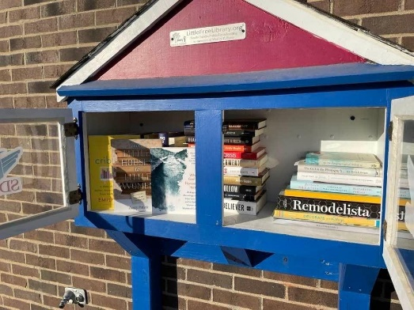

The SDPB Little Free Library is a success. We have filled it up with approximately 30 new titles a month. Most of these books were new from publishers. Most popular selections have been fiction, poetry, local authors, and hopeful books about living well in the world. Several times we have placed a book in the library, mentioned it on air, and had a reader from nearby the station stop by to pick it up within 30 minutes of show close. This has cleared clutter from inside our newsroom, provided excellent community outreach, and served as a great promotional tool for South Dakota authors to get their work into the hands of neighborhood readers. Each book is also stamped with a LFL stamp and our email address for follow-up. In January, Lori hopes to write more online about individual books, providing reviews. We also intend to add a card with a QR code inside certain books so people can easily access an author interview when they take the book home. Here is an example of a multi-media literary offering. <https://listen.sdpb.org/arts-culture/2021-09-27/ruth-ozeki-reveals-the-nature-of-reality-and-a-reader-confesses-to-refusing-to-share>

June 21, we aired live coverage of the South Dakota Senate Impeachment Trial of Jason Ravnsborg. This was a team effort across all departments. The trial was on sd.net, sdpb.org/news, SDPB 2, and radio. Engineering and production members from the Entertainment group were on hand to capture this historic event. SDPB was the pool feed for all media in the state. J-Team members in covering this included Lee Strubinger at the capitol, Seth Tupper directing our team of interns who pulled relevant audio for our radio coverage hosted by Lori Walsh. Then the team worked to provide newscast material for the next morning. Truly a team effort and a job well done.

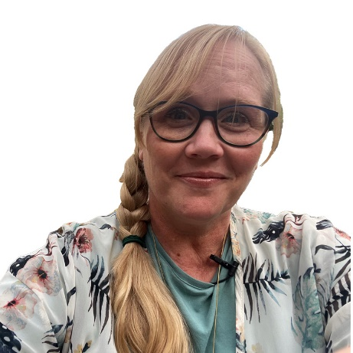

Congratulations to Lori Walsh named a 2022 Bush Fellow. From the formal announcement it’s quoted, “She brings to the table a unique combination of art and science as a journalist and an artist, a veteran, and a pacifist. She wants communities to form strong and vibrant storytelling networks that employ the tools of journalism to create solutions-based collaborations for local problems. To lead this transformational work, she will weave together technical training, travel, valued connections, and personal trauma work. She will build her long-form audio storytelling skills, ensuring the stories are told by the people who lived them. She also will pursue training in nonviolent and compassionate communication to counteract today’s divisive rhetoric.”

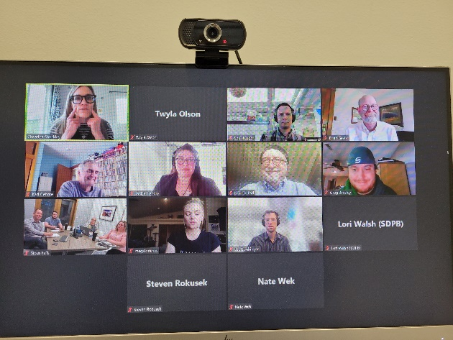Our producers from all content departments participated in vocal coaching. Here’s an image of the first gathering. Staff report it was a valuable experience, and there was a lot of laughter, and noises coming from the conference room. The trainer (upper left in the photo) held large group and individual coaching over a series of sessions. We have contracted with Christina Shockley to continue coaching our staff.

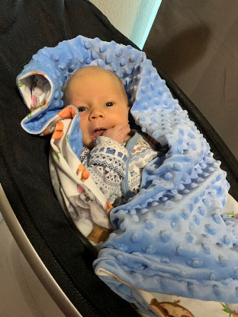

**Staffing:**

We welcome Amber Zora and Carl Norquist to the In the Moment team as temporary part time positions filling in for a producer who is on extended leave.

Congratulations to Jordyn Henderson and his wife on a Christmas Eve baby – as Haidyn Andrew joins the SDPB extended family.

We said goodbye April 22 to Arielle Zionts. She has taken a position with Kaiser Health as a medical beat reporter. She will be based in Rapid City.

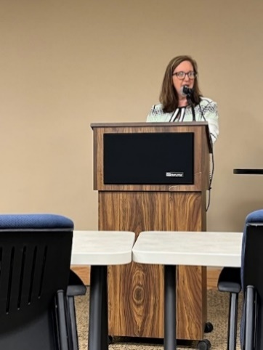I presented the 100-year history of South Dakota Public Broadcasting to the annual Dakota Conference on the Northern Plains. The theme for the conference was Radio Comes to the Northern Plains from Wireless to Wi-Fi. The history of SDPB traces its roots to KUSD-AM. This was one of the eldest educational radio stations in the United States. We celebrated our 100-year history at the end of May with a vocal reenactment by an Augustana University quartet. We know the first vocal broadcast was a quartet. So thanks to the music department for finding something from the time period and having students record it for us.

Lori Walsh gave the keynote address to the Women Veteran’s Conference. Her speech was about In the Moment and storytelling. Lori was also added to the Her Vote Her Voice honor wall. It’s a month-long women’s history initiative through the South Dakota historical society foundation.

Our Summer interns were a joy to have around. Jordan Rusche from SDSU, Marissa Brunkhorst from USD, and Slater Dixon and Andrew Kronaizl both from Augustana University. They provided daily news content and other special projects throughout the summer. They all opted to stay and continue through the fall semester.

In July, Joshua Haiar switched from Digital Content to a full time beat reporter. He will focus on business and economic development beat. He is based in our Sioux Falls Studio.

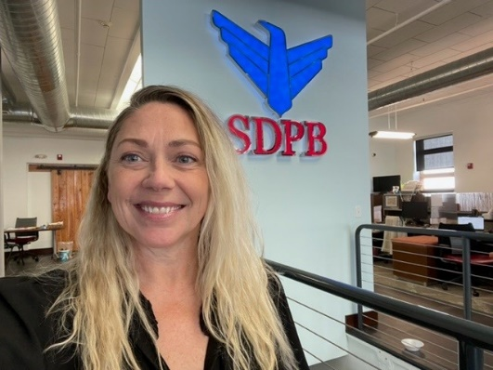In August we welcomed Krystal Miga and CJ Keene to our team – both are based in our Black Hills studio in Rapid City.

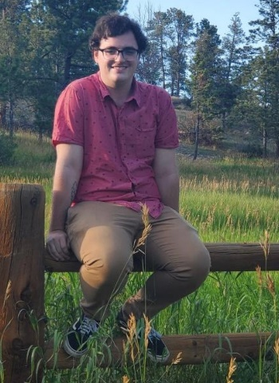**Krystal** is the local host of Morning Edition. She grew up in Rapid City, graduated from Stevens High School, and earned her master’s degree in broadcasting from San Francisco State University. She served as a producer and board operator for Cumulus Media in San Francisco and served as a producer and on-air talent for Pandora Media in Oakland and KXMZ in Rapid City. Krystal is a U.S. Air Force veteran. In her spare time, she loves ballroom and social dancing, hiking with her dog, and spending time with her family.

**CJ** is our beat reporter covering education, healthcare, arts, and culture. He studied journalism and film studies at Doane college and grew up in Omaha, Nebraska. CJ is passionate about film and music, and he spends his free time exploring the Black Hills.

We said a fond farewell to our senior supervising producer, Seth Tupper. Seth joined us in early 2020 where he was instrumental in our coverage of the pandemic and later leading our daily news content. Seth produced the documentary Remembering the 72 Flood and won a National Edward R. Murrow award for his coverage of fireworks at Mt. Rushmore. Seth was also key in several organizational workflow upgrades and helped design our sdpb.org/news page and digital first initiative. Seth leaves us for a new States Newsroom venture, and we wish him all the best and look forward to seeing what he does next.

A News Director has been hired and will start October 11. More to come – and yes, I buried the lede.

**SDPB Digital ET Board Report**

Greetings! As this is my first board report for the ET Board I wanted to take a moment to properly introduce myself. My name is Heather Benson and I am the Digital Strategy Manager for SDPB in our brand new Digital Department, which is itself a part of the greater SDPB Content team.

I have been with SDPB since June of 2016, originally coming on board as the Social Media Engagement Specialist and more recently as the Digital Marketing Manager in the Marketing department before moving into Content and taking on the newly created role of Digital Strategy Manager. My previous experience is in corporate marketing management, with an emphasis on digital and social strategy and working primarily with rural and non-profit entities. In my personal life, I have a 10-year-old daughter and we live on a small farm raising Icelandic sheep, training horses, and occasionally wrangling errant turkeys and harvesting the stories thereof for my Dalarna Farm website and social sites.

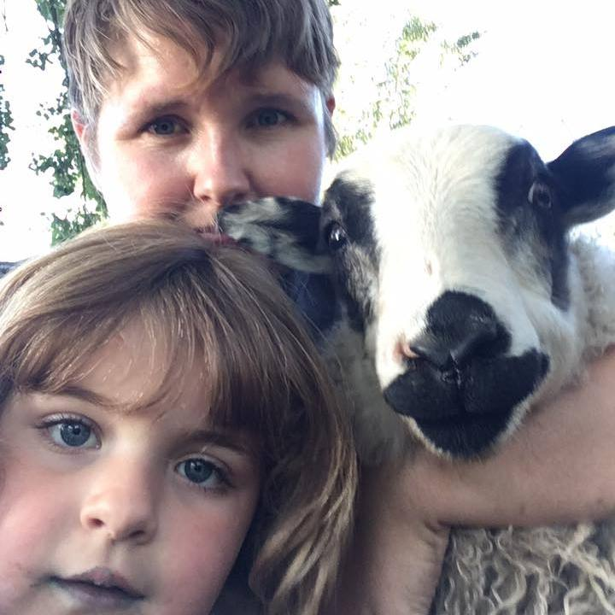

*Farm life at Dalarna Farm with myself, daughter Evie and Bandit the sheep*

**About the Digital Department:**

I view our new Digital Department as a “internal customer service” to our greater content teams. As they go out and tell the stories of South Dakota, it is the role of the Digital Department to provide those stories with the best possible opportunity in the digital realm. This means assisting the Education, Journalism and Entertainment teams in collecting, curating and deploying their content in such a way to not just reach the most South Dakotans possible, but to have the greatest possible impact. Our job is to support their work, expand their audience and connect them with the tools and resources to continue SDPB’s role as a digital content leader, both in South Dakota and in public media as a whole.

To this end, the Digital Department also serves as the audience data clearinghouse for SDPB. We collect audience data from 37 different sources and then break down and visualize that data so that our management team can use that information to guide decision making at both a micro and macro level. A major part of the Digital department’s strategic plan is creating increased “data literacy” in both our management and content staff so that as we continue to gather more information about how our content impacts South Dakotans, we can use it to make the best possible decisions as our organization continues to grow and change.

*The Digital Department collects audience data from 37 disparate sources, covering on-air TV and radio, web, social media, podcasting, membership and more. We also monitor emerging local and national trends that help inform new initiatives and platform development.*

Another major facet of what the Digital Department oversees is the planning and management of our digital content platforms, including the SDPB website. In the coming 12 months, a major project being undertaken by the Digital Department will be to migrate all of SDPB’s website content into one Content Management System (CMS), making it the first time all SDPB web content will be hosted at a single location on the internet. This will not only significantly improve our public user experience but will also greatly streamlines the backend processes for content producers.

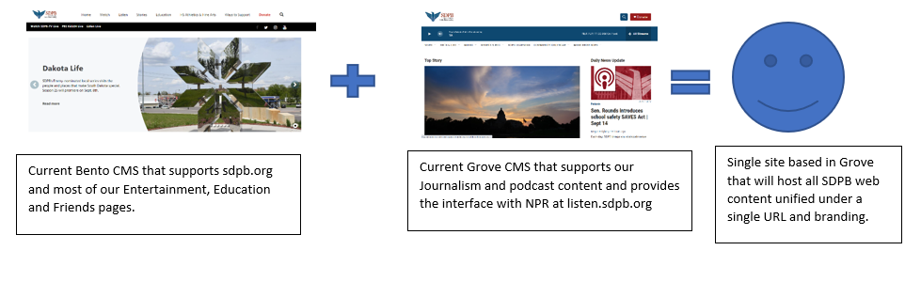

**New Hire:**

The Digital Department will be on-boarding it’s first employee outside department lead Heather Benson when Brent Duerre joins SDPB starting September 26. Brent will be taking on the role of Digital Content Curator, providing the daily hands-on service of editing, uploading and deploying SDPB educational, entertainment and journalism content to both our digital platforms and social media sites. Brent comes to us from KSDR-FM in Watertown where he was the Program and Sports Director for the past five years. In over two decades in South Dakota commercial radio, Brent has sprearheaded many digital projects for his employers and we look forward to his expertise, ideas and leadership in this new role.

**Digital Audience Highlights 2022:**

**Website:** Our sdpb.org and listen.sdpb.org websites have seen 1,278,315 users visit 4,048,345 pages so far in 2022. This is an increase of 3.6% in total users over the same period in 2021.

While our High School sports coverage garners the majority of our web traffic on a year-by-year basis, we have seen outstanding increased traffic come to our sdpb.org/live page through our partnership with the Levitt at the Falls as well as our continued live offerings of local programming such as Dakota Life and local documentaries on that page.

We also have seen the overall page time spent with our Journalism stories continue a strong run of above average read time and extremely low bounce rate, indicating a highly engaged audience that comes to our site and stays for long periods while consuming multiple web pages—the holy grail of web traffic.

**Online Video Viewership:**

**YouTube:**

Our YouTube page has 2,259,703 views for a watch time 296,294 hours in 2022. The 60-minute documentary “Vietnam War Survivor Stories”, loaded to the site by our Education team on April 9, has had an astounding 434,839 views, making it one of the most-watched videos of all time on any of our platforms. We have seen large increases in new viewers of our YouTube page, particularly in the last 90 days and an overall subscriber increase of nearly 5,000 year-to-date.

**Watch.SDPB.org/Passport:**

In 2022, we have continued to see strong usage of our on-demand video streaming provided on the watch.sdpb.org site through the PBS Passport interface. Year-to-date we have had 216,840 unique users open 572,420 sessions of this service. While many national programs such as PBS Newshour and Antiques Roadshow have strong local viewership on this platform (as they do over-the-air as well), our local programs and documentaries continue to gain viewers. In the first two seasons of the Dakota Life revamp, our online viewership on the Watch platform has increased by 109%.

Thanks to the continued analytic upgrades offered by PBS, we can now also see the geographic locations of our digital video viewers. The chart below shows the top 25 South Dakota towns by monthly users:

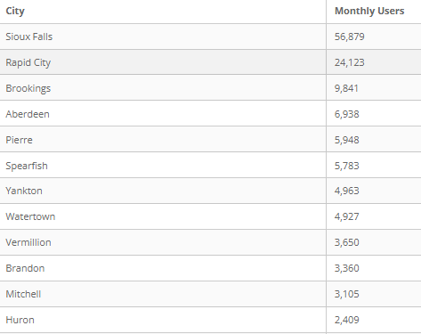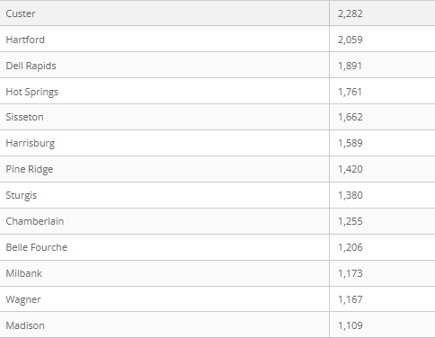

**Digital Audio and Podcasting:**

**Radio Livestream:**

The digital live stream of our radio programming has seen a spectacular rise year-over-year. To date, the average monthly cumulative listeners has increased 139% from 9,527 in 2021 to 22,762 in 2022. As digital streaming of radio programming continues to grow as an overall portion of our radio audience, this is an exciting trend to see in our numbers.

**Podcasts:**

Our initial forays into podcasting which includes programs such as the In the Moment podcast, the daily SDPB News podcast, In Play with Craig Mattick and History 605, have seen a total of 209,131 downloads and 91,443 users year-to-date. As we work with consultant Nate Tobey to continue to fine tune our current podcast offerings and develop new shows, we are excited to see how those solid numbers can grow from here.

**Social Media:**

Although the social media climate continues to see major upheavals in platforms, user interest and algorithms, SDPB’s social sites continue to outperform their local and public media peers. To date in 2022, SDPB’s social media pages have seen a total reach of 15,856,598, engagement of 984,060 and video views of 5,276,010.

As we enter the last quarter of 2022, we are excited to begin experimentation of new kinds of social content specifically developed for TikTok and Instagram audiences. This is an experimental period for these platforms as we learn both the backend process of how best to produce the content and the frontend process of how best to engage with audiences on those platforms.

**South Dakota Board of Educational Telecommunications**

**Education Report-Marcy Drew**

**September 2022**

**Early Learning Initiative (ELI)**

The ELI website was updated and reorganized to be more user-friendly and easier to navigate. The design reflects a concentration on four major “blocks” of information to support those who interact with young learners. These blocks are educational programming (videos, PBS Kids shows), interactive games (online and apps), educational resources (activities, lesson plans, articles), and professional development (virtual and in-person). Within each block, everything is aligned with the South Dakota Early Learning Guidelines. The Guidelines provide goals and learning targets for children ages birth-5 in the domains of approaches to learning, social/emotional, communication, language & literacy, health & physical development, and cognitive development (math, science, social studies, creative arts).

The Early Learning Links e-newsletter has seen a 25% increase in subscribers in 2022. Emailed weekly, Links includes articles, activity ideas, games, videos, and other resources to address learning in each domain of the SD Early Learning Guidelines. This summer, our partner, SDSU Extension, contributed to Links by sharing ideas for enjoying the outdoors, gardening, and nutrition with young children.

Early childhood educator Jodi Butzer, who teaches toddlers in Sioux Falls, piloted a new teacher fellowship program. She created a comprehensive teacher guide on the topic of insects, which includes activities, lessons, games, and other ideas based on the SD Early Learning Guidelines for parents, teachers, and caregivers to implement with children ages 2-5. The guide will be available online and promoted during outreach events throughout the upcoming year. Jodi also helped at local outreach events, using her knowledge and skills to interact with children and their families. The fellowship process is now being evaluated for possible implementation with other talented educators.

Early Learning Specialist Amelia Meyer moved from Spearfish, SD, to Chicago, IL, but remains part of the education team. She is consulting on the Links newsletter and digital content curation and development on a part-time contract.

To continue the momentum West River, Danielle Flom and Kayla Klein joined the early learning team in July 2022, to provide outreach and develop projects in the Black Hills and the greater western SD region. Danielle and Kayla are both from South Dakota and have worked in early childhood education and human services in the region. They bring many connections to the field and a first-hand understanding of the needs and opportunities in the western part of the state.

**K-12 Education**

The Homefront series website has been completed and can be viewed at <https://www.sdpb.org/learn/localheros/>. Here, WWII veterans tell their stories in audio interviews and by sharing photos of artifacts from their military experiences. Other resources include documentaries, news stories, and interviews with SD veterans throughout history. You can also find the story of and recipe for the famous Pheasant Salad Sandwich.

Each year, existing lessons and resources are updated to ensure the information is fresh, accurate, and accessible to teachers and students and all links work. Recently, we recorded a new video for the Steamboat North Alabama lesson plan, updating footage available for teachers and students to learn about the sunken ship near Vermillion and related topics. New content was added to the Native American Studies and Dakota Pathways websites.

SDPB resources continue to be used by educators across the state and nation via PBS Learning Media. Our Dissection 101 collection is one of the top 5 most accessed across the US for high school students on that platform. The STEM Education Collection, in collaboration with Sanford Research’s Promise program, is in the top 50 among over 300 educational collections. We are making plans to add to each of these collections.

Work on *Perspective Drawing with Dick Termes* project has started and will continue through the fall. Artist Dick Termes will create instructional art videos with advanced techniques, including drawing on spheres using his unique take on six-point perspective, to extend his existing series with SDPB, *Art Basics with Dick Termes.* SDPB educators will add teacher guides, lesson plans, and implementation ideas. A live Facebook event in May featured Mr. Termes giving a sneak peek into the new videos and his artistic vision.

The weekly Learn newsletter is distributed during the school year to over 3000 subscribers and includes resources to be used with preschoolers through high school students.

**Outreach and Professional Development**

The education team works together to provide outreach and professional development to families, caregivers, and educators to share all of the resources available from SDBP. SDPB education staff give presentations and host vendor booths at professional conferences for home and center-based childcare providers, Head Start staff, K-12 teachers, school administrators, school board members, and policymakers. We participate in events for children and families, including Youth & Family Services Kids’ Fair in Rapid City, Riverfest in Sioux Falls, and Storybook Land Festival in Aberdeen, along with back-to-school and resource fair events across the state. SDPB has partnered with the Statewide Family Engagement Center’s FamFest series, where businesses and organizations provide activities and information for families in a fun scavenger hunt around town.

Science Steve provided demonstrations and professional development for educators at several schools across the state, community locations such as libraries and museums, professional education conferences, and universities. He was featured at the annual Neutrino Day event at the Sanford Underground Research Facility in July. More than 1,150 people participated in Neutrino Day this year. Science Steve was featured in the “best of” video and online posts, where he was referred to as a “mainstay” and “perennial favorite” at Neutrino Day.

SDPB has increased our participation in educational initiatives at the local and state levels, such as early learning summits, educational boards, advisory committees, and work groups. The goal is to work in collaboration with the education and early learning professionals in South Dakota and provide our unique resources to children, families, care providers, and teachers.

**Board of Directors of Educational Telecommunications**

**SDPB Programming & Communications**

**Fritz Miller**

**September 30, 2022**

**Programming – TV**

Recently the Saturday line-up has been revised. The removal of some programs (by the shows’ distributors) and a desire to create better flow are the goals. We also wanted to expand the footprint of British programs, which continue to be audience favorites. Changes to the schedule took effect at the end of August, so there has not been an opportunity measure the audiences of these programs.

As an aside: It’s been a year since *The Lawrence Welk Show* was removed from the schedule. While there has been communication from our audience about this decision, there has not been anything like a groundswell of anger or a major reduction of donors.

Upcoming shows of interest:

* November highlights include SDHSAA Chorus & Orchestra, Football and Volleyball Championships, new episodes of the Dakota Life, Music Matters and Wish You Were Here with Eliza Blue (premiering in 2023), On Call with the Prairie Doc, documentaries about the SDSU marching band *The Pride of the Dakotas*, about famed spelunkers titled *The Ups and Downs of Herb & Jan Conn*, about interesting homesteads of early South Dakota settlers with the working title *Pioneer Homes*.
* December will be filled with plenty of holiday cheer, including local programs produced by Augustana and Mount Marty. We’ll also stream and broadcast the SD Symphony’s performance of Handel’s *Messiah*.

**Programming – Radio**

The weekend radio schedule was refreshed effective the weekend of July 2-3 in order to create a better flow between programs and give our audience exposure to new voices. The new schedule is below. New programs shaded blue, new times shaded green.

|  |  |  |
| --- | --- | --- |
| Time | **SATURDAY** | **SUNDAY** |
| 5 am | BBC World Service (overnight) | BBC World Service (overnight) |
| 6 am | The People's Pharmacy | Planet Money/How I Built This |
| 7 am | Weekend Edition | Weekend Edition |
| 8 am |  |  |
| 9 am |  | A Way with Words |
| 10 am | Wait, Wait…Don't Tell Me! | Travel with Rick Steves |
| 11 am | This American Life | Milk Street Radio |
| Noon | Radiolab | The Moth Radio Hour |
| 1 pm | Hidden Brain | Wait, Wait…Don't Tell Me! |
| 2 pm | Planet Money/How I Built This | This American Life |
| 3 pm | Code Switch/Life Kit | Radiolab |
| 4 pm | All Things Considered | All Things Considered |
| 5 pm | Latino USA | Fresh Air Weekend |
| 6 pm | Bullseye with Jesse Thorn | On Record with Matt Weesner |
| 7 pm | Conversations from World Cafe |  |
| 8 pm | American Routes | JN Extra |
| 9 pm |  | Big Band Spotlight |
| 10 pm | On Record with Matt Weesner | BBC Arts Hour |
| 11 pm |  | BBC World Service (overnight) |
| Mid | BBC World Service (overnight) |  |

**Personnel** – The Programming staff has been stable. We are in a position to hire a Traffic Coordinator to provide assistance and back-up for the ever expanding underwriting and promotional opportunities made available through digital expansion, and made necessary due to the success of the expanded Underwriting sales team.

**Marketing –**

**Staffing** – Turnover was a major issue between December and May. We have hired a new Marketing Manager, Public Relations Manager, and Graphic Designer – filling the positions that were left open by resignations. A great deal of training has and is taking place.

**SDPB Rebrand** – Progress has paused on this while the Programming and Marketing departments completed their merge and personnel issues were resolved. As per the Strategic Plan, the brand refresh is our department’s main priority in the next calendar year.

**Project Support** – With shifts in other departments the burden of generating content has been taken off the shoulders of the Marketing staff. However, we are working with Content, Outreach, Development, and Education to support their efforts.

**South Dakota Board of Directors for Educational Telecommunications**

**Technology Team Report – SeVern Ashes**

**September 2022**

Preparing for the Future.

As with other departments within SDPB. Our group has been actively looking at where we would like to be in the next 3,5, years. Of course, we take our guidance from the wider industry. As well as from our internal stakeholders within BIT/ SDPB, other state agencies Boards and commissions.

**Next Generation of Television,** (Next Gen TV or ATSC 3.0), is slowly rolling out nationwide. Much like the original digital TV transition, completed in 2009, Next Gen TV will revolutionize how people receive and interact with television. Because of manufacturers and the Broadcast industry. Are moving to the Next Generation of television technology. We are increasingly finding it difficult to source critical parts to maintain the Television transmitters. We are actively executing our 5-year TV replacement plan outlined below. That will replace the television infrastructure that supports the existing ATSC 1.0 and the ATSC 3.0 standards when the time comes a simple software update will support and transition equipment to the new NexGen TV platform. We are anticipating future cost-saving in electrical, and HVAC usage over our current 20-year-old TV transmitters, we anticipate reaching a break-even point in electrical and HVAC cost savings in 7 to 8 years

**KESD Brookings/Hetland Tower**: The Tower structure was damaged during the May 12th, 2022, Derecho storm that caused widespread damage in Eastern South Dakota.  On June 29th, 2022, BIT agencies South Dakota Public Broadcasting (SDPB) and State Radio Communications (SRC) jointly applied for 75% reimbursement of the cost to inspect and /or replace tower infrastructure.  A tower inspection on the 800 Ft. KESD Hetland/Brooking’s tower. The inspection shows significant damage was sustained.  This Tower was inspected on May 5th, 2022, and again after the storm on July 26th, 2022. Both inspections were performed by National Tower Systems Inc. of Crooks South Dakota. The post-storm inspection indicates significant damage on all sides (3) of the tower. We reached out to the professional tower engineering firm FDH Infrastructure Services for recommendations on how to proceed. Given the age of the tower and the type of damage, they recommend a complete replacement of the structure.  We are in the process of working with FEMA field inspectors and a 3rd party structural engineer for a complete analysis of the steel to verify the next step within the FEMA authorization process.

**2021-2022 Legislative session**, SDPB is very proud of the immense effort put into bringing the happenings in Pierre to the widest audience possible.  A major streaming upgrade to the Haivision Connect platform was half-implemented days before the session, and things went very smoothly for the home audience. Never were they able to see full presentations to the Appropriations Committee, and live videos of the committee in action. Also, before the 2022 session, Governor Noem authorized technical video and audio upgrades to the large conference room. SDPB and LRC are also working together on a multi-year plan to migrate the other meeting rooms within the capital complex to allow for streaming and archival meeting presentations/video content.

**Public Safety**

SDPB is also integral to fulfilling the Federally mandated WARN Act - Warning, Alert & Response Network. This System uses Wireless Emergency Alert (WEA) messaging that is embedded within the SDPB television programming. These messages are received throughout the state. Cellular carriers like AT&T, Verizon, and T-Mobil allow broadcast EAS messaging with national emergencies, alerts involving imminent threats to safety or life, and Amber Alerts to the citizen’s cell phone.

This system provides a 99.999% “always-on” backup to cellular wireless providers to receive and re-deliver alerting messages to the public via cell phones and other smart devices.

For more about how the WARN/WEA system has saved lives, watch <https://sdpbne.ws/3w7A0X7>

Commercial radio, television, and cable systems statewide look to one of our 11 SDPB FM radio signals as a primary EAS activation source. In addition, SDPB TV and radio provide local and regional weather emergency alerts.

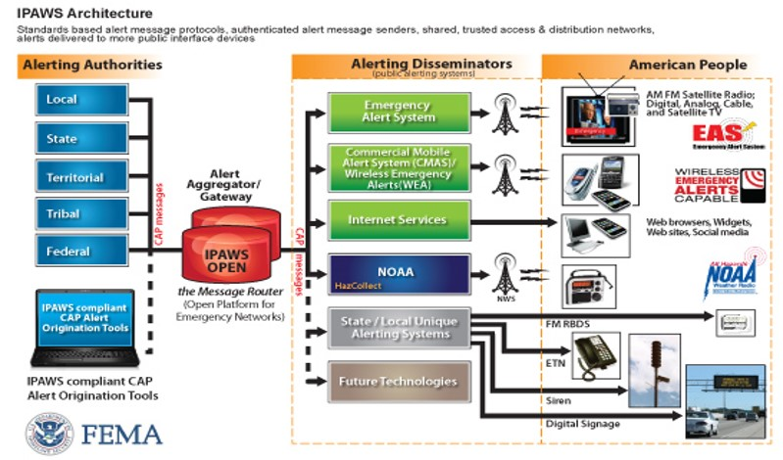

**SDPB Engineering Staff:** I am excited to report that for the first time in the past three years SDPB engineering is fully staffed. Our newest members are:

Colton Nickelson comes to us from Black Hills State University in Spearfish. Colton’s main responsibilities will be supporting studio and remote productions.

I’d like to introduce Eli Koppenhaver, Eli comes to us from a private radio group out of Fargo North Dakota. Over the summer he relocated to Vermillion. Eli is quickly coming up to speed within our field engineering group that is actively troubleshooting our point-to-point microwave interconnect, and has been involved in installing a new transmitter at Hetland /Brookings.

Lastly, Steve Munsen has been with the network for several years supporting radio and studio productions. Recently Steve stepped into his new role as East River-Field Engineering Supervisor I would like to congratulate Steve on his well-deserved promotion.