**Education and Telecommunications Board Report**

**August 2024**

**Twyla Olson**

**Director of Content & Assistant General Manager**

**Goal – SDPB will engage with every South Dakotan at least once per month.**

**Digital Content**

We lost Heather Benson as our Digital Strategy Manager on July 10, but not before she launched our new SDPB website on July 1st. It was a nearly 3-year, Herculean effort, led by Heather and involving BIT, SDPB and NPR staff, and programmers from around the world. Here is a peek at the new look, with updated branding. The new site allows for more flexibility, integrates all of our content onto one platform, and gives us more opportunity for Underwriting.

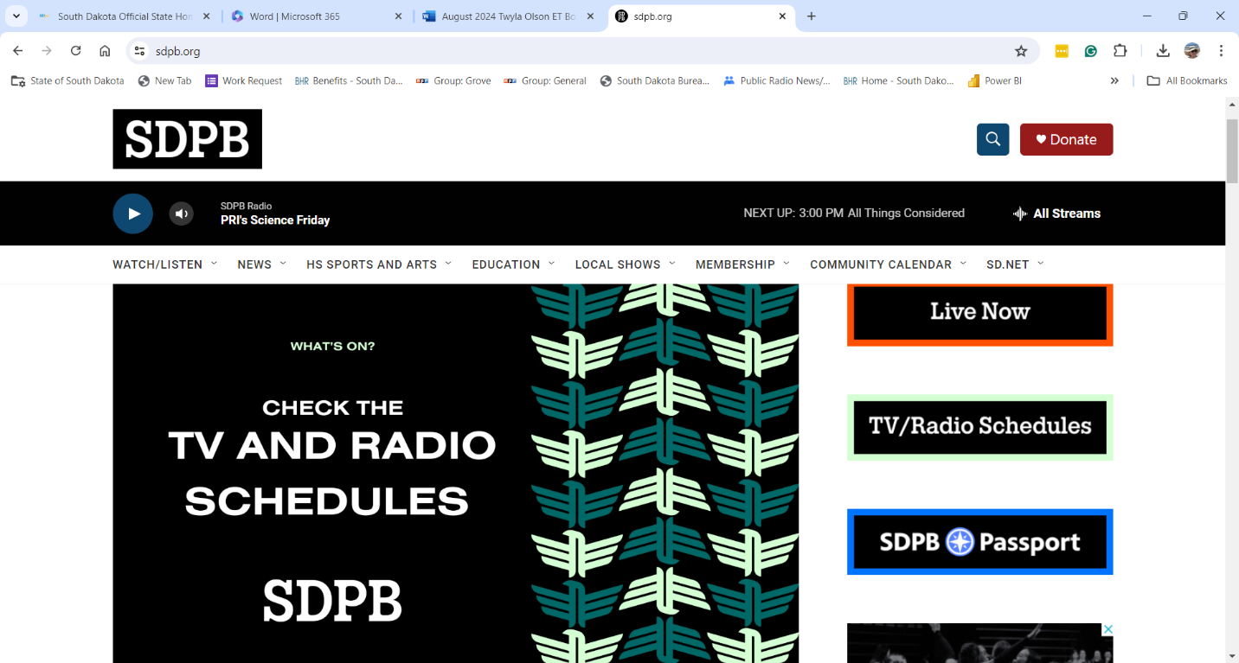

We have requested reclassification of the Digital Strategy Manager position through BHR, as we believe the job needs to be elevated to attract the best candidates. As we await that process, Brent Duerre, our Digital Content Curator, has temporarily stepped up to help with Heather’s tasks. We hope to post the position and fill it by September.

Our Digital Content continues to grow. I will discuss it further with a presentation at the Board Meeting.

**Entertainment and Journalism Content**

**Dakota Life** completed the 2023-24 Season in June with a crowd of 100 people at the Premiere at the Webster Theater. The Community Conversations in our upcoming nine communities were well-attended, and the excitement around the program continues to grow. Here are a couple of photos of the crew at work in Pine Ridge. Tim Davison was named the new host of Dakota Life, and his interactions with both his colleagues and communities will bring a new energy and direction to the program.

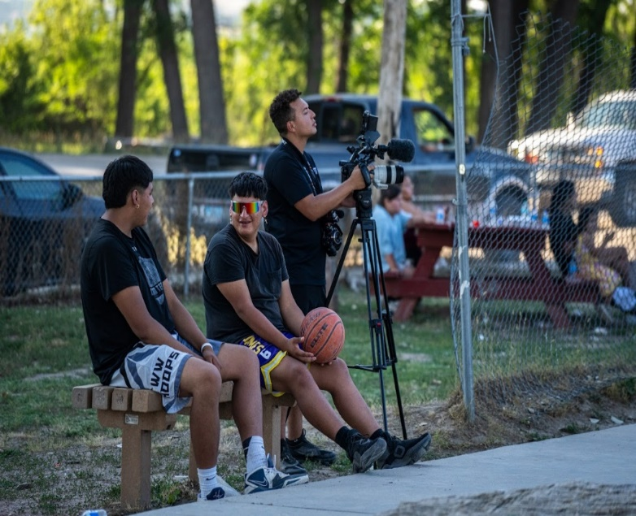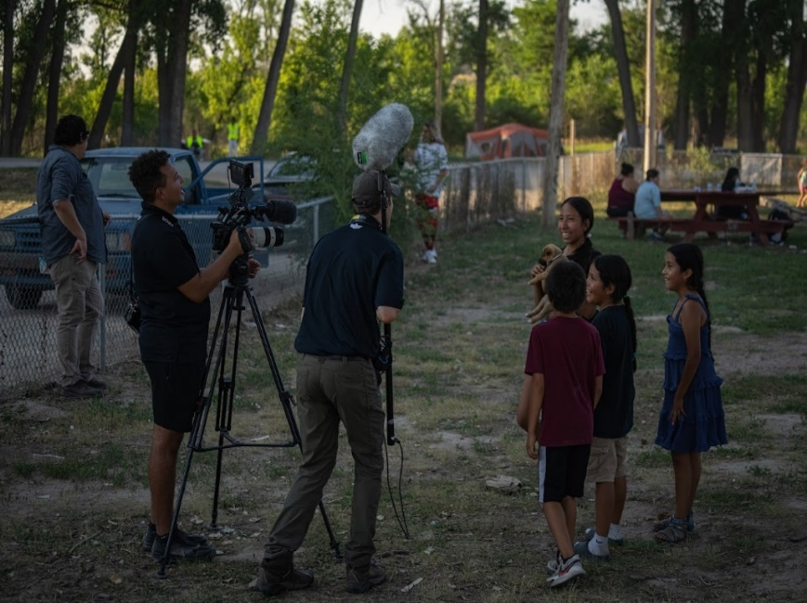

Tim Davison and Jaxon Thorson filming in Pine Ridge.

**High School Activities** ended in June with the second year of Softball Championships. Brad Van Osdel, Kyle Mork and I visited the Directors at their strategic planning session in Pierre, and their response to the work we do for them turned into a bit of a love fest. They are so grateful for our partnership and the broadcast we provide free to all South Dakotans.

We broadcast **High School Rodeo Championships** live on TV for the first time, in addition to streaming it live. We had a great response, and we will continue this course in the future.

We have started work on upcoming documentaries including **The Meridian Bridge** in Yankton, slated for October completion, and **South Dakota Women Veterans**, airdate is TBD.

**In The Moment** was awarded a grant from Arts Midwest, and they have used it to beef up their arts reporting and focus on increasing their digital footprint.

**In The Moment** also hosted their first One Book South Dakota event in June, with South Dakota author Trent Preszler, and it was a huge success. We’re hoping to host this event, presented by the SD Humanities Council, on an annual basis.

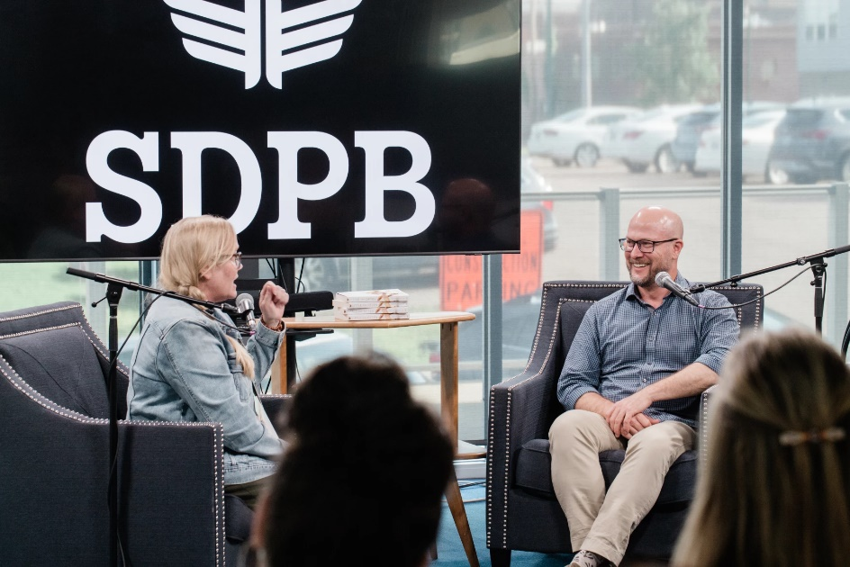

More great news is afoot with **In The Moment** that I’ll cover in my Board Presentation.

**South Dakota Focus** ended its season centered around the state of the child in South Dakota in May with a Town Hall. The season was well-received and impactful. We’re grateful to Marcy Drew, Director of Education, for her guidance and partnership in the content and direction of the season.

Jackie Hendry and Krystal Schoenbauer are out on the road, working on the new season of **South Dakota Focus**, which will center around all aspects of SD Tourism.

Cara Hetland and Josh Chilson continue to tweak daily local newscasts, and we’ll soon have more local content in Morning Edition and All Things Considered due to their work.

Work on the Vote South Dakota partnership project continues, which will culminate in a Town Hall at Dakota Wesleyan in Mitchell on September 19th.

The loss of our contractors in April has created unique opportunities for the E & J Teams to work closely together on their programming.

Brad Van Osdel and Cara Hetland continue to focus on bringing the best local content possible to South Dakotans on a daily basis.

**Education**

Marcy Drew brings a wonderful spirit of collaboration to our team. She and Steven Rokusek worked closely with Richard Two Bulls to create educational materials based our documentary Tatanka: A Way of Life, which were picked up by PBS Learning Resources. We’re eager to see how they are used in classrooms throughout the country.

[*Tatanka (Buffalo): A Way of Life for Native People in the Past and Present*](https://sdpb.pbslearningmedia.org/resource/buffalo-past-and-present-lesson-plan/tatanka-a-way-of-life/)

In addition, with money from a grant for the upcoming Ken Burns documentary, Da Vinci, Steven created a new dissection video, which will be available soon on our SDPB Learn pages.

Marcy and her team have also crisscrossed the state, providing educational materials to teachers, administrators, child-care specialists, and kids.

**Outreach**

Nathan Hofer and Brittany Neiles have kept busy with numerous events across the state. They experimented with a few new types of outreach, including partnering with Lost Cabin Brewery for the Short Walk Talk at our Rapid City studios, which was an intimate conversation with Lee Strubinger and Cara Hetland about the podcast, A Short Walk. In addition, Lost Cabin partnered with us in Hill City for an event to kick off research for South Dakota Focus. Both had good attendance, and we will continue to foster these kinds of partnerships.

Community Conversations were held in nine towns for the upcoming season of Dakota Life, and now plans are underway for the Premieres in the coming months, including Burke in September, McLaughlin in October, Box Elder in November, Britton in December, Elk Point in January, Garretson in February, Wessington Springs in April, Pine Ridge in May, Faith in June.

We hope you can join us at some of these Premieres and soak up the love for SDPB we experience at them.

Here are a few upcoming events:

|  |  |  |  |
| --- | --- | --- | --- |
| SDPB at the Brown County Fair | 16-Aug-24 | Brown County Fairgrounds | Aberdeen |
| South Dakota Board of Directors for Educational Telecommunications Summer Meeting | 20-Aug-24 | Black Hills Gallery | Rapid City |
| Black Hills Legacy Recognition Lunch | 21-Aug-24 | Black Hills Gallery | Rapid City, SD |
| Low Down Brass Band (pre-Levitt show) | 6-Sep-24 | Sioux Falls Gallery | Sioux Falls |
| Latino Day Parade & Festival | 15-Sep-24 | Levitt at the Falls | Sioux Falls |
| SDSO Young Composers Recital - RC | 18-Sep-24 | Black Hills Gallery | Rapid City |
| SDSO Music Composition Academy | 18-Sep-24 | Black Hills Studio |  |
| SDSO Music Composition Academy | 19-Sep-24 | Black Hills Studio |  |
| Vote South Dakota Candidates Forum | 19-Sep-24 | Dakota Wesleyan University | Mitchell |
| SDSO Music Composition Academy | 20-Sep-24 | Black Hills Studio |  |
|  |  |  |  |
|  |  |  |  |
|  |  |  |  |
| Buffalo Roundup | 27-Sep-24 | Custer State Park |  |
| Friends Board Meeting | 11-Oct-24 | East River - TBD | TBD |
| Connecting the Prairie, Yankton’s Meridian Bridge | 12-Oct-24 | Dakota Theater | Yankton |
| Belle Fourche Dakota Life Premiere | May/June | Belle Fourche Rec Center | Belle Fourche |
|  |  |  |  |
| Burke Dakota Life Premiere | 11-Sep-24 | Civic Center | Burke |
| Eastern SD Legacy Society Induction | 28-Aug-24 | Sioux Falls Gallery | Sioux Falls |
| Back to School Round Up | 27-Jul-24 | Ellsworth AFB | Box Elder |
| Box Elder Dakota Life Premiere | 7-Nov-24 | The Liberty Center | Box Elder |
| Leonardo da Vinci at the Washington Pavilion | 3-Oct-24 | Washington Pavilion | Sioux Falls |

**Education and Telecommunications Board Report**

**August 2024**

**Brad Van Osdel**

**Director of Entertainment Content**

**High School Activities**

May is a big month for SDHSAA events; Jazz Band and Show Choir started the month, the entertainment team streamed the event to SD.net, and the program was recorded for television and aired later in May. The Track and Field Championships for all three classes were held at Howard Wood Field, and all three days were live-streamed to YouTube and SD.net, with the final day also being broadcast live to SDPBTV. The totals for YouTube streaming: the first day, 16,000 views; the second day, 15,000 views; and the third day, 15,000 views. The live stream of Track and Field is widespread and continues to grow every year. The social media portion of our coverage is also a favorite with our audience. The team produces 11 articles and videos of the 3-day event that have been liked, shared, or commented on over 5000 times on Facebook. One of the stand out highlight clips was Aiden Hedderman of Sturgis Brown breaking the all-time 110-meter hurdle record with a time of 13.88. This video has been viewed over 80,000 times on Facebook. Another record-breaking performance was by 8th grader Reagan O’Neal of Bennett County. She broke the all-time girls 100-meter dash record with a time of 11.74. This video has been viewed on Facebook over 245,000 times. Many state records were broken over the three-day event. Still, perhaps one of the most interesting was when Beau Karst from Harrisburg broke his record that he had set just 11 days earlier with a vault of 16 feet 4 inches in the boy's pole vault. We had a chance to interview Beau and his couch, and this video has been viewed over 94,000 times on Facebook; Beau is ranked 29th in the nation in the boys' pole vault. Several other stories were produced about high school athletics. One highlights Sebastian DeYoung, a long-distance runner from Garretson who loves running with a smile that makes his teammates and opponents smile. This story has also been viewed over 29,000 times on Facebook.

After the state track meet, the team traveled to Aberdeen for the state softball tournament. Total impressions on Facebook for all content produced during the tournament was 148,542, with 5,053 link clicks and 1,114 reactions. A few of the stories written that performed well were Castlewood softball is truly a family affair – 52,868 impressions, 1,491 link clicks, and 446 interactions, Alcester-Hudson holds off late-game rally by Florence/Henry in the quarterfinals – 14,030 impressions, 392 link clicks, and 79 interactions, Chester bats dominate Castlewood, Flyers win ‘B’ softball title – 17,442 impressions, 434 link clicks, and 169 interactions. A video produced asking players what their favorite walk-up song is has 13,692 impressions and has been viewed 14,837 times on Facebook. The crew finished out the SDHSAA season with the state golf tournaments. Total impressions on Facebook were 62,998; link clicks were 2,513, and 515 interactions. A couple stand out stories were, Clark/Willow Lake’s Brynn Roehrich wins girls state ‘B’ golf title – 4,847 impressions, 72 link clicks, and 44 interactions, Gavin Colson of Sully Buttes takes home ‘B’ boys championship – 9,778 impressions, 192 link clicks, Carly Guthmiller hits hole in one at state tournament – 16,673 impressions, 162 link clicks, and 266 interactions.

**High School Rodeo**

The Entertainment travels to Ft. Pierre for the SD High School Rodeo Finals. This year is the 75th anniversary of the state finals in South Dakota. Over 620 youth athletes participated in the four-day rodeo. SDPB was on hand to live stream all for days, starting on Wednesday with Cattle Cutting and Reined Cow Horse and then Thursday and Friday with four prelim rodeos and rounding out the weekend with the short-go championships on Saturday with a live stream and television broadcast. All told, the live stream of these days was viewed at 17,406. Along with the event's live coverage, all event winners were interviewed, and those interviews were shared on social media through June and July. So far, with just over half of the videos released, they have been viewed over 80,000 times on Facebook. The events and finals will be archived on YouTube, and the finals will be archived at <https://watch.sdpb.org/>. Several stories were produced during the rodeo and shared on our website. The team also produced four video packages that will air in September in a program titled “Tales from the Arena,” highlighting South Dakota's love of rodeo.

**Dakota Life**

Dakota Life's May episode traveled to Beresford to capture unique stories of this South Dakota community. Twenty citizens of Beresford showed up for the premiere of their episode. We met some interesting Beresford folks who were willing to share their stories with SDPB and the Dakota Life Team. We visited the Olde 77 Car Museum. Glyndon and Mary Knutson gave us a tour of this collection, which they love sharing with visitors. This story has been viewed over 16,000 times on Facebook. We also met Ed Westberg and got a glimpse of his massive music collection, beyond records, with musical memories spanning four decades. This story has been viewed over 7,000 times on Facebook. We rounded out the episode by visiting some young folks who have moved back to Beresford to bring a spark to the downtown with new business, and we attended the Frostbite Four, one of the most famous road races in South Dakota despite being held in February. The preview video was produced to highlight the community and give folks an insight into the episode, which has been viewed 8,900 times on Facebook, and the whole episode has been viewed 11,000 times on Facebook. The April episode's individual stories were released in May and have been viewed on Facebook 19,000 times, and the episode has been viewed 9000 times on Facebook. We also produced two episodes of Dakota Life Detours on branding in South Dakota, which has been viewed over 4000 times on Facebook, and the second episode highlighted the Agritourism industry in South Dakota.

Dakota Life's June episode traveled to Webster, where 100 folks turned out to watch the premiere of their town episode. This Webster episode included a look at Laurel Prieb, who built a T-ball field, a mini replica of Target Field in Minneapolis. This mini field of dreams elevates the baseball experience for young kids just starting out playing baseball. We also highlight the Webster Annual Pumpkinfest; this event brings folks from across the area to Webster for a unique fall event, with the highlight being the parade of lights and a host of other community events. We take you on a tour of the Day County Museum, which shows the history of Day County and its accomplishments. The fourth story is about Kory Anderson and his passion for steam engines, which drove him to restore a Case 150 steam tractor that garnered him a place in the Guinness Book of Records for setting the world record by having his steam engine pull a 24-bottom plow. These stories combined have been viewed 87,000 views on Facebook.

I am excited to announce that Tim Davison will be the Host of Dakota Life. Tim is excited, and he and the Dakota Life Team have been busy recording stories and stand-ups in the Dakota Life communities for next season. The communities are as follows: September Burke, McLaughlin October, Box Elder November, Britton December, Elk Point January, Garretson February, Wessington Springs April, Pine Ridge May, Faith June. We produced two episodes of Dakota Life Detours, Branding in South Dakota, and Sheep of the Plains, which aired in April and June.

**Educational and Telecommunications Board Report**

**August 2024**

**Cara Hetland**

**Director of Journalism Content**

**Programming Highlights-**

The 29th Season of South Dakota Focus wrapped up in May with a look at what’s next for high school graduates. This was a beta test of a season focusing on one topic and spending nine episodes really diving deep into the issues surrounding children in South Dakota. Here are some highlights from this season:

* 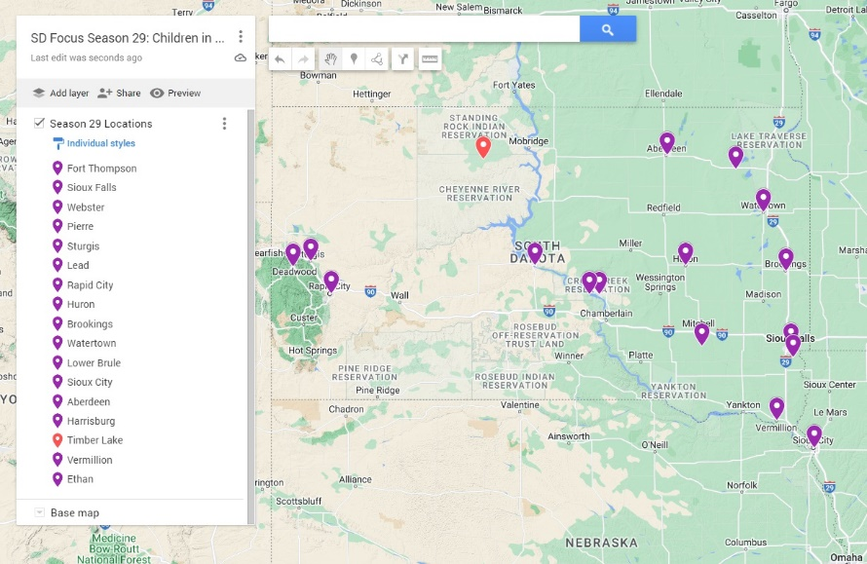The Focus team conducted 78 interviews (not including town hall events, legislative committee hearings, speeches, or conversations on In the Moment also used throughout the season)
* Footage from 16 different south Dakota Communities (one interview in Iowa)
* Two town hall conversations on child care
* Nine half hour television programs
* 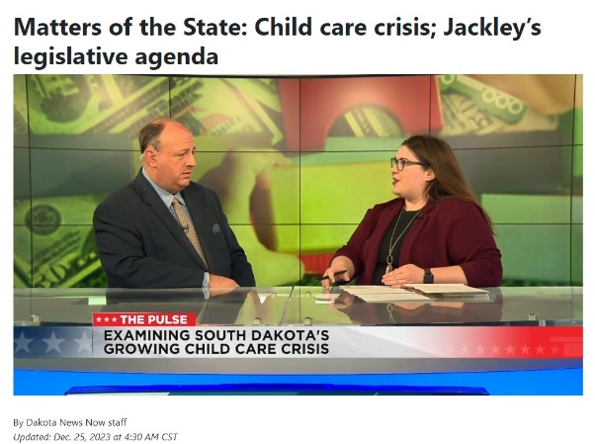Invitation to appear on a December Matters of the State on Dakota News Now to discuss the child care crisis.
* Citizens Award for ongoing coverage from SD Association for the Education of Young Children
* Asked to advise on material to include in press releases for child care task force.
* Nine print adaptations distributed ahead of the television program to all media in the state. (Front page in Argus Leader and the Mitchell Daily Republic) Graph of page views and time spent reading below along with links to each story.

|  |  |  |  |
| --- | --- | --- | --- |
| **2023-2024 SDPB Stories shared by SD NewsWatch** | | | |
| **Headline** | **Date** | **Page Views** | **Engaged Time** |
| [High school graduate eyes child care career path in South Dakota](https://www.sdnewswatch.org/south-dakota-home-child-care-shortage-career/) | 16-May-24 | 624 | 0:56 |
| ['The kids are what you love:' 2 foster families share their stories](https://www.sdnewswatch.org/south-dakota-foster-care-childcare-native-american/) | 18-Apr-24 | 545 | 1:43 |
| [More funding, partnerships could boost juvenile diversion services](https://www.sdnewswatch.org/south-dakota-juvenile-diversion-program-pennington-county-crime/) | 21-May-24 | 259 | 1:33 |
| [South Dakota's teacher shortage a matter of pay and pipeline](https://www.sdnewswatch.org/south-dakota-teacher-pay-salary-national-rankings/) | 15-Feb-24 | 900 | 1:28 |
| [Are government subsidies the solution to the child care crisis? Lawmakers weigh options.](https://www.sdnewswatch.org/south-dakota-child-care-legislature-sdpb/) | 22-Jan-24 | 474 | 1:15 |
| [Brain development science bolsters calls for quality preschool in South Dakota](https://www.sdnewswatch.org/funding-childcare-brain-development/) | 21-Dec-23 | 470 | 1:03 |
| [Responding to child trauma 50 years after Gitchie Manitou murders](https://www.sdnewswatch.org/gitchie-manitou-murders-1973-iowa-sandra-cheskey/) | 24-Nov-23 | 1,507 | 2:15 |
| [My career or my kids? Lack of options forces families to make tough decisions](https://www.sdnewswatch.org/south-dakota-childcare-options-home-daycare-providers/) | 19-Oct-23 | 777 | 1:57 |
| [South Dakota moms bond over a shared experience: C-sections](https://www.sdnewswatch.org/south-dakota-mothers-caesarean-section-maternal-healthcare/) | 20-Sep-23 | 254 | 1:30 |

**South Dakota FOCUS set its 2024/2025 season. Mission Statement:** Season 30 of South Dakota Focus will examine the benefits and challenges of the state economy driven by the tourism industry. Topics will include - Impact on natural resources; History of well-known attractions; Experiences and hospitality;Impact on local communities; Unintended consequences.

Reporting will cover all sides of the river as South Dakota angles to become one of the top ten most desired destinations in the United States.

**Show Themes:**

**August –** Sturgis

**September –** Innovation in Tourism and Science Tourism

**October –** History and Hauntings

**November –** Tribal Tourism

**December –** no show

**January –** Child Care Revisit

**February –** Pt. 1 – Hunting/Sports Tourism/Winter Tourism

**March –** Pt. 2 - Hunting/Sports Tourism/Winter Tourism

**April –** Agritourism

**May –** Water

**Engagement:**

* Premiere in Deadwood for the October - History and Hauntings
* Town Hall – end of season – Water/Resources

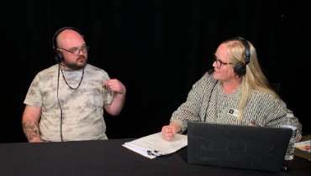**In the Moment: - Live broadcast from the 2024 South Dakota Arts Conference on June 7.**

**Guests include:** [Janet Brown](https://www.janetbrownandassociates.com/), nonprofit arts consultant and former president and CEO of [Grantmakers in the Arts](https://www.giarts.org/). Maren Engel, new arts coordinator with the city of Sioux Falls. Sculptor [Cameron Stalheim](https://cameronsculpture.com/) shares why he considers being an artist to be embedded deep in his soul and heart. We learn about his artistic journey and winning the People's Choice Award in 2023 for the [Sioux Falls SculptureWalk](https://sculpturewalksiouxfalls.com/). And ["Oscar Howe Legacy Across Four Generations"](https://www.washingtonpavilion.org/event/oscar-howe-legacy-across-four-generations) is now on display at the Washington Pavilion. We learn about the 16 different artists included in the exhibition with co-curator [Amy Fill](https://www.usd.edu/research-and-faculty/faculty-and-staff/amy-fill).

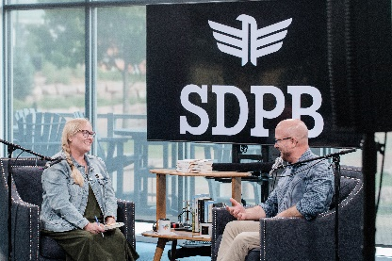SDPB hosted the first stop in the One Book Author Tour – Trent Preszler. About 40 people attended this Humanities Council sponsored event. All feedback forms were positive saying it was an effective and powerful conversation and would like more. One comment, “I have some new valuable thoughts to ponder. Thank you!”

**Look Ahead:** September 19 Candidate Town Hall – live on SDPB TV 8:00-10:00 PM Central from DWU. This is part of the Vote South Dakota Project and Partnership with South Dakota News Media Association, South Dakota Broadcasters Association, and South Dakota NewsWatch. SDPB is providing the pool feed to all broadcasters across the state. Live Spanish Interpretation on SDPBNews Facebook page.

September 3 – More local project begins with daily features/interviews in Morning Edition and All Things Considered and an extra hour of In the Moment. Launch of Producer’s Picks Podcast.

Mid-October – launch of Unplanned Democracy Podcast – a look at the history of abortion legislation and public voting in South Dakota.

**Staffing News:**

We said goodbye to interns Veda Tonneson and Zadya Abbot and welcomed Jackson Dierks. Jackson is a senior at Augustana University and is on the swim team.

Jackie Hendry has been nominated for the annual SDAHO Distinguished Service Award for Media Personality. Announcement of winner is in September.

**South Dakota Board of Educational Telecommunications**

**Education Report-Marcy Drew**

**August 2024**

**Resource Development and Distribution:**

* 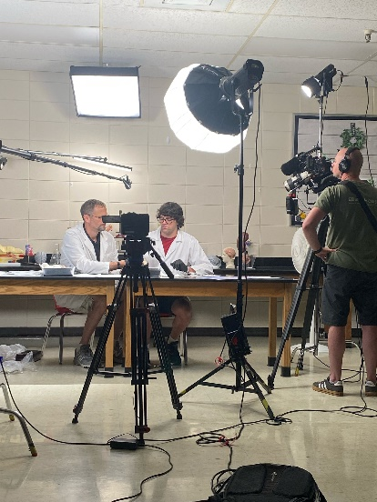A comprehensive lesson called [*Tatanka (Buffalo): A Way of Life for Native People in the Past and Present*](https://sdpb.pbslearningmedia.org/resource/buffalo-past-and-present-lesson-plan/tatanka-a-way-of-life/)was published on PBS LearningMedia in July 2024. The lesson utilizes video footage from the SDPB documentary *Tatanka: A Way of Life,* SDPB radio documentaries, and interactive lessons for students in grades 3-12. The lessons include a segment about the story of the White Buffalo Calf Woman and the Seven Sacred Ceremonies, presented by students from Maȟpíya Lúta in both English and Lakota, and some background information about the loss and restoration of the Lakota language. There is a section about living in harmony with the buffalo and the traditional and modern uses of the parts of the buffalo. This includes a look at a traditional buffalo hunt at Maȟpíya Lúta. The education team will promote this new resource in newsletters and at education conferences and professional development opportunities.
* Filming was completed on the latest video for the Dissection 101 series.

This is SDPB’s most popular resource on PBS LearningMedia. Between

July 2023-June 2024, the videos in this series were streamed over 850,000 times.

The new lesson about dissecting a sheep brain is part of SDPB’s grant from

WETA for projects related to the work of Leonardo Da Vinci, and should be

ready to publish in the fall of 2024.

* During fiscal year 2024, 94,734 users from every state in the US accessed SDPB

resources on PBS LearningMedia. Eighty-one percent of them used a desktop

computer. They spent an average of twelve minutes on each page. This data

indicates that users are spending time watching videos, reading lesson

information, and studying resources. Desktop use probably means teachers

are accessing materials at work and could be projecting or sharing the

resources with students.

**Outreach and Professional Development**

The education team provides outreach and professional development to families, caregivers, and educators to share the resources available from SDPB.

* Over 200 social studies educators attended sessions to learn about SDPB resources at the SD History and Civics Summit in Sioux Falls in June. Many more visited the SDPB exhibitor table to take home samples of lessons and find out more about how to access and use videos, lesson plans, activities, and more to teach their students. Many of the resources align with the new SD social studies standards.

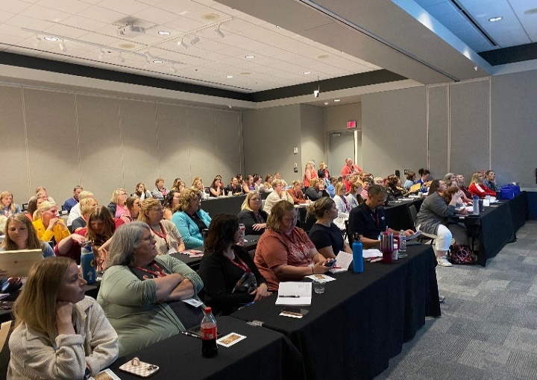

* Buddy’s Early Learning Expedition was officially launched in May 2024, with a community celebration at the Tri-State Museum and Visitor Center in Belle Fourche. Attendees included Belle Fourche mayor Randy Schmidt and his family, several young children and their families, and SDPB’s own mascot, Buddy. Currently, Belle Laundry, Lueder’s Food Center, and the public library have early learning activities and materials available for families.

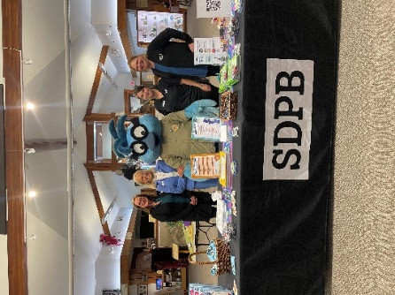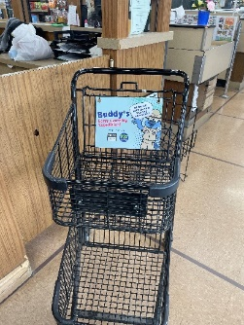

****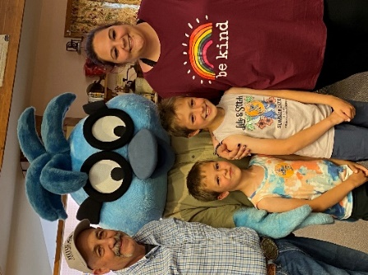

* SDPB provided children’s activities and acted as a media sponsor at YFS Kids Fair. Over two days in early April, over 7000 attendees visited The Monument in Rapid City to participate in hundreds of activities. We collaborated with the Black Hills Chapter of the South Dakota Association for the Education of Young Children (SDAEYC) and Early Learner Rapid City to share information about the importance of early learning.
* SDPB provided an informational booth and three breakout workshops at the South Dakota Early Childhood Education Conference in Oacoma. The workshop topics were, *Using Media with Young Children, Community and Family Engagement Using SDPB Resources,* and *Healthy Bodies, Healthy Minds with Sesame Workshop.*

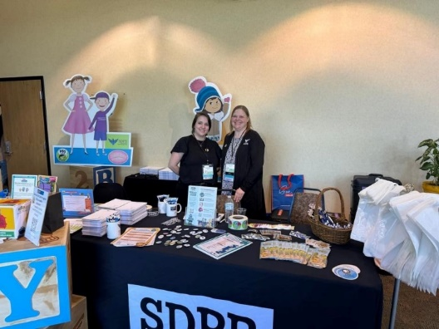

* SDPB provided an informational booth and two breakout workshops at the South Dakota Christian Homeschool Conference. The workshops included activities and lessons focused on art and science.
* SDPB partnered with the Siouxland Chapter of the South Dakota Association for the Education of Young Children (SDAEYC) to provide children’s activities at the annual Festival of Cultures in Sioux Falls. The host organization, the Multicultural Center, gathered volunteers, including a group of Boy Scouts, who helped hundreds of children and families create their own rain sticks.

**South Dakota Board of Educational Telecommunications**

**Engineering & Technology Report- SeVern Ashes**

**August 2024**

**SDPB Vermillion:** Office moves: The BIT Finance/ Business office has been relocated to Pierre, leaving unused space in the Neuharth Center building. It was essential for us to be good stewards of the space, so we have been proactively working with USD over the past six months on a plan to transition the SDPB front office and production staff areas from the first floor into the vacated space on the second floor. The Main TV Studio, Production Control, Network Operation, and Engineering shop are still on the first floor. We are excited to meet our new neighbors, The International Students, and their educational advisors.

**Mitchell FM New Station.** Progress continues in the new Mitchell FM station: The station is ready except for the Transmitter which is being funded through the NGWS CPB grant. Once the grant is fully signed, Field Engineering staff will order it, and they expect to have the station operational in December.

**NGWS (Next Generation Warning System**) is a FEMA Grant administered by CPB:

**Update: On July 15th**, SDPB received notice that all round 1 sites have passed all FEMA, National Environmental Policy Act, State, Tribal, and National preservation study requirements. The grant is currently being finalized for signatures. Once the grant is signed, we are ready to move forward with the following projects.

Round one of the grants will allow.

* Adding local EAS alerting at all 9 Television Broadcast transmitters. That will connect directly to the FEMA Integrated Public Alert & Warning System (IPAWS)
  + *In FY24 SD Joint Appropriation funded the EAS equipment for the 11 FM broadcast stations.*
* The microwave interconnection system will include Uninterrupted Backup Power supply systems, dehydrator systems, microwave antennas, transmission lines, and high-definition signal processors between SDPB Vermillion Main Studio, KUSD TV/FM Beresford, KCSD TV/FM Sioux Falls, KESD TV/FM Brookings, and KDSD TV/FM Pierpont/Aberdeen.
* New HD FM Transmitter in Mitchell, SD.
* New Digital FM radio translators at Aberdeen, Huron, Pierre, Lead, Mt Coolidge, Hot Springs, and Edgemont.
* Network Operations Server room air conditioner.

**SDPB - Public Safety:**

For more than a year, you’ve been receiving updates about the NGWS (Next Generation Warning System), grant funded by the Department of Homeland Security through FEMA and CPB. I realized it’s been quite a few years since I have shared how SDPB TV/FM contributes to public safety across South Dakota

SDPB’s 24/7 Network Operation Center in Vermillion and the statewide microwave tower interconnection system serve 9 Television and 11 Radio broadcast stations. To activate the State of South Dakota Emergency Alert System (EAS). Activations are directed by the Governor’s office, the Department of Criminal Investigation (DCI), the Office of Emergency Management, and others outlined in the State of South Dakota State Emergency Operations Plan, including continuity of governmental services.

SDPB is designated as the State’s Primary EAS Entry point for National and State Alerts within the South Dakota State Plan of Emergency Alert System.

* **National Alerts** are a special class of alerts only sent during a national emergency.
* **Public Safety Alerts** contain information about a threat that may not be imminent or after an imminent threat has occurred.  Public safety alerts are less severe than imminent threat alerts.
* **Imminent Threat Alerts** include natural or human-made disasters, extreme weather, active shooters, and other threatening emergencies that are current or emerging.
* **America's Missing**: Broadcast Emergency Response (AMBER) Alerts are urgent bulletins issued in child-abduction cases. Rapid and effective public alerts often play a crucial role in returning a missing child safely. An AMBER Alert instantly enables the entire community to assist in the search for and safe recovery of the child.
* **Endangered or Missing Persons Alert** (individuals in harm’s way over age 18)

**Wireless Emergency Alert (WEA):** SDPB is integral to fulfilling the federally mandated WARN Act - Warning, Alert & Response Network. This System uses Wireless Emergency Alert (WEA) messaging embedded within the SDPB television programming. These messages are received throughout the state. Cellular carriers like AT&T, Verizon, and T-Mobil allow broadcast EAS messaging with national emergencies, alerts involving imminent threats to safety or life, and Amber Alerts to the citizen's cell phones.

This system provides cellular wireless providers with a non-internet-dependent 99.999% “always-on” backup. It enables them to receive and re-deliver alerting messages to the public via cell phones and other smart devices.

For more about how the WARN/WEA system has saved lives, watch <https://sdpbne.ws/3w7A0X7>

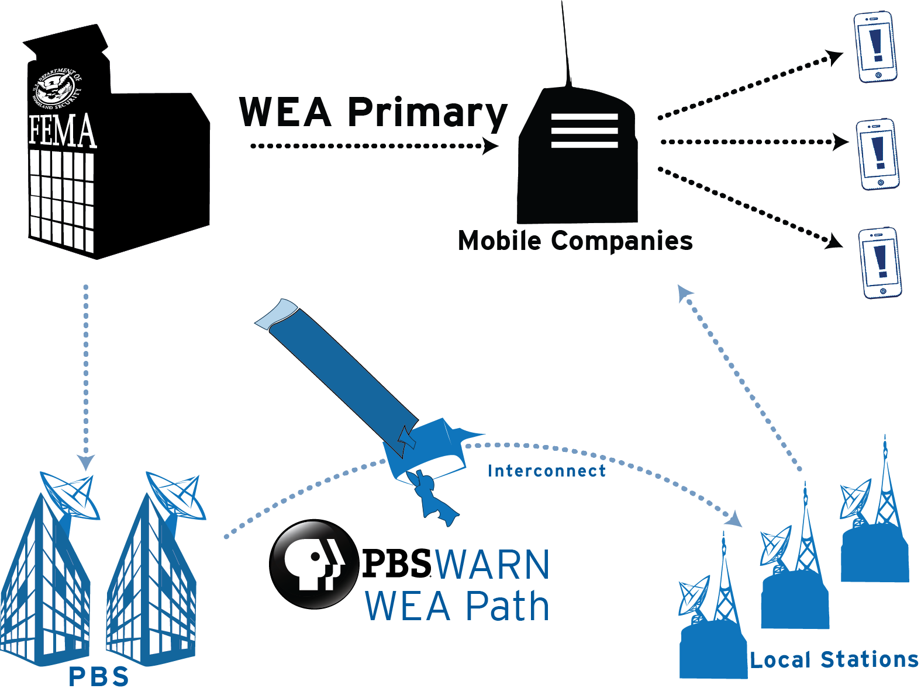

* Statewide Coverage: In many rural areas, SDPB is often the single source for local over-the-air television and radio programming and EAS alerts.
  + **North-west** communities include *Buffalo, Faith, Bison, and Lemon*.
  + N***orth-central*** communities include *Mobridge, Gettysburg, Agar*, and surrounding areas, including all communities within tribal lands of *Standing Rock and Cheyenne River Reservation.*
  + **South-west** communities include *Hot Springs*, *Custer,* Edgemont,and the surrounding areas.
  + **South-central** communities include *Martin, Mission, Pine Ridge,* and other communities within the tribal lands of *the Pine Ridge and Rosebud reservations*.
* SDPB and State Radio Communications share statewide tower infrastructure, buildings, administrative, and field engineering resources to provide local and statewide public services.

Respectfully submitted:

SeVern Ashes

SDPB Director of Engineering and Operations

**South Dakota Board for Educational Telecommunications**

**Programming & Communications**

**August 2024**

**Branding Progress Report:**

* After the Brand Refresh launched, the primary work of changing and updating has been completed. A few items need to be updated and replaced, but overall, we’re fully embracing our new branding across the network.
* The multi-media awareness campaign began the week of March 4 and ran through July. A few billboards remain in the I-90 corridor but will be replaced as our agreements expire.
* A series of updated TV and Radio brand promos are in production.

**Programming**

Television:

* Local productions that aired April through July included: SDHSAA events*; Oyate Woyaka: The People Speak; Every Single Note - SDSO Music Composition Academy; Woyute: A Way of Life; Cultivating Creativity: Dorothy Morgan,* and *A Musical Journey – the National Music Museum* as well as new episodes of *Dakota Life Detours.*
* Forthcoming programs and documentaries include *Dakota Life Detours, SD Focus* season 30*, On Call with the Prairie Doc* Season 23; *Dakota Life* season 26; *Tales from the Arena*; *Woyute: A Way of Life; Dakota Life Detours; Election 2024 Town Hall: Live from Mitchell; Power of Possibility: The Impact of Public Art in South Dakota,* two new documentaries from SDSU – *Voices of the Prairie* about Wynn Speece and Bob Faehn,and SDPB documentaries about the Meridian Bridge in Yankton and the High Line Railroad in Lead*.*
* SDPB’s 21st season of SDHSAA events begins in October with broadcasts of Soccer, Cheer and Dance, Football, Volleyball Championships, and All-State Chorus & Orchestra. We also anticipate coverage of the All-Nations Football Championships.
* Nationally, the TV schedule from PBS remains consistent. Election year coverage is ramping up with debates, specials from Frontline, coverage of the party conventions, and Election Night.
* We made some changes to the SDPB-TV schedule in late fringe, inserting local programming at 10pm Central/9 Mountain, followed by entertainment programming from BBC. Amanpour & Company was displaced from the schedule on the main channel, but will return at midnight in September.

Radio:

* The radio broadcast schedule on weekdays and weekends is changing. In the Moment will now have an additional airing at 9 a.m. CT.
* On weekends, we have the opportunity to add *Prairie Doc Radio* to our schedule after the commercial station in Brookings dropped it. This gives that show statewide radio exposure.

**Marketing**

* We continue(d) working with Friends and Outreach on events by providing materials and support.
* Work begins on the FY24 Annual Report for Friends of SDPB. We’re also creating the 2025 SDPB Calendar, and other materials for handout.
* Kara Brodsky, the Marketing Manager for SDPB, serves on the PBS Marketing Advisory Council.