**Digital Department Strategic Goal Update 3/30/2023**

**Goal: SDPB will grow its audience across all content platforms**

**Objective: We will grow our digital audience by 25 percent in two years**

SDPB has made considerable headway on this objective in a number of areas.

**Sports:** Starting in Fall of 2022, SDPB expanded live coverage of SDHSAA championship events from television and the SDPB website to also provide streaming on YouTube. This has allowed us to see large gains in overall viewership of these events.

To date, we have had an overall **78% increase** in digital live viewership over the previous SDHSAA season.

|  |  |  |  |
| --- | --- | --- | --- |
| Sport | 2022-23 | 2021-22 | Percent Increase |
| Football | 100,507 | 48,588 | 106 |
| Volleyball | 127,994 | 76,065 | 68 |
| Gymnastics | 18,852 | 4,252 | 343 |
| Wrestling | 430,003 | 297,710 | 44 |
| Basketball | 637,923 | 311,701 | 105 |
| Total | 1,315,279 | 738,316 | 78 |

Strategic changes in staffing and digital content production during SDHSAA Championship events has also seen large gains in social media video viewership. To date, content produced during the biggest month of coverage has seen **an increase of 167%** in total social media video views.

|  |  |  |  |
| --- | --- | --- | --- |
| **Month** | **2022-23** | **2021-22** | **Percent Increase** |
| **November** | **821,839** | **486,999** | **69** |
| **February** | **925,804** | **186,508** | **396** |
| **March** | **960,428** | **341,227** | **181** |
|  | **2,708,071** | **1,014,734** | **167** |

**Journalism Podcasts**: As SDPB continues to refine its podcasting strategy and digital deployment, it has seen significant audience growth in both its core journalism podcast offerings in a year over year comparison of the first quarter.

|  |  |  |  |
| --- | --- | --- | --- |
| Source | Total Users 1Q 2022 | Total Users 1Q 2023 | Percent Increase |
| Overall Audio | 34,470 | 48,656 | 41 |
| ITMO Podcast | 3,820 | 4,417 | 16 |
| SDPB News Podcast | 3,119 | 3,484 | 12 |

**Objective: We will grow new audiences by 25 percent in three years**

Deploying our Live Sports via YouTube as well as improving organization and deployment of produced video content on YouTube has also helped us meet the objective of finding new audiences, specifically a younger demographic. In 2022, we had 0 active subscribers watching in the under 24 age bracket. **In 2023, we had 18.3% of our active subscribers were under age 24.**

**Monthly YouTube Subscriber Growth September 2022 to Present:**

**YouTube Viewer Demographics 1st Q 2022 vs 1st Q 2023:**

|  |  |  |
| --- | --- | --- |
|  | **1st Q 2022** | **1st Q 2023** |
| **New Subscribers** | **1300** | **2200** |
| **% Active Subscribers Age 13-17** | **0** | **2.6** |
| **% Active Subscribers Age 18-24** | **0** | **15.7** |

**Instagram Audience Demographics:**

Similarly, as we have begun creating and deploying vertical video aimed for the Instagram Reels audience, we have seen gains in a younger demographic than our traditional social platforms.

On the SDPB Main Accounts, Followers under age 25 are 24.2% of the total on Instagram vs 13.8% on Facebook.

On the SDPB Sports Accounts, Followers under age 25 are 42.3% of the total on Instagram vs 31.8% on Facebook.

**Website Audience Demographics:**

Gains outside “young skewing” social platforms have also been seen. In comparing web users for the first quarters of 2022 versus 2023, the **share of users under age 35 grew by 7.8%.** This is especially notable as that demographic is traditionally one of the least likely to visit standard websites.

|  |  |  |
| --- | --- | --- |
|  | 1st Q 2022 | 1st Q 2023 |
| % Users 18-24 | 11.79 | 12.54 |
| % Users 25-35 | 15.7 | 17.1 |
| Total Percentage Users | 27.49 | 29.64 |

**Objective: Maximize Digital Content Impact to Grow Audience**

**Tactic:** Create Standards and Best Practices for Each Platform by FY24

Despite a challenging social media environment as changes in State of SD policy (banning TikTok usage) and social platform ownership (Elon Musk’s acquisition of Twitter and subsequent changes) required several strategy pivots, the SDPB content and digital teams are underway in creating a set of standards for each type of digital content we produce. It is expected that the initial versions of each SOP will be published within the second Q of 2023.

**Tactic:** Develop a Plan and Schedule for SDPB Domain Merger to Single CMS by FY24

Delays on the part of our NPR partners have set this back but we are in the process of clarifying if we can use our CPB grant for the domain merger for an outside partner versus waiting for the NPR/Brightspot team to fit us into their schedule. If we should get this permission granted, we already have an RFP written and ready for deployment so a local partner can be contracted, and this work can take place on a much accelerated timeline.

**Objective: Use Data to Better Understand Our Audiences**

**Tactic:** Identify Key Performance Indicators (KPI) for SDPB Content by FY24

Each of SDPB’s core content areas (Education, Entertainment and Journalism) have identified their current KPIs. A historic report for each was developed and year over year tracking began in January 2023. These KPIs will be continually evaluated and updated as strategic initiatives evolve.

**Tactic:** Educate Staff on Data Driven Decision Making

SDPB is working with State of SD BHR in evaluating components of the new SD Learn platform in meeting our training needs in this subject matter area. It is hoped that a custom curriculum will be ready for use in the third quarter of 2023.

**Education and Telecommunications Board Report**

**April 2023**

**Twyla Olson**

**Director of Content & Assistant General Manager**

**Goal – SDPB is an organization committed to diversity, equity and inclusion.**

**DIGITAL**

Heather Benson and Brent Duerre have formed close and productive relationships with content creators since our new Digital Department was created. With the addition of new staff in both the Journalism and Entertainment Departments and a focus on digital shorts and blog posts, we have seen impressive growth in our digital audience. We have also been able to tell more diverse stories. Here is a link to one of those stories: <https://listen.sdpb.org/sports-rec/2023-02-15/an-all-native-tournament-has-allowed-smaller-south-dakota-and-nebraska-schools-to-highlight-their-skills>

And here is a digital short from the Wrestling Championships that is just pure joy: <https://www.youtube.com/shorts/BIGx8xkYOEY>

Departmental meetings have begun for our data-driven decision making. Heather is working with department leaders to set quarterly goals for growth.

Our transition to one CMS platform has been delayed due to issues at NPR.

**DEI Training**

SDPB is dedicated to employing and serving our diverse communities in South Dakota. We have identified two tracks of DEI (Diversity, Equity and Inclusion) training for staff and board members. Brad Van Osdel and Fritz Miller have completed intensive training course in DEI through Public Media Diversity Leaders Initiative (PDMLI) and Cara Hetland is currently enrolled.

All other managers will attend the quarterly training throughout the next 2-3 years.

Here is a list of current DEI projects that are underway:

* Staff DEI training has begun, with sessions completed in the Rapid City and Sioux Falls studios. Training sessions in Vermillion are forthcoming in May/June.
* SDPB was awarded a grant from the Ken Burns National Engagement and Partnerships Team for outreach around Burn’s new documentary, American Buffalo, which airs Oct. 16 & 17.  The grant is for direct engagement with indigenous communities. Nathan Hofer and Kara Brodsky will attend a workshop with other grantees in Oklahoma City April 9-10. Plans are underway to host a screening premiere of both American Buffalo and a Tatanka: A Way of Life at Red Cloud School and other communities to be named later.
* Work has begun on an in-house documentary, Tatanka: A Way of Life with Richard Two Bulls as the writer and primary producer. The documentary is a companion piece to American Buffalo.
* Working with independent documentary team on finishing Lakota Language Project documentary. We received a rough cut of the documentary on March 29th.

* Filming the Young Composers Program in Sisseton in June in partnership with the South Dakota Symphony to produce a 30-minute documentary.
* Plans are underway to interact with The Levitt at the Falls this Summer around 4 events including Festival of Cultures, Indigenous Music Festival, a Native American day Wacipi, and a weeklong celebration of Jazz and HipHop including workshops with a well-known mother and son duo, Nneena and Pierce Freelon, who've been featured on PBS.
* Dakota Life communities were identified for the 2023-24 season, including the primarily Native American communities of Wagner, Ft. Thompson and Timber Lake.

**Education**

SDPB is a trusted source for educational resources in South Dakota, and Marcy Drew and her team continue to travel the state visiting with educators from preschool through high school. Marcy has increased her team’s reach in Black Hills Region by partnering with Klein Vision Visioneering Group, a firm that embodies SDPB’s mission, and has the resources to serve the children of that region. In the next few weeks, Marcy and her team will be headliners at events in Rapid City, Belle Fourche, Huron, Eagle Butte, and Kyle.  They have a full slate of summer events planned around the state.

**Outreach**

We are finishing the current season of Dakota Life Premieres in April and May in Belle Fourche and Lead. Attendance at these events continues to grow. The Dakota Life staff has chosen Hill City, Madison, Wagner, Onida, Ft. Thompson, Beresford, Union Center, Timber Lake, and Webster as featured towns for the 2023-2024 season. Community Conversations commence on April 18th.

You know you’ve made it in a small town when you are featured on a barrel in the middle of Main Street. That’s the welcome we got in March from the folks in Parkston—here's the proof.

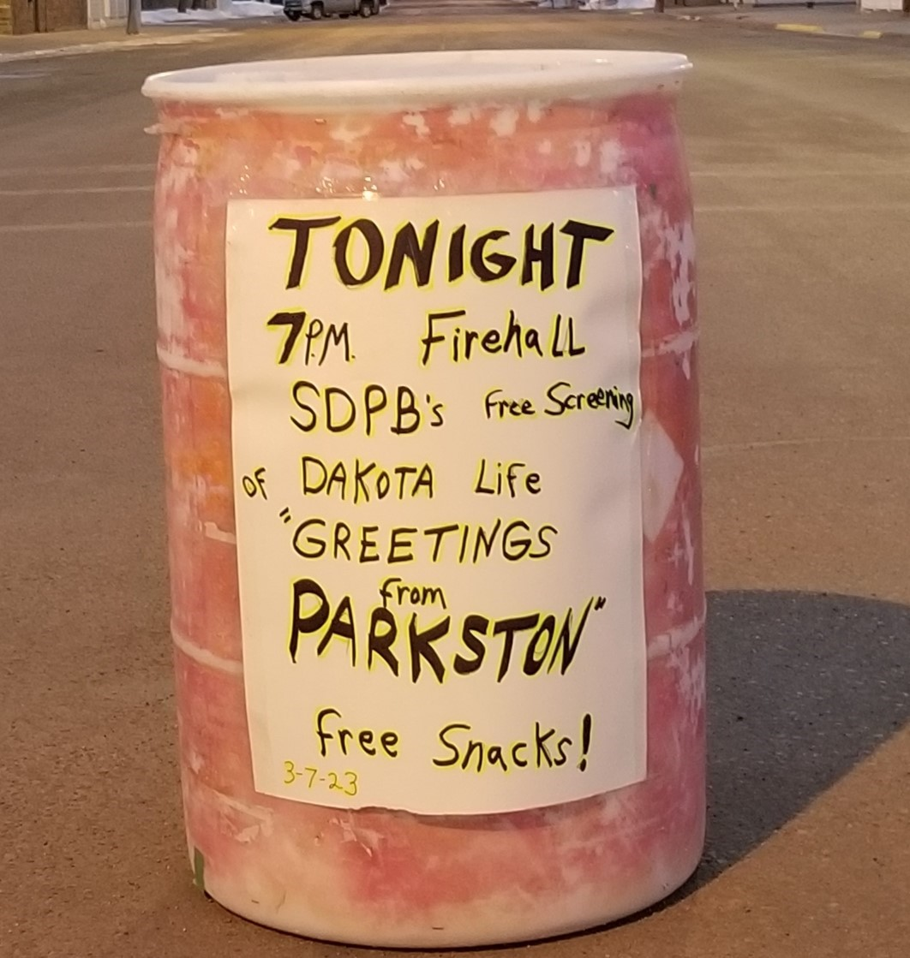

You can watch Dakota Life programs at this link   <https://www.sdpb.org/tv/dakotalife/>

And here is a snapshot of the next two month’s activities. As you can see, it is action packed and covers all corners of the state. **DL CC stands for Dakota Life Community Conversation.

|  |  |  |
| --- | --- | --- |
| DL CC: Ft. Thompson ** | 18-Apr | Community Center |
| DL CC: Beresford | 19-Apr | The Bridges |
| DL CC: Union Center | 20-Apr | Central Meade County Community Center |
| DL CC: Timber L | 25-Apr | Timber Lake & Area Museum |
| DL CC: Webster | 27-Apr | Webster Area Development Corp. |
| SDSO: Beethoven's 9th "Ode to Joy" | 29-Apr | Washington Pavilion |
| Lead Dakota Life Premiere | 2-May | The Roundhouse |
| May 2023 DTSF Art & Wine Walk | 5-May | SF Studio |

|  |  |  |
| --- | --- | --- |
| Dakota Life Idea Blast | 9-May | The Cascade Bldg - 605 Lounge |
| Dakota Life Idea Blast | 10-May | The Cascade Bldg - 605 Lounge |
| The Ups and Downs of Herb and Jan Conn Screening | 10-May | West Hills Village |
| The Ups and Downs of Herb and Jan Conn Screening | 11-May | Custer Beacon |
| Tea with Termes | 6-Jun | Donor Home |
| SD High School Rodeo Finals | 13-Jun |  |
| Friends Board Meeting | 16-Jun | TBD |
| Black Hills Con | 23-Jun | The Monument |
| Black Hills Con | 24-Jun | The Monument |
| Black Hills Con | 25-Jun | The Monument |
| Fiscal Year-End Radio Drive | 29-Jun | All Studios |
| Fiscal Year-End Radio Drive | 30-Jun | All Studios |
| Friends Pre-Levitt Party | 6-Jul | SF Studio |
| Neutrino Day | 8-Jul | SURF |

**Open Government**

SDPB continues its commitment to open government through our SD.net coverage of all legislative sessions and is expanding that coverage with cameras being installed in many convening rooms at the Capital for the coming session.

Our Spanish translation of the 2022 Debates were widely and well-received, and we are working on expanding that coverage for the next round of debates.

**High School Activities**

SDPB continues our commitment to serving all South Dakotans through our strong partnership with the South Dakota High School Activities Association, covering all activities.  Brad and his team are focusing on finding new and diverse voices to announce games in the coming championship season.

There is much more to share, but I will end here with kudos to our incredibly talented team and the recent submissions we’ve made in hopes of recognition for their outstanding work.

**2022 Edward R. Murrow Award Entries**

**(Winners announced Oct. 9th, 2023)**

**News Documentary:** Dave Eggers discusses his book being prohibited by Rapid City School District <https://listen.sdpb.org/show/in-the-moment/2022-05-13/dave-eggers-discusses-his-book-being-prohibited-by-rapid-city-school-district>

**Features Reporting:** Prairie Primitive Rug Hookers keep centuries-old, thrifty art form alive <https://listen.sdpb.org/arts-life/2022-05-06/prairie-primitive-rug-hookers-keep-centuries-old-thrifty-art-form-alive>

**Hard News:** How an anti-abortion group defeated Governor Noem's six-week abortion ban <https://listen.sdpb.org/politics/2022-02-28/how-an-anti-abortion-group-defeated-governor-noems-6-week-abortion-ban>

**News Series:** South Dakota brings no trust legislation after blockbuster Pandora Papers revelations <https://listen.sdpb.org/politics/2022-03-04/south-dakota-brings-no-trust-legislation-after-blockbuster-pandora-papers-revelations>

<https://listen.sdpb.org/politics/2022-03-07/privacy-laws-make-it-difficult-to-know-if-south-dakota-trusts-harbor-russian-assets>

**Breaking News Coverage:** With Roe v. Wade decision and trigger law, most abortions now illegal in South Dakota <https://listen.sdpb.org/politics/2022-06-24/with-roe-v-wade-decision-and-trigger-law-most-abortions-now-illegal-in-south-dakota>

<https://listen.sdpb.org/healthcare/2022-06-24/crowds-protest-supreme-court-abortion-decision-bring-your-rage-with-you-to-the-ballot-box>

**Continuing Coverage:** Attorney General Jason Ravnsborg Impeached <https://listen.sdpb.org/politics/2022-06-21/state-senate-removes-ravnsborg-from-office-and-bars-him-from-future-offices>

**Excellence in Writing:** Freedom Caucus zeroes in on South Dakota election process <https://listen.sdpb.org/politics/2022-09-07/conservatives-zero-in-on-south-dakota-election-process>

**Sports Reporting:** 'How far are you willing to go?' Some South Dakotans decry bills aimed at trans kids <https://listen.sdpb.org/politics/2022-01-21/how-far-are-you-willing-to-go-some-south-dakotans-decry-bills-aimed-at-trans-kids>

**Entertainment Group ET Board Report April 2023**

One of the Entertainment group’s objectives is to grow our digital audience by 25 percent in two years. To begin this process, we looked at what content we were producing and what format and platform we were delivering that content. This led us to hire two emerging media producers in the Fall of 2023 to produce content specifically for Facebook reels and Instagram. These videos are being produced at SDHSAA events and for Dakota Life and are designed to reach a younger audience who are not part of our usual digital audience. We have seen success in producing these stories that are shorter in length, are produced vertically, appear in the Facebook reels portion of Facebook and Instagram, and are more eye-catching than other stories we produce. The subject matters of the stories are also geared toward a younger audience. The video of how to see the Green Comet received 12,000 views on social media

During SDPB’s basketball and wrestling coverage, we continued to tell stories about the players and teams, but we also focused on the fans and exciting aspects of the tournament. We highlighted the band of the day, mat tappers, and the best dunks from the class AA boys’ basketball tournament. These stories were produced with a younger audience as the focus and increased our views on Facebook by 259% compared to last year’s basketball championships.

**8,000 views 10,000 views 5,700 views**

We also started streaming SDHSAA events to YouTube in addition to our regular broadcast and streaming platforms. YouTube is the most popular video site globally, second only to Google as the most used search engine. By including our live streams and other content on YouTube, we have made our content available to new and younger users who are already searching on YouTube for content. 43% of our YouTube watchers were under age 35, and nearly 22% were under 25:

The Entertainment’s second objective is to grow a new audience by 25% in three years through engagement and community conversations. We are just completing the first season of Dakota Life, where we implemented the community conversation portion of the program. This process began last summer when we visited the nine communities that were going to be highlighted and asked the community members what stories to tell about their towns. The process has been successful, with significant participation by community members, with 20 – 30 people attending the community conversations. The community members suggested 90 percent of stories for the season at the engagement event or suggestions from the community to contact for the story.

the stories where we spend an average of 50 hours at each of these communities’ gathering interviews and videos. The final step is premiering the program back in the community before it airs on TV, allowing the community to see it first. During this event, we also asked the community what we missed and what other stories we should tell. Producing episodes is the beginning of a relationship with each of these communities, and we want to continue that relationship with more stories beyond the episode that highlights their town. The premiere events have been successful, with 30-50 people in attendance. We have also seen an increase in our on-demand viewership of Dakota Life episodes as community members share the program with relatives and folks who grew up in South Dakota but have moved elsewhere.

Another objective is to grow our diverse audience through source development, the stories we tell, and engagement by 25 percent over five years. One of the first steps was to reengage with the staff at Red Cloud School. Two things have arisen with these meetings that we are focusing on first was to document the school’s annual buffalo harvest. SDPB sent a crew to follow the day’s events and tell a story for them to use at the school for educational purposes. The second is giving guidance on video equipment to enhance the boutique radio studio. Staff members from SDPB will travel to Red Cloud in April to give the students and staff training on using the audio equipment for projects they want to use. Staff will also give a tutorial on video equipment in preparation for when the school’s video equipment arrives.

The partnership with Red Cloud School and Buffalo Harvest has spurred an idea for a documentary to be produced this summer by the entertainment group. Tatanka’: A Way of Life will explore the relationship between Native Americans and how they utilized buffalo within their respective region. Buffalo was and has always been the primary food source for many tribes throughout the United States. Every part of this animal was utilized for tools, shelter, clothing, and more.  All of the tribes within South Dakota have their own buffalo program that is reintroducing this animal in their own way that not only serves their tribal members but also helps when food is in limited supply, such as what we faced during the COVID-19 Pandemic. Not only are South Dakota tribes and tribes within the region reintroducing buffalo, but they are also reintroducing the animal that is pure and not interbred with purebred/precontact buffalo. This documentary will chronicle South Dakota’s tribes’ effort to reintroduce the buffalo as a way of life, culture, and use before contact with European settlers.

**Educational and Telecommunications Board Report**

**April 2023**

**Cara Hetland**

**Director of Journalism Content**

**Our Mission: To inspire, connect and entertain South Dakotans with trusted Journalism, quality education, and compelling story telling.**

**Our goals: SDPB Will grow its audience across all content platforms**

**We will grow our digital audience by 25 percent in two years**

**We will grow new audiences by 25 percent in three years**

**We will grow our diverse audience through source development, the stories we tell, and engagement by 25 percent in five years.**

**Digital Audience:**  For the Journalism team – “digital” is defined by web traffic, online live listening, twitter and Facebook reach, podcast downloads, and newsletter open rate and click rates. We are working on setting the baseline so we can monitor growth. I will use data from our Feb. 2023 to Feb 2022 to indicate where we’re at on this. Here are a few highlights that indicate growth.

Legislative coverage and stories about winter storms win the top topics for web traffic this February. It’s difficult to get a true comparison because a year ago we were airing the impeachment hearings live on multiple platforms and these feeds were also used by other media organizations. We will continue to monitor our web traffic. We are making some adjustments with timing out stories, changing our top story throughout the day, and posting online first before broadcast.

This team focuses on two main podcasts – In the Moment provides its daily program in podcast form for on demand listening. Data shows a 31% increase in users and a 5% increase in downloads from Feb of 2022. Currently this podcast has 1,602 users and 2,852 downloads in February of 2023. The SDPB News Podcast has seen user growth of 17% in Feb of 2023 over Feb of 2022. There were 1,376 users and 2,972 downloads in February. We are working on self-promoting these two podcasts more within our daily news programming and brainstorming other ways to boost these podcasts.

The Morning Report E-Newsletter is sent out twice a week and highlights the top stories we have produced. These Wednesday and Saturday morning newsletters are sent to 1,868 emails who are people that signed up to receive this correspondence. The average open rate is 44.85% and the average click rate (meaning they went to our website to read more of the story) is 6.91%. both are significant increases.

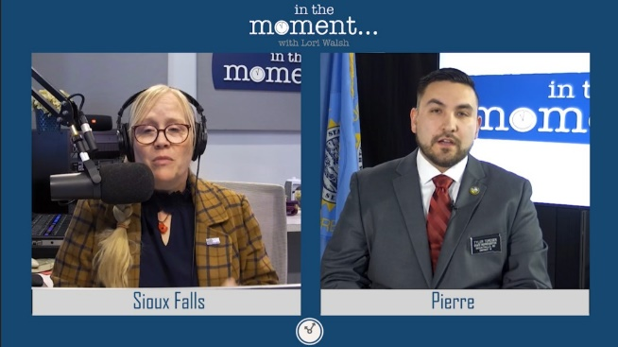

We have been experimenting with our Facebook live on the SDPB News page during the legislative session. In the Moment focused the full hour each Wednesday on legislative news. We had cameras in three different studios (Sioux Falls, Rapid City and Pierre) In February of 2022 we had 340 video views (primarily SD Focus live shows) while in 2023 we had 1,678 video views (all In the Moment). We are looking at premiering SD Focus at noon on Thursdays to see if we get a larger audience.

Twitter saw an increase of 23.5% in reach and 17.8% increase in engagement over 2022. With all the changes to this platform in the last year, we count this as true growth. In real numbers for February our reach was 157,400 on the SDPB News twitter.

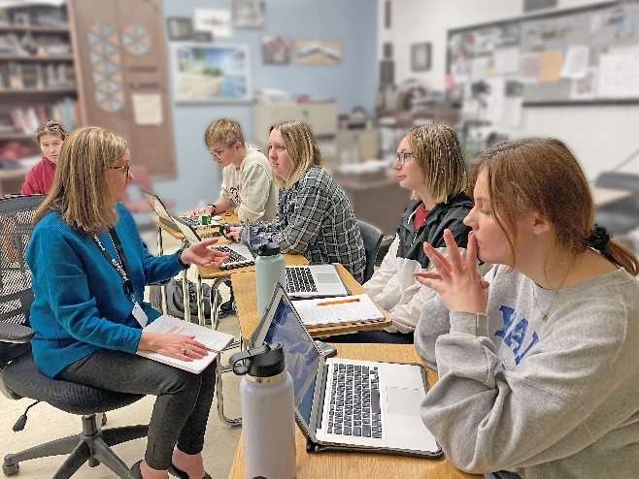**New Audience:** I’m working with Journalism students from Sturgis Brown High School on a pilot Youth Journalism project. These students are working on producing a video story about isolation and mental health among teens. They’re looking for the hope in their school. The work is student driven with guidance by me and my team as well as their teacher Teresa Froelich. I met with them in person and talked about the project and we meet weekly via zoom for updates. Brad Van Osdel gave them tips on shooting video, Jackie Hendry gave them tips on writing a script, and Krystal Schoenbauer is assisting with some drone footage for them to use. I will work with them on their final script and presentation. The plan is to air this story on May’s South Dakota Focus program. This is truly a team effort and one that has this group of about 15 students engaged in the journalism process. Also, thanks to Marcy Drew for connecting me with a PBS program that has story telling tutorials that I have shared with Mrs. Froelich to use in her classroom instruction.

Our effort to grow our youth audience on TikTok has been thwarted by an executive order and use of state resources. We are regrouping and reimagining what our digital content for younger viewers needs to be on other platforms.

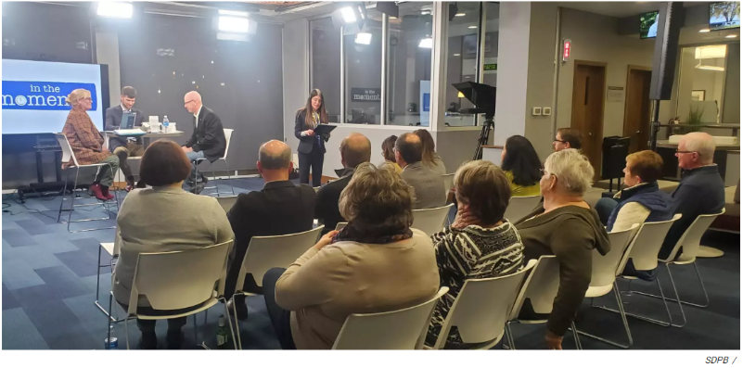We partnered with SDSU and hosted a discussion about the SDSU Poll in our Sioux Falls studio on November 14. Lori Walsh served as the moderator for the discussion. And on November 17 several of the authors of The City of Hustle gathered for a discussion in our Sioux Falls studio. About 40 people attended this program also moderated by Lori Walsh.

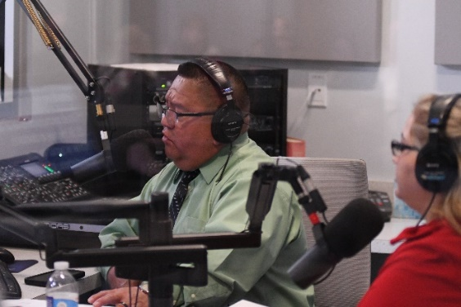**Diverse Audience:**

We offered a simulcast of Spanish interpretation of our live debates. The Spanish version was sent to the Latino Chamber of Commerce Facebook page. Selene Zamorano is the chairwoman of the chamber. She writes, “We are getting a lot of positive feedback from the Latino community. We are hearing more and more conversations regarding the debates; this is something that has NEVER happen before.”

We are continuing the conversation about how we can continue to share content for their online radio station and how we can tell stories important to the Hispanic community throughout the state.

We continue to diversify our sources for news content by reaching out to our partners and using our boutique studios. And we are in dialog with some of our Native American partners in how the journalism team can assist with after school and summer education programs.

**Staff Updates: Hello and Goodbye**

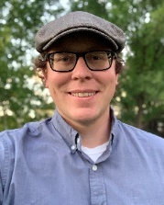We welcomed Josh Chilson to the SDPB J Team and our News Director. Josh is a South Dakota native, attended SDSU and has worked in newspapers and television for the last nine years. Most recently he was the managing editor at Dakota News Now. We are excited to have Josh on our team and we welcome his AP Stylebook knowledge and his skills in effectively back-timing in live television.

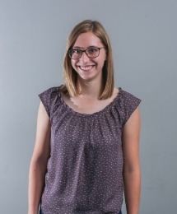We said goodbye to Chris Laughery on November 23. But he isn’t going far as he transferred to the Communications and Programming team. We wish him much success and look forward to working with him in his new role.

We welcomed Ellen Koester to the team on December 5. Ellen joins us as an In the Moment producer. She comes to us from the marketing department of Sanford Health, where she was a web copywriter for three and a half years. Her specialty was writing for digital platforms, including web and social media spaces. She is originally

from Sioux Falls and attended Drake University in Des Moines for English and public relations. She lives in Sioux Falls and loves to read, bake, hike, and spend time with her cat.

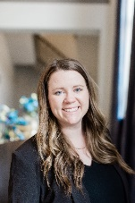Ari Jungemann is a producer with *In the Moment* and is based in Sioux Falls. She is a former English teacher in Lakeview, Minnesota. She and her husband own and operate AJ Production Company and are also foster parents.

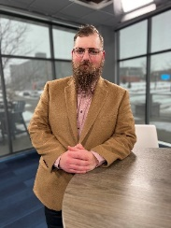

Evan Walton joins the team as a beat reporter. He will focus on healthcare and business reporting in the eastern side of the state. He is based in our Sioux Falls studios. He comes to us as a freelance writer, and former Recreation Program Director with the National Field Archery Association Foundation in Yankton. He has his Master of Arts in English Literature.

We said farewell to Megan Feighery on February 15. Megan was the host of All Things Considered for two and a half years. She joined us in the middle of the pandemic and worked in isolation in Vermillion and later moved to Rapid City. Megan brought stability to the newscast unit and organized our content and our interns. She is moving on to host a podcast with Wyoming Public Radio.

Krystal Miga is currently hosting both Morning Edition and All Things Considered and we have announced a new host will start on April 26. Plan to listen to Ryan Bozer on Morning Edition starting sometime in May. Ryan will be based in Rapid City. Krystal will shift to host All Things Considered and the daily news podcast.

**South Dakota Board of Educational Telecommunications**

**Education Report-Marcy Drew**

**April 2023**

**Strategic Plan Goal: SDPB is recognized as a trusted source of educational resources in South Dakota.**

**Objective: Utilize our broadcast, digital, and outreach structures to share educational resources and professional development opportunities.**

**Tactic:** Create a system to evaluate and improve professional development and engagement opportunities.

**Evaluation Procedures:**

* Participants complete evaluation forms at each professional development session to allow us to gather data on how useful the resources presented were, how knowledgeable the presenter was, and how they will use one idea from the presentation in the next week.
* Staff members evaluate each outreach event and professional development session. Data such as event attendance, attendee feedback and comments, the number of staff and volunteers needed, and information about attendees (e.g., families, K12 teachers, early childhood educators, or childcare providers), are collected. Staff record their perceptions about the success of the event and how it could be improved and whether the event should be repeated.
* A cross-departmental engagement team meets quarterly to discuss strategies for outreach, marketing, and community involvement. A smaller group meets twice monthly to plan and ensure the work is completed.
* The team meets monthly to focus on data and feedback from participants to inform decisions on future events, professional development offerings, and resource creation.

**Resource Development and Distribution:**

* South Dakotans continued steady use of SDPB Kids platforms to watch educational shows and play games. Growth continues among those streaming videos. In the top 20 PBS Kids users in SD, the biggest cities are represented, but smaller communities such as Sisseton, Pine Ridge, Wagner, and Milbank are also included.
* Users of educational content at PBS Learning Media are 22% lower than in February 2022, but SDPB-produced materials such as the dissection series and Art Basics with Dick Termes rank among the top 25 most popular in their content-area categories among resources from entities like Nova and Nature in Science and Pinkalicious in Art.
* E-newsletters continue to be a primary way to keep in contact with parents, childcare providers, and educators and give them easy access to SDPB’s high-quality educational content. The K-12 newsletter consistently continues to reach about 3,000 subscribers across SD. The Early Learning Links newsletter has also maintained a consistent subscriber list of over 1160 and a healthy open rate averaging around 30%.
* *Drawing with 6-Point Perspective with Dick Termes* is an instructional video series where the artist shares his unique, multi-dimensional drawing techniques. Video work is complete and lessons are being created by SDPB education specialists. The series will be available on PBS Learning Media later in 2023.
* *Create Your Own Studio*, an instructional series for elementary and preschool children to learn dance skills at home, will also launch soon on SDPB’s website, followed by PBS Learning Media. This partnership features professional dancers from Headlights Theater and will be shared with childcare providers, afterschool care programs, and families to give all children opportunities to dance, regardless of the availability of a dance studio nearby or income level.

**Professional Development and Outreach:**

* One good indicator of awareness of and trust in SDPB’s educational offerings is that our staff has needed to be more selective in choosing events and professional development opportunities to attend. To meet the strategic planning goal, we have focused on spreading our message to our target audiences of families, childcare providers, and teachers as efficiently as possible.
* To focus on families and the general public, we attend events such as YFS Kids Fair in Rapid City, Storybook Land Festival in Aberdeen, Neutrino Day in Lead, educational resource fairs, Family Festivals across the state, and various family events in Sioux Falls and other communities. A community early learning pilot program is in development in Belle Fourche, SD, where SDPB educators are gathering collaborators among local businesses and organizations to create spaces for young children and their families to access learning materials and activities while they shop and run errands.
* To reach childcare providers and teachers, the team attends a variety of professional conferences as presenters and exhibitors, presents to principal’s groups, and provides in-service training to schools and childcare centers.
* Science Steve, with his exciting demonstrations to get children and adults excited about learning, continues to be in high demand. Most of the engagements that were canceled due to Covid have been made up and he continues to share his talents and enthusiasm across SD at events, libraries, and schools.
* To reach vulnerable and underserved populations in SD, the education team has concentrated on building relationships with the child welfare and foster care system and with Native American communities. Work with educators in the Pine Ridge, Sisseton/Agency Village, Fort Thompson areas is ongoing. The team gave two presentations and met with educators from all of SD’s Indigenous communities at the Lakota Nations Education Conference. Resources and materials were distributed at the annual SD Prevention of Child Abuse conference, where attendees who work with children within the child welfare, law enforcement, mental and physical health, and family court systems commented that they could use them in their work in countless ways. Online live and recorded presentations for foster families and case workers were given regarding resources from Sesame Street in Communities and SDPB’s Native American studies collection.

**Strategic Plan Update**

**Programming & Communications**

**April, 2023**

Among the goals in the strategic plan, the one that the Programming and Communications department is closest to is the goal that **SDPB is recognized as a trusted brand.** The Objective, Strategy, and Tactics are outlined below:

**Objective 1**:  Complete a brand refresh by *end of FY24*.

Strategy: We will increase recognition of our logo and brand by new and existing audiences

Tactic: Establish Advisory Committee to provide oversight, and Working Group to provide implementation strategies

Tactic: Write “Scope of Work” document

Tactic: Meet with a select group of agencies and select partner organization to complete work

Tactic: Engage (outsource) organization to redesign SDPB Digital footprint, including website, social media, e-communication

Tactic: Roll out new brand to staff and boards of directors prior to public roll-out

Tactic: *By Sept. 2023* roll out comprehensive, multi-media external marketing campaign

**Progress Report:**

We have launched the Brand Refresh!

*Tactic 1*: We established an Advisory Group that will serve as a steering committee on this project. The group includes Julie, Twyla, Ryan, Heather, Kara, Mike Mueller (Friends of SDPB board member), Kay Jorgensen (as ET Board representative), and myself.

*Tactic 2*: The scope of work document was shelved as being unduly burdensome. Instead, we decided to ‘reverse engineer’ this process by speaking with agencies and giving them the chance to provide direction for this monumental task. As a result of our change in tactics, we moved on to the next phase…

…*Tactic 3*: In January, Kara Brodsky (SDPB Marketing and Brand Manager) and I identified full-service advertising agencies and marketing firms that we wanted to speak with. Kara and I met with four agencies. We briefed them on our goals, provided copies of our Mission, Vision, and Values from the strategic plan, and offered background research and data that we thought would help inform their presentations.

In March the Advisory Committee met and heard proposals from all four agencies. As a result, we offered the job to **Fresh Produce** of Sioux Falls.

The paperwork, including a scope of work document, is now being prepared and work will commence. The first phase is the Discovery process: Research.

The timeline, as laid out by Fresh Produce, indicates that we could meet our goal of completing the rebranding and rolling it out to stakeholders in September-October, 2023. We may roll out a comprehensive, multimedia campaign to our audience late this year. However, we will not sacrifice quality of work for the sake of meeting a timeline.

*Tactic1(a)*: Members of the Working Group have been identified. The goal of the Working Group is to consider how the rebrand will affect their specific area. These will be the folks that put the plan into action. Members of the Working Group, chosen by their manager/supervisors, are:

Kara Brodsky – Marketing (Chair)

Heather Benson – Digital

Brian Wood – Engineering

Jackie Hendry – J Team

Kyle Mork – E Team

Steven Rokusek – Education

Wendy Bergan – Friends

Thad Utech – Operations

Also on the Working Group are these members of the Marketing team:

Hannah Wold – Design

Kylin McKean – Public Relations

Aaron Siders – Promotion

The Working Group has not met.

All department heads will have a significant role in discussions and provide insight and strategic direction that will help inform Fresh Produce.

We will continue to inform the board of progress of this transformative project. I am always available.

Briefly, with regards to other objectives:

Objective: Audience Growth. From a programming perspective we have expanded our reach and broadcast shows created by independent local producers about topics relevant to our audience. Examples include documentaries about the Jewish settlements in Aberdeen and Deadwood, about the 1973 Wounded Knee standoff, about an organization that produces horse-drawn conveyances, and about a bar that represented a foregone time of live music.

Objective: Staff Retention. We have reviewed processes and procedures and streamlined many, eliminated some unnecessary work, and identified areas of need. This effort has resulted in updated procedure manuals and the establishment of a SharePoint site where those manuals can reside.

We have also identified training opportunities and are engaging employees to participate in those opportunities.

Objective: Increased Employee Engagement. A bi-monthly internal newsletter has been established and distributed to all staff. The newsletter contains news about projects, information about staff, bios of co-workers, and opportunities for friendly conversation and play.

Goal/Objective: Diversity. I have completed a multi-week course on Diversity, Equity, and Inclusion offered to public broadcasters through Furman University and South Carolina ETV. These lessons are shared in conversation and in practice. Bias and harassment training will soon be available to all, too.

Faithfully submitted,

Fritz Miller

Director of Programming & Communications

**Strategic Plan Update**

**Engineering & Operations**

**SDPB is a trusted and valued technical resource. 2022-2023**

Objective 1: Create a plan to actively identify local, state, and federal partners to strengthen our public safety initiatives through datacasting, WEA, and IPAWS Alerting by FY24.

* Renew relationship with SpectraRep Datacasting (Educating, Public Safety Datacasting)
* Shift Educating resources to Public Safety datacasting
* Identify partners for an Alpha testing pilot.

Update: Our major objective was to find a way to actively use the Educating technology acquired during the pandemic. The Technology allowed a means for school districts to distribute educational content and homework through a private IP stream that is hidden within the SDPB television network. Educating was originally developed by the SpectraRep system to be used within the public safety sectors. It was a natural fit to pivot and engage Trent Nincehelser who is the Technical Manager of BIT/ State Radio Communications (SRC). Partnering with Commissioner Clines, and SRC we presented the technology and benefits to the South Dakota Public Safety Council. We have received interest in 4learning more and seeing a Bata test in the state. And we are currently reconfiguring the backend systems and deploying receivers to do real-world testing starting in May 2023.

Objective 2:  Create a plan for migration to ATSC 3.0 -Next Gen Television by FY25.

Strategy: Replace aging television transmitters with new ones capable of both ATSC 1.0 and upgradable to ATSC 3.0.  Tactic: Capital replacement plan

* + - FY23 KDSD-TV Aberdeen $150K, KQSD-TV Lowry $140K, and KTSD-TV $120K

Update: Even though an exact date for the transition is an ever-moving target. When designing and making engineering decisions the new standard is always at the forefront to ensure we are moving the system to be forward-compatible with the new ATSC 3.0 standards. One of our major capital expenses in the transition will be the system infrastructure. The average age of our current transmitters are 18 years old. It’s crucial that we start replacing these now to ensure the current service. As well as be ready for the new standard. Originally, we identified the transmitters serving KDSD-TV Aberdeen, KQSD-TV Lowry, and KTSD-TV Pierre /Reliance. However, Earlier this fall we were having issues with the KUSD Beresford transmitter serving southeast South Dakota. And we made the decision to replace this transmitter first. And move the KDSD-TV Aberdeen transmitter into the next fiscal year’s plan. I am also pleased to report that as I write this report the other two transmitters for Pierre and Lowry are being delivered to the broadcast sites. We are on target to have these transmitters installed and on the air in the next month.

Objective 3:  Update the interconnection system (studio to transmitter connections.) by 2026.

Strategy: Identify funding sources through Federal grants and FEMA CPB funding.

* + - Tactic: Get a budgetary quote for SAFT IP-based Microwave systems.
    - Tactic: Find and hire a technical grant writer by December of 2023

Update: CPB guidelines for the FEMA infrastructure funding program haven’t or guidelines published as of the end of March. In preparation for the CPB FEMA infrastructure grant program guidelines to be published. Our engineering staff has been actively working with Heartland Communications and SAFT microwave technologies. To design a new IP-based microwave infrastructure for the network. We are planning to meet with both vendors in April at the National Broadcast of the Association (NAB) conference. We are still looking for a technical grant-writing consultant for these projects.

Objective 4: Create a plan to source sustaining fiscal infrastructure funding by FY26

Strategy: Seek opportunities to increase infrastructure funding

* + - Tactic: Evaluate the existing vertical tower real estate leasing model for new revenue streams.
    - Tactic: investigate the benefits of integrating into Service now.

Update: we are in the process of renewing lease contracts with Verizon, and AT&T. And are in discussions on how we can assist T-Mobile with their infrastructure needs throughout the state:

Objective 5:  Document and create a plan for review by Senior management to evaluate the feasibility of joining a Joint Master Control by end of FY23.

Strategy: Identify lead staff within NOC, Engineering, and Programming opportunities and risks in outsourcing master control.

* + - Meet with the Central cast to fully understand our options.
    - EAS responsibilities state primary, amber alerts for endangered persons, alerts in blue alerts, as well as other civil emergencies activated by state authorities.

Update: SeVern will be renewing discussions with the Joint Master Control Vendors. During the Public Media Venture group conference prior to the NAB conference in April.

Respectfully,

SeVern Ashes

Director of Engineering, Operations and, Digital Technologies