**Engineering & Operations Technology**

**Strategic Plan Update**

**August 2023**

**SDPB is a trusted and valued technical resource.**

**Objective 1: Create a plan to actively identify local, state, and federal partners to strengthen our public safety initiatives through datacasting, WEA, and IPAWS Alerting by FY24.**

* Renew relationship with SpectraRep Datacasting (Educating, Public Safety Datacasting)
* Shift Educating resources to Public Safety datacasting
* Identify partners for an Alpha testing pilot.

Update: Our major objective was to find ways to actively use the Educating technology acquired during the pandemic. The Technology allowed a means for school districts to distribute educational content and homework through a private IP stream that is hidden within the SDPB television network. Educating was originally developed by the SpectraRep system to be used within the public safety sectors. It was a natural fit to pivot and engage Trent Nincehelser who is the Technical Manager of BIT/ State Radio Communications (SRC). Partnering with Commissioner Clines, and SRC we presented the technology and benefits to the South Dakota Public Safety Council. We have received interest in learning more and seeing a Bata test in the state. And we are currently reconfiguring the backend systems and deploying receivers to do real-world testing starting in May 2023.

**Update: August 2023** - Spectra has reconfigured the datacasting server located in the SDPB Vermillion 24/7 NOC. The public safety data is currently being inserted within the television signal.

Future action items are-

1. Have our State Security Operations Team evaluate the Spectra rep software.

2. Coordinate with public safety entities to identify testing locations.

3. Deploy over-the-air antennas and datacasting receivers.

4. Work with and train Public Safety stakeholders on use cases.

**Objective 2:**  **Create a plan for migration to ATSC 3.0 -Next Gen Television by FY25.**

**Strategy: Replace aging television transmitters with new ones capable of both ATSC 1.0 and upgradable to ATSC 3.0.  Tactic: Capital replacement plan**

* + - FY23 KDSD-TV Aberdeen $150K, KQSD-TV Lowry $140K, and KTSD-TV $120K

Update: Even though an exact date for the transition is an ever-moving target. When designing and making engineering decisions the new standard is always at the forefront to ensure we are moving the system forward compatible with the new ATSC 3.0 standards. One of our major capital expenses in the transition will be the system infrastructure. The average age of our current transmitters is 18 years old. It’s crucial that we start replacing these now to ensure the current service. As well as be ready for the new standard. Originally, we identified the transmitters serving KDSD-TV Aberdeen, KQSD-TV Lowry, and KTSD-TV Pierre /Reliance. However, earlier this fall we were having issues with the KUSD Beresford transmitter serving southeast South Dakota. And we made the decision to replace this transmitter first. And move the KDSD-TV Aberdeen transmitter into the next fiscal year’s plan. I am also pleased to report that as I write this report the other two transmitters for Pierre and Lowry are being delivered to the broadcast sites. We are on target to have these transmitters installed and on the air in the next month.

**August 2023 update:** This past summer our field Engineering team successfully replaced the television transmitters at KUSD Beresford, KTSD Reliance/Pierre. And took delivery of the KQSD Lowry transmitter in early July. We are scheduled to install this transmitter in mid-August 2023.

**Objective 3:  Update the interconnection system (studio to transmitter connections.) by 2026.**

**Strategy: Identify funding sources through Federal grants and FEMA CPB funding.**

* + - Obtain budgetary quotes for IP-based Microwave systems.
    - Find and hire a technical grant writer by December of 2023

*April 2023- CPB guidelines for the FEMA infrastructure funding program haven’t or guidelines published as of the end of March. In preparation for the CPB FEMA infrastructure grant program guidelines to be published. Our engineering staff has been actively working with Heartland Communications and SAFT microwave technologies. To design the new IP-based microwave infrastructure for the network. We are planning to meet with both vendors in April at the National Broadcast of the Association (NAB) conference. We are still looking for a technical grant-writing consultant for these projects.*

**August 2023 update:** -At the April NAB conference, we were successful in meeting with the microwave technologies team. Over the past 3 months, our engineering team has spent many hours, planning, and designing over 2400 path miles within the network. And in Early July independent engineering firm came to South Dakota and visited many of our sites. We are now prepared to formally write the technical specification for the digital interconnection system. That will be included in the FEMA/CPB infrastructure grant.

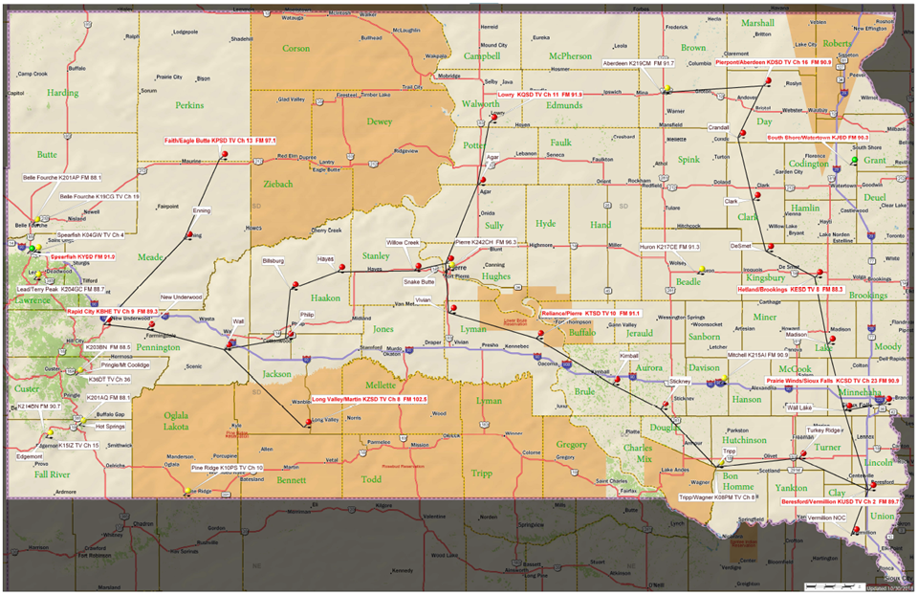

**August 2023 update:** *Digital Grant Writer*: This past July, we Identified a grant writer. To assist the with writing the formal FEMA/CPB grant. We are anticipating that FEMA/CPB will be publishing the formal grant criteria this fall. With all the technical design work over this past year. I believe we are prepared to respond to grant criteria.

**Objective 4: Create a plan to source sustaining fiscal infrastructure funding by FY26**

**Strategy: Seek opportunities to increase infrastructure funding**

* + - Evaluate the existing vertical tower real estate leasing model for new revenue streams.
    - Investigate the benefits of integrating the BIT Field Service assets and workflow module into the Service Now platform.

**August 2023 update:** AT&T Tower leases have been renewed at Vermillion, KUSD, and Lowry tower locations. The Verizon lease for the Vermillion tower site is in the renewal process now. We are continually looking for ways to safely leverage the infrastructure.

**August 2023 update:** Service Now asset management system. The BIT Telecommunications group. Set up a service now demonstration for SDPB and State radio communications (SRC). We believe there are several advantages to integrating the asset management and scheduling modules of the system within the tower infrastructure groups.

**Objective 5:**  **Document and create a plan for review by Senior management to evaluate the feasibility of joining a Joint Master Control by the end of FY23.**

Strategy: Identify lead staff within NOC, Engineering, and Programming. To identify opportunities and risks in joining joint master control.

* + - Meet with the Central cast to fully understand our options.
    - EAS responsibilities state primary, amber alerts for endangered persons, alerts in blue alerts, as well as other civil emergencies activated by state authorities.

*Update: SeVern will be renewing discussions with the Joint Master Control Vendors. During the Public Media Venture group conference prior to the NAB conference in April.*

**August 2023 update:** During the National Association of Broadcasting conference in April. We were able to meet with joint Master control vendors. The vendors have made exceptional advancements in their systems offering. They now offer complete master control services with a complete disaster recovery site that was established in a completely different geographical region of the United States. We are confident that we will be able to walk through the rest of the Evaluation process and have a complete feasibility study with recommendations to the senior management by the end of 2023.

Respectfully,

SeVern Ashes

Director of Engineering, Operations, and Digital Technologies

**South Dakota Board for Educational Telecommunications**

**Programming & Communications**

**August 2023**

**Branding Progress Report:**

* The Advisory Committee has met on a couple of occasions, first to choose the agency with which we are working, and more recently for their Discovery report.
* The Discovery phase included opportunities for staff, board members, Friends members, and members of the public to participate. They shared their thoughts about the organization’s mission, culture, and purpose, as well as their thoughts about our current branding.
* The Advisory group sat down with Fresh Produce to review the responses they received in their research and gave us a brief look at various directions this might go. Our next meeting with Fresh Produce will cover some of the creative directions they’ll explore.
* Members of our Working Group met on July 25 to begin a discussion about the process. First on the list is a logo audit – identifying every instance where the current brand/logo appears.
* Fresh Produce is reviewing the timeline for the completion of the project. I may have further details at the meeting.

**Programming**

Television:

* Schedules for the 2023-2024 TV season are being finalized. There are a number of local shows that will air throughout the season. We’re also receiving more (and better) submissions from external, local producers who want to showcase their work on SDPB TV.
* On the national level Doc Martin returned to our schedule in July. We’ll present season 8 through mid-September, followed by season 9 (which hasn’t aired on SDPB before). The final season will likely premiere in early 2024.
* Local productions that aired in May, June, and July included: *South Dakota Symphony’s Young People’s Concert; SDHSAA All-State Jazz Band; Dakota Life Detours: Silver Screens of the Prairie; The Ups and Downs of Herb and Jan Conn; SDHSAA Track & Field; SDHSAA Softball Championships; Viriditas: Twenty-First Century Hildegard; The Dean of South Dakota Broadcasting: Dean Sorenson; Voices in the Air: The Legacy of Verl Thomson; South Dakota High School Rodeo Championships,*

Radio:

* We’re looking at the potential of adding a new weekly show, “The Middle” on weekends. It’s a news/public affairs show hosted by Jeremy Hobson that brings the voices of the geographic and political middle into the national conversation.
* There are a couple of other opportunities to fine-tune the radio schedule on weekends that we’re investigating.

**Marketing**

* Public events include Storybook Land in Aberdeen and the Festival of Books in September.
* We’re working with Friends and Outreach on events like Prairie Songs, Dakota Life screenings, screenings of local documentaries, and on-air fundraising.
* Members of the Marketing and Programming team attended the PBS Annual Conference, PBS TechCon, and PMDMC.

**Education and Telecommunications Board Report**

**August 2023**

**Twyla Olson**

**Director of Content & Assistant General Manager**

**Goal – SDPB will engage with every South Dakotan at least once per month.**

**DIGITAL**

Heather Benson and Brent Duerre continue their great work with content creators in both the Journalism and Entertainment Departments with a focus on blogs, short features and digital shorts. We continue to see impressive growth and engagement in our digital audience. Producers are focusing on a variety of subjects from rodeos to kids in business to South Dakota History and Native American fashion shows. Here are links to a few of those stories:

Kids in Business: <https://www.youtube.com/watch?v=GR7Ya5LHytI>

Young Ropers: [A roping lesson from Macy | In Play](https://www.youtube.com/watch?v=J_8kvlZYUZE)

Blair Colony of Sully County: <https://www.youtube.com/watch?v=gOMnOwndynU>

Native American Fashion Show: <https://www.facebook.com/reel/847483366280818>

Giving back to youth: <https://listen.sdpb.org/sports-rec/2023-07-17/lance-christensen-spends-summer-giving-back-to-youth>

As we continue to populate our YouTube channel, Heather is experimenting with full documentaries with great success. She’ll continue posting new and past documentaries to grow awareness and audience.

Our transition to one CMS platform is still delayed due to issues at NPR.

**Journalism and Entertainment Content**

We cover all corners of the state with Dakota Life Outreach and Premieres. We see steady growth in the number of attendees at these events. Communities are reaching out to see when they will be featured in a Dakota Life episode, so our strategy to grow the audience and engagement is working. We ended the 2022-23 season with a record-breaking crowd of approximately 80 attendees in Lead. Work is well underway for the 2023-24 season, and the team has been returning to many past communities to do follow-up stories, just as we promised.

The Entertainment Team met in Sioux Falls in mid-May to review the past Dakota Life season, strategize on storytelling and best practices, choose the next community stories, and lay out next season’s schedule.

Work continues on our Tatanka documentary, which will preview at Red Cloud School on Pine Ridge on September 30th, with an afternoon of panel discussions and celebration of the buffalo, ending with a buffalo feed. More details and an invitation to attend will be coming your way soon!

We meet regularly with staff of Red Cloud School and the Veterans Youth Center at Agency Village to discuss ways we can work on projects together. Brad Van Osdel and Tim Davison recently visited the staff at Agency Village to teach them techniques on using their video equipment. We will be producing some content with them on a future project.

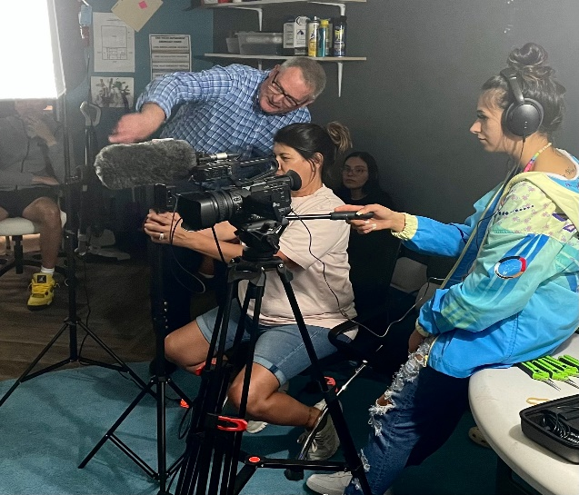

In early June, Cara and her team, including all the new Journalism interns, gathered at the Sioux Falls Studio for two days of intensive training on ethics, writing for radio, audio production and other best practices.

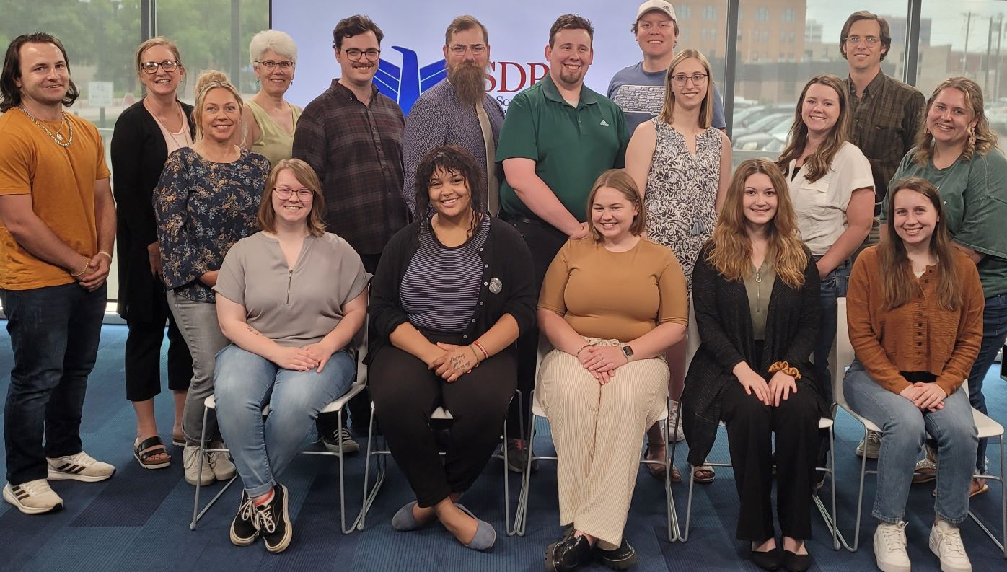

The South Dakota Focus Team has met with several key sources in planning out their 2023-24 season about the child in South Dakota. Jackie is working closely with Marcy Drew and her Education Team to identify issues and resources. Cara is planning a roundtable discussion of this topic connecting the state, which will be streamed from our Black Hills and Sioux Falls studios.

Lori Walsh and Lee Strubinger are working on a documentary about the Black Hills Forest, which is slated to air in mid-September.

In Partnership with South Dakota NewsWatch, Cara Hetland is planning a training for existing reporters in South Dakota about how to cover the court system, one in the Black Hills Studio on September 16th, and the other in the Sioux Falls Studio on September 23rd. There are two of these sessions. We will record video of one of the presentations for an archival project with NewsWatch. Lost in Court is a presentation that walks reporters through an old case. Judges, prosecutors, and defense attorneys are on hand to explain the case and what all the documents mean and what is open to the press and how to talk with a judge about coverage in a courtroom.

I attended the PBS Annual Meeting in San Diego in late May and met with several producers who are eager to work with us, including Providence Pictures, who is producing the 2nd season of of Native America, presented by PBS. I also met with members of FNX, First Nations Experience, and we discussed how we might soon be able to add their programming to SDPB, possibly via streaming. They are also interested in airing our content on their channel. I also met with the WETA staff, who is presenting the Ken Burns American Buffalo documentary. They are thrilled with the engagement and documentary we are producing with the grant money they’ve provided.

**Education**

Marcy Drew attended the Governor’s conference on the new South Dakota Social Studies standards. Marcy and her team are working on recommendations of SDPB materials that will support educators with the new standards. The Education Team has also made significant progress on partnering with local businesses in Belle Fourche, which they hope will be the flagship template for SDPB Early Learning areas in grocery stores, clinics, laundromats, and other businesses in communities with a deficit of childcare facilities. The Education Team is headed to Wylie Park in Aberdeen on July 21st to celebrate Storybook Land, an annual event celebrating kids. It’s an important event serving parents and kids in the Northeast, and team favorite event.

**Outreach**

With the completion of the remodel of our studios in Rapid City, we are hiring a full-time Events and Outreach Coordinator to assist Nathan Hofer. This position is key to expanding our outreach, presence, and membership growth in the Black Hills region and all of West River. We hope to have someone hired by early Fall.

Jazz Nightly travels to Mitchell on Tuesday, August 1st for a live performance at the Corn Palace Plaza to celebrate the completed tower project.

Prairie Songs returns this Fall with performances on August 18th at the Sioux Falls Zoo and August 19th at the Custer Beacon, featuring **The Cloverfold** and **Humbletown**. There will be an additional performance in Aberdeen on September 8th in Aberdeen at their new downtown plaza performance Space.

Then the new season of Dakota Life Premieres begins in Hill City at 7 pm on Tuesday, 5th at the Hill City Center. Come join us if you can!

Here is a snapshot of the next few month’s activities. As you can see, it is action packed and covers all corners of the state. **DL CC stands for Dakota Life Community Conversation.

|  |  |  |  |  |  |  |  |  |
| --- | --- | --- | --- | --- | --- | --- | --- | --- |
| SDPB Legacy Society | 16-Aug | Arbor Spring/Refuge Retreat | Aberdeen | Friends |  |  |  |  |
| Prairie Songs | 18-Aug | Great Plains Zoo | Sioux Falls | Comm. Impact | Friends |  | 2:00 PM | 6:00 PM |
| Prairie Songs | 19-Aug | Custer Beacon | Custer | Comm. Impact | Friends |  | 2:00 PM | 7:00 PM |
| SDPB Legacy Society | 24-Aug | Black Hills Studio | Rapid City | Friends |  |  |  |  |
| SDPB Legacy Society | 29-Aug | Sioux Falls Studio | Sioux Falls | Friends |  |  |  |  |
| Hill City DL Premiere | 5-Sep | Hill City Center | Hill City | Entertainment | Comm. Impact |  | 5:45 PM | 7:00 PM |
| Aberdeen Prairie Songs | 8-Sep | Central Park | Aberdeen | Comm. Impact | Friends |  | 2:00 PM | 7:00 PM |
| Lost in Court Training | 16-Sep | BH Studio | Sioux Falls | Journalism | Engineering |  | 8:00 AM | 9:00 AM |
| Forest Doc Listening Session | 20-Sep | Black Hills Studio | Rapid City | Journalism | Engineering |  | 10:00 AM | 11:00 AM |
| Festival of Books | 23-Sep | Deadwood Mtn. Grand | Deadwood | Marketing | Journalism |  |  |  |
| Lost in Court Training | 23-Sep | SF Studio | Sioux Falls | Journalism | Engineering |  | 8:00 AM | 9:00 AM |
| Fall Radio Drive | 28-Sep | All Studios |  |  | Engineering |  |  |  |
| Fall Radio Drive | 29-Sep | All Studios |  | Friends | Engineering |  |  |  |

|  |  |  |  |  |  |  |  |  |
| --- | --- | --- | --- | --- | --- | --- | --- | --- |
| Honoring Thathanka Oyate | 30-Sep | Red Cloud Indian School | Pine Ridge | Comm. Impact | Marketing | Education | 11:00 AM | 1:00 PM |
| Fall Radio Drive | 30-Sep | All Studios |  | Friends | Engineering |  |  |  |
| Onida DL Premiere | 3-Oct | Phoenix Center | Onida | Entertainment | Comm. Impact |  | 5:45 PM | 7:00 PM |
| Dick Termes Six Point Perspective Screening | 12-Oct | BHSU - Meier Hall | Spearfish | Friends | Education | Engineering |  | 7:00 PM |
| Friends Board Meeting | 13-Oct | TBD | West River | Friends |  |  |  |  |
| Union Center Premiere | 1-Nov | Mead County Community Center | Union Center | Entertainment | Comm. Impact |  | 6:00 PM | 7:00 PM |
| Cheers, SD! 2023 | 2-Nov | TBD | Sioux Falls | Friends |  |  |  |  |
| Madison DL Premiere | 4-Dec | Dakota Cinema | Madison | Entertainment | Comm. Impact |  | 5:45 PM | 7:00 PM |

**High School Activities**

SDPB continues our commitment to serving all South Dakotans through our strong partnership with the South Dakota High School Activities Association, covering all activities. We ended the year with the first fully sanctioned baseball tournament in Aberdeen. Brad’s team also covered the non-sanctioned State Rodeo and gathered memorable interviews with the champions.

There is much more to share, but I will end with kudos to our incredibly talented team and the recent awards we received in recognition of their outstanding work.

**Awards**

SDPB won two Regional Edward R. Murrow Awards for Small Market Radio for reporting in 2022. Murrows are awarded by the Radio Television Digital News Association.

SDPB has won in the following categories:

**Continuing Coverage** - [Attorney General Jason Ravnsborg Impeached](https://listen.sdpb.org/politics/2022-01-19/north-dakota-investigators-point-to-discrepancies-in-ravnsborg-testimony). Producer: Lee Strubinger.

**News Documentary** - [Dave Eggers Discusses His Book Being Prohibited by Rapid City School District](https://listen.sdpb.org/show/in-the-moment/2022-05-13/dave-eggers-discusses-his-book-being-prohibited-by-rapid-city-school-district). Producer: Lori Walsh, Carl Norquist, Chris Laughery

**South Dakota Board of Educational Telecommunications**

**Education Report-Marcy Drew**

**August 2023**

**Resource Development and Distribution:**

Educational resources for parents, caregivers, and educators are primarily housed or linked on the SDPB website, YouTube, and PBS LearningMedia. Team members have been engaging in training to learn how to create and upload these resources and make them accessible to everyone. A focus for existing and newly developed resources is increasing accessibility of resources for individuals with vision impairment, learning disabilities, and other needs. Ongoing training and technical support from PBS LearningMedia will assist in this plan.

New lessons on epigenetics, immortal cells, and CRISPR, developed in partnership with Sanford Research’s Program for the Midwest Initiative in Science Exploration (PROMISE), are now available nationwide on PBS LearningMedia.

A new video series called *Create Your Own Studio* is now available on the SDPB Education website and YouTube. These instructional videos and lessons were developed in partnership with Headlights Theater, a professional dance company. The videos and included Dance Action Cards teach children ages 5-10 how to set up a safe dancing space at home and how to create a choreographed dance sequence on their own. The goals are to give children and families who may not be able to access dance lessons because of a rural location, finances, or time constraints the opportunity to experience the joy of expressing themselves through creative movement.

Email newsletters continue to be a primary way to keep in contact with parents, childcare providers, and educators and give them easy access to SDPB’s high-quality educational content. The K-12 newsletter consistently continues to reach about 3,000 subscribers across SD. The Early Learning Links newsletter has also maintained a consistent subscriber list of 1365, an increase of 18% since April 2023, and an open rate averaging around 30%. Topics in the newsletter are organized according to current SD Content Standards or SD Early Learning Guidelines to support learning and development for all ages and stages.

SDPB developed documents aligning PBS KIDS programs and interactive games with the SD Early Learning Guidelines to help busy parents and teachers quickly identify what skills and knowledge children gain when they choose educational programming. These documents are distributed online and during outreach and professional development events across the state.

**Outreach and Professional Development**

The education team provides outreach and professional development to families, caregivers, and educators to share the resources available from SDBP. SDPB education staff give presentations and host exhibitor booths at professional conferences for home and center-based childcare providers, Head Start staff, K-12 teachers, school administrators, school board members, and policymakers.

At the annual SD Early Childhood Education Conference in April 2023, over 200 early childhood teachers, childcare providers, and others in the field gathered from across the state for professional development and networking opportunities.SDPB presented a keynote address designed to “Blow up oldideas about early learning” and share new and exciting resources. A total of three SDPB breakout sessions focused on activities to promote health and physical development, literacy, and social and emotional learning.

The education team also provided a table in the exhibitor area with photo opportunities with characters, fun items for teachers, and samples of lesson plans. Many attendees mentioned that they already subscribed to SDPB’s educational newsletters and used the resources with the children in their care, but over 100 new subscribers added their contact information to receive the newsletters during the conference.

Other recent events for professionals include regional and school-wide in-services for K-12 teachers, participation at the SD Homeschool Conference, area school and Head Start administrators’ meetings, and a short presentation at Kindergarten Academy.

Outreach directly to children and families happens online and in communities across SD. In April, Science Steve and the education team, along with some dedicated volunteers, spent two days providing hands-on science experiences and interactive activities at YFS Kids Fair in Rapid City. Over 8400 people attended the event, and at least 1000 of them stopped by the SDPB booth. Other recent engagement opportunities include the Festival of Cultures in Sioux Falls, STEAM Day at Grandview Elementary in Rapid City, Lead Live in the park in Lead, and the Lower Brule Community Resource Carnival.

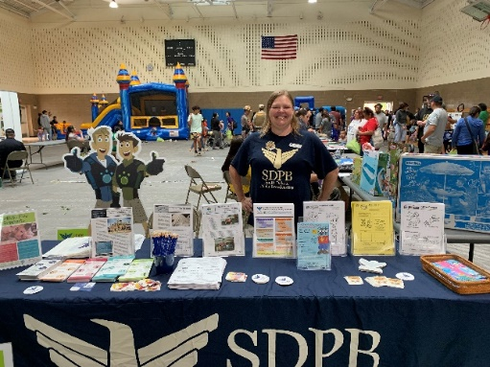

Work continues in Belle Fourche to create early learning spaces throughout the community, wherever young children and families spend their time. Agreements with businesses like the local laundromat and grocery store, economic development and chamber of commerce, and organizations including Head Start, the parks department, and the public library are in progress. Information and materials that support learning and growth will help parents provide learning opportunities during everyday play and activities.

**Entertainment Group ET Board Report August 2023**

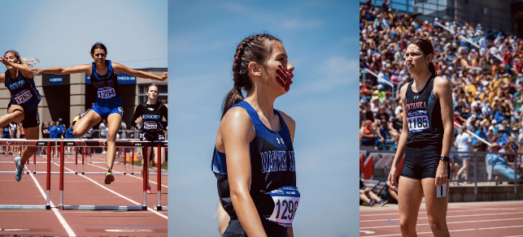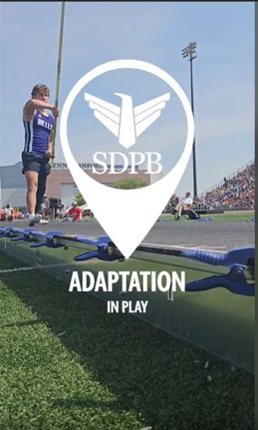One of the Entertainment group’s objectives is to grow our digital audience by 25 percent in two years. 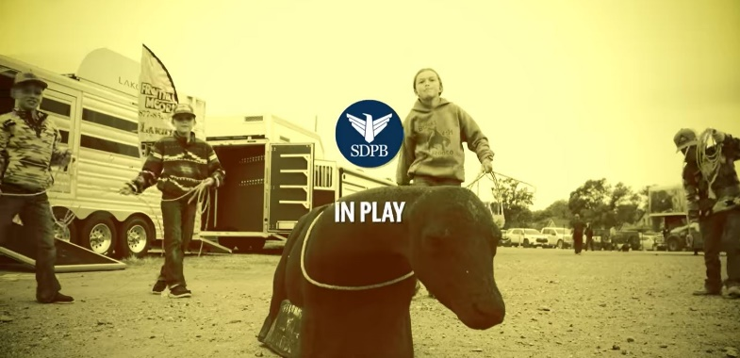During SDPB’s coverage of the High School rodeo, the entertainment team was boots on the ground for social media. Along with recording the rodeo for broadcast, streaming and on-demand crews were engaging with the audience and participants at the event to bring their stories to social media. This focused storytelling on specific events like the high school rodeo and other High School tournaments, events, and activities, produces a high impact in views and engagement on social media. The stories produced ranged from short-form videos with kids explaining how to rope and a father-son bull riding bond to longer-form stories on families and their love of rodeo and the winner of the rodeo queen contents. We also produced short videos with all 16 saddle winners, giving insight into their love of rodeo. Overall, the entertainment team produced 24 stories for SDPBs coverage of the SD High School Rodeo Finals. These stories received 0ver 7,000 likes, comments, and shares and 218,000 views pushing our engagement way beyond the event’s broadcast. The high school rodeo is a great example of the entertainment group’s effort to grow our digital audience. The first-ever SDHSAA girl's softball tournament was held in June, and SDPB was in Aberdeen for the event. SDPB streamed every game for all three classes and broadcast the AA 3rd and 4th place game and championship. Track and Field took place in May, and all track events were streamed live to sdpb.org, with the final day being broadcast to SDPB-TV. Along with the crew tasked with streaming these live events, producers and videographers were on hand for both events to tell the stories of participants, fans, and families. Several stories stood out from all the great stories that were told. One was about pole vaulter Logan Tyndall from Belle Fourche, who had his foot amputated at a young age but has not let that keep him from doing what he loves. This story received 54,000 Facebook views and 1400 likes, shares, and comments. For Mackenzie Everson of Castlewood, playing in the first-ever SDHSAA softball tournament was a thrill, but it also marked her 5th SDHSAA tournament for the year. She, individually or as part of a team, played in the state torment for volleyball, basketball, track & field, softball, and golf. This blog reached 475,554 people. Simeon Birnbaum of Rapid City Stevens finished his career with a record-breaking run for the 1600 meter, breaking the previous state record with a time of 4:02:78. The story reached 143,000 people. Three young Ladies from the Pine Ridge area impacted the state track meet with seral placings and some school records broken. This story, produced for SDPB by freelance writer and photographer Jonathan Kelley, captures these young athletes' community pride and athleticism. The story has a reach of 80,000 people.

**Pole Vaulter Logan Tyndall**

**First-Class Native Athlete Trio Does The Unexpected**

**Tip Down, Elbow Up**

The Entertainment’s second objective is to grow a new audience by 25% in three years through engagement and community conversations. We completed our community conversation portion of the Dakota Life next season by holding listening sessions in each of the nine communities. The communities met this enthusiastically, and there was no shortage of great ideas. Fifty community members were on hand in Onida to visit with SDPB staff about their community. The team is well into production for next season, with trips to several communities based on stories from our audience. Last season ended on a high note as 80 people from Lead were on hand to watch the premiere of the Greetings from Lead episode of Dakota Life. This screening generated many more story ideas as folks were interested in SPBP continuing our relationship with Lead. This relationship with communities across South Dakota continues to unfold with trips back to communities visited last season. We returned to Parkston for a story about two friends that sang on a Mitchell radio station in the 1940s, visited Eagle Butte for the Red Can Graffiti Jam, Murdo for the Ranch Rodeo, Springfield for a dedication of a bridge honoring a local veteran and Mission for the Farmers Market and a Little League Baseball Game. The partnership with communities continues to grow, and we have begun to see folks we have met contact SDPB with these and many other possible stories.

**THUNDER LEAGUE**

**Premiere event of the Lead Episode of Dakota Life**

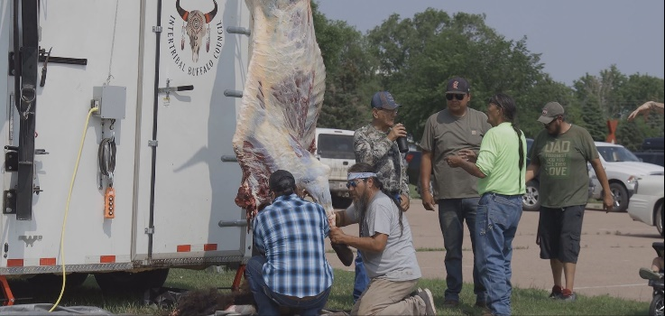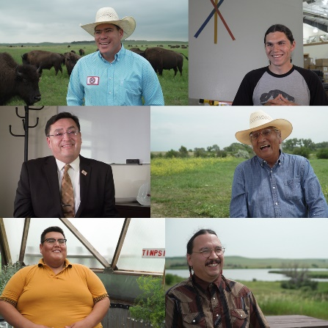Another objective is to grow our diverse audience through source development, the stories we tell, and engagement by 25 percent over five years. As the entertainment group began to plan for the Tatanka documentary and began to research and contact people involved with buffalo programs in native communities, we realized this program needed to be done on a larger scope. This has led us to expand the series into three parts airing over the next year, with plans for more episodes after that, the work being done by Native Americans on food sovereignty, buffalo reintroduction, youth mentoring, and the overall importance of the buffalo to native people are important stories to tell. The first episode, released this Fall, will tell a brief history of Native Americans' relationship with the buffalo and the effects the buffalo being almost driven to extinction had and has on Native Americans. It will conclude with the story of the Red Cloud School buffalo harvest. This first episode lays the groundwork for the next two episodes featuring the WoLakota Bison Project in Mission and the buffalo project in Flandreau. As we begin to tell this important story, we also realize the importance of community storytellers. There are many people in Native communities telling these stories already and working with these folks is a natural fit for SDPB. The Flandreau community recently hosted a Buffalo Harvest workshop, and we enlisted the help of a local storyteller to capture this story.

**Buffalo Roundtable & Workshop, Flandreau**

**WoLakota Buffalo Project, Mission**

The partnership with the Levitt in Sioux Falls to live stream their summer concert series has reached the halfway point. The series consists of 50 concerts from late June to early August. Along with the national acts being streamed each night, a local band or singer is featured live on stage. Two large events co-hosted by the Levitt, The Festival of Culture and All My Relatives. These two events feature speakers and discussion groups that SDPB live-streamed, all with the concerts on those weekends.

**Educational and Telecommunications Board Report**

**August 2023**

**Cara Hetland**

**Director of Journalism Content**

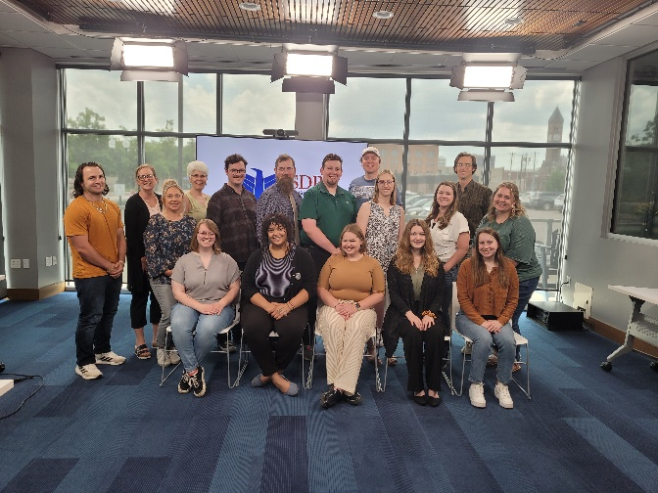

The Journalism Team gathered in Sioux Falls the first week of June for training. Our freelance editor Kate Smith talked about writing newscast scripts, using our gear, and conducting interviews. Volunteer Jon Hunter discussed source development. News Director Josh Chilson addressed workflow and processes and Cara Hetland conducted a session on ethics in our reporting. It was a good two-day session to get to know our new interns and connect with one another as a team.



Congratulations to Lee Strubinger and Lori Walsh for each winning a Regional Edward R. Murrow award. Lee won for Continuing Coverage for his reporting on the Jason Ravnsborg Impeachment and Lori won in the News Documentary category for her discussion with author Dave Eggers about his book being prohibited in Rapid City Public Schools. These are now automatically entered in the National Murrow competition with winners announced in October.

Jackie Hendry attended the National Press Foundation Fellowship training around the future of the American Child. While we’re still planning out the 2023/2024 season of SD Focus, we have agreed on this mission statement: ***South Dakota Focus in the 2023/24 season will provide an overarching look at how South Dakota’s youngest are being prepared for the future and how the state values children.*** We will provide a statewide look at daycare and healthcare, trauma, labor, juvenile justice, and education.

Congratulations to News Director Josh Chilson for being named a fellow in the next cohort of the Editorial Integrity & Leadership Initiative. This is a program funded by the Corporation of Public Broadcasting in partnership with the Poynter Institute. He will travel to St Petersburg, Florida for this weeklong intensive program in September.

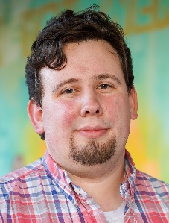

Ryan Bozer joined the SDPB team as the local Morning Edition host on April 26. Over the past ten years, Ryan has worked as an educator in classrooms and museums nationwide. As an SD Mines alumnus, Ryan is excited to return to the Black Hills. Krystal Miga is hosting All Things Considered. Both are based in Rapid City.

We said goodbye to interns Slater Dixon, Andrew Kronaizl, Marissa Brunkhorst, and Jordyn Rusche. We welcome summer interns Madeline Grabow (Georgetown), Zadya Abbott (USD), Veda Tonneson (Augustana), and Elizabeth Jones (Creighton). These students have set the bar high and have a great radio presence and will took over weekend hosting in June.

Hats off to our In the Moment team to pivot on the breaking news surrounding the Supreme Court ruling on the Indian Child Welfare Act (ICWA). On the day of the ruling, University of Sioux Falls Professor Mike Thompson discussed the decision. We followed with reaction from Representative Peri Pourier, and ACLU attorney Stephanie Amiotte. And Professor Frank Pommersheim discussed his research and writings on Indian Law. Pommersheim was cited in Justice Gorsuch concurrence opinion.

Special thanks to the students at Sturgis Brown High School for their participation in a pilot program to produce content for South Dakota Focus. The students took the “mental Health” topic and brainstormed a story about Isolation. We had regular meetings with the students and walked with them in every part of their story creation process. The finished story aired in the May, 2023 SD Focus episode.

Here are some comments from students who worked on the project:

“It gave us a challenge. With that challenge, we all knew that we had to work together.”

“I enjoyed working as a class to get the final product. I thought everyone did a good job on what they were supposed to do. I liked all of the B-roll and the variety of interviewees. I also liked how the topics throughout the video flowed. There’s always room for improvement, like audio, but overall, I think it was really good, considering the audio isn’t something we can really fix.”

Brainstorming for student involvement has begun for next season. We hope to add an additional high school program and we find tune this youth journalism partnership.

Summer with the symphony returns on Monday’s this summer on In the Moment. Freelance editor Matt Weesner produces these highlight programs from last season’s South Dakota Symphony concerts.

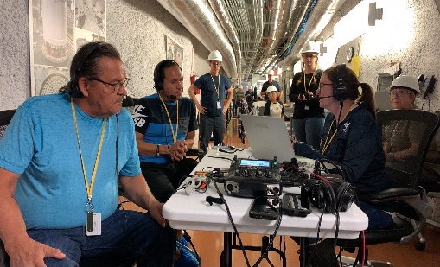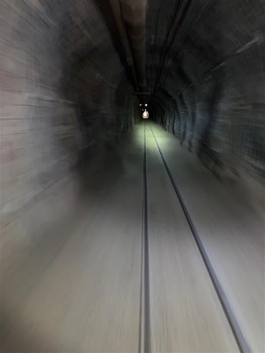Neutrino Day broadcast on July 6 from the 4850 foot level of the Sanford Underground Research Facility (SURF). Guests included science comedian Brian Malow, Henry Red Cloud from Red Cloud Renewable, and Sam Meijar from the Los Alamos National Lab in the search for the decay of nature’s rarest isotope: tantalum-180m. He’ll discuss what they know and what they hope to find.