**Content Report**

October 2021

Strategic Plan Goals:

**SDPB Media initiatives; Special Projects; Content Division Strategies:**

**SDPB Media Initiatives:**

The impact of the **Coronavirus** continues to resonate through our content strategies. Remote production crews (and those working in the office) take mask and other precautions. While we have guests in our studio, we not hosting public events in the studio spaces at this time.

The Journalism group has reformatted the SD Focus production to NOT be a “4 guests talk in the studio” program. The hour format is now similar to “In the Moment” in that it features original work and contributions from “beat” reporters; follow on topics from previous features, and lifestyle stories. The centerpiece of the program is a 20 to 25 minute investigate report on a single topic/theme. The program is scheduled for play on the last Thursday of the month.

The J Group also promotes a “Theme of the month” for a variety of reports developed and distributed across platforms. The November theme is science and technology in South Dakota.

The Entertainment group manages production of **SDHSAA** events with golf, tennis, soccer, cheer and dance, and cross-country coverage complete, and chorus and orchestra, football, volleyball, and oral interpretation speaking events ahead before the end of the year. SDPB Video broadcasts are distributed to our TV and video streaming channels and some will also be shared with the National Federation of High Schools streaming network. And in the spirit of being a good neighbor, we are open to share pictures with fans, high schools, and local newspapers; share video highlights with TV broadcasters and give some accommodation to radio broadcaster who cover their local team at state events.

The E group has reaffirmed our commitment to local music events and artists by dramatically changing our suite of content and creating new or updating partnerships with Levitt at the Falls and the South Dakota Symphony.

**Special Projects: All platforms contributing to local media production and outreach**

“SD Symphony live streaming concerts 21/22”

“Music Matters and Levitt in your living room”

“Monthly Journalism topics”

“SDPB Early Learners Initiative (ELI)”

“Laura Ingalls Wilder Society” radio-play production

“Dakota Life Community Engagement” events

**Education and Telecommunications Board Report**

**October 2021**

Brad Van Osdel

**Director of Entertainment Content**

**Music**

SDPB partnered with the Levitt at the Falls to produce and stream 40 concerts this summer. These concerts were streamed to SD.net and Facebook and gave our viewers a chance to watch some great performances from local and national acts in genres of music ranging from country and folk to hip hop and rock and roll. This partnership also launched programs that we have leveraged across all of SDPB's platforms. Music Matters, a digital and television series, and the television series Levitt in Your Living Room. Apolonia Davalos, a freelance producer from Sioux Falls, is the host and producer of these programs. Apolonia worked with SDPB staff to interview musicians about their inspiration, style, and why music matters.

SDPB will be continuing our partnership with the South Dakota Symphony Orchestra again this season by streaming nine symphony concerts to SD.net and sdpb.org. The entertainment group will edit four concerts from these nine streams to air on SDPB-TV, Victory Songs: the Lakota Music Project, the Messiah, Vivaldi's Four Seasons, and the Young Peoples Concert. The first concert, Maya Buchanan Plays Beethoven, streamed on Oct 2nd and had 780 viewers on sdpb.org.

**SDHSA Events**

The South Dakota High School State Track meet was held at three locations on Memorial Day weekend. This is the usual format, but due to COVID protocol, finals were held at all three sites instead of at one location. The Entertainment Group rose to the challenge and broadcasted from all three sites and brought the people of South Dakota complete coverage of class B, A & AA state track meet. South Dakotans visited the track main page on sdpb.org 24,796 times, class B page 13,864, class A 13,646, and Class AA 8,685 times.

October is the kick of SDPBs coverage of SD High School activities. The entertainment group began with boys A and AA golf coverage and girls A & AA with action photos, results, and awards photos. The SDPB crew was also able to catch a hole-in-one by Kyan Overbo of Sioux Valley at the Boys class A golf and interview him for a radio story and a web page and Facebook post that has reached over 20,000 people.

During October and November, the crew continues coverage with Soccer, Cheer, Dance, chorus & orchestra, football, and volleyball being broadcast on SDPB TV and at sdpb.org. Along with Craig Mattick as our main play-by-play announcer, we added Stacy Bauer-Jones to our crew of talented sports announcers. Stacey will host the coverage, with coaches and players' interviews, and work with our social media staff to engage with the venue's audience and folks watching from home.

**Documentaries**

The entertainment group has been working on several documentaries over the summer and fall. The first of which aired on Oct 14th, "Old guitars and the Musicians Who Love Them," takes viewers on a journey across the state and explores the unique guitars owned by South Dakota musicians and on display at the National Music Museum. The documentary explores the different sounds each guitar can have based on its construction, the type of material used, and why artists prefer their guitar of choice. Four other documentaries are in production and scheduled to air in 2021, Civil War Veterans that Settled South Dakota, The Pride of the Dakotas: A History of the SDSU Marching Band, and 50 Years of Title IX: The Pioneers of Women's Athletics in South Dakota.

**Rural Stories:**

Dakota Life production continues the new format of centering each episode around a South Dakota Community. This season has been difficult for staff due to the death of Melissa Hamersma, who played an essential role in the production of Dakota life. Still, the Dakota Life team has pulled together to overcome the loss of our friend and colleague.

This season to focus on rural South Dakota, tell the community's stories and build lasting relationships with community members. We have begun a three-step process in the production of Dakota Life. The first step is to contact the community to find people who have an insight into the town's history, culture, and why people choose to live there and call it home. During this step, we also travel to the community to interact, ask questions, and find the stories that make people proud of their town. The second step is the story and shows production, and the third step is to celebrate and screen the episode at a venue in the community and connect with people a third time and ask them about their thoughts on the program, what we missed and what stories are yet to be told. This process has been very successful for the first two episodes and has improved the quality of the stories we tell and helped SDPB build long-lasting relationships in these communities. October’s episode “Greetings from Milbank” garnered 10,000 views and reached 20,00 people this month on SDPB’s Facebook page.

SDPB live-streamed the Custer State Park Buffalo round-up again this fall, and it was a huge success again for the network. Due to the success of the webcast last year, we made production changes to enhance the experience for viewers. To enhance the view of the herd and scenery of Custer State Park, SDPB added cameras to the production. SDPB added announcers to give insight into the history of the round-up, the planning of the round-up, and the benefits the round-up provides for the health of the buffalo and the park. 5,392 people viewed the live stream at sdpb.org, 25,627 watched on YouTube, and 43,895 watched on Facebook.

**Education and Telecommunications Board Report**

**October 2021**

**Cara Hetland**

**Director of Journalism Content**

**Content:**

We began our Spotlight feature topic in April as we changed our *In the Moment* programming. The April spotlight was on Guns in South Dakota. The Second Amendment is something held near and dear to the people of this state. Tourism dollars rely heavily on the hunting heritage and culture of this place. And yet around the country we are seeing mass shootings, hearing calls for gun reform legislation, and a feeling of fear having a democratic administration and majority. We invited our audience to share their stories and early memories of guns. We received several responses. Here is a link to the capstone summarizing the month of conversations. [SDPB's 'Guns In South Dakota' Finale](https://www.sdpb.org/blogs/news-and-information/sdpbs-guns-in-south-dakota-finale/)

May’s Spotlight shines on the crisis of Missing and Murdered Indigenous People. We spent the month on *In the Moment* and one of the *SD Focus* programs exploring the statistics and the stories, the traumas, and the efforts to apply modern solutions to a decade’s old inequity

June’s Spotlight shines on rodeo in South Dakota. We spent the month exploring rodeo traditions, the culture, the horses, and the politics behind some new facilities. We had feature stories about music, profiles of athletes, and stories from cowboys.

July’s Spotlight shines on summer school as we looked at state history and civics, and how these subjects are taught in South Dakota. We talked about Critical Race Theory, Social Studies standards, and some tough elements in history including government boarding schools. One hour was dedicated to the return of the remains of nine Rosebud Sioux students returned home from the Carlisle Indian Industrial School in Pennsylvania.

The August Spotlight explored the history of the Black Hills National Forest. We looked at the forest and the people who lived there, traveled along with the Custer Expedition to see how the forest looked 100 years ago, and tracked the history of the federal forest management and looked at the tension between timber interests and those seeking to protect the forest for generations to come.

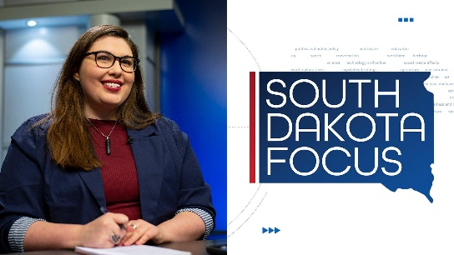The September Spotlight looked at our literary heritage in South Dakota. The interviews lead up to the SD Festival of Books in early October.

For all of our coverage check out [www.SDPB.org/Spotlight](http://www.SDPB.org/Spotlight)

We spent the summer working on a new format for SD Focus with Jackie Hendry. This is a shift for all journalism reporting to have a video component. You will see more of this content on social media as well. The program highlights suicide prevention in the season premiere on September 30.

SDPB.org/news has a new look thanks to our new content management system through National Public Radio.

**Journalism Team on Social Media:**

[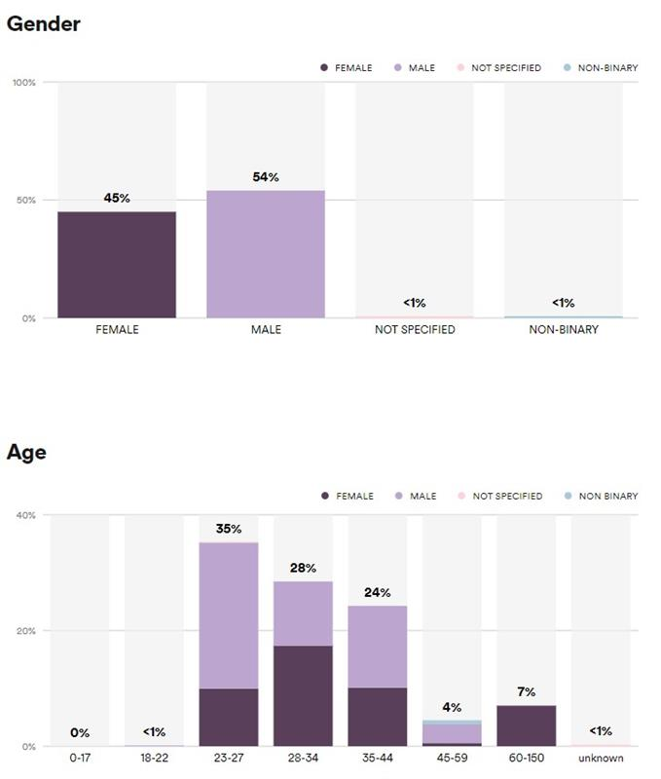](https://api.ams.gcc.teams.microsoft.com/v1/objects/0-gccaz-d2-8b1194e0835cde30fb298c3abf6e391d/views/imgo)**Podcasts:**

* **SDPB News: 252 listeners on Spotify**
* **In the Moment: 192 listeners on Spotify**

We are #1 on Google when searching “South Dakota podcast”, and “South Dakota news podcast”. Our subscribers are steadily growing **(last reported 131 listeners and now it’s 454)** on Spotify.

We are most popular with listeners in the 23-27 age group.

**Morning Report:**

The Morning Report is a twice weekly e-newsletter featuring the most recent content from J Team.

**We have 1350 Subscribers (another 100 new subs since May). Click-through Rate: 26.7% (Industry Average is 2%)**

**Twitter:**

[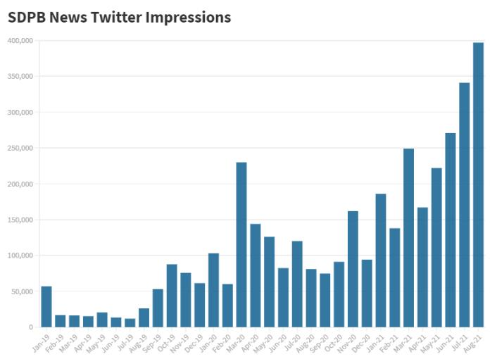](https://api.ams.gcc.teams.microsoft.com/v1/objects/0-gccaz-d1-ae498af89a807927eba774bd715ca135/views/imgo)[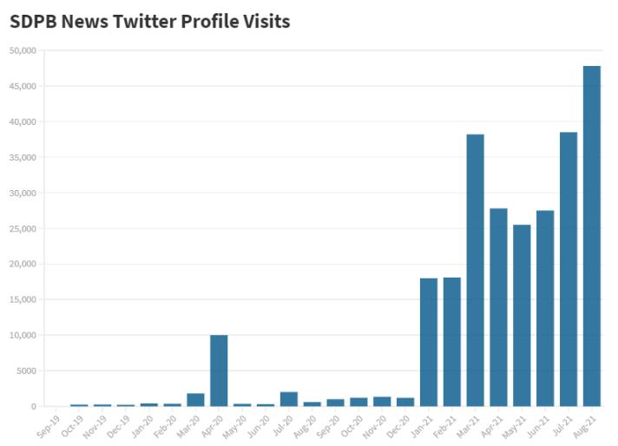](https://api.ams.gcc.teams.microsoft.com/v1/objects/0-gccaz-d2-c0ef4e078dcb0a1a67ca839b1991f6ee/views/imgo)

**Staffing:**

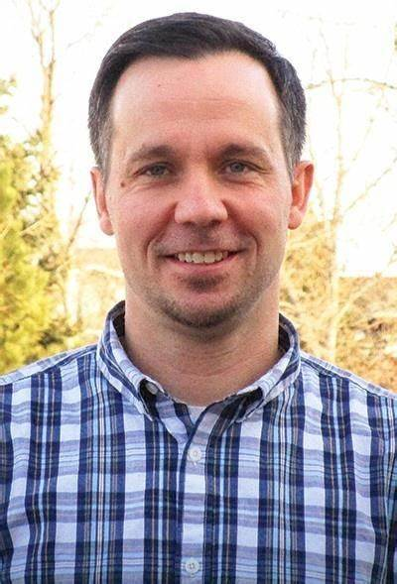Seth Tupper has been promoted to the Supervising Senior Producer position. He will oversee our daily news content and the public affairs programs on SDPB. Seth joined SDPB in January of 2020 after a successful career in newspaper reporting. He covered the business and economic development beat for the journalism team.

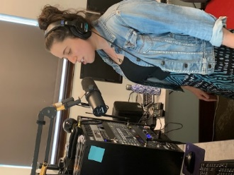Arielle Zions joined the SDPB J Team as a beat reporter. She covers the business and economic development beat. This includes helping urban and rural South Dakotans understand the economy, how it impacts their lives, and how they make a living.

Before joining SDPB, Arielle worked as a criminal justice reporter at the *Rapid City Journal* and as a general assignment reporter at the *Nogales International*. In her free time, you can find Arielle riding her gravel and mountain bikes throughout the Black Hills, listening to podcasts, and spending time with her cats Sully and Esther.

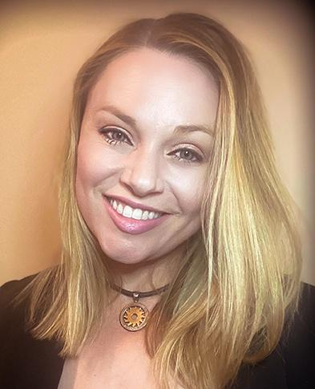All Things Considered Host Megan Feighery moved to Rapid City and will host the program from the Black Hills Studio.

We said farewell to Morning Edition host John Nguyen. John moved back to his home in Minnesota for personal reasons. We wish him well and are currently searching for a replacement. Interns Kyle Ireland and Genna Scott are hosting.

Congratulations to SD Focus Host Jackie Hendry – she was selected as a participant for Poynter’s virtual online group seminar called Poynter Producer Project. This live online instruction discusses everything from writing, finding diverse sources, and managing stress and trauma during a pandemic.

Lee Strubinger and Seth Tupper will attend the National Edward R. Murrow awards ceremony in New York – They each won national recognition for writing and investigative reporting.

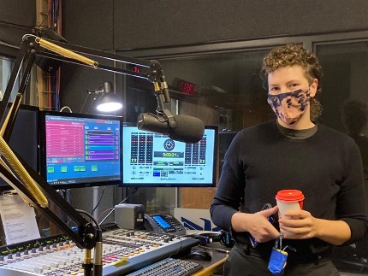On October 12, we welcome Stel Kline as the new local on-air host for *Morning Edition*. Kline was born and raised in Schenectady, New York, attended the Maryland Institute College of Art (MICA) in Baltimore. Stel began audio and radio work while interning at WYPR in Baltimore and has worked as a freelance producer with programs such as *On the Media* and *This American Life.* Stel looks forward to being the local voice of *Morning Edition* to help South Dakotans start their day and bring warmth and understanding to the way they experience the news.

**Board of Directors of Educational Telecommunications**

**SDPB Programming & Communications**

**October 29, 2021**

With the retirement of Bob Bosse in June, Fritz Miller assumed the duties of programming, and the programming and marketing departments were merged into a single department named Programming and Communications. Reorganization within the merged department continues.

**Programming – TV**

It was decided in the spring to not renew our contract for *The Lawrence Welk Show*. The last broadcast was August 7. We have received a few calls and notes regarding the elimination of the show, but nothing that can be regarded as a groundswell of objections. For the time being we’ve inserted Antiques Roadshow. It’s likely we’ll adjust the Saturday evening schedule to expand our British sitcoms.

Our overall TV audience has grown when comparing viewership year-to-year. Some of this can be attributed to growing audiences on our 3 digital subchannels. Considering the increasing use of online streaming services (Netflix, Amazon Prime, etc.) we must be satisfied that we haven’t seen drops in viewership.

* In October SDPB featured a new documentary produced in conjunction with the National Music Museum *Old Guitars and the Musicians Who Love Them* (a preview at the NMM was well attended), a compilation of material from our summer coverage of the Levitt concert called *Music Matters*, and a special performance of the SD Symphony featuring Emanuel Ax playing Beethoven’s Piano Concerto No. 5, Op. 73 “Emperor.” We also feature performances from the Levitt Shell.
* The SDHSAA All State Chorus & Orchestra Concert will be presented live (for the first time since the pandemic) on Oct. 30.

Upcoming shows of interest

* November highlights include SDHSAA Football and Volleyball Championships, new episodes of the revamped Dakota Life and Wish You Were Here with Eliza Blue, On Call with the Prairie Doc.
* December will be filled with plenty of holiday cheer, including local programs produced by Augustana, Mount Marty, and the University of Sioux Falls. We’ll also stream and broadcast the SD Symphony’s performance of Handel’s *Messiah*, and a special televised radio play from the Laura Ingalls Wilder players.

**Programming – Radio**

There have been no significant changes to the Radio schedule since March 29, when *In the Moment* shifted to a 1-hour format and began broadcasting twice a day (Noon CT and repeated at 7pm CT). The good news is that we have had steady growth in listenership from June through September 2021.

(Keep in mind, these numbers reflect ONLY online listening – not over-the-air listening):

|  |  |  |  |
| --- | --- | --- | --- |
| Month | Year | Duration (Seconds) | Unique Users |
| April | 2021 | 58712 | 9880 |
| May | 2021 | 62109 | 9200 |
| June | 2021 | 59777 | 9578 |
| July | 2021 | 60441 | 9217 |
| August | 2021 | 63916 | 10705 |
| September | 2021 | 61613 | 19425 |

Note that we are on pace to equal the numbers from 2020 – a highly contentious election year.

**Marketing –**

**Data Dashboard** – The work on this project concluded in June and was rolled out to managers and other users. We are settling into standard procedures to keep this dashboard fed with up-to-date information. The goal is to improve our ability to compare audience information briefly in an efficient, low cost and low-impact manner.

**SDPB Rebrand** – Progress has paused on this while the Programming and Marketing departments complete their merge. We anticipate getting back at it in November or December. This comprehensive project will take time. We have an opportunity to coordinate the roll-out of a new brand with the 100th anniversary of KUSD Radio - May 2022.

**Social Media** continues to grow. The chart below shows results we have experienced for the past two calendar years. You will note that we experienced our usual March bump in 2021, due to coverage of high school basketball. Usage tailed off in the spring of 2021 as the world opened up post-COVID (at least, temporarily). A batch of new content drove strong numbers in August 2021. Our total number of followers across all platforms continues to increase at a steady rate.

|  |  |  |  |  |
| --- | --- | --- | --- | --- |
|  | Reach | Video Views | Engagement | Total Followers |
| Sept-19 | 1,320,607 | 359,951 | 101,823 | 110,430 |
| Oct-19 | 1,680,617 | 345,853 | 108,361 | 111,795 |
| Nov-19 | 2,834,836 | 705,070 | 165,673 | 113,969 |
| Dec-19 | 1,424,057 | 389,417 | 94,561 | 114,912 |
| Jan-20 | 1,508,649 | 423,847 | 105,694 | 116448 |
| Feb-20 | 2,670,171 | 826,948 | 204,937 | 118,326 |
| Mar-20 | 3,144,057 | 858,916 | 242,471 | 122,601 |
| Apr-20 | 1,450,606 | 361,989 | 102,489 | 124,639 |
| May-20 | 1,889,066 | 479,992 | 145,431 | 125,986 |
| June-20 | 1,765,394 | 523,852 | 127,395 | 127,082 |
| July-20 | 1,259,904 | 242,666 | 97,148 | 128,501 |
| Aug-20 | 854,681 | 195,116 | 61,312 | 130,955 |
| Sept-20 | 1,659,257 | 310,908 | 101,407 | 133,057 |
| Oct-20 | 4,056,936 | 2,084,812 | 204,019 | 134,600 |
| Nov-20 | 3,168,970 | 828,316 | 156,930 | 136,763 |
| Dec-20 | 2,519,193 | 924,006 | 150,498 | 137,107 |
| Jan-21 | 1,317,326 | 258,453 | 92,952 | 137,941 |
| Feb-21 | 1,881,118 | 290,048 | 101,831 | 139,613 |
| Mar-21 | 3,702,305 | 694,133 | 184,510 | 142,715 |
| Apr-21 | 1,383,345 | 280,031 | 77,984 | 143,431 |
| May-21 | 2,015,911 | 514,015 | 92,351 | 144,935 |
| Jun-21 | 1,445,708 | 165,245 | 65,285 | 151,594 |
| Jul-21 | 1,087,565 | 169,461 | 39,873 | 152,972 |
| Aug-21 | 3,267,565 | 185,813 | 127,992 | 153,931 |
| Sept-21 | 1,126,000 | 196,944 | 64,269 | 155,365 |

**South Dakota Board of Educational Telecommunications**

**Education Report-Marcy Drew**

**October 2021**

Marcy Drew started as Director of Education on June 24, 2021. This means the education team consists of Marcy, Steven Rokusek, longtime K-12 educator, and early learning specialists Kevin Nelson and Amelia Meyer. The team is engaging in team building and strategic planning to increase connections and cross-promotion between early learning and K-12 work and create a plan for providing resources and professional development for parents, caregivers, and educators across South Dakota.

**Early Learning Initiative**

Planning stages for a datacasting pilot include members of the education team trying out the equipment at home to be prepared to answer questions and solve problems. We are collaborating with engineering to make sure we have the proper equipment.

Bright by Text is a nationwide text messaging service that sends free tips, information, games, and resources to parents and caregivers of young children. SDPB partners with this service to provide this information, along with local events and services to benefit South Dakota families. Local content has been expanded to include information appropriate for children pre-birth to age thirteen. Locally, Bright by Text messages reach 113 South Dakota children. Bright by Text subscribers in South Dakota received several local messages along with nationwide messages about children’s health, development, and learning. Local information sent via text messages included a family health fair, a virtual book discussion with a children’s book author, and Native American studies lessons and activities. SDPB is working with organizations such as the Statewide Family Engagement Network, SD Parent Connection, and the Act Early committee to add new subscribers and useful messages.

ELI Links Newsletter is distributed weekly to just over 1000 subscribers. Information in Links is based on the SD Early Learning Guidelines and gives subscribers information, activities, and ideas for high-quality interactions with young learners. Topics in September included instructions about how to investigate items that sink or float, information about SDSU Extension’s Mountain Plains Crunch-Off to celebrate Farm to School Month, parenting styles, and a day with a butterfly expert to explore the stages of the butterfly life cycle.

ELI staff members attended Early Learner South Dakota strategic planning sessions, which included representatives of agencies and organizations from across the state who support young children’s learning and development. Amelia is a member of the Early Learner Rapid City leadership team, Marcy and Kevin are members of the Early Learner SD leadership team, and SDPB is represented on several working committees.

ELI specialists attended the following events such as early learning recruiting events, open houses, and resource fairs in schools and early childhood centers across the state. They also presented at the annual Principal’s Conference, at a training for librarians, and at the Boys and Girls Club.

**K-12 Education**

Dakota Pathways content has been updated and moved to the new, more user-friendly website. The old site now redirects to the updated one. This collection of educational videos, resources, and lesson plans are available for teachers at no cost.

There were two in-person Science Steve shows in July in Yankton and Beresford, marking the beginning of the new season. There are a number of upcoming shows and presentations at schools and conferences this year.

Steven updated and added new lessons and resources to the Native American studies website. The main page highlights educational content from *Oceti Sakowin: The People of the Seven Council Fires* to documentaries like *Lost Bird of Wounded Knee*. “Tribes of Dakota” was added to the Native American Studies suite of resources. As noted on the site, this was a “project of SDPB in 2006 to research, explore, uncover, and share the unique history and culture of South Dakota’s Native Americans,” and includes recordings of Native American people sharing their own stories. Lessons include examples of Lakota terms, addressing myths, and an activity to build a model of a sweat lodge.

In a partnership with Sanford Research PROMISE program, 12 units from their educational collection are live and available on PBS Learning Media. The lessons will be promoted via the Learn email newsletter, with one lesson highlighted each week.

The “Learn” newsletter resumed weekly distribution to approximately 3000 subscribers in September, coinciding with the start of the school year. Complete, easy to implement lessons based on content standards are shared along with other online and broadcast resources.