**Educational Telecommunications Board Report**

**July 2025**

**Twyla Olson**

**Director of Content & Assistant General Manager**

**Digital Content**

The Digital Department has settled into a great rhythm. Byron and Brent have synthesized a shared vision and put together cohesive Digital plans for each local program and content area for FY26. Those plans are rolling out this month.

Byron is also finishing a comprehensive dashboard of metrics for our programming on all platforms, and he will unveil that later this month.

We experimented with fundraising on YouTube during the live stream of the High School Rodeo Championships in June. We have since met with the Friends team to start creating strategies around our YouTube content and how we can maximize its fundraising potential. The plan is to roll out a full campaign during the Custer State Park Buffalo Roundup in September.

Byron and Brent also experimented—with great success—using both FB ads and boosting around High School Activities. We saw great results with bringing new people to that audience, and we look forward to future growth.

**SDHSAA:**

Julie, Brad, Laura, Byron, Brent, and I spent many hours working on both the bid and presentation to win the SDHSAA 5-year contract from 2025-2030. There were sleepless nights and gut-wrenching waits, but because of the outstanding work of Brad’s team, our long relationship with SDHSAA, Laura’s magic with budgets, and Julie’s determination and grit, we were awarded that contract. *We are so delighted to look forward to the next five years of great High School coverage.*

**Grants and Special Projects:**

In addition to all of the great work that the Content Team produces on a daily basis, which you will read about in their reports, we have had wonderful success with recent grants and special projects. Here are the highlights.

**Giants in the Earth project:**

The South Dakota Symphony approached us a year ago to partner with them in their historic production of Giants in the Earth, a Pulitzer Prize-winning opera. We agreed to record the live performances, produce a TV show, and produce a 30-minute introduction to the opera. We agreed to partner with them only if our Friends organization raised the $50K we needed to fund the productions—and they did that and more!

Brad and his team recorded the opera, and Cara and her team produced 6 hours of interviews with various experts on the opera, the book it was based on, and experts in the Scandinavian emigration to the United States. Those interviews will be cut down to a 30-minute special. The programs will air in September and October.

This was a wonderful bit of teamwork between Entertainment and Journalism, which we hope to employ in future projects.

By raising the funds ahead of the production, we were able to purchase updated equipment for the production truck, rent lenses, and pay contractors to help with the 3 full nights of work it took to record the opera. The funds will also pay for the time it takes to edit and produce the program, and to present an exclusive screening at The State Theater for major funders and members of both SDPB and SDSO in October.

This was a new and successful way to approach funding special projects such as this we are working with Friends to employ it with future productions.

**Women in Uniform Documentary**

This documentary is underway, and we hope to complete it by late Winter. Again, members of both Entertainment and Journalism have been working together to complete interviews with women veterans of South Dakota.

Friends have begun fundraising around the documentary, and have received 2 gifts to date.

In addition, we applied for a grant from the Sioux Falls DAR and secured $5K to plan multiple screenings in Sioux Falls. We will also screen the documentary in RC and possibly other sites in the state.

**Independent Lens Documentaries Grant**

In an effort to increase our Outreach and Events during the slower, winter months, and to reach new and younger audiences, we applied for a $5K grant. Though the amount was small, the impact was much greater than we anticipated, thanks to teamwork from our Outreach and Journalism Teams.

Here is a bit of the grant report that Nathan Hofer submitted with some impressive audience numbers:

*This year, we made significant strides in expanding our outreach to younger audiences through thoughtful curation of films and deliberate community engagement. The diversity of the films presented, particularly Bike Vessel and We Want the Funk, allowed us to connect with a new segment of community partners and audiences that had not engaged with SDPB events previously. These two films, especially, resonated with younger viewers, sparking conversations both in person and online, and provided a fresh pathway into building relationships with the under-35 demographic.*

*In addition, we strategically utilized our social media platforms, including SDPB's Main and News profiles on Facebook, Instagram, and X, to amplify our reach and engagement. From January to May, we featured promotional announcements, vertical video content, and supporting posts for every Indie Lens screening. Across all platforms, we reached over 1.5 million accounts and generated nearly 20 million views. Notably, approximately 30% of this audience was under the age of 45, with strong traction in the under-35 range, particularly for short-form vertical content.*

*Our Indie Lens-specific social content alone received approximately 110,000 views from approximately 90,000 unique accounts, proving that digital-first strategies are effectively building audience diversity and awareness.*

**Ken Burns American Revolution Grant**

We were awarded a $10K grant for screenings of the upcoming, multi-part documentary, American Revolution, but WETA. We are still in the planning stages of all the screenings we will hold, but we will have a date set for one of them at The Journey in Rapid City and another one at The Pavilion in Sioux Falls. There are many more details to be worked out in the next few months.

In the Moment will interview Ken Burns and his production partners as part of the programming surrounding the series' release.

**Fred Rogers Productions**

Because of the outstanding work and reputation of Marcy and her Education Team, SDPB was approached by Fred Rogers Productions to receive a $10K grant to support the first-ever Be My Neighbor Day in SD. The events will be held in Rapid City on Saturday, September 20th, and in Aberdeen on Saturday, September 27th, at the local public libraries. These events are an opportunity for SDPB to collaborate with new and existing partners while promoting local volunteerism, family engagement, and community development.  Daniel Tiger will be there, along with SDPB’s mascot, Buddy the Bird, and Science Steve.

**StoryCorps**

StoryCorps is currently in Sioux Falls, recording stories of South Dakotans with a focus on gathering historic moments during COVID-19. We were able to host them in Sioux Falls with no outlay of costs due to a grant that StoryCorps received from the Library of Congress. Generally, hosting stations must pay for lodging for the StoryCorps crew.

Members of the StoryCorps team will also travel the state to collect additional stories in rural areas.

We have also been contacted by the StoryCorps Military Voices Initiative. We’re looking to host them early next Spring in the Rapid City area to collect stories of those who have served in the military or have relatives who served and want to preserve those stories.

**Last, but certainly not least, SDPB has been invited to participate in the CPB-Funded, NPR Upper Midwest Region Newsroom. We were notified on Monday, July 2nd, that the grant was awarded to MPR, who will manage the funds. We are awaiting the paperwork. Here are the details:**

**Brief outline for NPR’s Upper Midwest Region**

**REGION:  NPR Upper Midwest**

This exceptional collaboration of public media in Wisconsin, South Dakota, North Dakota, and Minnesota will be working to ensure impactful journalism thrives throughout the region.

**MISSION**:  Groundbreaking enterprise and investigative reporting across the region, while offering training, editorial, and data journalism resources to newsrooms in need. Topic areas may include environment/water, agriculture, native issues, mining, inspirational stories, and new audience development. Offering more robust reporting from this region will serve national audiences in their understanding of America today.

**STRUCTURE:**  MPR News will be the accountable partner to NPR for conducting regularly scheduled editorial discussions, pitch sessions, resource and training opportunities, and delivery of journalism across platforms and stakeholders.  Opportunity for participation will be open to all public media outlets (radio, television, digital) within the defined region, with the following leadership team of journalists.

1. Deputy Managing Editor: (1 FTE, MPR News)
2. Editor: (1 FTE, MPR News)
3. Native News Reporter: (1 FTE, MPR News)
4. Reporter:  (1 FTE, Prairie Public North Dakota)
5. Reporter:  (1 FTE, SDPB South Dakota)
6. Reporter: (1 FTE, Wisconsin Public Media)

**NEW PRODUCTS:**

1. Research/development/implementation of technology for improved content sharing, sponsorship, and revenue generation
2. Shared, multiplatform strategy on attracting new, young adult audiences

**BUSINESS STRATEGY/SUSTAINABILITY:**

1. Leveraging additional APM resources, including APM Reports nationwide investigative mentoring experience and the Research Lab data journalism team
2. Cultivation of new, young adult audience
3. Digital engagement best practices for revenue, including video training and equipment
4. Technology and products to implement for new/increased shared revenue opportunities, while providing accessible journalism to the communities we serve
5. Leveraging geographic collaboration for matching/additional philanthropic and underwriting opportunities

**BUDGET:**

NPR Start-Up Investment: $750,000/year x 3 years = $2,250,000

**South Dakota Board of Educational Telecommunications**

**Engineering & Technology Report**

**SeVern Ashes**

**July 2025**

**FCC EAS/WEA Update – New “Missing and Endangered Persons” (MEP) Code**

As a reminder, the FCC adopted a new “Missing and Endangered Persons” (MEP) event code last year to enhance the nation’s Emergency Alert System (EAS). This new code supports the implementation of the Ashanti Alert Act, enabling law enforcement agencies to issue timely alerts for adult missing persons who do not meet the criteria for AMBER Alerts.

Beginning **September 1, 2025**, the FCC will require updates to both the **Emergency Alert System (EAS)** and the **Wireless Emergency Alert (WEA) System** to accommodate this new event code.

**South Dakota Public Broadcasting (SDPB)** is actively coordinating with the **DCI AMBER Alert Activation Committee** and the **South Dakota Broadcasters Association to** incorporate the necessary protocols and ensure compliance across our statewide network. These changes will help increase public awareness and improve response efforts in critical missing person cases.

**Fiscal Year 2025**

**SD.NET**

In Fiscal Year 2025, SDPB-supported streaming services across South Dakota’s public institutions continued to deliver robust access to live and archived content. South Dakota Public Broadcasting (SDPB) led with 992 total hours of coverage across 307 events, drawing a remarkable 329,934 live views, reflecting its central role in statewide civic engagement. The Legislative Research Council (LRC) held the highest number of meetings at 463, with 710 hours of streamed content and 65,869 live views, supported by 17,841 archived stream views, demonstrating sustained legislative transparency. Boards and Commissions logged 304 hours across 186 meetings, with modest live viewership of 5,568, but exceptionally high archive engagement at 187,154 views, suggesting strong post-meeting public interest. Meanwhile, the Unified Judicial System (UJS) Supreme Court sessions accounted for 39 hours and 279 streamed only (no archive) Court sessions. attracting 54,890 views, with notable long-tail audience access via archive platforms. This collective data illustrates the continued demand for open government through accessible live and on-demand media.

**Broadcast Television and Radio – FY25 Network Uptime**

In Fiscal Year 2025, SDPB maintained exceptional on-air reliability across its statewide broadcast infrastructure:

* **Digital Television Transmitters On-Air:** 99.9644%
* **Digital FM Transmitters On-Air:** 99.9434%

Operating with a **“five nines” uptime standard** (99.999%), this performance reflects the continued coordination and dedication of our **studio engineers, field technicians**, and **24/7 Network Operations Center staff**. Together, they ensure uninterrupted delivery of live productions, remote events, and scheduled programming. From **air chain integrity** to **statewide microwave interconnectivity**, the entire network remains highly resilient and mission-ready, reinforcing SDPB’s role as a trusted public broadcast service across South Dakota.

**NGWS is the Next Generation Warning System**. *NO CHANGE* CPB received a STOP WORK ORDER for processing grant funds. Julie will include updates in her report. Engineering and Finance are working through the remaining capital assets funds to prioritize critical systems that cannot wait for the NGWS grant funding.

**Key Capital Initiatives for FY26**

SDPB's FY26 capital plan prioritizes critical infrastructure upgrades and preventive maintenance to ensure continued reliability and service continuity across the statewide network. Planned initiatives include ongoing upgrades to the audio bank, processing systems, and interconnect infrastructure supporting SDPB radio automation. Field repairs are scheduled for microwave antennas at the **KTSD site in Reliance**, alongside **tower inspections at KQSD**. Power resiliency improvements include installing a **backup power system for the Black Hills Studio,** deploying a **bank of battery systems for the Trip and Stickney microwave towers sites,** and **replacing the engine generator at the Trip site,** which supports both **TV Channel 8** and microwave operations. In addition, SDPB will implement a **K-Teck single-process solution for Sioux Falls and Pierrepont** to streamline signal processing. As part of our preventive maintenance cycle, we will also replace **backup AC generator batteries at all tower locations** to mitigate failure risk and maintain broadcast uptime.

Respectfully submitted:

SeVern Ashes

SDPB Director of Engineering and Operations

**South Dakota Board of Educational Telecommunications**

**Programming & Communications**

**July 2025**

**Branding Progress Report:**

* External signage will soon be completed in Rapid City office. That should wrap up the bulk of the work with the brand refresh work.

**Programming**

Television:

* Local productions that aired March 2025 through June 2025 included: SDHSAA events – Basketball, All State Band, All State Jazz Band, Gymnastics, Track & Field, Softball; Legislative coverage of the House and Senate; a documentary from France titled *Wibaux Wanted* about a French immigrant who settled in Montana and established a successful cattle operation, and a successful gold mine in South Dakota*;* a profile of the SD First Lady *Sandy Rhoden: South Dakota* Rising; SD High School Rodeo Finals; as well as new episodes of *On Call with the Prairie Doc, South Dakota Focus, Dakota Life,* and *Dakota Life Detours.*
* Forthcoming local/regional programs and documentaries include *Winning the War: Harry, Ike and the Fight for Democracy; Innocence Should Be Enough: Clemency in the Midwest; Shift: The RAGBRAI Story; The Real Wild West; Remember the Children* and *My Native America* by Jim Warne (Oglala/Lakota); *60th Annual Buffalo Roundup at Custer State Park; Galena: The Ghost Town that Refuses to Die; SDSO Presents Giants in the Earth*
* Nationally, the TV schedule from PBS premiered new programs: Masterpiece’s *Wolf Hall, Marie Antoinette, Call the Midwife* (season 14), *Miss Austen, Grantchester* (season 10); *Finding Your Roots; Antiques Roadshow; American Masters; Independent Lens; Caregiving; Walking with Dinosaurs,* the series *Royal Doctor Flying Service;* and episodes of *NOVA, Nature, American Experience, and Frontline.*
* Syndicated fare continues to evolve. *Doc Martin* left our regular schedule on May 25. We’ll host a marathon of season 10 for one last *Doc Martin* blast in August. Elsewhere we’ve added *Hope Street, The Madame Blanc Mysteries,* improved the visibility of *My Life is Murder*

Radio:

* The radio broadcast schedule on weekdays and weekends has remained stable.
* Special holiday programming aired on holidays

**Marketing**

* We continue working with Friends and Outreach on events by providing materials and support.
* Promoting the StoryCorps Mobile Recording Booth (in Sioux Falls thru Aug. 7)
* Long lead promotion for American Revolution, Ken Burns next opus premiering in November

**Other**

* Promoting Protect My Public Media to encourage our audience, fans, donors, etc. to advocate on our behalf.
* Kylin Hunter, SDPB’s Public Relations Manager, resigned her position (husband got a job in Omaha). We are interviewing replacements as this is being written.

**SD Board of Educational Telecommunications**   
**July 2025**  
**Byron Pillow**   
**Digital Report**

**Department Projects and Updates**  
   
Building on the planning we began at the onset of 2025, much of the past months has been spent realizing and activating the tools and processes to approach FY26 in an organized, holistic, and data-driven manner.

A major development in the department has been the implementation of new data collection protocols. We are now collecting monthly core metric data across all of our digital platforms and storing them in secure, redundant internal datasheets. This data collection procedure is fully documented in a Digital Data Handbook, ensuring data accessibility and continuity.

Alongside data collection processes across our digital platforms, a data dashboard has been developed to facilitate quick access to the information from these datasheets with simple visualizations and various ways to access period-over-period performance. This dashboard includes reports for our primary platforms across Social, Video, Audio channels, as well as our two web properties SDPB.org and SD.net, and more focused reports for tracking project metrics for Dakota Pathways educational content, our High School Activities livestreaming, and AppleNews.   
   
Significant strategic planning has taken place within the Digital Department and across our collaboration with different content areas and departments. The Integrated Digital Strategy, a guiding document that outlines the priorities, high level strategies, and coming projects for the fiscal year, is in the final stages of review.

**Content Projects**

We have now finalized Local Content Supporting Plans that better outline what, and when, additional digital content and promotional material will be created and published to showcase our core TV programs Dakota Life, South Dakota Focus, and our High School Activities Coverage. The effectiveness of these plans throughout this year will form the backbone for increasing supporting across SDPB programs and events as a whole.

Continuing our expansion into the area of paid social media advertising that began at the end of last year, we are now running local, statewide, and targeted ads not only for livestreams of High School Activities, but also for SDPB events such as screenings, and other community projects including the StoryCorps program.

To date, our ads for SDPB contents have generated over 300k impressions across social platforms and lead to over 8k people clicking through to SDPB web pages or other platforms.

Alongside paid advertising, we have also implemented content monetization across our eligible Facebook, Instagram, and YouTube channels. These programs provide revenue returns to SDPB based on various criteria including number of views and video rankings. Since March 1, these programs have provided nearly $3k in passive revenue.

At the end of March, SDPB launched a presence on the AppleNews platform, publishing curated content to a new audience. Viewership on this platform has increased every month, now reaching approximately 2.5k unique viewers with 16.1k average monthly impressions. This content is free for all Apple users.

**General Metrics**

Since the last board meeting, our digital platforms continue to show growth and strong performance across core metrics.   
  
Our social media accounts reached an average monthly audience of just under 1 million users, with follower growth of 9.1k users, an increase of over 38% from the same period in 2024. Video viewership across social platforms was particularly strong, with a total watch time of over 2.6 million hours from over 2.5 million video views since March 1. Total content impressions during that same period was 24.7 million, a 12% year on year improvement.

Our video streaming platforms and PBS apps reached an average monthly audience of 222k users, roughly even with the same period last year, but total video views has increased in the period dramatically to over 4.9 million.

Audio content, including radio webstreams and podcasts across our owned and NPR platforms, reached a monthly average of over 15k users who listened to over 169k hours of SDPB audio content.

Our web properties, SDPB.org and SD.net, delivered 2.7 million views from 677k users and 66k views from 13.1k users respectively, with the top performing pages being our ‘live now’ page, basketball coverage, our podcasts, and the UJS courtroom.

**High School Activities**  
   
A variety of SDHSAA events have taken place since the last board meeting, including basketball, softball, and rodeo, and the numbers for our live webstreaming continue to show strong use and interest.

Since the previous board meeting, our digital audience streamed over 450k hours of live high school activities coverage across our digital platforms, with over 200k unique users logging over 1.5 million views of individual event streams.   
   
Social ad placements for high school activity livestreams continue to show returns on reaching new audiences and social followers.

With receipt of the new SDHSAA contract for 5 more years of coverage, it will be fantastic to watch these numbers continue to grow and evolve.

**South Dakota Board of Educational Telecommunications**

**Education Report-Marcy Drew**

**July 2025**

**Resource Development and Distribution:**

* Several of SDPB’s SD history and Native American Studies resources are now live on the [SD Department of Education’s History Hub](https://sdhistory.sd.gov/). This site “connects teachers with resources to assist them in building their own knowledge and in teaching students about South Dakota’s history, government, geography, and economy.”
* The [Tatanka (Buffalo): A Way of Life for Native Peoples in the Past and Present](https://sdpb.pbslearningmedia.org/resource/buffalo-past-and-present-lesson-plan/tatanka-a-way-of-life/) lesson plan has been viewed approximately 5,000 times by teachers since its launch on PBS LearningMedia in August 2024. The five videos are embedded in the lesson plan to make the resource easy for teachers to implement, so PBS LearningMedia cannot track metrics for these. We assume some or all of the videos are viewed, so the actual resource view count could be closer to 20,000-30,000.

Here are some recent comments from teachers about the resource:

* + "Thank you for sharing these resources with us. I am excited to explore them to use for a Native studies course I will be teaching next semester."
  + "SD teachers need to use this site more!!! Wow! I will present to our staff."
  + "By far my favorite presentation. Enjoyed all of it and how I can watch, learn and teach kids.”
  + "Good presentation. I was unaware that SDPB has so many resources on Native American studies."
* The [Dissection 101 | Sheep Brain Dissection: Lesson Plan](https://sdpb.pbslearningmedia.org/resource/sheep-brain-dissection-lesson-plan/dissection-101/) has been viewed approximately 1,500 times by teachers since its launch on PBS LearningMedia in February 2025. The four videos are embedded in the lesson plan, so PBS LearningMedia cannot track metrics for them. We assume some or all of the videos are viewed so the actual resource view count could be closer to 4,800 - 6,000.

Here are some recent comments from teachers about the resource:

* + "Studying the brain has a lot of terms to remember, but with the activities presented, it's a cool way for kids to remember how the brain functions."
  + "My 5th graders are begging to dissect. I may actually do it now that I have these resources. Loved your enthusiasm for the topic and the thoroughness of your lessons."
  + "The presenter's joy and enthusiasm for the topic is contagious - how fun! You make me think of Moulding's message about curiosity. Great session"

**Outreach and Professional Development**

The education team provides outreach and professional development to families, caregivers, and educators to share the resources available from SDPB.

* Education Specialist Steven Rokusek was the guest speaker for two classes at Augustana University in March, sharing resources with pre-service teachers and education faculty. The students said the presentations were engaging and exciting, and full of resources they can use in their future classrooms. Faculty said they will add SDPB resources to their courses and asked to add these presentations to their syllabi for upcoming semesters.
* SDPB provided an information and activity booth at the Early Learner Aberdeen community celebration. Community members across Aberdeen have been working to make their city a great place for young children and their families.
* At the April SD Early Childhood Education Conference in Watertown, SDPB talked with over 200 child care providers and Head Start staff from all across South Dakota at a vendor booth and presented a session on using resources from “Carl the Collector” and another on SDPB’s local resource, “Create Your Own Dance Studio.”
* 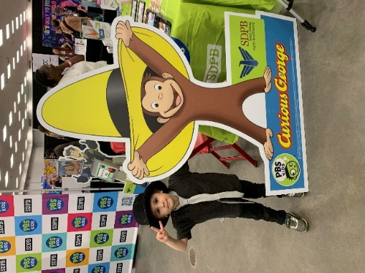SDPB’s photo booth experience was one of many activities at the annual Youth & Family Services (YFS) Kids Fair in April. Over 8200 people attended the event in Rapid City.

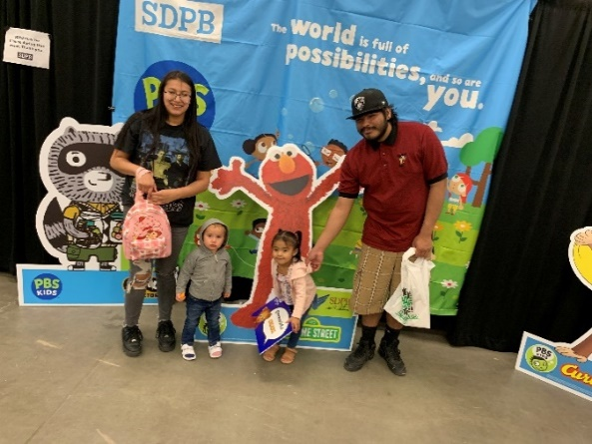

* At the Rapid City Kindergarten Transition Fair in April, SDPB shared resources and information with hundreds of families getting ready to send their children to kindergarten.

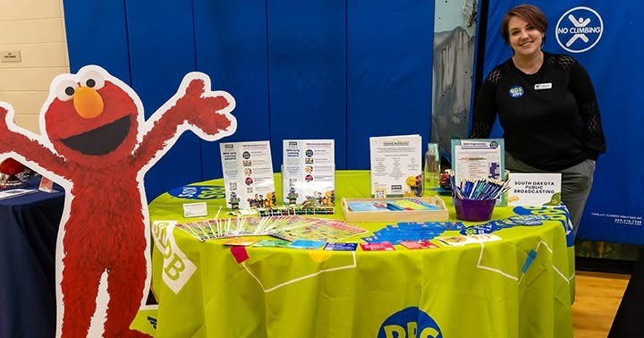

* 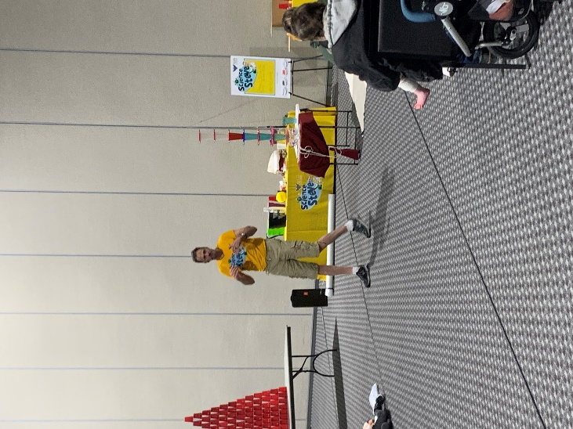SDPB’s Science Steve was a featured presenter at the statewide SD Homeschool Conference in May. Adults and children were in awe of his exciting science demonstrations. After recovering from some health issues, the Science Steve traveling science demonstration show will resume a full schedule this fall. Videos of the demos and teacher resources on how to use them in classrooms are in the planning stages.
* SDPB received a grant from Fred Rogers Productions to support the first-ever Be My Neighbor Day in SD. The events will be held in Rapid City on Saturday, September 20th, and in Aberdeen on Saturday, September 27th, at the local public libraries. These events are an opportunity for SDPB to collaborate with new and existing partners while promoting local volunteerism, family engagement, and community development.  Daniel Tiger will be there, along with SDPB’s mascot, Buddy the Bird, and Science Steve.

**South Dakota Board of Educational Telecommunications**

**Entertainment Report July 2025**

**Brad Van Osdel**

**SDHSAA**

The two basketball weekends in March are the crew's favorite, bringing a massive audience to SDPB. For the Girls' basketball weekend, 101.9k unique viewers, 632.2k views, total watch time of 180.2k hours, and for the Boys’ Basketball weekend, 98.8k unique viewers, 569.3k views, total watch time of 160.5k hours

During March, the entertainment team produced 43 stories, highlights, and blogs for social media. Twenty of those were video packages viewed 889,000 times on Facebook. The Entertainment team produced great stories highlighting retiring coaches, sibling teammates, coaches & their teams' philosophies, student managers with heart, players overcoming challenges, and team mascots. The Entertainment group captured the overall spirit of Basketball in South Dakota during the six basketball tournaments. The most watched video was a story about the Rapid City Central High School Drumline that performed during halftime; this video has been watched 202,000 times. Two other popular videos were the high school mascot identification videos, where we asked students to identify mascots from other high schools across the state these two videos have been viewed 110,000 times We also posted to social media the exciting end to the Girls class A championship game between Sioux Falls Christian and Mahpiya Luta this video has been watched 85,000 times and the last minute win by Bennett County at the girls B semifinal night to make it to the state championship round has been viewed 110,000 times.

May is a big month for SDHSAA events; the Jazz Band and Show Choir started the month, the entertainment team streamed the event to SD.net, and the program was recorded for television and aired later in May. Two tennis championships were held during the week of May 19th, and SDPB was on hand to tell stories, take photos, and post statistics on SDPB’s web page. The Track and Field Championships for all three classes were held at Howard Wood Field, and all three days were streamed to YouTube and SD.net, with the final day also being broadcast live to SDPBTV. These are the totals for YouTube: the first day, 20,000 views; the second day, 25,000 views; and the third day, 25,000 views. This year, the team also added live streams for five of the seven field event locations, which provided a live stream for shot put, high jump, pole vault, long jump, and triple jump for all three classes, boys and girls. These streams were viewed on YouTube 22,000 times during the three-day event. We highlighted the O’Neil sisters from Bennett County, who broke three records in Class B at the state meet. Peyson broke the 100 m hurdle record, her sister Reagan broke the 100 m dash record, and they were part of the Bennett County 4x100 relay that also broke a state record. The video of Reagan’s race has been viewed 237,000 times on Facebook. Kaili Rignstmyer from Pierre broke the Class AA 100 m dash record, and her record-breaking race has been viewed 93,000 times on Facebook. The Colman-Egan girls 4X200 also broke the record at 1:29:91. The video of their race has been viewed 136,000 times on Facebook. We also produced stories highlighting a couple of light-hearted angles of the state meet. We asked athletes, “What would you use instead of a relay baton?” and asked parents, “What does your athlete always forget?” These videos have been viewed 41,000 times on Facebook. We also told a story about the Stiefel sisters from Custer who took 1st, 2nd, and 3rd place in the Class A Girls pole vault. Their father is the Pole Vault coach for Custer and says the pole vault is a family tradition. This story has been viewed on social media 65,000 times.

The SDHSAA season ended with two sporting events in June: The Girls State Softball Tournament and Spring Golf. The live streams of the state softball tournament games were viewed over 28,000 times on YouTube. We also told several stories from the state softball tournament ranging from “what’s your walk-up song” and “game day superstition” to more heartfelt stories about sisters who play on separate teams and a tribute to a player who couldn’t make the tournament because of her commitment to the national guard as well as a clip of a huge walk off win for the Tri-Valley Mustangs. These stories have been viewed on Facebook over 130,000 times. For spring golf, along with results, photos, and blogs, we asked golfers “what their least favorite golf club is”, “who their favorite professional golfer is and why”, “best golf advice for younger golfers”, and a video with some of the best golf swings. These videos have been viewed on Facebook over 28,000 times.

**High School Rodeo**

In June, the Entertainment team traveled to Ft. Pierre for the SD High School Rodeo Finals. Over 620 youth athletes participated in the four-day rodeo. SDPB was on hand to live stream all four days, starting on Wednesday with Cattle Cutting and Reined Cow Horse, and then Thursday and Friday with four prelim rodeos and rounding out the weekend with the short-go championships on Saturday with a live stream and television broadcast. All four days will be archived at <https://watch.sdpb.org/>. The temperature reached over 100 degrees all four days of the high school rodeo. Still, the crew stayed cool-headed and released several stories about the event that have been viewed on Facebook 70,000 times. Over July, we will release videos highlighting the winners of each event.

**Dakota Life**

Dakota Life's April episode traveled to Wessington Springs to capture unique stories of this town where east and west meet in South Dakota. Eighty-five community members of Wessington Springs showed up for the premiere of their episode. Most cities shape the landscape they’re on, but in Wessington Springs, it’s the other way around. We Learn how the people have shaped the town with Rockin’ Ribfest, the legacy of Whiskey Road, the impact of FFA, and the beauty of Shakespeare Gardens. We also ride along with the Kyle Evens Wagon train and event that celebrates the spirit of the west in this small community and the legacy of country singer and South Dakota troubadour Kyle Evens. These stories have been released to social media and have garnered 54,000 views on Facebook since the program's release.

Dakota Life's May episode traveled to Pine Ridge to capture stories of this South Dakota community. Twenty citizens of Pine Ridge showed up for the premiere of their episode. We met interesting folks who were willing to share their stories with SDPB and the Dakota Life Team. We attended the 39th annual Oglala Nation Wacipi, the state's largest celebration. We watched the Toby Classic at the skate park and learned why Pine Ridge is known as a basketball town. Additionally, we visited the Heritage Center to explore Indigenous art from around the world. The episode has been watched over 8,200 times on YouTube, and the stories released on digital have been viewed 40,000 times.

Dakota Life's June episode traveled to Faith, where 40 folks turned out to watch the premiere of their town episode. Stories included in this episode: The 114th annual Faith Stock Show and Rodeo which has been around as long as the town, we visited the Faith Livestock Auction in Mid-October where 10,000 head of cattle move through the sale barn a day, the historic Ice house that is now a museum, meet a flint napper who has been making arrows since he was a boy, and learn the history of the town and its plans for the future. These stories have been viewed 80,000 times on Facebook. After completing the 24/25 season, the team begins recording stories about the seven communities for season 25/26 over the summer.

**Documentaries**

April saw the recording of the Giants in the Earth opera. The opera performed by the South Dakota Symphony Orchestra, based on the novel Giants in the Earth by O.E. Rolvaag, tells the story of Norwegian immigrants who settled in South Dakota and the hardships they faced establishing their homesteads. The Opera was composed by Douglas Moore and won the Pulitzer Prize in 1951. Although it is an award-winning opera, it has only been performed twice, and both times by non-professional university orchestras. This April performance marks the professional debut of this opera and the first performance in over four decades. SDPB was on location to record this historic performance, and the program will be broadcast later this year on SDPB-TV.

**ET Board Report – July 2025**

**J Team – Cara Hetland**

**March Highlights:** The JTeam continued with our coverage of the legislative session, SD Focus looks at short-term rentals and how that growing industry is regulated and the impact it has on tourism.

It’s been six months since we changed our format of In the Moment and we are asking if we have seen any change in listener habits with the change in In the Moment format and adding the 9:00/8:00 am broadcast of the show. There is more to dive into and more analysis/discussion to have but here is a quick look at what we know.



***Webcast streaming***

|  |  |  |  |  |
| --- | --- | --- | --- | --- |
| **Time slot** | **Users** | **Listening hours** | **Session Length** | **Sessions** |
| 8am | 305 | 177 | :34 | 196 |
| 9am | 237 | 137 | :34 | 117 |
| 12pm | 163 | 101 | :37 | 81 |
| 7pm | 76 | 43 | :34 | 31 |

Some Take Aways:

* 9am is now the most trafficked ITMO timeslot
* The 8am timeslot continues to outperform the ITMO timeslots, and this timeslot saw the SMALLEST losses across all measures
* ITMO podcast saw a decrease in downloads of –5.6%, and a decrease in users of -19%. However, the entire SDPB catalog saw respective decreases of –26.2% and –43%.
* Month on Month, ITMO has been outperforming the station average in download rate at –1.4% against –5.5% since Sep 1.
* A large portion of the overall user and download numbers for the pre-change window were driven by traffic for “Short Walk"
* ITMO pages have seen a substantial increase in performance on SDPB.org since Sep 1, with most metrics returning over 30% increases and MoM growth of 10-20%.
* While podcasts performance for ITMO is down, overall SDPB podcast performance is also on a downward trend, and ITMO podcasts have faired better than the station average with overall changes <10% across averaged metrics
* In terms of live webcasts, ITMO timeslots have seen a slightly more prominent loss of audience than the SDPB station average, though it is a small difference averaging <5%.

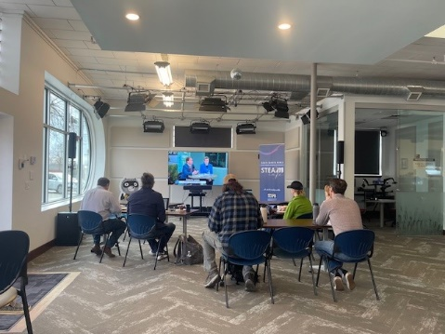SDPB Sioux Falls and Rapid City were host to the latest training for Journalists in the state. The topic is covering federal courts. Our partnership with SDNewsWatch, the Bar Foundation, and Friends of SDPB were key in putting this together. Fifty people signed up to have access to the training. About 35 people were present in both studios and online. Judges Lange and Schrier appreciated having the opportunity to talk directly to journalists about how to tell the stories that come from their courtroom. Training is an ongoing twice a year series. We have looked at covering state courts, open government, and now federal courts. The next training is set for October 10.

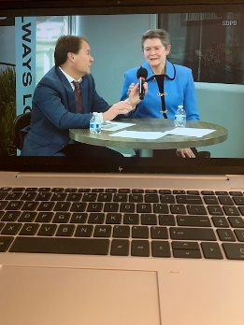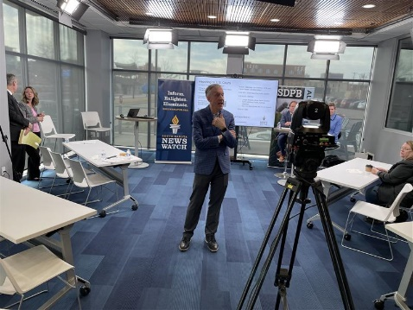

View from Rapid City View from Sioux Falls View from sd.net

**April Highlights:** This month the JTeam focused on impact that passed legislation will have in South Dakota. Intern Jackson Dircks broke the story of the CEO of the company behind a proposed billion-dollar corn-based jet fuel plant near Lake Preston saying the project won't go forward in South Dakota without a carbon sequestration pipeline. He also broke the story about an alleged check-kiting scheme with a Canadian owned swine operator. South Dakota Focus looked at infrastructure supporting tourism in the state. In the Moment went on the road to Brookings to learn about a new major in the engineering department focusing on medical innovation.

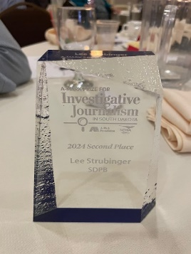SDPB aired the 100th Legislative Session Celebration on Saturday, April 12, on SDPB TV. Staff from engineering, Entertainment Group, and JTeam made the special live broadcast happen. Thanks to a great team effort serving our mission. The In the Moment Team conducted a series of interviews to set up the Giants in the Earth SDSO opera production. We aired two hours of conversations leading up to the performance. This will be made into a half hour television program to air prior to the production of the opera that will air this fall.

Congratulations to Lee Strubinger winning second place for his podcast Short Walk in the SDNA A-Mark Prize for Investigative Journalism in South Dakota. This came with a cash prize for both Lee and SDPB.

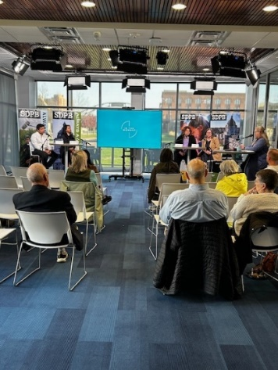**May Highlights:** In the Moment had a live recording of a panel discussion on May 2 about Alzheimer research and care as part of our Independent Lens series of screening events. About 20 people attended the recording in the Sioux Falls studio.

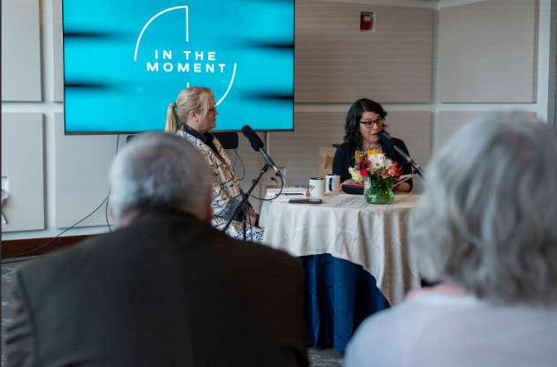Lori Walsh kicked of the humanities council’s one book author tour with a conversation in Rapid City May 4. About 80 people attended the discussion and book signing.

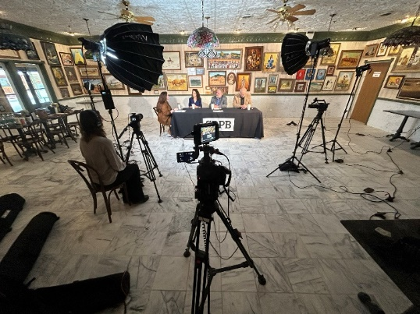SD Focus final program of the season looked at staffing for the upcoming tourism season. The roundtable discussion was recorded at Wall Drug and featured guests representing Wall Drug, Badlands and Mt. Rushmore.

**June Highlights:** June has been about staff taking vacations, planning for fall events, covering the Project Prison Reset task force, and looking at emergency care in rural areas for the next season of SD Focus.

In the Moment took several road trips to Mitchell to highlight the community following our new signal going on the air. They featured an interview with the mayor, civil conversations at the McGovern Center, and DWU History Professor Sean Flynn previews his new book about former US Senator Karl Mundt and the cold war and soft power.

**Staffing Changes:**

We said goodbye to two key staffers this month – Politics and Public Policy Reporter Lee Strubinger’s last day was June 13. Lee left SDPB after nine years of award-winning reporting. Lee won two national Edward R Murrow awards during his tenure.

Morning Edition Host Krystal Miga’s last day was July 1. Krystal has been a friendly voice guiding us through news of the day for three years.

We were able to offer or intern Jackson Dircks a full-time reporting position – he started June 24 after a year of his internship. Jackson graduated from Augustana University in May.

Search for a new morning host has begun – CJ Keene, Jackson Dircks, and Cara Hetland will rotate hosting duties in the interim. Lee’s position will remain open.