South Dakota Board of Directors for Educational Telecommunications
Director of Media Content Report
June 2020

Strategic Plan Goals:
SDPB Media initiatives; Special Projects; Content Division Strategies:

SDPB Media Initiatives:

* Coronavirus has dominated our Journalism and Entertainment groups coverage since early March. Both teams have been operating in a more complex work-from-home, video conference world while adding to their work and distribution load. In this serious situation, audiences seek reliable information because they want to know if they could die… but as time has goes on, they want to know how they are going to live and enjoy life. SDPB does both of topics very well. Journalism has added news casts, specials reports, and digital updates; Entertainment has added digital features, digital programs, and is working with iconic events and venues to have a presence even though they have canceled their seasons. SDPB efforts have been recognized by increased audiences and membership support. While there are a variety of reasons for the positive impact, the primary reason is SDPB Staff is professional, dedicated, and has risen to the occasion to serve South Dakotans.

* The SDHSAA season ended prematurely, but during the uncertainty of Spring Activities, SDPB was awarded a new contract for partnership with SDHSAA thru Spring 2025.

Special Projects: All platforms contributing to local media production and outreach

* “Election 2020”
* “The Vote,” observing the centenary of American Women Suffrage.
* “Unladylike 2020” National/Local content celebrating little-known American heroines
* “Rural Connections – The Middle of Everywhere” SDPB Documentary Sept 2020
* “Blood Sugar Rising” local content and outreach postponed to 11/2020
* “SDPB Early Learners Initiative”
* “CPB Coming Home” project Audience survey followed by content production
* “ELI” Early Learners Initiative
* “Beat” Underwriting
Content Division Strategies

* SDPB Journalism: Jackie Hendry “Healthcare and Education”; Lee Strubinger “Politics and Public Policy”; Seth Tupper “Business and Economic Development”; Richard Two Bulls “Diversity”; Cara Hetland and Kent Osborne “Technology and Innovation”
* SDPB Entertainment: Nate Wek “Sports and Recreation”; Brian Gevik “History and Rural Life”; Melissa Sievers “Rural Life”; Kevin Patton “Music and Cultural”; Chynna Lockett “Arts and Cultural”

* Entertainment Group “Dakota Life Digital Edition” and “The Creative: Arts and Cultural Digital Magazine”

* Other: Sound Vision 2.0: Programming and Endowment.

This is an example of how the Journalism and Entertainment groups work across platforms to provide comprehensive coverage of special events or an on-going issue.

2020 Statehouse Content Coverage Plan

Mission of our coverage: To inform and educate the public about policies and laws that impact their daily lives.

LIVE Coverage:
• SDPB will provide live gavel to gavel coverage of every committee and floor sessions throughout the legislative session on SD.Net.
• SDPB TV and Radio provides live and/or feature coverage of the Governor’s Budget Address, State of the State Address, and all other major presentations to the legislature.
• SDPB TV2 will air the daily House session live and Senate delayed following the adjournment of the House, and live coverage of end of week press conferences

Daily Coverage:
• Daily Newscast – coverage of daily committees and house and senate
• In the Moment – Daily conversations with lawmakers, cabinet department heads, committee chairs, and the people impacted by issues discussed in Pierre
• SD Focus – topics during legislative session will focus on issues being discussed.
• Daily Digital pull – Video and soundbite for TV Broadcast and social media
• Statehouse Podcast – Summary of all stories and conversations produced daily
• Online: Each Legislative day SDPB highlights a story of the day. Find us online:
Facebook: @SDPBNews
Twitter: @SDPBNews #Budget2021 #statehouse #sdleg

South Dakota Board of Educational Telecommunications
SDPB Television
June 2020
Programming

TV Viewership in March:

SDPB Television viewership is measured in the Sioux Falls and Rapid City markets. Sioux Falls ranks #113 out of 210 by market size with 229,420 TV households and 0.214 % of the US population. Rapid City ranks #169 out of 210 US markets with 86,610 TV households and 0.081% of the US population. Measurement is done by a combination of Nielsen encoders in the homes of a random sample of each market and return path data from program providers such as satellite providers and cable systems.

This year’s March measurement period ran from February 27th the March 25th.

Our March Nielsen ratings show that 427,790 individual viewers, tuned in to SDPB’s four channel during the month. 68.4% of TV households across both markets tuned to SDPB’s main channel.

Most watched programs in March 2020
1. High School Girls B Tournament first round 8:45pm 18,280 viewers
2. High School Girls B Tournament first round 7:00pm 16,860 viewers
3. High School Wrestling Championships 14,310 viewers
4. High School Girls B Tournament first round 2:45pm 8,940 viewers
5. America’s Test Kitchen 8,310 viewers
6. Ken Burns Country Music 8,230 viewers
7. Antiques Roadshow (average) 5,840 viewers
8. Shakespeare and Hathaway (Saturday) 5,700 viewers
9. High School Girls B Tournament first round 1:00pm 5,320 viewers
10. John Denver Country Boy 4,100 viewers

Radio Listenership in April
SDPB Radio listenership is measured via online live streaming numbers with no over-the-air measurement available. In April, our streaming audience saw 60,519 total listening hours and 12,176 cumulative streaming audience SDPB Radio listenership is measured via online live streaming numbers with no over-the-air measurement available.

Social Media and web stats
Social Media video views for April 361,989
Total Social Media reach 1,450,606
SDPB.org had 192,167 active users in April, up from 65,829 last year
SDPB Total page views for April, 461,411.

Changes
As Pandemic regulations were instituted in early March, SDPB shifted focus in several ways.

For example, while our live broadcast crews were in the middle of broadcasting the Girls B basketball tournament, that tournament and all subsequent high school activities were cancelled through the rest of the school year. We went from having 72 tournament games in the schedule to having only four. Nonetheless, the four tournament games we were able to broadcast represented the top-rated broadcasts for the month.
We quickly adapted our schedule as best we could, creating a Classic Sports series featuring some of the best high school basketball and football broadcasts from our archives, along with re-airings of our historical sports documentaries.

On March 23rd, we began providing live television and radio broadcasts of the Governor’s press updates, which continue daily.

A weekly Radio special, What You Need to Know about Covid 19 from NPR began in late March and continues weekly at 9am central time.

Because schools shut down, we responded with a new Learner’s Connection block of programming to serve at home students from grades 6 through 12. This consists of a daily special broadcast of both national and local, South Dakota focused learning material, along with a full slate of educational materials, student discussion guides, and additional learning materials. This block supplements our SDPB Kids channel which features educational material for preschoolers, and our main channel PBS kids programming which features programs geared toward elementary students.

In order to provide timely news and information, we expanded the South Dakota Focus season, which would ordinarily end in May, through June and added 1 episode per month in the Dakota Life timeslot on Thursday nights.

Because of the shutdown, we were challenged with keeping our Dakota Life series going when we could not send crews out to produce stories. The show concept was quickly adapted to digital form, featuring arts and cultural stories and performances online and using digital technology. Our staff also creates numerous arts and culture-related video and blog segments to be shared via social media and on our website. These include content repurposed from our television projects, as well as original digital content created specifically for social media which will appear in our on-air product throughout the year.

The Journalism content group began producing nightly 2-minutes news updates that follow the PBS Newshour on SDPB Television each weeknight.

The On Call with the Prairie Doc series features three new hosts following the death of the show’s originator and host Dr. Rick Holm. They continue to create new shows each week providing medical information.

Fundraising
The SDPB Radio spring on-air fundraising drive was held May 18-23rd. A total of over $49,000 was raised from 196 donors.

Our annual March on-air membership drive ran February 29th through March 15th. We raised a total of $71,026 from 386 pledges and gained 128 sustaining members. Our best performing programs included Suze Orman’s Ultimate Retirement Guide, Feel Better Fast, Memory Rescue and My Music: The Best of 50’s Pop.

Our next full drive will be May 30 through June 7th with an additional Downton Abbey marathon on SDPB 3 running through June 23rd.

SD Board of Directors for Educational Telecommunications
SDPB Journalism Team Report – Cara Hetland
June 11, 2020

Journalism Content:
I’d love to tell you we were following our road map of focusing on one topic across all platforms each month. It was a great plan with our legislative coverage taking up January and February. All content producers are involved. We showcased generosity in November, faith in December and were moving toward diabetes in April. Then Covid-19 hit – the pandemic that transformed our journalism team and coverage in such profound ways.

We had a multi-phase plan prepared prior to the first positive case in South Dakota. The staff knew what to expect and were well prepared to execute it. We began distancing all staff in each studio and keeping all guests out of the buildings. Eventually we have transitioned to several people working from home.

We have twice daily check in meetings with the In the Moment crew and a daily check in with all J-team content producers. All three daily meetings are open to any staff for input and ideas. In the Moment really took the lead in the coverage and all newscast material comes from the daily interviews.

SD Focus went to weekly programs and really looked into a topic a week dealing with the pandemic. Stephanie did a great job adapting to recording interviews and having guests on virtually. We will continue this weekly through June and will take July and August off to regroup for the next season. Governor Noem was on for an hour in April, in one day we received more than 2,000 questions and comments from listeners.

I can’t even begin to count the number of stories and conversations and interviews we have produced around the pandemic. Everything is archived at sdpb.org/covid. Kudos to Heather Benson and her assistance in getting transcripts of interviews posted online and creating a one stop shop for all of our related content.

During the legislative coverage we added a two-minute news update to SDPBTV. It airs at 6:58 pm and when the pandemic hit, we continued to produce these short updates. We have decided to continue to provide these local news headlines each weeknight.

Josh Haiar and John Nguyen have created a daily news podcast. Again, what began as a statehouse update podcast has turned into a daily podcast that will continue. The number of daily news podcast
subscribers has doubled in the last 30 days. Of the 288 listeners of SDPB News on Spotify, 68% are 23-27

Josh is also working on weekly best of podcasts of news and arts conversations from In the Moment. We have learned that a video conversation with two Augustana professors about faith has become required viewing for students. The news twitter feed has received 1000 new followers since March.
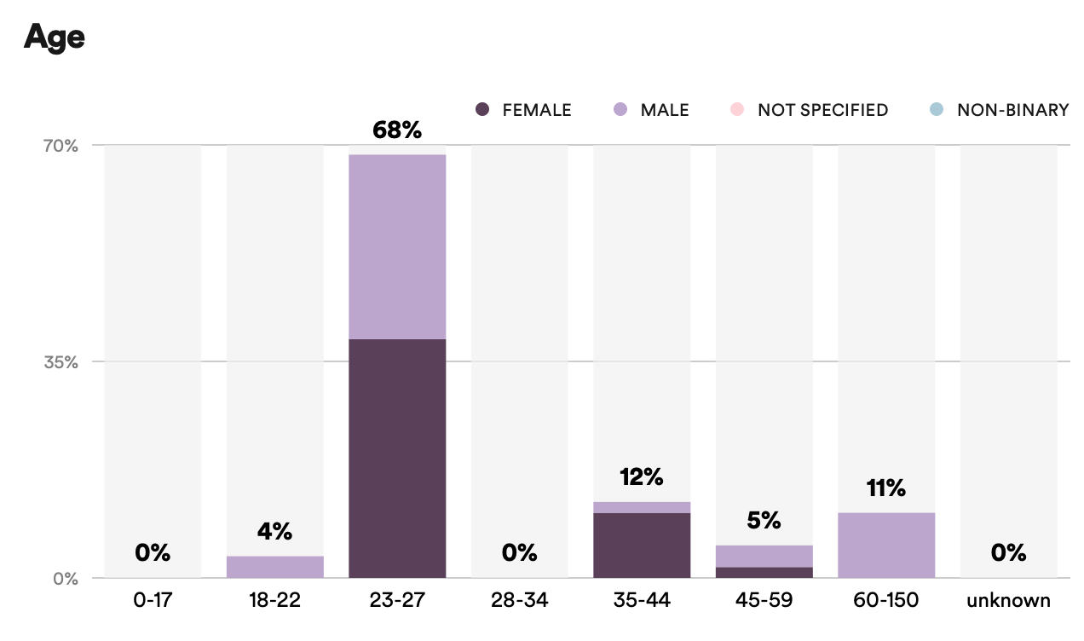
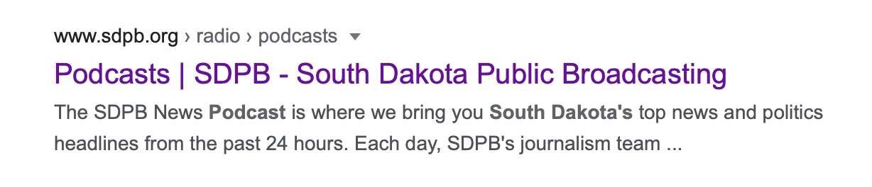

This team effort is really taking root and moving to other projects. As we talk in our virtual meetings and use the Teams technology we are collaborating more and more. Our food supply project that aired the first week in June is an example of multiple people across the network shaping the coverage. I am confident this is our new normal and more great work ahead.
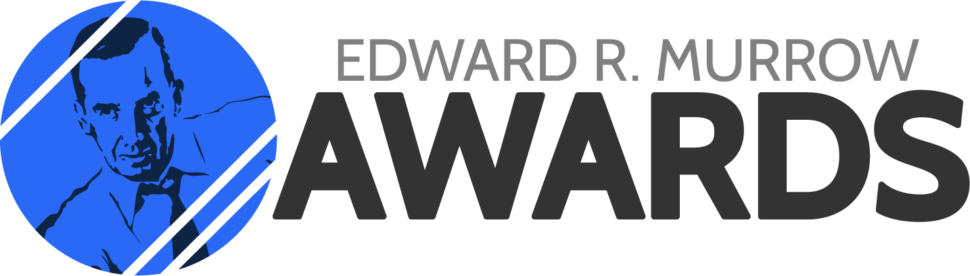
Team SDPB was awarded 5 Regional Edward R. Murrow awards for our reporting in 2019. Region Four is comprised of stations in Minnesota, North Dakota, South Dakota and Wisconsin. This year’s winners are:

Writing – Victoria Wicks and her coverage of the Stanley Weber trial
Feature – Jackie Hendry and her story called A Teacher, a Patient, a Donor: Body Donation Drives Medical Education
Investigative – Lee Strubinger and his work State Groups Want Clarity on CBD Legality Following Arrest in Sioux Falls
Multi-media – our flood coverage – all the spark pages (kudos to Brad Van Osdel and Heather Benson)
News Documentary – Lee Strubinger and Andrew Bork for their work on the Buddy Red Bow documentary.

Staffing:

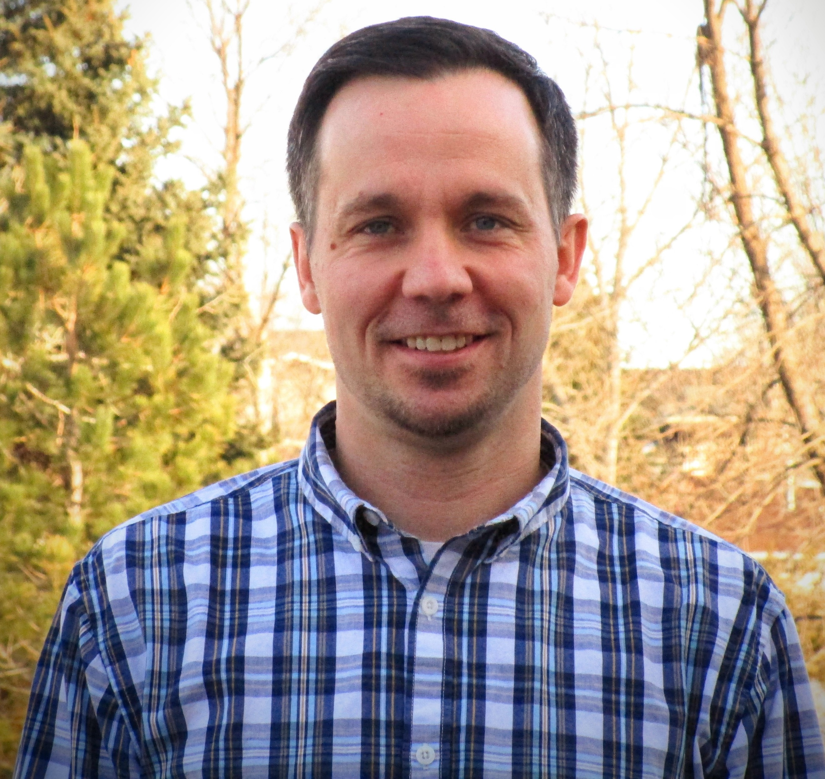
In January we welcomed Seth Tupper as SDPB’s new Business and Economic Development Reporter. Seth is based at our Black Hills Studio in Rapid City. He was raised in Wessington Springs and Kimball and graduated from Kimball High School. Seth earned his bachelor’s degree in journalism from South Dakota State University. He most recently reported for the Rapid City Journal, where he spent five years covering politics, Black Hills-based natural-resource management, county government and numerous other topics. Prior to his tenure at the Journal, Seth worked for The Daily Republic in Mitchell and The Daily Globe in Worthington, MN. He wrote the 2017 book Calvin Coolidge in the Black Hills (Arcadia Publishing), about the president’s eventful three-month stay in 1927.

In March, we said goodbye to videographer and producer Andrew Bork. He left us to produce video for the city of Sioux Falls. In April, we said hello to Jordyn Henderson as a multi-media content producer. Jordyn graduated from Brandon Valley High School. He went on to play soccer for Florida Southern College where he earned his degree in Communication, Sports Communication and Marketing. He spent two years at WINK News in Fort Myers, Florida where he shot and edited video packages and worked on the morning show. He moved back to South Dakota with a May (now July) wedding planned.

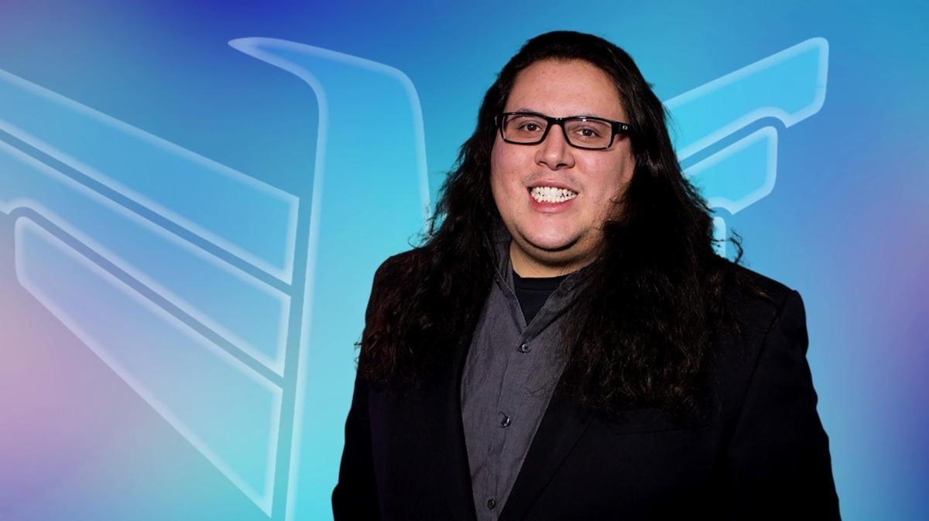
June 1, we welcome Richard Two Bulls to the SDPB team. Richard joins us as our Diversity Beat reporter. He comes to us in our partnership with Report for America. Richard formerly worked for KOTA and now KEVN in Rapid City as a reporter and chief photographer. He is an enrolled member of the Oglala Sioux Tribe. Richard is based in our Black Hills Studio.

SDPB J-Team has three summer interns. USD student Nicholas Nelson will work in Vermillion, Augustana University student Beau Bordewyk will work in Sioux Falls, and BHSU student David Scott will work in Rapid City.

We have also brought on Lura Roti, Tom Hanson and Brenda Wade Schmidt as Freelance Content Producers.

Board of Directors of Educational Telecommunications
SDPB Entertainment Team Report – Brad Van Osdel
June 11, 2020

Dakota Life has continued to tell the stories of interesting people and places from across South Dakota. The approach to telling these stories has changed with the creation of Dakota Life Virtual and the Dakota Life Digital Edition. Dakota Life Virtual brings museums, musicians and other South Dakotans’ stories to our audience by using technology like zoom to tour their location, perform music or demonstrate what their organizations have to offer.

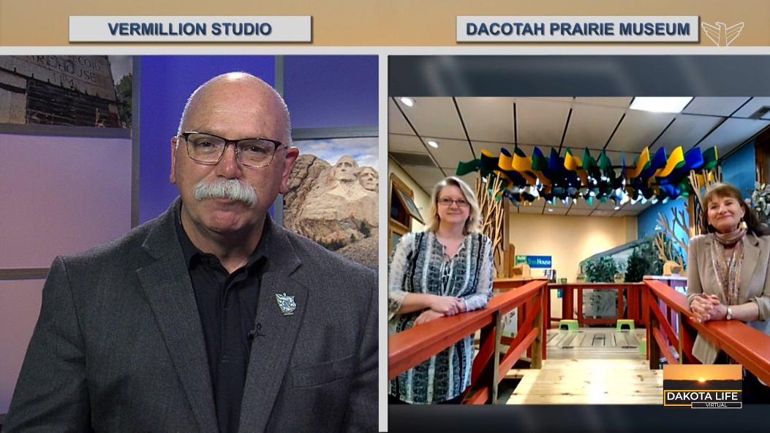
Dakota Life Virtual Host Larry Rohrer
The Dakota Life Digital Edition brings the best of the stories produced each week on all of our platforms about arts, culture, history and rural South Dakota into one easy digital presentation that is shared on social media, SDPB website and emailed to our audiences.
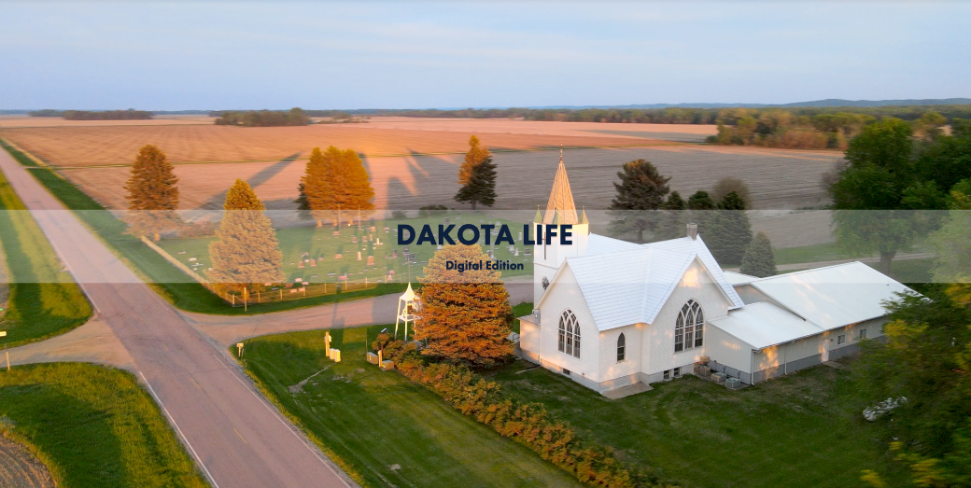
Dakota Life Digital Edition
Production for the fall premiere of Dakota Life will begin in July and August as crews travel the state producing stories for the television program and digital content for social media and our web page.
In Play continues to highlight South Dakota Athletes from all different areas of high school sports and we have adapted the format to individual conversations with students on their future in athletics and how they have adapted to the spring season being cancelled and how they continue their athletics careers in the future.
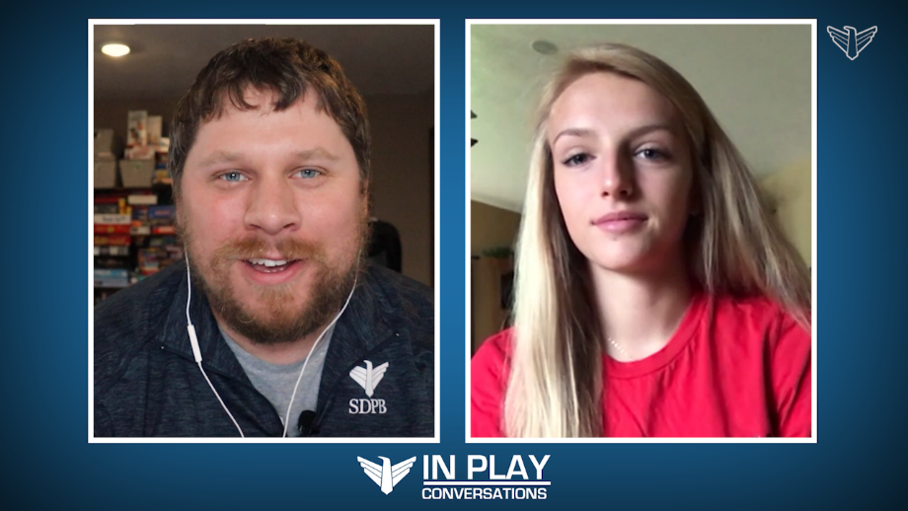
In Play conversations Producer Nate Wek

The Summer of 2020 has been dubbed the year of the garden; we developed a series for digital called South Dakota Home Garden. Erik Helland of Landscape Garden Center provides the expertise in gardening and Kyle Mork produces and distributes the video to the appropriate platform. Each week a topic about gardening is produced into a video for social media, SDPB web page and highlighted on Wednesday’s episode of In the Moment.

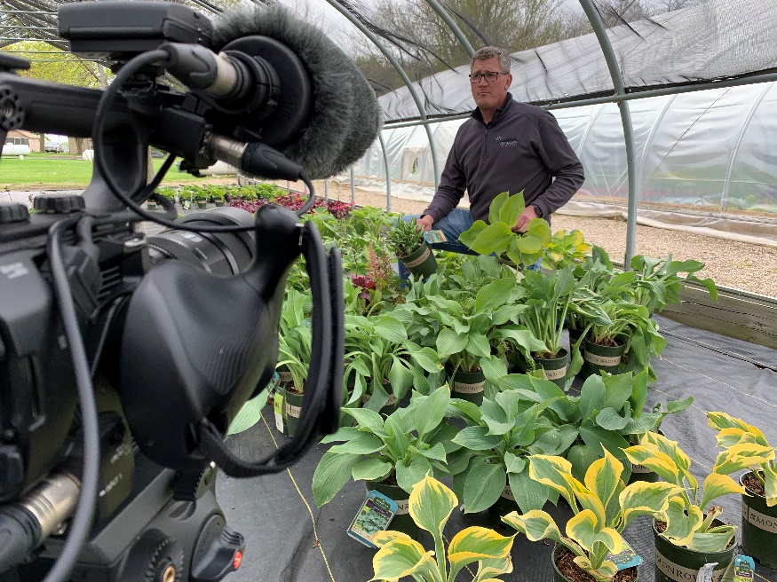
South Dakota Home Garden Host Erik Helland

The Middle of Everywhere: Connecting Rural South Dakota - this documentary highlights the journey South Dakotans have taken in connection with each other and what the future holds for technology and South Dakota. The documentary will air this Fall on SDPB with digital content being delivered to our website and social media all summer leading up to the premiere.

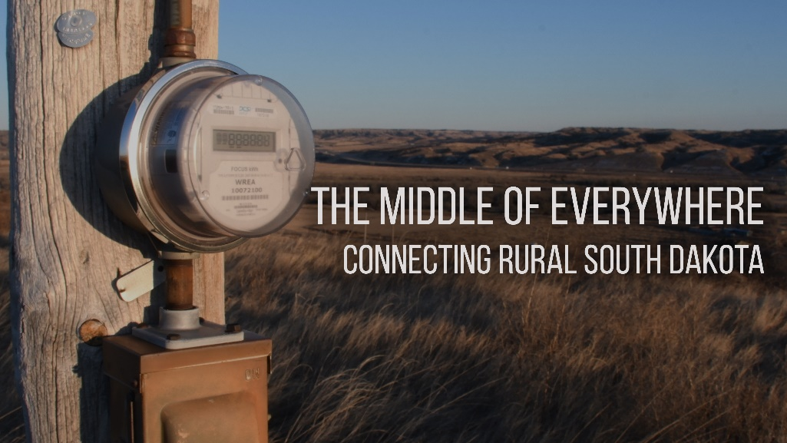

SDPB’s coverage of High School Sports and Fine Arts will continue this Fall. Leading off this coverage will be a production of state High School Rodeo recorded in June in Ft. Pierre with a broadcast in July.

Board of Directors of Educational Telecommunications
SDPB Marketing Report
June 11, 2020

Marketing –

Prehistoric Road Trip – With events from April postponed then subsequently canceled in June we found a new way to present screeners for this program. We scheduled a live event at a drive-in movie theater where attendees will be able to watch the screening from the safety of their car. It’s June 9 at Roy’s Black Hills Twin Drive In in Hermosa. The next evening, we present a live, in-studio virtual screening for everyone across the state. The series, featuring Rapid City native Emily Graslie visiting paleontologically significant sites in South Dakota and surrounding states, airs June 17, 24 & July 1 on SDPB and nationally on PBS.
The Vote – SDPB obtained a grant from WGBH to create content in association with American Experience: The Vote. The program recognizes the history of the Women’s Suffrage movement. SDPB is producing a series of interviews on In The Moment, a documentary – “Simple Justice” – along with digital shorts to be shared on social media and the web.
Blood Sugar Rising – Screening associated with this project are cancelled. We are planning a series of on-air conversations and digital shorts about Diabetes in November during International Diabetes Awareness Month. Fortunately, we were able to retain 75% of the funds granted to us to see this project through.
Coming Home: South Dakota – this project, with funding by CPB, is back on track and after being placed on hold for two months. Materials and surveys are being prepared. We are shifting gears to identify new methods of obtaining information from one-on-one interviews and focus groups.
Unladylike 2020 – We are reviewing our opportunities with this project, since face-to-face screenings won’t happen. We’re working with the program producers, Red Cloud Indian School & Heritage Center, Oglala Lakota College, SD Humanities Council and others to arrange a virtual screening and discussion about Zitkála-Šá. The screening will likely happen in September 2020.

Education & Outreach –

At-home Learning – With schools going virtual and desire for at-home learning resources at an all-time high, Steven Rokusek and Kevin Nelson have been hard at it making resources available and helping educators, home-schoolers, daycare providers and parents understand where to access and how to utilize our materials.
Early Learning Initiative – Beginning April 1 we launched ELI – the SDPB Early Learning Initiative. Kevin has sent daily ELI emails to hundreds of subscribers with lessons parents and others can incorporate into their child’s life. These lessons are tied to pre-K programming available on SDPB1-TV and SDPB4-TV.
SDPB Learners Connection – Also on April 1 we began airing a mix of national and local shows during a learning block on SDPB2-World Channel. We support that programming by making resources available to parents, teachers and others via the SDPB LearnersConnection newsletter and website.
PBS LearningMedia - This site is a collection of lessons on a wide array of topics that meet national and state educational standards. Think of it as “PBS Passport for Teachers.” Teachers and other users can access this free service that includes content that SDPB has created, and content created by PBS stations nationwide. Not surprisingly, we have seen a significant increase in use of SDPB-created resources available on the PBS LearningMedia site. In February there were 12,137 users who accessed SDPB content. In March that number grew to 31,171. In April we hit 62,794. These numbers represent users nationwide who have accessed content that SDPB created and made available via PBS LearningMedia.
SDPB Education Newsletters – We have 2,887 South Dakota educators who receive the monthly SDPB Educators Newsletter that Steven Rokusek distributes.

Educational Outreach – Prior to the pandemic, Steven Rokusek visited numerous locations presenting his “Science Steve” curriculum – schools in Spearfish, Herreid and Groton – about 750 students in all. Approximately 400 people attended an event at Aberdeen’s Dacotah Prairie Museum, which was a record setting attendance for the museum. SDPB presented at the Math and Science Conference in Huron and co-presented a session with the Sanford Research Facility. No outreach events are scheduled for the foreseeable future.

Social Media continues to grow. The chart below shows results we have experienced for the past two calendar years. Of particular note are the results in February and March this year. Due to a combination of Wrestling coverage and interest in content produced about Coronavirus, we saw a large uptick in reach and video views.

 | Reach | Video Views | Engagement | Total Followers
Apr-18 | 2,070,433 | 470,286 | 100,886 | 88,517
May-18 | 1,434,972 | 452,063 | 101,694 | 89,996
June-18 | 1,071,392 | 257,631 | 62,725 | 91,047
July-18 | 1,254,199 | 394,475 | 77, 906 | 92,293
Aug-18 | 1,188,347 | 287,116 | 64,538 | 93,208
Sept-18 | 1,100,051 | 320,458 | 71,226 | 94,219
Oct-18 | 1,577,034 | 338,082 | 89,758 | 95,694
Nov-18 | 1,709,078 | 312,220 | 76,723 | 97,060
Dec-18 | 1,150,076 | 326,777 | 74,318 | 98,255
Jan-19 | 1,816,748 | 529,368 | 101,444 | 99,202
Feb-19 | 2,103,831 | 558,555 | 122,229 | 100,738
Mar-19 | 3,056,218 | 667,389 | 188,337 | 102,953
Apr-19 | 1,161,827 | 263,455 | 71,390 | 103,995
May-19 | 2,012,852 | 575,691 | 111,076 | 105,385
June-19 | 1,468,889 | 410,952 | 90,824 | 105,637
July-19 | 1,087,014 | 314,809 | 61,848 | 106,478
Aug-19 | 1,111,006 | 271,178 | 72,563 | 107,572
Sept-19 | 1,320,607 | 359,951 | 101,823 | 110,430
Oct-19 | 1,680,617 | 345,853 | 108,361 | 111,795
Nov-19 | 2,834,836 | 705,070 | 165,673 | 113,969
Dec-19 | 1,424,057 | 389,417 | 94,561 | 114,912
Jan-20 | 1,508,649 | 423,847 | 105,694 | 116448
Feb-20 | 2,670,171 | 826,948 | 204,937 | 118,326
Mar-20 | 3,144,057 | 858,916 | 242,471 | 122,601
Apr-20 | 1,450,606 | 361,989 | 102,489 | 124,639

Due to the Coronavirus outbreak, many in-person events have been canceled or postponed.

Educational Telecommunications Board Report
South Dakota Public Broadcasting Engineering, Digital, and Operations
Submitted by SeVern Ashes
June 11, 2020
SDPB Digital
If there were doubts about the mission and purpose of SD.net, the past 3 months of COVID-19 quarantine have shown the flexibility and need for the public service. After the legislative session the platform normally switches from a public information service to one of entertainment, wrapping up the spring sports seasons of basketball and track. Spring of 2020 is significantly different.

Normally around 80,000 unique viewers watch basketball tournament coverage online.
Legislative coverage and COVID-19 press briefings by the Governor more than replaced the lost basketball viewers. That trend continued into April and May increasing SD.net viewership tenfold over previous years.
In response to a need to move away from physical board meetings, plans were made to expand SD.net streaming service to users of popular conferencing software such as Zoom and Microsoft Teams. SDPB has increased its ability to dial-in to public meetings, being held more and more telephonically. Ten channels of streaming have been rolled out to the Unified Judicial System to allow them to stream court proceedings live to the internet from the web conferencing Zoom. An additional 30 channels have been provisioned for Boards and Commissions going forward. There are significant hurdles to integrating this new platform into our current SD.net system and work is ongoing.
Network Operations, Studio and Field Engineering
These divisions of SDPB technologies division were deemed critical essential staff that were needed to continue their 24/7 duties in support of the entire SDPB network. Their work continued as usual behind the scenes staffing NOC, Studio and Field Engineering taking on call 24/7; and just like the mailman, they go out when called day or night in all adverse weather to keep our network available to our public throughout the state. This staff's professional dedication is why our network continues to be available in a 4 to 5- 9 uptime environment 99.999%.
COVID-19 Pandemic Response-Chad Sharkey, our field engineer based out of Pierre, has shifted his efforts to include assisting with Governor Noem and the Department of Health daily press conferences; as well as supporting various Boards and Commissions with the shift for public meetings into a remote teleconferencing or zoom environment in a way to allow live streaming to the public on SD.net.

Looking ahead--
New HD FM Transmitters for KZSD 102.5 MHz Long Valley/ Martin and KPSD 97.1 MHZ. Faith /Eagle Butte. Equipment is on site and will be installed throughout the summer. With the new transmitters IBOC aka HD-1 and HD-2 Classical 24 will be available in these areas with this newly acquired HD license for our Lowry FM 91.9 MHz station. By the end of summer every full powered FM station within the SDPB-FM network will have HD radio available to the public. (Note: FM Low power translator stations will remain analog main channel programing only)

Datacasting: Active discussions with SpectraRep on providing datacasting within our television signal. Traditionally datacasting has been used within the public safety industry. However, South Carolina has partnered with SpectraRep and the SC Department of Education to use the ETV signal to imbed educational material within the TV signal that is then delivered to students that had limited to no Internet access. This is done through an asynchronous “one way” download into a remote device like a laptop, Chromebook type devise. More to come…

Looking ahead to Fall SDHSAA sports and Statehouse coverage.

