Digital Department Strategic Goal Update 07/01/2023

Goal: SDPB will grow its audience across all content platforms

Objective: We will grow our digital audience by 25 percent in two years

SDPB has made considerable headway on this objective in a number of areas.

Sports Live Digital Coverage: Starting in Fall of 2022, SDPB expanded live coverage of SDHSAA championship events from television and the SDPB website to also provide streaming on YouTube. This has allowed us to see large gains in overall viewership of these events.

To date, we have had an overall 81% increase in digital live viewership over the previous SDHSAA season.

Sport | 2022-23 | 2021-22 | Percent Increase
Football | 100,507 | 48,588 | 106
Volleyball | 127,994 | 76,065 | 68
Gymnastics | 18,852 | 4,252 | 343
Wrestling | 430,003 | 297,710 | 44
Basketball | 637,923 | 311,701 | 105
Track | 70,177 | 29,085 | 141
Total | 1,385,456 | 767,401 | 81

Strategic changes in staffing and digital content production during SDHSAA Championship events has also seen large gains in social media video viewership. To date, content produced during the biggest month of coverage has seen an increase of 167% in total social media video views.

Month | 2022-23 | 2021-22 | Percent Increase
November | 821,839 | 486,999 | 69
February | 925,804 | 186,508 | 396
March | 960,428 | 341,227 | 181
 | 2,708,071 | 1,014,734 | 167

YouTube:
Actions taken by both Entertainment and Journalism teams to create more total content as well as more varied content (YouTube shorts, etc) has directly correlated to growth on that platform:

Year | Views | Subscribers
2022 | 2,722,486 | 27,375
2023 | 3,160,475 | 34,483
% Increase | 16 | 26

Overall Social Media presents a more difficult picture to compare. Not only are they, as always, highly susceptible to skewed numbers from one or two highly viral posts, in the past year, the individual platforms changed the way they calculate reach making year over year comparison of that statistic nearly useless. In addition, staffing changes and content initiatives had significant impact during the first 3 quarters of FY23 on type and total content available.

And so we take a look at what might be our closest “apples to apples”—average engagement and video views per post in the final quarter of FY23 vs FY22.

SDPB Sports | Average Views per Video | Average Engagement Per Post
4th Q FY 2022 | 1,637 | 395
4th Q FY 2023 | 6,063 | 479
Percent Increase | 270 | 21
SDPB Main Page
4th Q FY 2022 | 2,052 | 198
4th Q FY 2023 | 2,909 | 266
Percent Increase | 41 | 34

Journalism Podcasts: As SDPB continues to refine its podcasting strategy and digital deployment, it has seen solid audience growth in both its core journalism podcast offerings in a year over year comparison. These numbers are actual below true value as we await NPR’s resolution to their error of underreported data collection on our SDPB News podcast.

Year | Total Users | Total Downloads | ITMO Users | ITMO Downloads
2022 | 69,678 | 153,967 | 8,054 | 17,678
2023 | 79,216 | 160,598 | 8,192 | 18,837
Percent Increase | 13.7 | 4.3 | 1.7 | 6.6

PBS Kids Livestream
PBS Kids | Users | Streams
2023 | 462,866 | 9,144,043
2022 | 458,045 | 10,327,778
% Change | 1.1 | -11

Digital TV Streams
Year | Streams | Users
2023 | 592,871 | 332,236
2022 | 546,752 | 319,588
% Increase | 8.5 | 4

Objective: We will grow new audiences by 25 percent in three years

Deploying our Live Sports via YouTube as well as improving organization and deployment of produced video content on YouTube has also helped us meet the objective of finding new audiences, specifically a younger demographic. In 2022, we had 0 active subscribers watching in the under 24 age bracket. In 2023, we had 18.3% of our active subscribers were under age 24.

YouTube Viewer Demographics 1st Q 2022 vs 1st Q 2023:
 | 1st Q 2022 | 1st Q 2023
New Subscribers | 1300 | 2200
% Active Subscribers Age 13-17 | 0 | 2.6
% Active Subscribers Age 18-24 | 0 | 15.7

Instagram Audience Demographics:
Similarly, as we have begun creating and deploying vertical video aimed for the Instagram Reels audience, we have seen gains in a younger demographic than our traditional social platforms.
On the SDPB Main Accounts, Followers under age 25 are 24.2% of the total on Instagram vs 13.8% on Facebook.
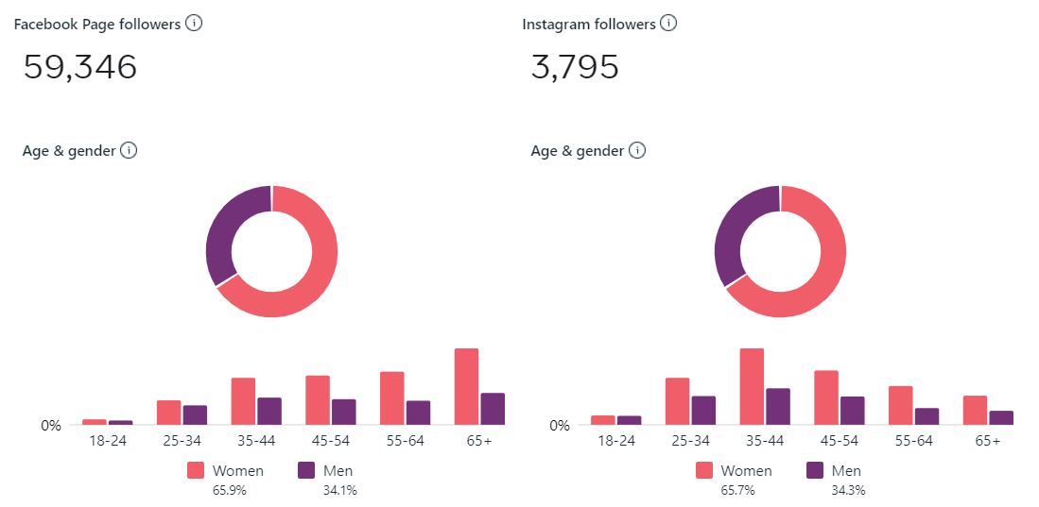
On the SDPB Sports Accounts, Followers under age 25 are 42.3% of the total on Instagram vs 31.8% on Facebook.
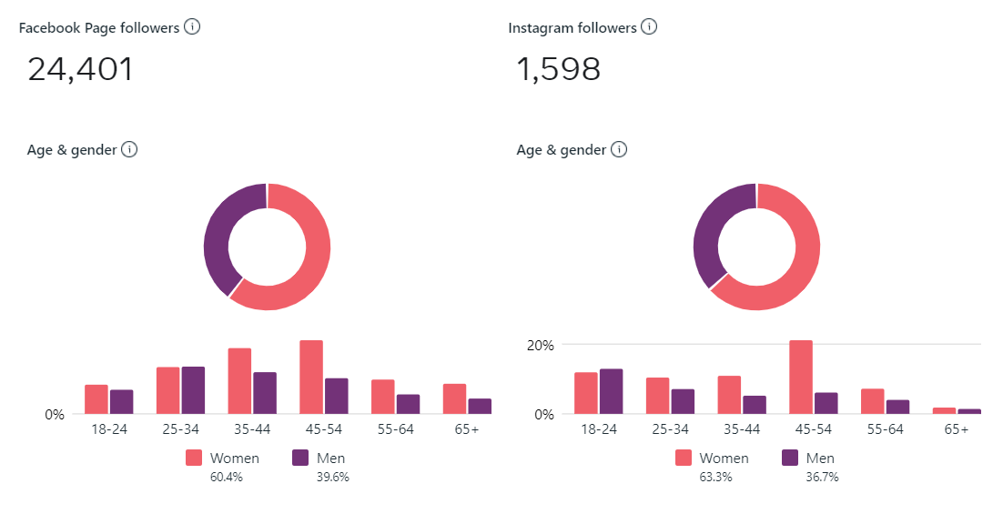

Website Audience Demographics:
Gains outside “young skewing” social platforms have also been seen. In comparing web users in FY2022 versus FY2023, the share of users under age 35 grew by 7.5%. This is especially notable as that demographic is traditionally one of the least likely to visit standard websites.
Objective: Maximize Digital Content Impact to Grow Audience
Tactic: Create Standards and Best Practices for Each Platform by FY24
Despite a challenging social media environment as changes in State of SD policy (banning TikTok usage) and social platform ownership (Elon Musk’s acquisition of Twitter and subsequent changes) required several strategy pivots, the SDPB content and digital teams are underway in creating a set of standards for each type of digital content we produce. It is expected that the initial versions of each SOP will be published within the second Q of 2023.
Tactic: Develop a Plan and Schedule for SDPB Domain Merger to Single CMS by FY24
Delays on the part of our NPR partners have set this back but we are in the process of clarifying if we can use our CPB grant for the domain merger for an outside partner versus waiting for the NPR/Brightspot team to fit us into their schedule. If we should get this permission granted, we already have an RFP written and ready for deployment so a local partner can be contracted and this work can take place on a much accelerated timeline.

Objective: Use Data to Better Understand Our Audiences

Tactic: Identify Key Performance Indicators (KPI) for SDPB Content by FY24
Each of SDPB’s core content areas (Education, Entertainment and Journalism) have identified their current KPIs. A historic report for each was developed and year over year tracking began in January 2023. These KPIs will be continually evaluated and updated as strategic initiatives evolve.

Tactic: Educate Staff on Data Driven Decision Making
SDPB is working with State of SD BHR in evaluating components of the new SD Learn platform in meeting our training needs in this subject matter area. It is hoped that a custom curriculum will be ready for use in the third quarter of 2023.

Our Values

Public Service
We believe in earning public trust through responsible stewardship of the resources we are given and the services we provide

Innovation
We encourage exploration, imagination, and creativeness in the content we create and the problems we work to solve

Personal Integrity
We are honest and truthful and hold ourselves accountable to our audience
and each other

Collaboration
We value building bridges and fostering engagement

Joy
We are enthusiastic about the work we do and find happiness in being of service
to others

Inclusion
We are respectful of our differences and work to ensure everyone feels valued

Excellence
We strive to continually improve ourselves and our organization

Our Vision:
A South Dakota equipped with the information and education for an inspirational tomorrow.
Our Mission:
To inspire, connect and entertain South Dakotans with trusted Journalism, quality education, and compelling story telling.

Goal – SDPB will engage with every South Dakotan at least once per month.
Objective 1 – We will grow our audience by 25 percent in two years.
Strategy: We will grow our audience through national/regional programming acquisition and new content platforms
Tactic: Localize You Tube TV.
Tactic: Add Hulu TV and Local Now
Tactic: Streamline digital platform development and workflows

Objective 2 – We will grow audiences by 25% in three years through local content development and deployment.
Strategy: Use our Rapid City, Sioux Falls and Vermillion studios for community conversations and engagement
Tactic: Hire Community Engagement Specialist for Black Hills
Tactic: Host quarterly town hall engagement events focused on local issues.
Strategy: Maximize the reach and awareness of SDPB’s local content.
Tactic: Expand Dakota Life community engagement events to include education, public safety, and journalism opportunities.
Tactic: Reformat South Dakota Focus to concentrate on a singular topic for the season.
Tactic: Hire freelance and contractors to assist in local content creation.
Strategy: We will grow our diverse audience through source development, the stories we tell, and engagement by 25 percent over five years.
Strategy: Create strategic partnerships with schools and community organizations already connected to diverse and minority communities.
Tactic: Build partnerships with Tribal and Latino communities.

Goal – SDPB is recognized as a trusted brand.
Objective 1: Complete a brand refresh by end of FY24.
Strategy: We will increase recognition of our logo and brand by new and existing audiences.
Tactic: Develop a paid external marketing plan.
Tactic: Develop a marketing and roll-out plan for SDPB platforms.
Tactic: Utilize SDPB internal working group to implement the rebrand.

Goal - SDPB is recognized as a trusted source for educational resources in South Dakota.
Objective 1: Utilize our broadcast, digital, and outreach structures to share educational resources and professional development opportunities.
Tactic: Create a system to evaluate and improve professional development and engagement opportunities.

Goal - SDPB will operate and communicate efficiently and effectively.

Objective 1: Improve the fiscal operations of SDPB and Friends of SDPB for maximum efficiency

Tactic: Work with BFM and BIT Finance to improve processes and financial reporting.

Tactic: Work with Friends and NETA to streamline Friends financial reporting and forecasting.

Goal – SDPB will be known for its strong staff and boards of directors.
Objective 1: We will retain our staff and decrease our turnover rate to 5% by 2025.
Strategy: By providing a good work environment, our staff will find joy in their work.
Tactic: Improve workflow strategies
Tactic: Improve training opportunities
Tactic: Create a streamlined and standardized onboarding process
Tactic: Establish a mentoring system for new employees
Tactic: Cross-train staff

Strategy: Build a strong engineering team to support staff and our infrastructure
Tactic: Identify current industry standards
Tactic: Identify technical skill set assessment needs.
Tactic: Identify and partner with industry training experts within the Society of Broadcast Engineering and BHR/BIT to develop skill set training for our staff.

Objective 2: Increase Employment Engagement Results in the BIT Employee Satisfaction Survey by 5% by end of FY 24.

Strategy: Provide staff with regular communication and personal development opportunities.

Objective 3: Keep Board member turnover to less than 3% outside of term limit turnover.

Strategy: By providing meaningful engagement, our Board members will find joy in volunteering their time and talents to SDPB.

Tactic: Provide regular communication and SDPB updates to Board members.

Objective 4: Establish a plan for future organizational leadership by FY25.

Strategy: Develop the next generation of SDPB leadership

Goal - Create a Data Driven Culture

Objective 1: Identify Key Performance Indicators (KPI) for SDPB by end of FY24.

Objective 2: Create a Standard Operating Plan (SOP) for data-driven decision making by end of FY24

Goal – SDPB is known for its support of open government

Objective 1: Increase public usage of SDPB open government resources by 10% by end of FY24.
Strategy: Move from audio to video streaming of public meetings.
Tactic: Seek alternative solutions through already in place state contracts
Tactic: Look into expanded partnership with DDN
Strategy: Integrate SD.net and SDPB.org to maximize exposure and audiences

Strategy: Bring in new stakeholders
Tactic: Leverage our existing relationship with BIT

Tactic: Explore opportunities presented by the new open gov’t portal

Goal – SDPB builds and maintains a valued infrastructure

Objective 1: Create a plan to actively identify local, state, and federal partners to strengthen our public safety initiatives though datacasting, WEA and IPAWS Alerting by FY24.

Objective 2: Create a plan to for migration to ATSC 3.0 -Next Gen Television by FY25.
Strategy: Replace ageing television transmitters with new ones capable of both ATSC 1.0 and upgradable to ATSC 3.0.
Tactic: Develop a 5-year capital replacement plan
      - FY24 KPSD-TV Faith $80K, KZSD-TV Long Valley/ Martin $130K.
      - FY25 KBHE-TV Rapid City $130K

Strategy: Create a plan and budget to add ATSC 3.0 channels in our major markets Sioux Falls, Pierre, Rapid City
Tactic: Look at channel search acquisition cost
Tactic: Conduct tower analysis budget load for new transmission line and antenna equipment
Tactic: Get quote on ATSC 3 transmitter, encoder and STL links

Objective 3: Update interconnection system (studio to transmitter connections.) by 2026.
Strategy: Identify funding sources through Federal grants and FEMA CPB funding.
Tactic: Get a budgetary quote for SAFT IP based Microwave systems.
Tactic: Implement 150 Mbs. or more symmetrical fiber interconnect for KCSD Sioux Falls, KESD Hetland, KJSD Watertown and KDSD Pierpont.
Tactic: Work with (SRC) State Radio Communication and BIT networking to identify joint site locations. To leverage staff and other service cost savings.

Objective 4: Create a plan to source sustaining fiscal infrastructure funding by FY26
Strategy: Seek opportunities to increase infrastructure funding
Tactic: Evaluate existing vertical tower real estate leasing model for new revenue streams.
Tactic: Completely overhaul the lease management system.
Tactic: Actively promote the state infrastructure to T-Mobile and others
Tactic: Identify possible partners to promote and leverage datacasting technologies.
Tactic: Secure tower modernization funding through the state maintenance and repair fund or Federal grants.
Tactic: Identify strategic business models from ATSC3 to assist in revenue.

Objective 5: Document and create a plan for review by Senior management to evaluate the feasibility of joining a Joint Master Control.
Strategy: Identify opportunities and risks in outsourcing master control.
Tactic: Meet with central cast to fully understand our options.
- EAS responsibilities state primary, amber alerts endangered persons, alerts in blue alerts, as well as other civil emergencies activated by state authorities.
- Programing local acquisition and prep.
- Local control for live shows in Studio, Statehouse and SDHSAA events.
- Infrastructure monitoring. STL and Burke SACADA (Supervisory control and data acquisition) transmitter building monitoring systems

Goal - Friends of SDPB will provide for the ongoing needs and future growth of SDPB by building a premier philanthropic experience for our donors.
Objective 1: By FY25 Friends of SDPB will work to achieve 15,000 Members
Objective 2: By FY25 Friends of SDPB will work to achieve 40% of our members give via sustaining membership
Objective 3: By FY25 Friends of SDPB will work to achieve $1,000,000 in Underwriting revenue annually
Objective 4: By FY25 Friends of SDPB will work to achieve $1,000,000 in Major Giving revenue annually
Objective 5: By FY25 Friends of SDPB will work to achieve $1,000,000 in Legacy Giving revenue annually

