SDPB Board Report
October 2021
Engineering and Operations Report

EAS/FCC
The Federal Emergency Management Agency The 2021 National Periodic Test was conducted on August 11, 2021. I’m pleased to report that SDPB’s NOC was in full compliance and successfully completed the test and all compliance reports are complete and filed with the FCC.

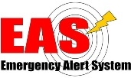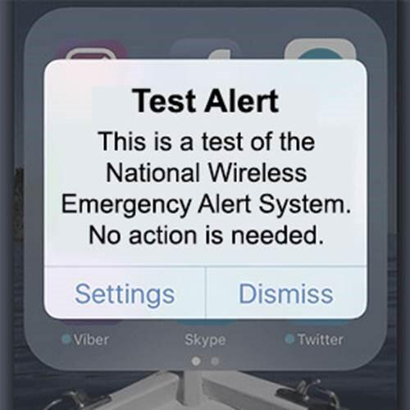
In previous National Alert testing FEMA primarily concentrated on testing the common alert protocol using the Integrated Public Alert and Warning System (IPAWS) and wireless emergency alerts (WEA). 2019 national test resulted in 91% of systems successfully receiving and retransmitting the alert to the public.

New this year: FEMA will originate the test via the National Public Warning System with a focus on Wireless Emergency Alerting *(WEA) facilities. The intent of conducting the test with a focus on the WEA delivery method to determine the capability of the EAS system to delivery via Wireless Cell phone companies. This model tested the traditional broadcast daisy chain delivery system as well as Alerting through the internet.

Amber Alert and Endangered Persons Alerts:
This past quarter SDPB assisting in Activation of 2 Amber Alerts and 3 Endangered Alerts. “All were found safe.”

Remote Productions: Studio Engineering, Brian Wood and Team have been busy designing and rebuilding power to portable production systems. The current systems were built in 2009 when we transitioned to digital television to support 3 simultaneous tournaments on air. Now these systems are used not only for SDHSAA. They are also used to support many different streaming and broadcast events throughout the state.

KDSD – Transmitter building. Field Engineering, The State Office of Engineering has determined that improvements are need to our KDSD TV FM transmitter building serving Northeast South Dakota. These improvements will protect the transmitters and lower operating costs well into the future.

Digital- The new SDPB “new” content management system NPR Grove project was completed. Overall, it was a successful conversion through this new management system. Thank you to Kent Osborne, Laura Dimock, and radio staff for shepherding this through to completion.

SD.net-We are seeing an increase in SD.net remote productions from the State Boards and Commissions. Recently supported legislative Research Council redistricting committee. to stream eight meetings in three days in multiple cities throughout the state. Thank you to Kent and Brian Woods teams that made this possible.

Also, Haivision CDN. We are in the process of rebuilding our back-end streaming management system. Much of the system will transition in October and November.

Respectfully Submitted by SeVern Ashes

