Media Content Report-March 2021
Strategic Plan Goals:
SDPB Media initiatives; Special Projects; Content Division Strategies:

SDPB Media Initiatives:
Coronavirus and the health and safety of our staff drives how we go about our production work. Thanks to the creativity and support from the SDPB engineering staff, there has been limited impact on what programs and stories we produce. Virtual connections to guests have provided a new look and sound but also presented us with new tools and options that we will continue to utilize in our new normal. Considering the pace of vaccinations, we are planning for “return to work and studio guests in the months ahead. In the meantime, we are maintaining polices that meet or accede health and media production safety guidelines. SDPB’s capability and experience in virtual production and web streaming has served us well in the Journalism Group and helped create production partnerships with several arts organizations through the Entertainment group.

The 2020/21 SDHSAA season is through Fall and Winter activities with limited interruption. The Grand Chorus and Orchestra concert has been delayed till mid-April and will be orchestra only. Other fine arts speaking events we converted to virtual competition, and where possible SDPB provided a webcast to provide audience access to fine arts performances. During the legislative session, SB 128 “an act to revise certain provisions related to news media coverage of high school activities” was passed. However, this bill deals specifically with the media rights at the school or school district level. brought attention to exclusive media rights for coverage of high school activities. During debate, those testifying went out of their way to amend the bill and say “it does not impact state events” and “we do not want to get in the way of the relationship SDHSAA has with SDPB”.

Special Projects: All platforms contributing to local media production and outreach
“SD Symphony and Levitt Concerts”
“Monthly Journalism topics”
“SDPB Early Learners Initiative (ELI)”
“CPB Coming Home” project Audience survey followed by content production
“Beat” Development and Underwriting
Content Division Strategies
*SDPB Journalism: Jackie Hendry “News and Public Affairs Issues”; Open “Healthcare and Education”; Lee Strubinger “Politics and Public Policy”; Seth Tupper “Business and Economic Development”; Richard Two Bulls “Diversity”; In the Moment “Technology and Innovation”
*SDPB Entertainment: Nate Wek “Sports and Recreation”; Brian Gevik “History and Rural Life”; Melissa Sievers “Rural Life”; Kevin Patton “Music and Cultural”; TBD “Arts and Cultural”
*Entertainment Group “Dakota Life Digital Edition” and “The Creative: Arts and Cultural Digital Magazine”
*Other: Sound Vision 2.0: Programming and Endowment
Board of Directors of Educational Telecommunications
SDPB Marketing Report
March 31, 2021

Marketing

Coming Home: South Dakota – this project, funded by CPB, is a public media initiative to increase and promote authentic local storytelling through multi-platform media and engagement that develops and delivers a renewed narrative about life in rural America. New multi-platform content, created by local stations with local voices and talent, will celebrate the diversity, culture, traditions, and richness of small-town America, not being told by commercial media.
The first phase of this initiative has concluded and the results of the research (shared at previous board meetings) is now being used by the Content Team to develop programming opportunities.
Sesame Street in Community – A grant from WNET and Sesame Workshop has given us the opportunity to partner with other South Dakota organizations and create a series of virtual workshops and discussions utilizing resources produced by Sesame Street. Nearly 500 kits have been distributed. The kits contain workbooks, and information that care-givers can use in helping their pre-K children be ready to learn once they become Kindergarten age.
Data Dashboard – we are working with BIT Development to create a dashboard that automatically collects audience information in one dashboard. This will improve our ability to compare audience information at a glance in an efficient, low-cost and low-impact manner.
SDPB Rebrand – Polling colleagues and reviewing procedures for a rebrand of SDPB. As a reminder: Since adopting the current version of our logo and brand in 2002 the organization has gone through tremendous evolution. As the organization evolves, and as we learn more about our audiences and potential audiences, our brand needs to evolve with it. With that in mind, we are beginning the process of addressing our brand so that it accurately reflects who we are and who we strive to be. This comprehensive project will take time. We have an opportunity to coordinate the roll-out of a new brand with the 100th anniversary of KUSD Radio - May 2022. That’s our initial goal. We shall see.

Education & Outreach

At-home Learning – The education team continues to create and promote at-home learning resources available on TV and online. Steven Rokusek, Kevin Nelson and Amelia Meyer are helping educators, home-schoolers, daycare providers and parents understand where to access and how to utilize our materials.
Early Learning Initiative – Launched a year ago ELI includes weekly emails to hundreds of subscribers with lessons parents and others can incorporate into their child’s life. These lessons are tied to pre-K programming available on SDPB1-TV and SDPB4-TV.
Dakota Pathways – This Emmy-winning series was originally produced over 15 years ago. It remains relevant and well-used in 4th grade classrooms to meet state standards. The website had fallen into disrepair due to changing streaming standards. Steven spent the better part of 3 months updating the website, extending the lifespan of this resource for years.
SDPB Education Newsletters – We have nearly 3,000 South Dakota educators who receive the monthly SDPB Educators Newsletter that Steven Rokusek distributes.

Social Media continues to grow. The chart below shows results we have experienced for the past two calendar years. You will note that the months of October and November 2020 we had extremely high Reach and Video Views – no doubt fed by the election and our coverage of high school sports. In fact, October 2020 was a record-setting month with the highest reach and video views of any ever recorded in our social media history.

 | Reach | Video Views | Engagement | Total Followers
Mar-19 | 3,056,218 | 667,389 | 188,337 | 102,953
Apr-19 | 1,161,827 | 263,455 | 71,390 | 103,995
May-19 | 2,012,852 | 575,691 | 111,076 | 105,385
June-19 | 1,468,889 | 410,952 | 90,824 | 105,637
July-19 | 1,087,014 | 314,809 | 61,848 | 106,478
Aug-19 | 1,111,006 | 271,178 | 72,563 | 107,572
Sept-19 | 1,320,607 | 359,951 | 101,823 | 110,430
Oct-19 | 1,680,617 | 345,853 | 108,361 | 111,795
Nov-19 | 2,834,836 | 705,070 | 165,673 | 113,969
Dec-19 | 1,424,057 | 389,417 | 94,561 | 114,912
Jan-20 | 1,508,649 | 423,847 | 105,694 | 116448
Feb-20 | 2,670,171 | 826,948 | 204,937 | 118,326
Mar-20 | 3,144,057 | 858,916 | 242,471 | 122,601
Apr-20 | 1,450,606 | 361,989 | 102,489 | 124,639
May-20 | 1,889,066 | 479,992 | 145,431 | 125,986
June-20 | 1,765,394 | 523,852 | 127,395 | 127,082
July-20 | 1,259,904 | 242,666 | 97,148 | 128,501
Aug-20 | 854,681 | 195,116 | 61,312 | 130,955
Sept-20 | 1,659,257 | 310,908 | 101,407 | 133,057
Oct-20 | 4,056,936 | 2,084,812 | 204,019 | 134,600
Nov-20 | 3,168,970 | 828,316 | 156,930 | 136,763
Dec-20 | 2,519,193 | 924,006 | 150,498 | 137,107
Jan-21 | 1,317,326 | 258,453 | 92,952 | 137,941
Feb-21 | 1,881,118 | 290,048 | 101,831 | 139,613

Due to the Coronavirus pandemic, all in-person Marketing events were canceled or postponed. We are planning for events and activities to ramp up through the summer and into the fall.

Entertainment Report
Submitted by Brad Van Odel

SDHSAA Events
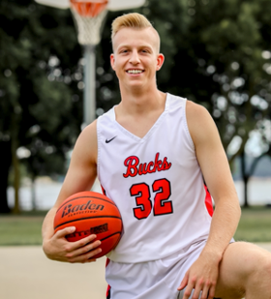
The entertainment group continues to highlight outstanding South Dakota athletes and musicians as part of In Play Digital series. Mathew Mors has one of the most impressive resumes in South Dakota basketball history, early in February the Entertainment Group produced a biographical story on Mathew Mores. The story was hugely popular on social media and garnered over 66,000 views on Facebook, The SDPB Sports Facebook page reached over 192,000 users in February.

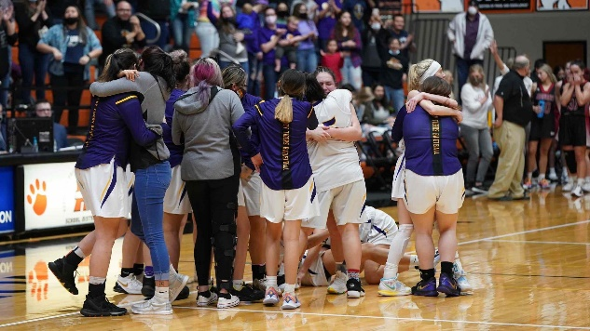
The Entertainment group produced five High School Athletic championships since the beginning of November, released results from the virtual competitions of Oral Interpretation and Debate and streamed the Class B State One Act Play Competition with results and photos from all three classes. During the 3-day tournament for Football, we reached 549,538 people on our SDPB Sports Facebook page and 155,315 during the volleyball tournament. Twitter for November on our SDPB Sports Twitter page reached an audience of 982,700. During wrestling the video of Pierre High School winning the Duel Championship received over 100,000 views on Facebook. During Girls B Basketball, the last second basket by White River sending them on to the championship round garnered 30,000 views on Facebook. Below are the streaming stats for the 5 tournaments since November 1st.

- Football - 31,997 views over the 3-day tournament
- Volleyball – 55,554 views over the three, 3–day tournaments
- Gymnastics - 3000 views over the 2-day tournament
- Wrestling – 8,100 views Friday and Saturday nights

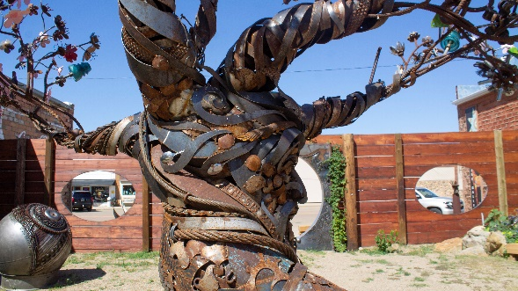
Dakota Life
Dakota Life continues to highlight communities across the state and has visited De Smet, Freeman, Hot Springs, Newton Hills State Park, Canton and Lemmon. The visit to Lemmon in November featured two stories from the community, Wheeler Manufacturing and artist John Lopez and his newest sculpture “the Tree of Life” these two stories were very successful on social media and garnered 90,000 views on SDPBs Facebook Page.

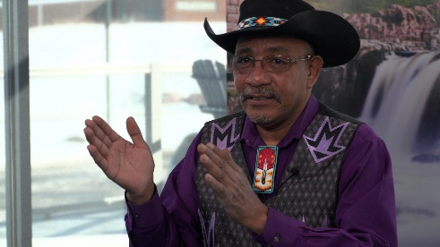
Digital content for Dakota Life continues to be a priority for the E group. SDPB sat down with the bull-fighting rodeo cowboy Lynn “Smokey” Hart who successfully lobbied for state recognition of Martin Luther King Day and Native American Day in South Dakota. This interview garnered over 10,000 views on Facebook reaching 14,000 people in the SDPB Facebook community.

Music
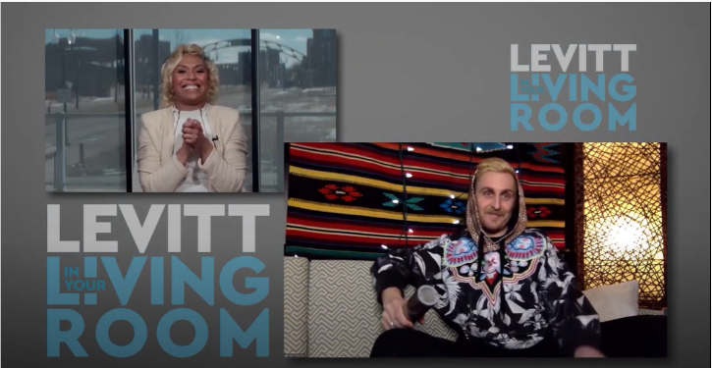
The Entertainment group produced several streaming concerts partnering with the South Dakota Symphony Orchestra. The concert, Sacred Sounds of Christmas aired on Dec. 3rd on SD.net and SDPB.org. The E. group also produced a holiday concert with local bluegrass band the Teels. The concert was recorded at the Canton Performing Arts Center and aired on Christmas Eve. The Entertainment group also partnered with musician Eliza Blue to bring a special digital only holiday concert, Christmas from Rabbit Butte. This concert produced by Eliza Blue and Friends gathered 28,000 views on the SDPB Facebook Page. The Entertainment Group’s most recent partnership is with the Levitt at the Falls. SDPB has teamed up with the Levitt to bring three episodes of Levitt in Your Living Room. This virtual concert series features interviews and concert footage from diverse musical acts from across the United States the first Episode featuring Lemmon Bucket airs on Facebook March 27th.

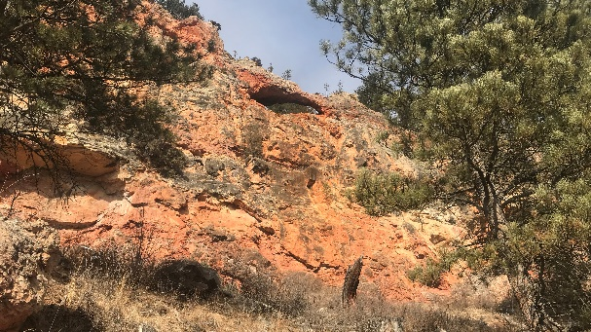
Rural
South Dakota has many beautiful outdoor places; while some are well known others remain less so. Since the pandemic the Entertainment group has visited both well-traveled and remote locations to connect South Dakotans with the natural beaty of our state. Recently articles were written about The Grand Canyon of the Black Hills, Turtle Butte and Black Elk Peak. These three on-line stories reached more than 33,000 readers on social media.

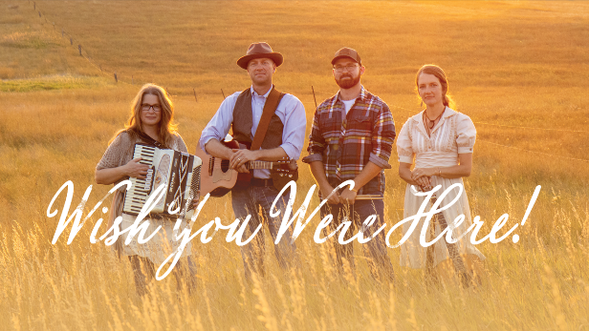
Wish You Were Here, SDPB’s newest rural program visited Hoover Store and Slim Buttes. This musical travelogue treks across the state sharing history about lesser traveled areas of South Dakota while bringing music that has the feel of rural South Dakota. The program is a first for SDPB in that it premiers on social media before it airs on television this strategy has been very successful as the program gathered 30,000 views on Facebook in the month of January.

ET Board Report
Journalism Team – Cara Hetland
March 2021

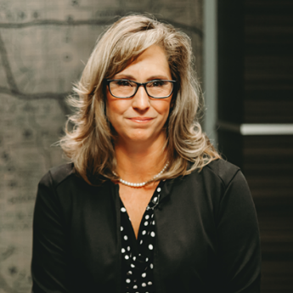
Staffing
We said goodbye to Stephanie Rissler. She has been with SDPB for 20+ years as a producer and most recently the host of South Dakota Focus. She has been the face of SDPB’s legislative coverage and produced several historical documentaries. Stephanie has accepted a position as Communication Manager with the South Dakota Association of Healthcare Organizations (SDAHO). SDPB audiences have been greatly served by her dedication to journalism, professional work in covering issues, and creating documentaries. We will miss her as a colleague and wish her the best in a new career.

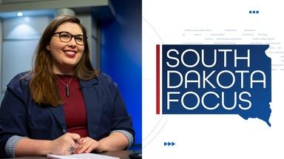
Jackie Hendry was hired as the host of South Dakota Focus, replacing Stephanie Rissler. Jackie has been our education and healthcare beat reporter for the last three years. She says this is her dream job, combining her love of video production, creative storytelling, and journalism ethics to create a public affairs program on SDPB.

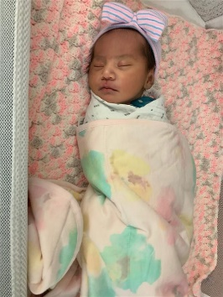
Richard Two Bulls and his fiancé welcomed Hero Lynn Two Bulls on January 13. She weighed 7 lbs. 9.5 oz and was 20 ¼ inches long.

Kyle Ireland is our weekend voice. He is a student intern and is majoring in journalism at the University of South Dakota. Kyle replaces Nick Nelson who graduated in December and accepted a job at KOTA television in Rapid City.

A reorganization of the journalism team has been approved. I am in the process of hiring a supervising senior producer to manage the daily flow of news content. Other aspects of the reorganization include placing staff into teams and having team leaders to help with projects and flow of content.

Content:
Our content producers worked hard covering the news of the election, the pandemic, and the legislative session. Seth Tupper, Lee Strubinger, and Jackie Hendry have been heard on programs like Science Friday, Morning Edition, Here and Now, and On Point. These national programs have showcased South Dakota for election results and the rising cases and deaths from Covid-19. Seth Tupper’s reporting comparing South Dakota to Vermont in how it’s handled the pandemic through policy and messaging had 750,000 views on NPR’s website in the first three days.

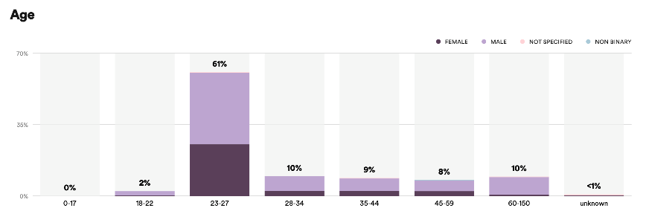
Josh Haiar has been working on building our podcast presence. In the last half of 2020 we have dropped 1,586 minutes of content over 185 episodes. We are #1 on Google when searching “South Dakota podcast”, and “South Dakota news podcast”. Our subscribers are steadily growing with 131 listeners on Spotify. We are most popular with listeners in the 23-27 age group.

We do not have data from iTunes but below is a screenshot of some comments. We currently have a five-star rating. The below comments indicate we are doing well.
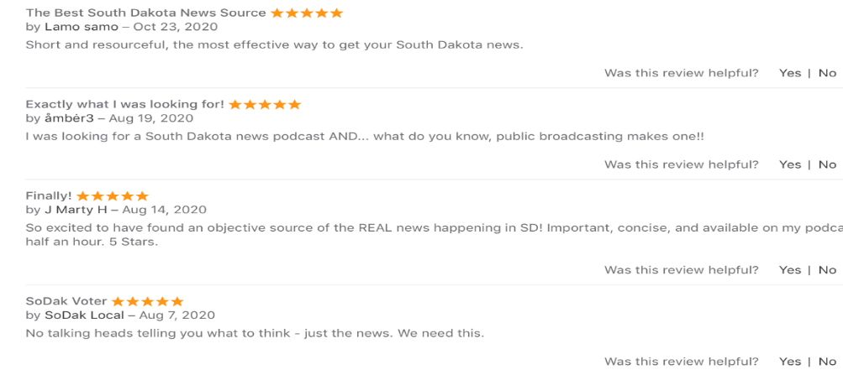
Our comprehensive coverage known as Statehouse began with coverage of the Governor’s budget and State of the State addresses which included follow up conversations on In the Moment and SD Focus. Statehouse refers to our package of production that includes: gavel to gavel coverage of house and senate chambers on SD.net and television, all committee meetings on SD.net, produced radio stories for newscasts and In the Moment, live interviews on In the Moment and SD Focus, daily two- minute stories on television, news podcast and social media postings. Lee Strubinger heads up the coverage in Pierre with assistance from all staff.
In the Moment celebrated 1000 episodes on March. 3. We have been testing the proposed format change for In the Moment over several days in February and March. We continue to work on our workflow and processes as we prepare for the March 29 launch of new programming. In the Moment will go to an hour at noon central with a replay at 7 pm central.

South Dakota Focus has a new look, new format and a new host. Jackie Hendry had two programs in December, January, and February with a focus on what’s happening in Pierre. She has discussed the merger between the department of agriculture and the department of environment and natural resources, and civics education. We are bringing in signature segments featuring Lee Strubinger interviewing newsmakers in Pierre and Seth Tupper taking an historic look at issues, we call it Why is that? One of the Signature segment for SD Focus is “Why is that?” It looks at a current legislative proposal and then gives some history behind the issue. The story about the history of airplanes had 3.4 thousand views on Facebook and the story about merging the department of agriculture with the department of environment and natural resources had 4.5 thousand views on Facebook.

The entire J Team and the E Group have worked together to bring this reformatted program to the air. Congratulations on a great team effort.

Working with our Social Media Manager, the J-Team is more deliberate in its @SDPBNews Twitter account. January saw a 1047% increase in profile visits.

South Dakota Board of Educational Telecommunications
SDPB Television
March 2021

Programming
TV Viewership in December:

SDPB Television viewership is measured in the Sioux Falls and Rapid City markets. Sioux Falls ranks #113 out of 210 by market size with 229,420 TV households and 0.214 % of the US population. Rapid City ranks #169 out of 210 US markets with 86,610 TV households and 0.081% of the US population. Measurement is done by a combination of Nielsen encoders in the homes of a random sample of each market and return path data from program providers such as satellite providers and cable systems.

Nielsen reporting is delayed by several months, and the most recent numbers available are from December 2020. This year’s December measurement period ran from December 3rd through December 30th.

Our December Nielsen ratings show that 333,870 individual viewers, tuned in to SDPB’s four channel during the month. 57.6% of TV households across both markets tuned to SDPB’s main channel.

Most watched programs in December 2020

1. American Masters: Laura Ingalls Wilder 7740 viewers
2. Washington Week average 6320 viewers
3. 49th Annual Laura Ingalls Wilder Pageant 5840 viewers
4. Antiques Roadshow Mondays at 7pm average 5570 viewers
5. Dakota Life 5,220viewers
6. As Time Goes By average 5190 viewers
7. Call the Midwife Holiday Special 4950 viewers
8. Antiques Roadshow Mondays at 8pm average 4555 viewers
9. Keeping Up Appearances average 4490 viewers
10. Midsomer Murders average 4050 viewers

Radio Listenership
SDPB Radio listenership is measured via online live streaming numbers with no over-the-air measurement available. In February, our streaming audience saw 60,214 total listening hours and 10,214 cumulative streaming audience. SDPB Radio listenership is measured via online live streaming numbers on all devices with no over-the-air measurement available.

Television program changes

In October, we added the series Frankie Drake Mysteries to our lineup on Thursday nights and on Saturday nights.

Since our last meeting, SDPB has provided live coverage of the State Football, Wrestling, Gymnastics, and Volleyball Championships. We increased our coverage of Wrestling this year by adding the team Championships in addition to the individual Championships and spreading the two classes over two channels.

The SDPB Learner’s Connection block of programming weekdays from 11am to 4pm on SDPB 2 will continue through at least the end of the school year. This special programming serves students from grades 6 through 12. This consists of a daily special broadcast of both national and local, South Dakota focused learning material, along with a full slate of educational materials, student discussion guides, and additional learning materials. This block supplements our SDPB Kids channel which features educational material for preschoolers, and our main channel PBS kids programming which features programs geared toward elementary students.

Radio schedule changes

Starting in November we worked with a consultant to discuss how to make In the Moment a stronger local program and make it sustainable in terms of staff workflow. As a result, we will present a new weekday lineup beginning March 29th. We will air 1-A live from 9 to 11am and On Point from 11 to noon. In the Moment will be reformatted to one hour, airing twice per day, live at noon and a same day repeat at 7pm central time. Here and Now, currently a 2-hour offering will move to one hour, airing at 1pm central time and Fresh Air with Terry Gross will air each weekday at 2pm central time. We feel that the program will be more focused and offer new opportunities to reach audiences with the evening airtime. Local content produced for the program will also be used in Morning Edition and All Things Considered, as well as to expand our digital offerings.

Other changes

In anticipation of upcoming staffing and organizational changes, we have contracted with a Programming service to consult on programming and to create our TV schedules. Beginning in April, P3 Public Media of Lincoln Nebraska will build all of our schedules. The consultants there have many years of programming experience and contract with numerous Public Broadcasters across the country for this service.

South Dakota Board of Educational Telecommunications
Engineering, Digital, & Operations Report—SeVern Ashes
March 2021

Preparing for major system replacements within our NOC (Network Operation Center) in Vermillion. Due to vendors sunsetting systems support; our Studio Engineering teams are actively preparing to upgrade or replace several key systems and to include our Grass Valley television automation and playout servers. ATEME video encoding equipment advances in video encoding technology will allow increased channel quality and future proof the delivery system for Next gen TV.

Our Studio Engineering and Digital teams have been responding to Covid 19 through assisting content production teams with live to air and records using Zoom and Team virtual meeting platforms.

Field Engineering’s remote work environments has allowed staff to remain on a regular maintenance and repair schedule while supporting the network. If you recall in October of 2020, the Field Engineering team completed the last phase of the statewide FM replacement project. This project brought all 11 full power transmitters to current solid-state technology. We will now move on to implementing improvements to the technology that delivers signals from Vermillion out to the transmitter sites over our terrestrial microwave system.

Educating/Datacasting--We are in the early stages of building a service that imbeds educational data within the SDPB television signal. The data is received through a traditional TV antenna; be it on the roof, in the attic, a flat panel antenna in a window or the traditional rabbit ears. Instead of decoding the SDPB TV channels datacasting receiver decodes the Educational data that is hidden within the TV signal. This receiver now emulates a small Intranet/Wi-Fi servicer within the home that students can access.

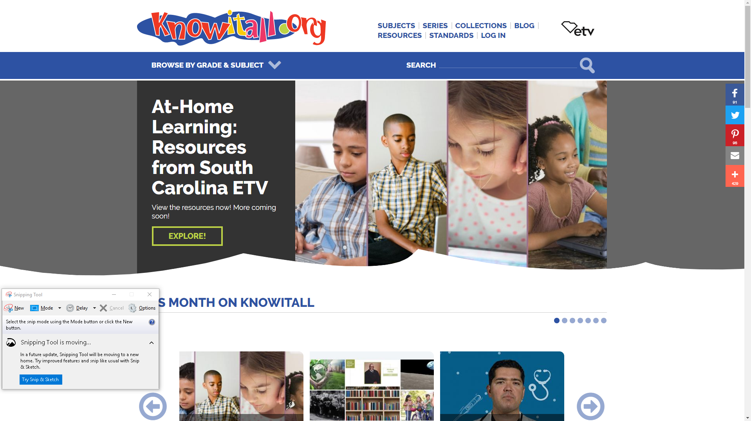
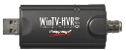
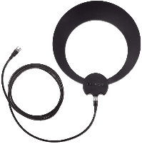
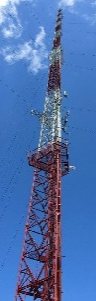

Of course, this is a very simplified outline of the service. You will hear more on this service as we build it out.

