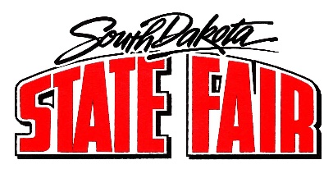
Call to Order: Chairman Faron Wahl called the meeting to order. The roll call was called, and a quorum was present.
Members present: Faron Wahl, Jo Beal, Denise Muntefering, Loren Noess, Jamie White, Amanda Stade, Scott Cordts, Dusty Anderson, Gary Sharp, Sherman Gose, Tom Harmon, and Justin Bell.
Staff members and others present: Secretary Hunter Roberts, Brian Faris, Peggy Besch, Jason Coenen, Cliff Hadley, and Pam Geppert.

- Summary of Daily Events:
  - Discussion items:
    - Admission tickets: There were some issues on Sunday with purchasing on-line tickets. Will have to research further.
    - VIP Tickets: There were issues with some VIP tickets not working (scanning correctly). Will need to research further.
    - May need to establish a “Parking Committee” to address challenges. Need to establish some consequences.
    - Labor challenges: Are there any incentives to encourage seasonal employees to work all week? Will need to research further.
    - Discussed parking issues and how parking is being abused. Will start towing practices.
    - Heard many positive comments.

- Nex meeting: October 18, 2022.

- Adjourned.

