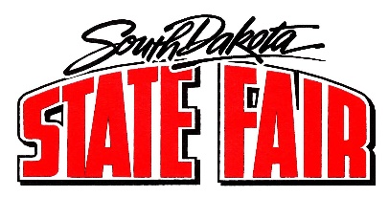
Call to Order: Chairman Faron Wahl called the meeting to order. The roll call was called, and a quorum was present.
Members present: Faron Wahl, Jo Beal, Denise Muntefering, Loren Noess, Jamie White, Amanda Stade, Gary Sharp, Sherman Gose, Erin Yost, and Justin Bell.
Staff members and others present: Secretary Hunter Roberts, Peggy Besch, Candi Briley, Representative from Office of Emergency Management, Jason Coenen, and Dr. Mendell Miller.

- Summary of Daily Events:
  - Discussion items:
    - Discussed parking issues and how parking is being abused. Will start towing practices.
    - Discussed the concert and the need for additional people to aid with carding and selling beverage tickets.

- Commissioner Reports and Assignments:
  - Members reviewed their assignments for the day.

- Adjourned.

