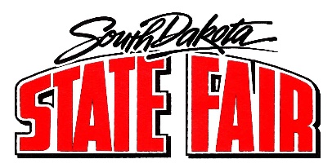
Call to Order: Chairman Faron Wahl called the meeting to order. The roll call was called, and a quorum was present.
Members present: Faron Wahl, Scott Cordts, Jo Beal, Denise Muntefering, Tom Harmon, Loren Noess, Jamie White, Amanda Stade, and Justin Bell.
Staff members and others present: Secretary Hunter Roberts, Peggy Besch, Brian Faris, Jason Coenen, and Dr. Mendell Miller.

- Summary of Daily Events:
  - Discussion items:
    - Three-wheel motorized vehicles: Starting to see some three will motorized vehicles on the fairgrounds creating some safety concerns (different from the scooters used for people with disabilities). Future discussion topic.
    - Horse trailer parking: Several commissioners will assist with parking and will need to have them park close together.
    - Brief discussion about traffic at the gates, scanning and possibly moving some people around to aid with congestion.

- Commissioner Reports and Assignments:
  - Members reviewed their assignments for the day.

- Adjourned.

