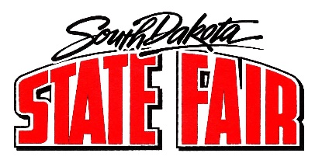
Call to Order: Chairman Faron Wahl called the meeting to order. The roll call was called, and a quorum was present.

Members present: Faron Wahl, Dusty Anderson, Gary Sharp, Scott Cordts, Jo Beal, Denise Muntefering, Tom Harmon, Loren Noess, Jamie White, Sherman Gose, Amanda Stade, Erin Yost, and Justin Bell.
Staff members and others present: Secretary Hunter Roberts, Peggy Besch, Jason Coenen, Cliff Hadley, and Dr. Mendell Miller.
- Approval of July 19, 2022, Minutes: Motion was made by Bell, seconded by Yost to approve minutes; motion carried.

- Public Comment Period: There were no public comments.
  - Cliff Hadley, Camping Superintendent: Hadley introduced himself and briefly shared his experience thus far mentioning he assisted Camper Bob last year so had some general knowledge. Generally positive experience. Biggest challenge is campers are getting bigger and bigger.
  - Dr. Miller, SD Animal Industry Board: Everything going smoothly. Nothing significant to report.
  - Jason Coenen, Security Superintendent: Nothing to report.

- Summary of Daily Events:
  - Besch reported:
    - Due to staffing issues, Brave Enough Entertainment cancelled their services to offer Virtual Reality Gaming.
    - SD Office of Emergency Management will be onsite throughout the fair to serve as a training opportunity but also to observe and gain some general knowledge of overall fair operations to aid with strengthening emergency planning procedures.
    - State Fair logo was introduced last night at the Bull Bash. Well received.
    - The Open Class Sheep (showed August 27-28) and Beef Show (showed August 30-31) were successful.
    - The “RAISE The SHED” fundraising campaign was launched at the Open Class Sheep Show on August 26. Lots of excitement. Goal is to raise $3 million.

- Commissioner Reports and Assignments:
  - Members reviewed their assignments for the day.
  - Stade reported 4-H static exhibits are up substantially from last year.

- Adjourned.

