Anyone wishing to participate via telephone conference call should contact the South Dakota State Fair at 605.353.7340 no later than 3 PM Central Time on Monday, October 18, 2021.
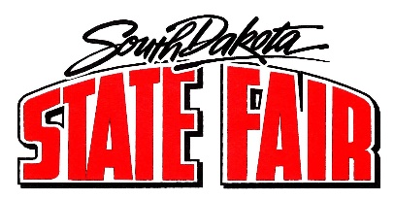
Call to Order and Roll Call

- Approve Agenda - Additions/Changes

- Approval of August 24, 2021 Minutes

- Public Comment Period

- DEX Update

- Master Plan

- Strategic Plan

- 2021 SD State Fair
  - Measurable Outcomes
  - Wrap-up Notes, Comments, Observations

- 2022 SD State Fair
  - September 1-5, 2022
  - Entertainment Agency
  - Open Class Beef and Sheep Show
  - Admission Fees

- Non-Fair Time Activities
  - Cold Storage
  - Winter Riding and Stalling
  - Williams & Ree

- Commissioners or Manager Reports

- Executive Session (if applicable): Move for executive session pursuant to SDCL 1-25-2(3) to discuss contractual matter.

- Adjournment

This meeting is being held in a physically accessible place. Individuals needing assistance, pursuant to the Americans with Disabilities Act, should contact the South Dakota State Fair at 605.353.7340 in advance of the meeting to make any necessary arrangements.

