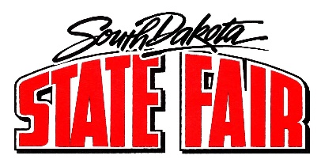
Anyone wishing to participate via telephone conference call should contact the South Dakota State Fair at 605.353.7340 no later than 3 PM Central Time on Monday, February 14, 2022.
Call to Order and Roll Call
- Approve Agenda - Additions/Changes

- Approval of October 19, 2021, Minutes

- Public Comment Period

- Election of Officers (Chair and Vice Chair)

- Strategic Plan Review (Executive Summary)
- Goals
  - Increase daily attendance by 5% year over year.
  - Define and secure financial resources to support ongoing staffing needs.
  - Maximize gate efficiencies to support increased fairgoer attendance.
  - Triple non-fair revenue.
  - Build and strengthen new strategic partnerships.

- DEX Update

- 2022 SD State Fair (September 1-5)
  - Open Class Sheep and Beef Show
  - Camping/Livestock & Competitive Exhibits
  - Vending
  - Admission Fees
  - Entertainment
  - Department of Corrections Community Service Program
  - Scratch Lottery Ticket
  - Safety and Security Measures
  - Mural

- 4-H Update

- Non-Fair Time Activities

- Maintenance & Repair

- Commissioners or Manager Reports

- Executive Session (if applicable): Move for executive session pursuant to SDCL 1-25-2(3) to discuss contractual matter.

- Adjournment
This meeting is being held in a physically accessible place. Individuals needing assistance, pursuant to the Americans with Disabilities Act, should contact the South Dakota State Fair at 605.353.7340 in advance of the meeting to make any necessary arrangements.

