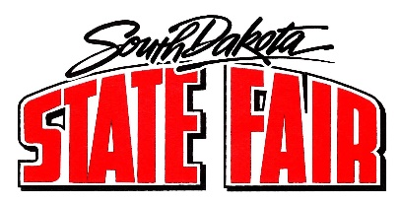
Call to Order and Roll Call (if a quorum is present)

- Approve July 19, 2022, Minutes

- Summary of Daily Events

- Commissioner Reports and Assignments

- Adjournment

