October 2020

Strategic Plan Goals:
SDPB Media initiatives; Special Projects; Content Division Strategies:

SDPB Media Initiatives:
Coronavirus continues to dominate our Journalism and Entertainment group coverage and production process. SDPB has policies and procedures in place for individuals or crews doing media production in a fixed studio, remote field production, and a policy to admit a single guest at a time into a studio location. These polices meet or accede health and media production safety guidelines. That being said, if individual staff members feel uncomfortable in regard to health and safety measures in the workplace, all reasonable accommodations are being made.

The 2020/21 SDHSAA season is underway. Following the acceptance of the SDPB bid to continue as media partner through 2025, an operating contract has been signed that includes contingencies for changing events dates, locations, or presentation, and compensation if an event is canceled.

Special Projects: All platforms contributing to local media production and outreach
- “Election 2020”
- “Blood Sugar Rising” local content and outreach postponed to 11/2020
- “SDPB Early Learners Initiative (ELI)”
- “CPB Coming Home” project Audience survey followed by content production
- “Beat” Underwriting
Content Division Strategies
- SDPB Journalism: Stephanie Rissler “News and Public Affairs Issues” Jackie Hendry “Healthcare and Education”; Lee Strubinger “Politics and Public Policy”; Seth Tupper “Business and Economic Development”; Richard Two Bulls “Diversity”; In the Moment “Technology and Innovation”
- SDPB Entertainment: Nate Wek “Sports and Recreation”; Brian Gevik “History and Rural Life”; Melissa Sievers “Rural Life”; Kevin Patton “Music and Cultural”; TBD “Arts and Cultural”
- Entertainment Group “Dakota Life Digital Edition” and “The Creative: Arts and Cultural Digital Magazine”
- Other: Sound Vision 2.0: Programming and Endowment.

This is an example of how the Journalism and Entertainment groups work across platforms to provide comprehensive coverage of special events or on-going issues.

2020 Statehouse Content Coverage Plan

Mission of our coverage: To inform and educate the public about policies and laws that impact their daily lives.

LIVE Coverage:
• SDPB will provide live gavel to gavel coverage of every committee and floor sessions throughout the legislative session on SD.Net.
• SDPB TV and Radio provides live and/or feature coverage of the Governor’s Budget Address, State of the State Address, and all other major presentations to the legislature.
• SDPB TV2 will air the daily House session live and Senate delayed following the adjournment of the House, and live coverage of end of week press conferences

Daily Coverage:
• Daily Newscast – coverage of daily committees and house and senate
• In the Moment – Daily conversations with lawmakers, cabinet department heads, committee chairs, and the people impacted by issues discussed in Pierre
• SD Focus – topics during legislative session will focus on issues being discussed.
• Daily Digital pull – Video and soundbite for TV Broadcast and social media
• Statehouse Podcast – Summary of all stories and conversations produced daily
• Online: Each Legislative day SDPB highlights a story of the day.
• Social Media Posts: Facebook: @SDPBNews Twitter: @SDPBNews
• Social Media Tags: #Budget2021 #statehouse #sdleg

Board Report Slides

SDPB Local Content Production
Organization: Topics of Focus for Original and Investigative Story Production
Utilize Radio, Television, Digital, Social Media, and Direct Audience Engagement

Journalism Group – Cara Hetland
Politics and Public Policy; Business and Economic Development; Education and Healthcare; Diversity; Rural Issues; Science and Technology
Blog posts; Digital Video; SD Focus; In the Moment; Newscasts

Entertainment Group – Brad Van Osdel
Rural Life; Fine Arts, Literature, Music, and Entertainment; History; Sports and Recreation
Blog posts; Digital Video; In Play; Digital Dakota Life; The Creative; Jazz Nightly; Dakota Life; No Cover, No Minimum; In the Moment;

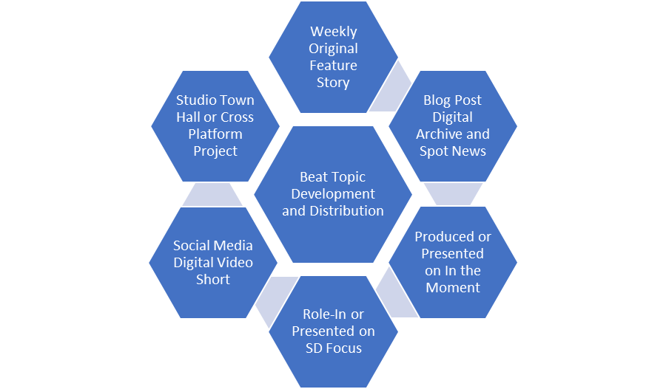 | - Committed to Relevant and Topical Stories  - Assignment Expectations  - Focused Stream of Digital Content  - Regular Segments for In the Moment  - Open or Additional Reporting to SD Focus  - Reporting to Social Media Topic Groups  - In Studio or on Location Engagement  - Cross-Platform Project Leader  - Social Media Audience Development  - Topic Specific Sponsorships  - TBC Beat Specific Advisory Groups  - Documentaries and Special Projects Follow the Same Path and Content Deployment

Education – Early Learning Objectives

Landscape:
Strong Presence serving K-12 Teachers and Promoting SDPB Educational Assets, Limited Pre-K
SDPB 4 – PBS Kids Channel researched to be developmentally and demographically relevant
SDPB 1 – Daytime focus for pre-school ages and early learners
PBS Kids – Online Activities
Indecision and Lack of Comprehensive Leadership and Direction for Pre-School Education

Action:
Contract with and Early Learning Specialist to: Assess, Organization, Advise, Move Forward
Build SDPB Presence and Partnerships with Early Learner “Influencer” Organizations
Align Early Learner Content with SD Guidelines and Plan for Additional Localized resources
Serve: Preschool Professionals, Childcare Providers, and Parents Caring for Children at Home
Corona Virus? Pivot Outreach, Strengthen Communication to Serve Increased Parental Care

What areas of program production in greatest need of additional support and investment (people, equipment, other attention)?
What program themes, topics, or other services need to be created or developed by SDPB to provide the greatest service to South Dakotans?”
Decision-making Criteria:
Long term focus; cross platform workflow/distribution; SF/RC Studio opportunity; Series/on-going project (not a one-off); Demographic variety; audience/public engagement; personal impact
SF/RC Studio A/V Production: What reasonable production skills and staff capacity are needed in SFS and BHS to accommodate increased program development and help in field production;
Education: RV Pre-K Showplace; Science Steve Mobile; Partnership with parents, daycare, K-12 organized efforts to fill the pre-k gap. SDPB/PBS Pre-K on the road too events, summer intern(s)
Programming Content:
Journalism: In South Dakota, the evolution of journalism is more about the lack of resources rather than partisan or “fake news” journalism.
Beats: Where are we; Where can we go; Where do we want to be
Politics and Public Policy – The product of the democratic process and how it impacts South Dakotans.
Business, AG, and Community Development – The Economy. How it impacts people, communities, state-wide.
Education and Healthcare – Caring for and improving our lives with knowledge and opportunity
Technology and Innovation – Research and discovery in South Dakota and feeding our inner-geek
Diversity – Recognizing, understanding, and celebrating the racial mixture and heritage in South Dakota
Entertainment
Storytelling: The stories of who we are and how we express ourselves are virtually non-existent in local media. These are a priority for SDPB and we tell them in various shapes and sizes across our media.
SDHSAA, Sports, and Recreation – Activities we watch, cheer for, and participate in
Place, Community, and Rural – People, places, and things highlighting the personality of South Dakota.
Images of the Past; Dakota Life;
Fine Arts, Literature, Music, and Entertainment – The artistic and creativeness of South Dakota.
History – Recognizing and documenting the past in context to shape our future
Organization; Staffing; Deliverables; Packaging;
Board of Directors of Educational Telecommunications
SDPB Marketing Report
October 2, 2020

Marketing –
Coming Home: South Dakota – this project, funded by CPB, is a public media initiative to increase and promote authentic local storytelling through multi-platform media and engagement that develops and delivers a renewed narrative about life in rural America. New multi-platform content, created by local stations with local voices and talent, will celebrate the diversity, culture, traditions, and richness of small-town America, not being told by commercial media.
The first phase of this initiative includes local planning, pre-production and engagement grants to identify and utilize local talent, producers, filmmakers and local citizens in rural communities to share their stories about what “home” means, in terms of pride of place, culture, and shared values. In partnership with the Chiesman Center for Democracy, a survey is available for SD residents to complete, and a demographic overview of the state has been completed. We are obtaining information from one-on-one interviews and focus groups.
Blood Sugar Rising – A series of on-air conversations and digital shorts about Diabetes will be broadcast in November during International Diabetes Awareness Month. This project was put on hold from April as a result of the pandemic and is being revisited to fulfill the terms of a grant.
Unladylike 2020 – We arranged a virtual screening and discussion about Zitkála-Šá. A segment about this South Dakota Native American activist was produced as part of a national digital series titled Unladylike 2020. Working with the SD Humanities Council we are hosting an online event October 13.
SDPB Rebrand – Since adopting the current version of our logo and brand in 2002 the organization has gone through tremendous evolution. As the organization evolves, and as we learn more about our audiences and potential audiences, our brand needs to evolve with it. With that in mind, we are beginning the process of addressing our brand so that it accurately reflects who we are and who we strive to be. This comprehensive project will take time to accomplish and some basic research has begun. We have an opportunity to coordinate the roll-out of a new brand with the 100th anniversary of KUSD Radio - May 2022. That’s our initial goal. We shall see.

Education & Outreach –
At-home Learning – The education team continues to create and promote at-home learning resources available on TV and online. Steven Rokusek and Kevin Nelson are helping educators, home-schoolers, daycare providers and parents understand where to access and how to utilize our materials.
Early Learning Initiative – Launched April 1 ELI – the SDPB Early Learning Initiative included daily emails to hundreds of subscribers with lessons parents and others can incorporate into their child’s life. These lessons are tied to pre-K programming available on SDPB1-TV and SDPB4-TV. We’re analyzing our summer activities and adjusting to continue making this a useful resource. This project continues to evolve as we partner with more organizations and as the pandemic informs our users’ experience.
PBS LearningMedia – This site is a collection of lessons on a wide array of topics that meet national and state educational standards. We continued to see an increased use of resources well into the summer.
February – 12,137
March – 31,171
April – 62,794
May 2020 – 41,348
June 2020 – 10,084
July 2020 – 5,310
These numbers represent users nationwide who have accessed content that SDPB created and made available via PBS LearningMedia.

SDPB Education Newsletters – We have nearly 3,000 South Dakota educators who receive the monthly SDPB Educators Newsletter that Steven Rokusek distributes.

Social Media continues to grow. The chart below shows results we have experienced for the past two calendar years.

 | Reach | Video Views | Engagement | Total Followers
Apr-18 | 2,070,433 | 470,286 | 100,886 | 88,517
May-18 | 1,434,972 | 452,063 | 101,694 | 89,996
June-18 | 1,071,392 | 257,631 | 62,725 | 91,047
July-18 | 1,254,199 | 394,475 | 77, 906 | 92,293
Aug-18 | 1,188,347 | 287,116 | 64,538 | 93,208
Sept-18 | 1,100,051 | 320,458 | 71,226 | 94,219
Oct-18 | 1,577,034 | 338,082 | 89,758 | 95,694
Nov-18 | 1,709,078 | 312,220 | 76,723 | 97,060
Dec-18 | 1,150,076 | 326,777 | 74,318 | 98,255
Jan-19 | 1,816,748 | 529,368 | 101,444 | 99,202
Feb-19 | 2,103,831 | 558,555 | 122,229 | 100,738
Mar-19 | 3,056,218 | 667,389 | 188,337 | 102,953
Apr-19 | 1,161,827 | 263,455 | 71,390 | 103,995
May-19 | 2,012,852 | 575,691 | 111,076 | 105,385
June-19 | 1,468,889 | 410,952 | 90,824 | 105,637
July-19 | 1,087,014 | 314,809 | 61,848 | 106,478
Aug-19 | 1,111,006 | 271,178 | 72,563 | 107,572
Sept-19 | 1,320,607 | 359,951 | 101,823 | 110,430
Oct-19 | 1,680,617 | 345,853 | 108,361 | 111,795
Nov-19 | 2,834,836 | 705,070 | 165,673 | 113,969
Dec-19 | 1,424,057 | 389,417 | 94,561 | 114,912
Jan-20 | 1,508,649 | 423,847 | 105,694 | 116448
Feb-20 | 2,670,171 | 826,948 | 204,937 | 118,326
Mar-20 | 3,144,057 | 858,916 | 242,471 | 122,601
Apr-20 | 1,450,606 | 361,989 | 102,489 | 124,639
May-20 | 1,889,066 | 479,992 | 145,431 | 125,986
June-20 | 1,765,394 | 523,852 | 127,395 | 127,082
July-20 | 1,259,904 | 242,666 | 97,148 | 128,501
Aug-20 | 854,681 | 195,116 | 61,312 | 130,955

Due to the Coronavirus outbreak, all in-person Marketing events have been canceled or postponed.

Educational Telecommunications Board Report

South Dakota Public Broadcasting Engineering, Digital, and Operations

Submitted by SeVern Ashes

September 16, 2020

FCC Radio licensing window opening for NCE (noncommercial educational) FM AND LPFM STATIONS. Earlier this year FCC Commissioner Paj informed Congress that there will be a window opening for NCE FM stations later this year or early 2021. With this notice I reached out to Doug Vernier our telecommunication consultant and had a frequency study in the Mitchell South Dakota area. The frequency studies show that we are unable to increase the power on our current FM translator. The next best choice at Mitchell would be to apply for a new noncommercial education facility license during the upcoming window. Channel 206, 89.1 MHz is open and will work at our translator tower site. This station can have an excellent power of ~17 kW, depending on the antenna height on the tower. This will serve ~22,000 people within the 60 dBu (60 DBU is a signal strength that a receiver that is located on a first floor inside a building structure can receive). As a reference our current signal can be picked up on the east side of Mitchell right at the James River Bridge and at Betts Road on the west.
If you recall from past reports the Mitchell area reception has suffered since and is our largest area for FM reception trouble calls. The reception problems are due to a full powered commercial radio station going on the air in the Salem area. This full powered station is completely legal and in compliance with all FCC rules and regulations they are simply overpowering our 9 W translator in the Mitchell area. If we were to apply for and receive a new license at 17 W we would effectively restore SD PB radio to the city of Mitchell SD. While adding SDPB Radio and Primary EAS alerting service to new households in the surrounding communities. For your consideration to apply for the permanent full power license in the Mitchell area. (The map represents the proposed NEW Licensing coverage area)
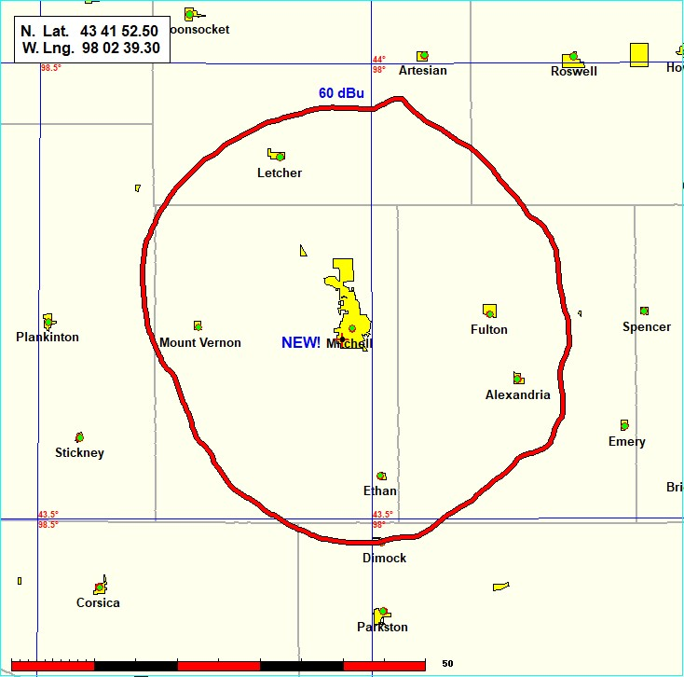

IBOC FM KZSD, KQSD, KPSD - Update (We have confirmed Licenses have been issued and we should have them in place early October. --- New HD FM Transmitters for KZSD 102.5 MHz Long Valley/ Martin and KPSD 97.1 MHZ. Faith /Eagle Butte. Equipment is on site and will be installed throughout the summer. With the new transmitters IBOC aka HD-1 and HD-2 Classical 24 while available in these areas with this newly acquired HD license for our Lowry FM 91.9 MHz station. By the end of summer every full powered FM station within the SDPB-FM network will have HD radio available to the public. (Note: FM Low power translator stations will remain analog main channel programing only.

FCC DATES:

July 31, 2020 was the deadline for uploading contact information for Dish and DirecTV, and for terrestrial cable TV operators.

Oct 1, 2020 - Noncommercial educational television stations ware no longer be required to request carriage on DBS systems in writing every three years. Instead, we will be required to upload a single, one-time only carriage request to the FCC online database called OPIF. We have submitted 2 must requests

KCSD Prairie Winds with an alternative station KUSD Beresford for the Sioux Falls /Mitchell DMA

KBHE Rapid City SD. For the Rapid City DMA

Dec 1, 2020 –

Annual EEO report, we are working with BIT Bureau Human Resources on this filing FM License renewal applications for radio broadcast stations in South Dakota are due to be filed with the FCC.

Dec 1. We are working with our FFC Attorney Howard Lieberman in Washington DC to submit a separate application for each of our FM stations.

The FCC has eliminated the requirement for pre-filing announcements, but the post-filing announcement obligation remains. Starting on December 1, for the next three months, post- filing announcements need to be aired.

Looking Ahead:
Buffalo Round up Live Stream

Fall SDHSAA Events
Legislative Coverage

South Dakota Board of Educational Telecommunications
Entertainment Team Report
October 2020

SDPB Sports – The first SDHSAA championship is right around the corner the sports group has been telling stories about South Dakota’s young athletes since the abrupt end to last season. COVID 19 is top of mind with everyone in high school athletics and SDPB’s coverage has been popular on social media and our website. The article written by Nate Wek titled “What’s the Key for this to Work?” reached over 12 thousand people on Facebook and 930 reads on the SDPB web page. The video package produced about the history of two Bon Homme football coaches and their unique relationship with each other and their community garnered 27,000 views on Facebook and reached over 60,000 people. Two articles written about the about the upcoming volleyball season each received more than 1100 reads. SDPB’s coverage of SDHSAA is well under way and the first tournaments, Boys Class A & AA Golf and Girls Class A Tennis will be held Oct. 5th & 6th followed by Girls Class AA Tennis on Oct. 8th & 9th.

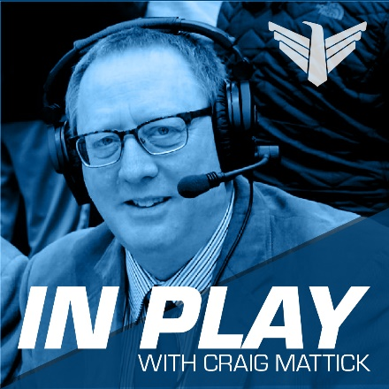
September was also the launch of SDPB’s latest podcast “In Play with Craig Mattick”. Craig has been announcing SDPB’s tournament coverage for almost 20 years and will now take a deeper dive into High School sports and activities from the past to the present. The podcast is released on the 2nd and 3rd Tuesday of each month. The September 8th episode highlighted how coaches and the SDHSAA are dealing with Covid 19. The formation of the All Nations Football Conference last year and how the conference is expanding. The September 22nd episode featured the career of legendary basketball player Harold Thune and his impact on high school sports as a player and a coach.

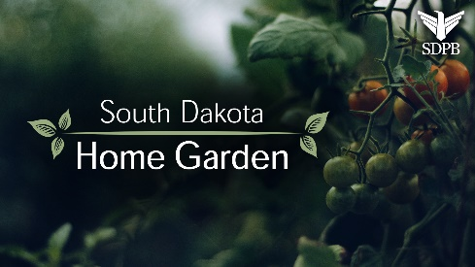
South Dakota Home Garden - As the growing season comes to end for backyard gardeners the entertainment group is also wrapping up production on the digital series South Dakota Home Garden. Twenty digital videos were produced on a wide range of garden and landscape ideas and tips, one video was released each week beginning at the end of April. The videos were shared on Facebook and averaged 3200 views per video with the video on “Hanging Baskets” receiving 9400 views. The stories are also available on YouTube, SDPB watch and the SDPB web page where the blog post received 511 reads with Flower Plants having 138 reads. Each week the host of South Dakota Home Garden, Erik Helland, is a guest on SDPB’s In the Moment for a discussion with host Lori Walsh on the weekly garden topic. This has been a successful partnership with Erik Helland of Landscape Garden Centers and has been shared across all platforms on SDPB, the Entertainment Group is making plans to continue this program in the 2021 growing season.

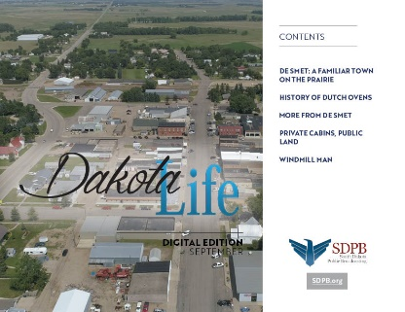
Dakota Life - The season kicks off with two new concepts of connecting with our audience. First, we have taken the program on the road by traveling to a different community each month. Host Larry Rohrer records the stand-up portion of the show on location. Our first stop was the community of De Smet. The program features stories, history and interesting things about the community as Larry transitions between stories. The second addition to Dakota Life is a new look on the Dakota Life Digital Edition this digital publication has transitioned from a webpage format to digital magazine format like the SDPB Monthly Magazine. The digital edition will be shared on social media, newsletters and on sdpb.org and will be available the third week of each month.

History – Two historical documentaries were produced of the last few months. Simple Justice: Suffrage in South Dakota aired on August 19th and chronicles the women of South Dakota that battled for their right to vote. This documentary was produced with many cross-platform components leading up to the broadcast on radio’s In the Moment as well as digital content on social media and at sdpb.org.
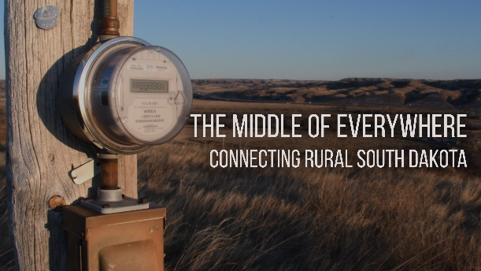
The Middle of Everywhere: Connecting Rural South Dakota explores the advances made over the last century and a half that allowed South Dakota to stay connected to both each other and beyond our borders. The documentary has been under production over the summer and has also utilized all the platforms at SDPB. The video stories released on social media have received 35,000 views so far with 3 more videos to be releases leading up to the November broadcast of the program.

Images of the Past also premiered in September with a look at the history of the Custer State Park Buffalo Round-up as its first episode of the season on In The Moment and sdpb.org. This lead up to our live stream coverage of the 2020 Custer State Park Buffalo Round-up on September 25th. The Entertainment Team continues its work on music programing with TV and Radio broadcast “No Cover No Minimum” and “Jazz Nightly” with blog post on sdpb.org. You can dig into the music and check out “Behind the Beat” or our other blog series about music.

South Dakota Board of Educational Telecommunications
SDPB Television
October 2020

Programming
TV Viewership in July:

SDPB Television viewership is measured in the Sioux Falls and Rapid City markets. Sioux Falls ranks #113 out of 210 by market size with 229,420 TV households and 0.214 % of the US population. Rapid City ranks #169 out of 210 US markets with 86,610 TV households and 0.081% of the US population. Measurement is done by a combination of Nielsen encoders in the homes of a random sample of each market and return path data from program providers such as satellite providers and cable systems.

This year’s July measurement period ran from July 2nd to July 29th.

Our July Nielsen ratings show that 369,691 individual viewers, tuned in to SDPB’s four channel during the month. 55.9% of TV households across both markets tuned to SDPB’s main channel.

Most watched programs in July 2020

1. Images of the Past (following Rodeo) 6790 viewers
2. High School Rodeo Finals (Thursday premiere) 5430 viewers
3. Antiques Roadshow Monday at 7 average 5120 viewers
4. A Capitol 4th 5330 viewers
5. Lucy Worsley’s Royal Secrets 5320 viewers
6. Antiques Roadshow Monday at 8 average 5040 viewers
7. Grantchester average 4770 viewers
8. Masterpiece Elizabeth the 1st 4680 viewers
9. As Time Goes By 4610 viewers
10. America’s Test Kitchen average 3540 viewers

Radio Listenership in August
SDPB Radio listenership is measured via online live streaming numbers with no over-the-air measurement available. In August, our streaming audience saw 59,699 total listening hours and 11,419 cumulative streaming audience. SDPB Radio listenership is measured via online live streaming numbers with no over-the-air measurement available.

Television program changes
In an effort to improve audience flow and to freshen up our longtime Saturday late afternoon and evening schedules, we dropped Classic Gospel Saturdays at 5pm and reworked the early Saturday night lineup. We are now airing Lawrence Welk at 5pm, Carol Burnett’s Favorites at 6pm, Keeping Up Appearances at 7, As Time Goes By at 7:30. This will further change with the addition of the Frankie Drake Mysteries at 8pm starting in mid-October.
The SDPB Learner’s Connection block of programming weekdays from 11am to 4pm on SDPB 2 will continue through at least the end of the year. This special programming serves students from grades 6 through 12. This consists of a daily special broadcast of both national and local, South Dakota focused learning material, along with a full slate of educational materials, student discussion guides, and additional learning materials. This block supplements our SDPB Kids channel which features educational material for preschoolers, and our main channel PBS kids programming which features programs geared toward elementary students.

Radio schedule changes

As of September 5th, SDPB has dropped Live from Here. The program had been providing reruns since early August and has discontinued any further production. Our Saturday lineup now consists of Conversations from the World Café at 5, and Live from the Mountain Stage at 6 on Saturdays.

We will be dropping the second hour of the weekday morning program On Point. The show’s distributors have notified us that they will no longer be offering a second hour. We will add the daily program 1A in the 10am timeslot starting October 5th.

Due to the timeliness of the topic and as part of a multi-platform project, we produced a special edition of South Dakota Focus on economic issues related to the pandemic in South Dakota on August 13th. The regular new season premiered on September 10th.

The On Call with the Prairie Doc series premiered a new season of live programs on September 10th They continue to create new shows each week providing medical information.

Fundraising
The SDPB Radio spring on-air fundraising drive was held May 18-23rd. A total of over $46,201 was raised from 196 donors. Our next on-air radio fundraising drive will be held

Our annual Television August/September on-air membership drive ran August 29th through September 6th, with special outside of normal drive pledge programs on September 12 and 13th. We raised a total of $53,614 from 326 pledges and gained 76 sustaining members. Our best performing programs included Suze Orman’s Ultimate Retirement Guide, Feel Better Fast, memory Rescue and Riverdance 25th Anniversary.

Our next full drive will be November 28th December 6th.

ET Board Report
Journalism Team – Cara Hetland
September 2020

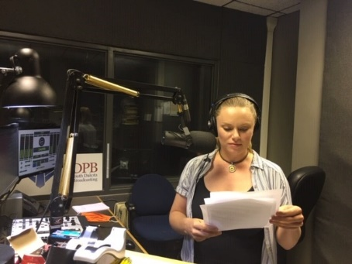
Staffing: The J-Team welcomes Megan Feighery as our new local host for All Things Considered. Megan comes to SDPB from Wyoming Public Radio. Megan grew up in southern California and received her Bachelor and Master’s degrees from Cal State, Fullerton. Megan spent a year in the Republic of Georgia, and four years in Japan. She says she is thrilled to be in a state where you don’t have to look up to see the sky. Special thanks to Steve Zwemke for filling in as an interim host.

Content Highlights:

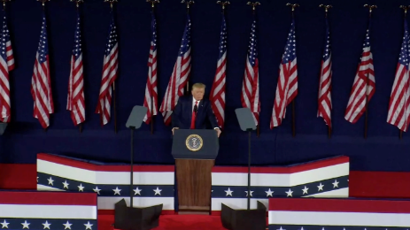
Presidential Visit, July 3, we had complete coverage with reporters, Lee Strubinger, Seth Tupper, Richard Two Bulls, Chynna Lockett and Michael Zimny capturing audio and video around the black hills, of the event, protestors, and the fireworks.

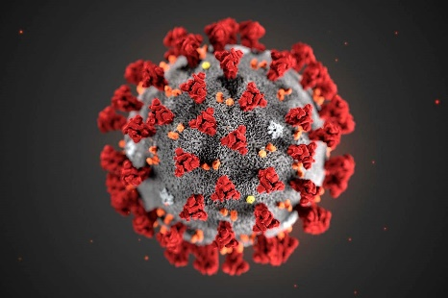
Covid19 Coverage – In the Moment and South Dakota Focus continue with ongoing coverage. In the Moment has weekly updates each Monday asking the important question “what do we know today that we didn’t know last week?” We have rotating medical experts from Sanford, Avera and Monument healthcare systems. Jackie Hendry has put together a multi-platform project that aired in August on back to school issues. Stephanie Rissler had a special South Dakota Focus on the same topic to compliment the coverage looking at individual districts and their plans of returning to school. Lee Strubinger follows the policies being recommended regarding masks and different perspectives around the state. He also worked with NPR on our coverage of the Sturgis Motorcycle Rally. Seth Tupper is working on the economics and business challenges regarding what’s happening with the pandemic. Richard Two Bulls follows how our sovereign tribes in the state are addressing the pandemic.
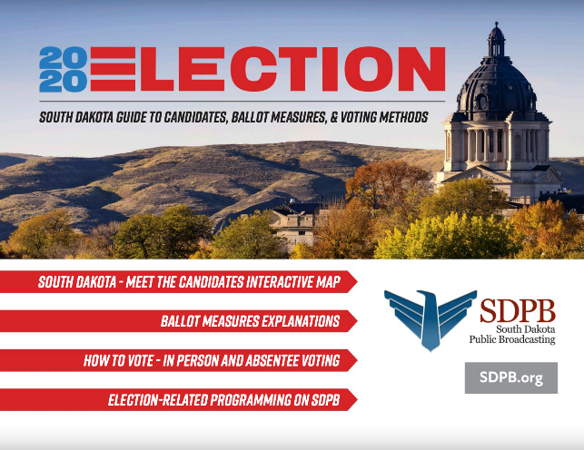
Election Coverage – We have produced an interactive election guidebook. Josh Haiar brought a fresh perspective and asked why we don’t have one place for people to go to learn how to vote and also have everything they need to know to make their choices. There is an interactive map that when you click on your legislative district you can hear the interviews with those candidates. There are short videos explaining the ballot questions. There are also links to the secretary of state absentee voting request sights and voter registration, as well as lists of our election related programming and debates. We will continue to populate this site with our ongoing coverage. Special thanks to Matti Smith and Heather Benson from our Marketing team with their assistance in putting this together. The full link is here.
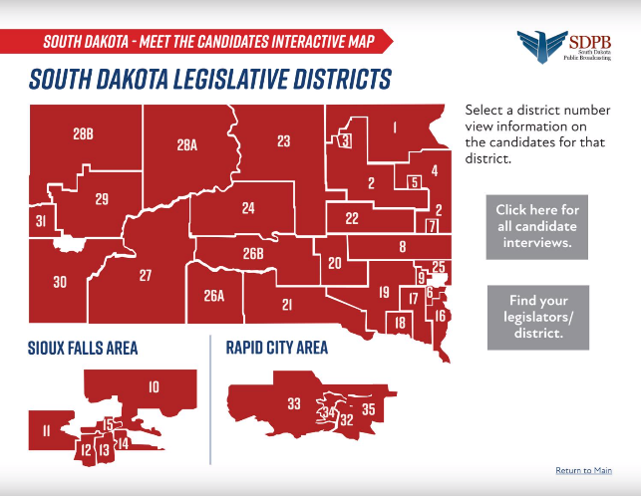
Debates – Presidential debates will air on tv and radio, September29, October 5 and October 22. The Vice-Presidential Debate is October 7. TV will air our US Senate Forum will air on October 13 and the US House candidate forum is on October 20. A special ballot issues program will air on October 29.
Meet the Candidates – we began this series July 6, with interviewing legislative candidates on the November ballot. We try to have four to six candidates on each week. We have heard from about half the candidates who are interested in these live radio interviews.
You and Your Democracy – These are short discussions about the constitution and why democracy matters, hosted by Chuck Parkinson. We have started airing these on In the Moment and also on our social media platforms.
Dakota Life Features – the J team was encouraged this summer to produce some feature stories to use in future Dakota Life segments. It’s a great way to do some feature storytelling about people and places of importance to South Dakota.
Women’s Suffrage - We concluded our summer of women focusing on the historic look at women’s suffrage with a compilation podcast. You can find it at https://www.sdpb.org/blogs/history/in-the-moment-podcast-suffrage-in-south-dakota/
Music: We conclude our Summer with the Symphony series that featured several recorded concerts by the South Dakota Symphony Orchestra and interviews with the maestro and performers. Matt Weesner assisted with the production. This aired every Monday this summer.

