Annual Report
2014-2015
South Dakota Special Education Advisory Panel on Students with Disabilities

Governor’s Special Education Advisory Panel on Students with Disabilities

The South Dakota Department of Education, Special Education Programs is pleased to present this annual report to the Governor of South Dakota. This report describes the programs, priorities and activities the Advisory Panel has participated in for the 2014-2015 school year, and represents the continuing progress toward meeting the goal of the Department.

800 Governor’s Drive
Pierre, SD 57501
(605) 773-3134

Letter from the Chairperson and Vice Chairperson

To the Governor of South Dakota,

The South Dakota Advisory Panel for Children with Disabilities continues its service in an advisory role and advocate for children with disabilities and their educational opportunities. This annual report highlights the priorities, recommendations and activities of the panel for the past year.

The board is committed to working to enhance the lives of people with disabilities. Professionals representing different areas of expertise work together to provide insight, input, guidance and direction to the office of Special Education so that South Dakota can continue to provide our students with the best possible education

Team efforts and focus during this past year, July 1, 2014 – June 30, 2015, have been highlighted by ongoing consultation, training, sharing, input and updates with the state office of Special Education.

Marie Ivers, Chairperson
Penny McCormick-Gilles, Vice Chairperson
Table of Contents
Letter from the Chair and Vice Chair | 3
The South Dakota Advisory Panel | 5
Requirements in the Administrative Rules of South Dakota | 5-6
Panel Responsibilities | 7
Membership | 8-9
Panel Priorities
Behavioral Health | 10
Funding | 11
Unmet Needs | 12-13
Meeting Dates | 14
State Performance Plan Indicators | 15

The South Dakota Advisory Panel
The South Dakota Advisory Panel, composed of individuals from around the state and selected by the Governor of South Dakota, advises the Department of Education, Special Education Programs (SEP) on issues related to students with disabilities.
In compliance with this responsibility the panel conducts public meetings throughout the state. During this year, the panel met in Sioux Falls, Custer and Pierre.
The panel’s role as a stake holder group for the State Performance Plan and the Annual Performance Report is vital. The SEP wishes to thank the panel for their assistance and guidance.
Another issue addressed by the panel was the declining number of special education teachers and related service providers throughout the state. The panel also advised the SEP on ways to improve the information provided to parents by the school districts and increase parent participation in the yearly surveys requesting parent input as to the services provided to their children.

Requirement in the Administrative Rules of South Dakota

24:05:14:18.State advisory panel -- General.
The department shall establish and maintain an advisory panel for the purpose of providing policy guidance with respect to special education and related services for children with disabilities in the state.

24:05:14:19. State advisory panel -- Membership.
The advisory panel must consist of members appointed by the Governor, or any other official authorized under state law to make such appointments, be representative of the state population, and be composed of individuals involved in, or concerned with, the education of children with disabilities, including:

(1) Parents of children with disabilities, ages birth through 26;
(2) Individuals with disabilities;
(3) Teachers;
(4) Representatives of institutions of higher education that prepare special education and related services personnel;
(5) State and local education officials, including officials who carry out activities under subtitle B of title VII of the McKinney-Vento Homeless Assistance Act, as amended to January 1, 2007;
(6) Administrators of programs for children with disabilities;
(7) Representatives of other state agencies involved in the financing or delivery of related services to children with disabilities;
(8) Representatives of private schools;
(9) Not less than one representative of a vocational, community, or business organization concerned with the provision of transition services to children with disabilities;
(10) A representative from the state child welfare agency responsible for foster care; and
(11) Representatives from the state juvenile and adult corrections agencies.

A majority of the members of the panel must be individuals with disabilities or parents of children with disabilities, ages birth through 26.

24:05:14:20. State advisory panel -- Duties.
The advisory panel shall:

(1) Advise the department of unmet needs within the state in the education of children with disabilities;
(2) Comment publicly on any rules proposed by the department related to the education of children with disabilities;
(3) Advise the department in developing evaluations and reporting on data to the U.S. Secretary of Education under section 618 of the IDEA;
(4) Advise the department in developing corrective action plans to address findings identified in federal monitoring reports under Part B of the IDEA; and
(5) Advise the department in developing and implementing policies related to the coordination of services for children with disabilities.

Panel Responsibilities

- Advise the SEA of unmet needs within the State in the education of children with disabilities.
- Comment publicly on any rules or regulations proposed by the State regarding the education of children with disabilities.
- Advise the SEA in developing evaluations and reporting on data to the Secretary under section 618 of the Act.
- Advise the SEA in developing corrective action plans to address findings identified in Federal monitoring reports under Part B of the Act.
- Advise the SEA in developing and implementing policies relating to the coordination of services for children with disabilities.
- Review and comment on final due process hearing findings and decisions.
- Advising on eligible students with disabilities in adult prisons. The advisory panel also shall advise on the education of eligible students with disabilities who have been convicted as adults and incarcerated in adult prisons.

Membership
Name: Marie Ivers  Chairperson  Representation: Parent, Special Education Administrator  Address: Brookings, SD  Term Ends: 06/30/2015 | Name: Penny McCormick-Gilles  Vice Chairperson  Representation: Other State Agencies/Cooperative  Address: Mount Vernon, SD  Term Ends: 7/09/2015 | Name: Karolyn Baumann  Representation: Parent  Address: Brandon, SD  Term Ends: 06/30/2015
Name: Roger Bowie  Representation: Parent  Address: Sioux Falls, SD  Term Ends: 06/30/2015 | Name: Jody Carpenter  Representation: Parent  Address: Brookings, SD  Term Ends: 06/30/2015 | Name: Heather Stettnichs  Representation: Parent  Address: Sioux Falls, SD  Term Ends: 6/30/2015
Name: Dr. Greg Cooch  Representation: Higher Education Preparer of Special Education and Related Service Providers  Address: Spearfish, SD  Term Ends: Appointed | Name: Traci Glanzman  Representation: Individual  Address: Pierre, SD  Term Ends: 6/30/2015 | Name: Michelle Greseth  Representation: Special Education Administrator, Parent  Address: Sisseton, SD  Term Ends: 6/30/2015
Name: Bernie Grimme  Representation: Transition and State Agency Responsible for Financing and Delivering Related Services.  Address: Pierre, SD  Term Ends: Appointed | Name: Lisa Heckenlaible  Representation: Special Education Administrator  Address: Mitchell, SD  Term Ends: 6/30/2015 | Name: Doug Herrmann  Representation: State Juvenile Corrections  Address: Custer, SD  Term Ends: Appointed
Name: Sara Hoogheem  Representation: Parent, Special Education Teacher  Address: Clark, SD  Term Ends: 06/30/2015 | Name: Judy Hoscheid  Representation: State Child Welfare Agency responsible for Foster Children  Address: Pierre, SD  Term Ends: Appointed | Name: Sarah Carda  Representation: Parent  Address: Yankton, SD  Term Ends: 06/30/2015

Name: Laura Johnson-Frame  Representation: McKinney-Vento  Address: Pierre, SD  Term Ends: Appointed | Name: Mark Krogstrand  Representation: Individual with a Disability, Administrator  Address: Aberdeen, SD  Term Ends: 6/30/2016 | Name: Kerry Larson  Representation: Parent  Address: Sioux Falls, SD  Term Ends: 06/30/2015
Name: Shelly Shaw  Representation: Special Education Teacher, Parent  Address: Mission, SD  Term Ends: 06/30/2015 | Name: Erin Schons  Representation: Private School  Address: Sioux Falls, SD  Term Ends: 8/30/2017 | Name: Linda Turner  Representation: State Director of Special Education  Address: Pierre, SD  Term Ends: Appointed
Name: Merle Doolittle  Representation: Secretary, SDDOE  Address: Pierre, SD  Term Ends: Appointed | Name: Ben Morrison  Representation: Program Specialist, SDDOE  Address: Pierre, SD  Term Ends: Appointed

20 panel members from across South Dakota, 12 of these members represent as parents or individuals with disabilities, 60% of the membership.
Panel Priorities
- Behavioral Health
- Funding
- Unmet Needs
  - Transition
  - Highly Qualified teacher
  - Service Providers

Priority 1 Behavioral Health

Member Participants: Greg Cooch, Lisa Heckenlaible, Erin Schons, Roger Bowie, Judy Hoscheid, Shelly Shaw, Kerry Larson, Marie Ivers

Activities:
- Restraints and Seclusion
  - Had a workgroup meeting last week.
  - South Dakota is only 1 of 2 states that doesn’t have a law regarding this.
  - Questions regarding what kind of restraints will be included – chemical, physical, mechanical.
  - Will there be a universal form of non-physical training that is required (CPI)
- Autism Rules Updates
  - Updated rules based off of DSM-V, which we previously used DSM – IV
  - Went over all 5 changes to the SM – starting in 1952
  - DSM-V changes eliminated Pervasive and removed Rhetts disorder
  - Autism, Aspergers, PDD-NOS all moved into Autism spectrum disorder
  - Team consists of school psych, SPED teacher, Speech, and Occupational Therapists, which they all must have experience working with a student with autism.
  - for example)

Priority 2 Funding

Member Participants:
Jody Carpenter, Michelle Greseth, Penny McCormick-Gilles, Tracy Glanzman, Karolyn Baumann

Activities:
- State Application for Funds
Currently funds are required for specific activities include monitoring, complaint investigation, Facilitators, mediations, and SD Parent Connections Navigator Program. Authorized activities are for support and direct services, including technical assistants, personnel preparation, and professional development and training. These funds help deliver the SPP Coordinators, SSIP Activities and Technical Assistance Contracts for the districts. To assist LEA’s in providing positive behavioral interventions and supports and appropriate mental health services for children with disabilities the State budgets fund for PBIS and Family preservation. Funds are also budgeted for other purposes, such as technology, transition to post-secondary, and development and provision of appropriate accommodations for children with disabilities.

Results/Recommendations:
- Understanding of educational funding, and relation to unmet needs of students with disabilities. Recommend that funding continue

Priority 3 Unmet Needs

Member Participants:
Sara Hoogheem, Laura Johnson-Frame, Doug Hermann, Sarah Carda, Mark Krogstrand, Heather Stettnichs, Bernie Grimme

Activities:
- Comprehensive Plans
  - Broke into small groups and went over different sections
  - Panel identified issues they came across and Linda gathered their notes and will compile issues
- Parents Rights
  - Broke into small groups
  - Took suggestions
  - Michelle Bennett wrote the draft
- SSIP – State Systemic Improvement Plan – Indicator 17(Dawn Wirth)
  - SSIP Framework – Using stakeholder input and looking at what we are doing as a department
  - Look at data, identify biggest area of need – Reading – increase proficiency by 3rd grade for SLD students
  - Achievement gap – based off of our statewide assessment on reading proficiency – 3rd Grade General Education 78% proficient – Students with Disabilities– 53% and Specific Learning Disabilities – 36% 11th Grade General Education – 70%, Students with Disabilities 26%, Specific Learning Disabilities 13%
  - SiMR – State-identified Measureable Result – Student with specific learning disabilities will increase reading proficiency by fourth grade from 36%, to 45% by 2018, as measure by statewide assessments
  - Baseline 36.05% - 1.724% per year increase 2014-37.77%, 2015 – 39.5%, 2016-41.22%,2017 – %42.95, 2018 – 44.67%, coherent improvement strategies, data analysis instructional strategies, parent involvement, Pilot districts include Aberdeen, Andes central , Kadoka, Rapid city, Sioux Falls, Vermillion

Result/Recommendation:
- Comprehensive Plans
  - Edited and accepted by the panel
  - Changes adopted
  - Document was released in September
- Parents Rights
  - Recommended to add introduction and table of contents
  - Add Parent 1st language
  - Changes were adopted
  - Document released in July

Meeting Dates 2014-2015

September 30th
Deadwood Mountain Grand, Deadwood, SD

January 13th
AmericInn, Chamberlain, SD

March 23rd – 24th
South Dakota School for the Deaf, Sioux Falls, SD

June 2nd
MacKay Conference room #1, Pierre, SD

** A copy of the meeting minutes can be found on the SDDOE website:
http://doe.sd.gov/oess/sped_advisory.aspx
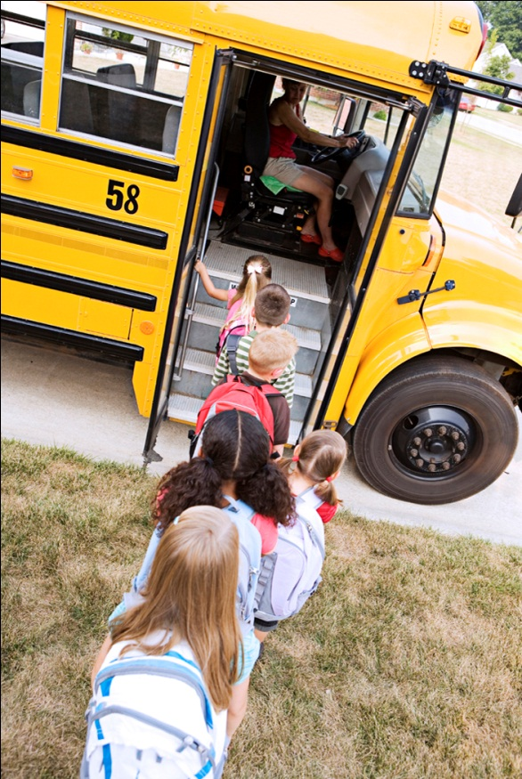

17 Indicators in the SPP
Indicator 1 —Improving graduation rates for students with disabilities
Indicator 2 —Decreasing dropout rates for students with disabilities
Indicator 3 —Ensuring all students with disabilities participate in statewide assessment
Indicator 4 —Reducing suspension and expulsion rates for students with disabilities
Indicator 5 —Providing services for students with disabilities in the least restrictive environment.
Indicator 6 —Providing preschool children with disabilities services in the least restrictive environment
Indicator 7 —Improving cognitive and social outcomes for preschool children with disabilities
Indicator 8 —Improving parent involvement in their child’s special education program
Indicator 9 —Reducing disproportionality of cultural groups in special education
Indicator 10—Reducing the number of students from other cultures in certain disability categories
Indicator 11—Improving efforts to locate, evaluate, and serve students with disabilities
Indicator 12—Ensuring a smoother transition from preschool programs to school-based programs
Indicator 13—Improving transition services for students with disabilities at the secondary level, i.e., 16+ years
Indicator 14—Improving the outcomes for students moving from secondary to postsecondary activities
Indicator 15—Making sure school districts correct noncompliance areas in the special education program within one year
Indicator 16—Decrease the number of mediation held within a year.
Indicator 17 – State Systemic Improvement Plan

