Annual Report
2015-2016
South Dakota Department of Education Special Education Advisory Panel

South Dakota Department of Education Special Education Advisory Panel

The South Dakota Department of Education, Special Education Programs is pleased to present this annual report to the Governor of South Dakota. This report describes the topics discussed and recommendations made, along with priorities and activities the Advisory Panel has participated in for the 2015-2016 school year, and represents the continuing progress toward meeting the goal of the Department.

800 Governor’s Drive
Pierre, SD 57501
(605) 773-3134

Letter from the Chairperson and Vice Chairperson

To the Governor of South Dakota,

The South Dakota Department of Education Special Education Advisory Panel continues its service in an advisory role and advocate for children with disabilities and their educational opportunities. This annual report highlights the priorities, recommendations and activities of the panel for the past year.

The board is committed to working to enhance the lives of people with disabilities. Professionals representing different areas of expertise work together to provide insight, input, guidance and direction to the office of Special Education so that South Dakota can continue to provide our students with the best possible education

Team efforts and focus during this past year, July 1, 2015 – June 30, 2016, have been highlighted by ongoing consultation, training, sharing, input and updates with the state office of Special Education.

Marie Ivers, Chairperson
Penny McCormick-Gilles, Vice Chairperson
Table of Contents
Letter from the Chair and Vice Chair | 3
The South Dakota Advisory Panel | 5
Requirements in the Administrative Rules of South Dakota | 5-6
Panel Responsibilities | 7
Membership | 8-9
Panel Priorities
Secondary Transition | 10
Topics Covered | 11
Presentations to the Board | 12
Advisory Panel Group Statements Released to the Public | 13
Meeting Dates | 14
State Performance Plan Indicators | 15

The South Dakota Advisory Panel
The South Dakota Advisory Panel, composed of individuals from around the state and selected by the Governor of South Dakota, advises the Department of Education, Special Education Programs (SEP) on issues related to students with disabilities.
In compliance with this responsibility the panel conducts public meetings throughout the state. During this year, the panel met in Sioux Falls, Custer and Pierre.
The panel’s role as a stakeholder group for the State Performance Plan and the Annual Performance Report is vital. The SEP wishes to thank the panel for their assistance and guidance.
Another issue addressed by the panel was the declining number of special education teachers and related service providers throughout the state. The panel also advised the SEP on ways to improve the information provided to parents by the school districts and increase parent participation in the yearly surveys requesting parent input as to the services provided to their children.

Requirement in the Administrative Rules of South Dakota

24:05:14:18. State advisory panel -- General.
The department shall establish and maintain an advisory panel for the purpose of providing policy guidance with respect to special education and related services for children with disabilities in the state.

24:05:14:19. State advisory panel -- Membership.
The advisory panel must consist of members appointed by the Governor, or any other official authorized under state law to make such appointments, be representative of the state population, and be composed of individuals involved in, or concerned with, the education of children with disabilities, including:

(1) Parents of children with disabilities, ages birth through 26;
(2) Individuals with disabilities;
(3) Teachers;
(4) Representatives of institutions of higher education that prepare special education and related services personnel;
(5) State and local education officials, including officials who carry out activities under subtitle B of title VII of the McKinney-Vento Homeless Assistance Act, as amended to January 1, 2007;
(6) Administrators of programs for children with disabilities;
(7) Representatives of other state agencies involved in the financing or delivery of related services to children with disabilities;
(8) Representatives of private schools;
(9) Not less than one representative of a vocational, community, or business organization concerned with the provision of transition services to children with disabilities;
(10) A representative from the state child welfare agency responsible for foster care; and
(11) Representatives from the state juvenile and adult corrections agencies.

A majority of the members of the panel must be individuals with disabilities or parents of children with disabilities, ages birth through 26.

24:05:14:20. State advisory panel -- Duties.
The advisory panel shall:

(1) Advise the department of unmet needs within the state in the education of children with disabilities;
(2) Comment publicly on any rules proposed by the department related to the education of children with disabilities;
(3) Advise the department in developing evaluations and reporting on data to the U.S. Secretary of Education under section 618 of the IDEA;
(4) Advise the department in developing corrective action plans to address findings identified in federal monitoring reports under Part B of the IDEA; and
(5) Advise the department in developing and implementing policies related to the coordination of services for children with disabilities.

Panel Responsibilities

- Advise the SEA of unmet needs within the State in the education of children with disabilities.
- Comment publicly on any rules or regulations proposed by the State regarding the education of children with disabilities.
- Advise the SEA in developing evaluations and reporting on data to the Secretary under section 618 of the Act.
- Advise the SEA in developing corrective action plans to address findings identified in Federal monitoring reports under Part B of the Act.
- Advise the SEA in developing and implementing policies relating to the coordination of services for children with disabilities.
- Review and comment on final due process hearing findings and decisions.
- Advise on eligible students with disabilities in adult prisons. The advisory panel also shall advise on the education of eligible students with disabilities who have been convicted as adults and incarcerated in adult prisons.

Membership
Name: Marie Ivers  Chairperson  Representation: Parent, Special Education Administrator  Address: Brookings, SD  Term Ends: 06/30/2018 | Name: Penny McCormick-Gilles  Vice Chairperson  Representation: Other State Agencies/Cooperative  Address: Mount Vernon, SD  Term Ends: 7/09/2018 | Name: Betsy Schwenk  Representation: Parent  Address: Harrisburg, SD  Term Ends: 06/30/2018
Name: Larry Ayres  Representation: Parent  Address: Brookings, SD  Term Ends: 06/30/2018 | Name: Stacy Haber  Representation: Parent  Address: Sioux Falls, SD  Term Ends: 06/30/2015 | Name: Lori Larson  Representation: Parent  Address: Rapid City, SD  Term Ends: 6/30/2015
Name: Dr. Donna Johnson  Representation: Higher Education Preparer of Special Education and Related Service Providers  Address: Marion, SD  Term Ends: Appointed | Name: Traci Glanzman  Representation: Individual  Address: Pierre, SD  Term Ends: 6/30/2015 | Name: Bernie Grimme  Representation: Transition and State Agency Responsible for Financing and Delivering Related Services.  Address: Pierre, SD  Term Ends: Appointed
Name: Kaitlynn Donohoe  Representation: State Juvenile Corrections  Address: Rapid City, SD  Term Ends: Appointed | Name: Sara Hoogheem  Representation: Parent, Special Education Teacher  Address: Clark, SD  Term Ends: 06/30/2018 | Name: Judy Hoscheid  Representation: State Child Welfare Agency responsible for Foster Children  Address: Pierre, SD  Term Ends: Appointed
Name: Sarah Carda  Representation: Parent  Address: Yankton, SD  Term Ends: 06/30/2018 | Name: Laura Johnson-Frame  Representation: McKinney-Vento  Address: Pierre, SD  Term Ends: Appointed | Name: Mark Krogstrand  Representation: Individual with a Disability, Administrator  Address: Aberdeen, SD  Term Ends: 6/30/2016

Name: Shelly Shaw  Representation: Special Education Teacher, Parent  Address: Mission, SD  Term Ends: 06/30/2018 | Name: Erin Schons  Representation: Private School  Address: Sioux Falls, SD  Term Ends: 8/30/2017 | Name: Linda Turner  Representation: State Director of Special Education  Address: Pierre, SD  Term Ends: Appointed
Name: Merle Doolittle  Representation: Secretary, SDDOE  Address: Pierre, SD  Term Ends: Appointed | Name: Ben Morrison  Representation: Program Specialist, SDDOE  Address: Pierre, SD  Term Ends: Appointed

18 panel members from across South Dakota, 10 of these members represent as parents or individuals with disabilities, 56% of the membership.
Panel Priority – Secondary Transition

Panel Recommendations:
- Recommendation 1: Utilizing Lifespan folder to assist teachers and families with transition:
  - Lifespan folder- Dept. Of Human Services (Birth to Aging)- 1-800-265-9684 dhs.sd.gov

- Recommendation 2: Create posters with QR reader for Lifespan Folder to be utilized in areas with high traffic participants

- Recommendation 3: Create training videos. Distribute to State Special Education Dept., Parent Connections, TSLP, Parents, Teachers, and other providers as well as high transition traffic areas.
  - Video 1: For Teachers- This video is to exhibit a variety of stages of transition. Panel recommends using the Training Video with teachers to help utilize existing resources during IEP and transition meetings.
    - Create a checklist of Transition Scenarios to be utilized during IEP and transition meetings
  - Video 2: For parents: Help families understand transition and their responsibilities.

- Recommendation 4: Panel recommends utilizing programs such as: sdmylife.com and http://www.itransitionks.org/
  - In conjunction with sdmylife.com the panel recommends creating a video game for students and parents walking through the stages of transition

- Recommendation 5: Panel recommends adding Transition Services Liaison Project (TSLP) contact information to the Department of Human Services Lifespan folder.

- Recommendation 6: Panel recommends creating a one page parent informational flyer based on the TSLP Parent Transition Checklist to be distributed to high traffic transition participation areas.

Topics Covered

For full details of topics covered and meeting minutes, please visit the State of South Dakota Board of Commissions Website at:

SD Advisory Panel for Children with Disabilities Board Meeting Minutes

Restraint/seclusion Proposed Policy Review (9/17- SEP, 1/22 – SEP)
Interagency Agreements Updates (9/17- SEP)
Compliance Determinations (9/17 – SEP)
Complaints/Mediations (9/17 – SEP)
Dispute Resolutions (9/17 – SEP)
Due Process Hearings and Resolutions (9/18 – SEP)
NCSC Standard Setting Update (9/18-Shelly Shaw)
State Performance Plan Updates – (1/22 – SEP)
SEP Personnel Updates – (1/22 – SEP, 3/21 – SEP)
Department of Social Services/Department of Juvenile Corrections Agreement Review –
Recommendations Made by Advisory Panel – see minutes (1/22 – SEP)
Special Education Teacher Certification/Preparation – Recommendations Made by Advisory Panel - see minutes (1/22 – SEP, 3/21 – Recommendation to NOT have an Alternative Certification)
Federal Funds Application (3/21 – SEP)
SD Legislation/Rules Updates (3/21 – SEP)
Panel Bi-Laws Discussion/Updates (6/6 – SEP) Assisted Travel Rates Discussed

Presentations to the Board

MTSS Presentation (9/17- Karen Taylor)
Vocational Rehab Presentation (9/18 - Bernie Grimme)
National Special Education “Hot Topics” (9/17 - Barb Rowenharst)
RtI overview and implementation (9/18- Deadwood Reading Coaches)
Priority Setting Explanation (9/1 - Shauna Crane TAESE)
Transition Service/Indicator 13 Review in South Dakota (1/22 - Dan Rounds)
SD MyLife (3/21 - Megan Tatum)
Smarter Balance Read Allowed Accommodations for Smarter Balance State Assessment (3/21 - Beth Schiltz)
State Systematic Improvement Plan (3/21 - Ambrea Sikes)
NSU Disability Coordinator Presentation (6/6 - Doris Stusiak)
SD School for the Deaf/Blind Presentation Board Updates (6/6 - Marje Kaiser)

Advisory Panel Group Statements released to the Public

Board Comment Submission

Marie Ivers submitted a board-agreed-upon-statement to the South Dakota public comment website at rules.sd.gov regarding the proposed “Emergency Safety Intervention Policy” on restraint and seclusion policy. The following statement was submitted on 2/22/16.

“We, the South Dakota State Advisory Panel for Children with Disabilities, support the need for a collaborative restraint and seclusion policy, however, we do not feel that the proposed Emergency Safety Intervention policy realistically provides for adequate safety for both students and staff as it is currently written. Specifically, we are concerned with prohibiting prone and supine restraints as stated in 24:44:02:05. In certain situations alternate types of restraints may be safer, more effective and potentially decrease the chance of students and staff being harmed.
We are also concerned that the deadline of July 1, 2016 does not provide adequate time for SD educational facilities to follow all procedures stated in 24:44:04:01, nor does it provide adequate resource-options for training or offer a financial solution or plan for/of implementation.

Meeting Dates 2015-2016

September 17-18th
Children's Home Society, Rapid City, SD

January 22nd
AmericInn, Chamberlain, SD

March 21st
South Dakota Department of Education, Pierre, SD

June 6th
South Dakota School for the Blind and Visually Impaired, Aberdeen, SD

** A copy of the meeting minutes can be found on the SDDOE website:
http://doe.sd.gov/oess/sped_advisory.aspx
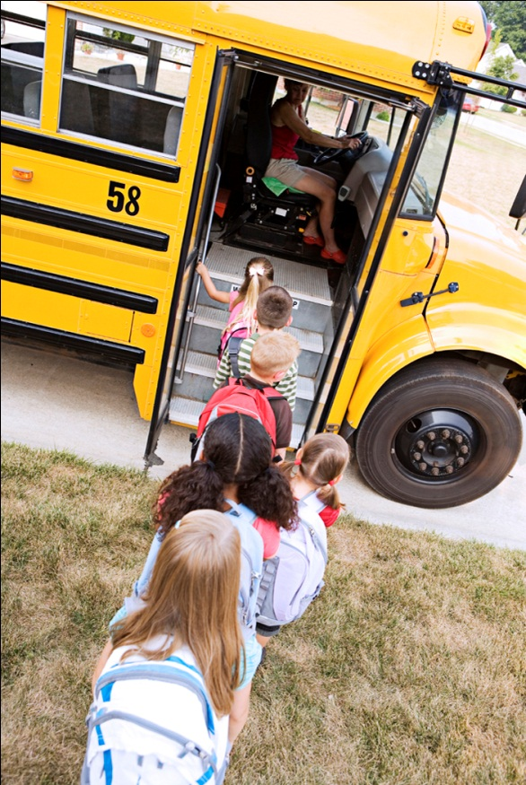

17 Indicators in the SPP
Indicator 1 —Improving graduation rates for students with disabilities
Indicator 2 —Decreasing dropout rates for students with disabilities
Indicator 3 —Ensuring all students with disabilities participate in statewide assessment
Indicator 4 —Reducing suspension and expulsion rates for students with disabilities
Indicator 5 —Providing services for students with disabilities in the least restrictive environment.
Indicator 6 —Providing preschool children with disabilities services in the least restrictive environment
Indicator 7 —Improving cognitive and social outcomes for preschool children with disabilities
Indicator 8 —Improving parent involvement in their child’s special education program
Indicator 9 —Reducing disproportionality of cultural groups in special education
Indicator 10—Reducing the number of students from other cultures in certain disability categories
Indicator 11—Improving efforts to locate, evaluate, and serve students with disabilities
Indicator 12—Ensuring a smoother transition from preschool programs to school-based programs
Indicator 13—Improving transition services for students with disabilities at the secondary level, i.e., 16+ years
Indicator 14—Improving the outcomes for students moving from secondary to postsecondary activities
Indicator 15—Making sure school districts correct noncompliance areas in the special education program within one year
Indicator 16—Decrease the number of mediation held within a year.
Indicator 17 – State Systemic Improvement Plan

