Public Information Comment
Phone Comment:
One director of a CSP called to share comments (also filled out survey). Would like to see the Council help encourage the use of/help fund AI in remoting monitoring. He shared how its been working for him at his CSP, the potential benefits it brings, etc.
Survey Monkey Information:
Demographic Information:
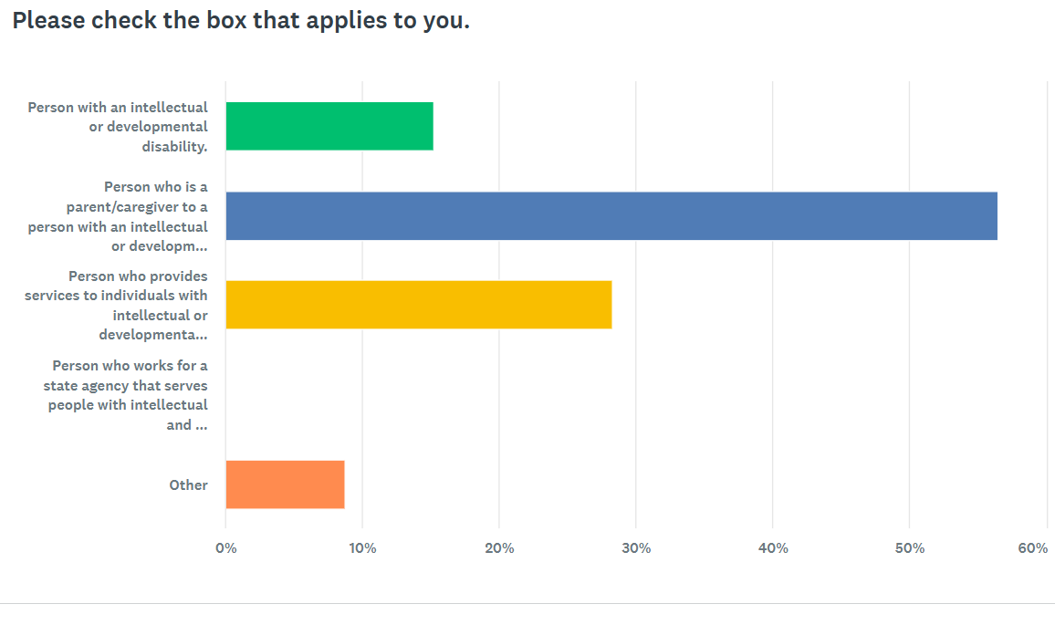
GOAL ONE FEEDBACK
For our first goal, those who took the survey rated our goal as a 4.11 out of 5. Below are some of the comments that were made on this goal.
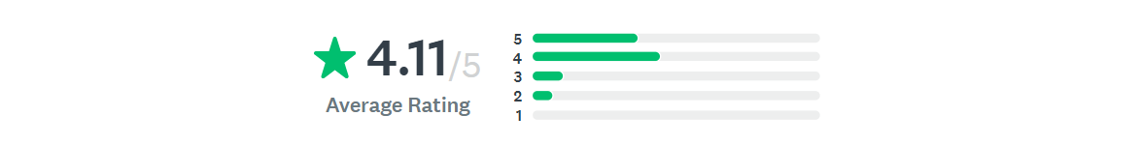

Pro-Comments about the goal/objectives:
- Easy access to what other more experience families are doing. Events and activities all posted in one place and on one Facebook group. Ideas and options for care and transportation
- I feel its important due to seeing the necessary and expansion of ability to provide remote support and find solutions.
- Partners alone would provide approximately 100 new clients
- I think the goal is worthwhile.
- Educating others is importance
- Starting earlier so parents understand timelines and options
- Partners in policymaking alone would train 25+ persons alone by 2031. Wish that it could be more.
- To get more people for Partners in Policymaking
- Obtainable and needed
- Education being provided for professionals as well as tools for families to use is very important. I think this is a good goal to have.
Concerns about the goal/objectives:
- There are so many services affected families/providers do not know about.
- Not specific enough to understand what they are doing.
- I think this goal is much too weak in the context for the transformational kind of work that the community supports services needs - from decades of federal and state neglect. Awareness and access are only gong to apply if there is a healthy system of supports for people to be aware of and access. The goal is missing having the big impact that could happen if it were swinging for the fences vs trying to just not strike out. What are best practices? Are they transformational practices that account for current and future projections of workforce availabilities and family aging dynamics? Does it consider practices that meaningfully resolve the crisis care gaps? Would it be not waiting only for seeing what can get passed on from others but to also include participating in the development of practices that aren't even best practices yet, but needed to be developed practices in the face of lack of workforce, affordable housing shortages, and slow technology adoption the IDD service sector suffers from currently?

Goal One Respondent Input on Key Activities:
- I think it is also about providers coming together to share ideas in order to make initiatives and changes together for this positive goal. Every provider has heard what the individuals and families want it also is about involving community/programs that access government funding could increase their accessibility to create bridge programs in schools, food giveaway could include IDD population as well by receiving and offering to volunteer. However main issue typically involves transportation costs and staffing due to low competitive wages.
- Transportation options
- Virtual trainings are very convenient
- Find out what other programs are available for such training and combine services to increase education for more persons
- Increase outreach to participants on the CHOICES Waiver. From a provider perspective, it seems like the DD Council prioritizes FS360 and Parent Connection families over those who use comprehensive services and paid provider staff.
- Increasing opportunities for families to gain additional knowledge about intellectual and developmental disabilities through partnering with organizations who are passionate about serving them.

GOAL TWO FEEDBACK
For our first goal, those who took the survey rated our goal as a 4.19 out of 5. Below are some of the comments that were made on this goal.
Pro-Comments about the goal/objectives:

- Disability Awareness Day at the Capital has gotten so popular. Maybe activities could be held in conjunction with that, since so many are already gathered?
- Another great goal.
- The Partners in Policymaking program is a good one. It would be nice if there was a video or virtual platform to the program due to transportation and personal assistance time constraints. It would also be nice if provider organizations were supplied with materials like the People First groups once used, so that paid staff could utilize the materials in regular training on the local level. A west river organization has the A-Team. This framework was developed by an organizer who was brought in. It takes local leadership to educate self-advocates on issues and facilitate action planning. This is needed on a larger scale, beyond Partners participates and graduates, and the few FS360 advocates who are active and serve as voices of a select group of the IDD population. CHOICES participants often do not have that advocacy outside of west river's A-Team.
- The more education we can get to people the better quality life their loved ones with disabilities can live.
- I love the advocates getting together and the cross disability initiatives.
Concerns about the goal/objectives:
- Great 30,000 foot level to have within Council Goals. Same as Goal #1 though where I think there is massive room for transformational work to be done. Ex. One long time U.S Senator said that until people with disabilities start to vote (in numbers and ways that highly visible), they keep getting what they have always gotten. I think there is room to lead a movement that is similar to what AARP has done with the senior community where decision makers about so much in policy and funding unquestionably know that the senior voting bloc is organized, educated and showing up to vote. The same three things can happen with the disability voting bloc, but it needs leadership and funding to get it launched big enough and loud enough.
No one commented on any activity they would like to see.

