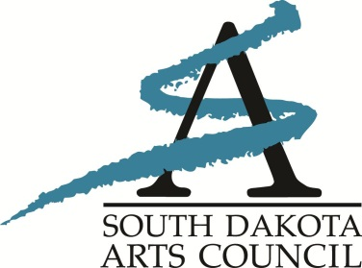
From Rebecca Cruse
Deputy Director, SDAC
605.773.3301

FOR IMMEDIATE RELEASE: May 20, 2021

ARTS COUNCIL TO HOLD SPECIAL MEETING

PIERRE, S.D. – Members of the South Dakota Arts Council, the advisory board of the state arts agency, will meet remotely via online/call-in format May 27 for a special Council meeting.

The meeting will begin at 12:30 p.m. CDT/11:30 a.m. MDT. The public is invited to listen to the proceedings. An agenda and audio link will be posted 72 hours prior to the meeting at https://boardsandcommissions.sd.gov/Meetings.aspx?BoardID=7.

Constituents are also invited to offer public comment in accordance with South Dakota Open Meetings Laws. Due to the virtual meeting format, we invite public comment to be submitted in writing to be read during the meeting. Constituents may also join the meeting online or by calling in during the public comment period. Anyone wishing to offer live comments during the meeting should contact the SDAC office, 605-773-3301 or e-mail sdac@state.sd.us.

During the special meeting, the Council will review a budget decision made at the May 7 grants meeting.

An office of the South Dakota Department of Tourism, the South Dakota Arts Council’s mission is to provide grants and services to artists, arts organizations and schools across the state, with funding from the National Endowment for the Arts and the South Dakota Legislature. The South Dakota Department of Tourism is comprised of Tourism and the South Dakota Arts Council. The Department is led by Secretary James D. Hagen.

-30-

