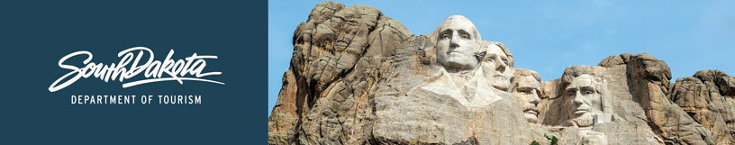

GOVERNOR’S TOURISM ADVISORY BOARD MEETING
Tentative Agenda
Wednesday, December 11, 2019, 1 pm
Dolly Reed Plaza
2nd Floor Conference Room
Pierre, SD 57501

December 11, 2019
1:00 p.m. CT

- Call Meeting to Order, Ivan Sorbel
- Mickelson Award
- Ziolkowski Award
- Ben Black Elk Award
- A.H. Pankow Award
- Excellence in Tourism Innovation Award/Name Change for 2020
- Global Marketing and Brand Strategy Update, Mike Gussiaas
- Global Media and Public Relations Update, Katlyn Richter
- Global Travel and Trade Update, Cole Irwin
- Industry Outreach, Development and Research Update, Kirk Hulstein
- Tourism Conference Update, Natasha Bothun
- New SD Great Places and SD Great Face Programs, Natasha Bothun
- Hot Topics and Open Forum, Jim Hagen
- Adjourn

