**Education and Telecommunications Board Report**

**March 2025**

**Twyla Olson**

**Director of Content & Assistant General Manager**

**Goal – SDPB will engage with every South Dakotan at least once per month.**

**Digital Content**

Byron Pillow joined our team on Dec. 2nd, and he has made quick work of making himself part of the SDPB family.

Byron and Brent Duerre have settled into their roles and are tackling daily tasks as well as taking a long look at our digital priorities for FY26.

Byron is meeting with all department heads to determine key performance indicators and map out data collection to help meet goals.

We continue to grow our digital audience on all platforms, and we look forward to Byron’s new ideas and fresh takes on how we can continue to attract and engage with new audiences.

**Entertainment and Journalism Content**

Dakota Life continued its extremely successful season with good attendance at the premiere in Britton in December. We also had full houses and great interactions in Elk Point and Garretson. The team is doing a great job of expanded storytelling with the new format. Upcoming episodes air the following dates:

4/10 Wessington Springs

5/15 Pine Ridge

6/12 Faith

Due to losing our contractors last January and increasing SDHSAA sanctioned activities,  the Dakota Life season will go from 9 to 7 programs next season. The communities for the 2025-26 season were selected in early December and are as follows:

1. Agency Village
2. Newell
3. Clear Lake
4. Edgemont
5. Eureka
6. White River
7. Centerville

 Brad’s team also produced a Dakota Life Detours program entitled Highline of the Hills, with historic recordings of Black Hills residents who rode the 1880 train when it was still a passenger service. This program would not have happened if we had not included Hill City in a previous Dakota Life episode. The relationships we are building with communities throughout the state are exposing us to new audiences and new opportunities for partnerships. The footage was provided by the current owner of the 1880 train and museum. We had a record number of attendees at the screening in Hill City—115 in all.

**South Dakota High School Activities**

SDHSAA activities have started again in February with three championships in one weekend. State Dual Wrestling Championships, Gymnastic Championships and E-Sports Championships were all held the weekend of Feb 14th & 15th.

E-Sports Championships are new this year, and it was exciting to see a new group of kids compete in a new and novel way. It was a great success.

The Gymnastic highlights will be aired as a TV program in March, date is TBD.

The State Wrestling Championships for Boys and Girls was held the weekend of Feb 27-March 1st.

All of these tournaments required multiple streaming channels, and with the help of the Engineering Team, Brad and his team made it all look seamless.

We continue to stream concerts for the South Dakota Symphony Orchestra, and we are preparing to record the opera, Giants in the Earth, in April.

**Journalism Legislative Coverage**

Cara’s team has been extra-busy with the change of Governor and the addition of an unplanned Inaugural ball, speeches and press conferences. In addition, with staff changes and responsibilities, Cara’s team has taken on all of the daily coverage, save for a few live events when Entertainment and Engineering have helped. This is a big shift, and it helps the Entertainment team with their workload during the busiest months High School Activities.

**In the Moment** has continued its weekly round-up of legislative affairs, which is then turned around as a TV program on Thursday afternoons.

The Journalism Team has done a great job of covering our own legislative news this year, with the former governor’s suggested budget cuts.

**South Dakota Focus** revisited the Childcare Crisis coverage from last year in January’s show and returned to this year’s topic of Tourism with reporting from the Tourism conference, showcasing the people who make South Dakota one of the top tourist destinations in the U

**Education**

Marcy Drew and her team continued their great representation of SDPB with educational resources at the Lakota Nation Education Conference in December in Rapid City. Carl The Collector, a new PBS Kids program, was the star of the show, and activities around collections were a big hit.

Steven Rokusek finished his dissection series on Sheep Brain, with proceeds from the Da Vinci grant we received last year. The series is now published on PBS Learning, and we know it will be equally as successful as the other dissection series that Steven has produced in past years.

The Education Team also presented resources to the student chapter of the Council for Exceptional Children at the University of South Dakota. The School of Education invited SDPB to their January 2025 meeting to provide professional development.

They also traveled to the West Central School District to share SDPB resources for an in-service.

Upon hearing about the outstanding work being done by her team, Marcy was contacted by Fred Rogers Productions and asked to apply for a $10K grant to present Be My Neighbor outreach and activities in FY26. A very excited team is making some amazing plans. Stay tuned for programming near you soon!

**Outreach**

Nathan Hofer and Brittany Neiles have had an incredibly busy few months, with numerous screenings and outreach throughout the state. SDPB received a grant for outreach around the PBS Independent Lens series. In early January, we partnered with The Journey to present a film, Without Arrows, which followed a South Dakota family from Green Grass for a span of 13 years, produced by a team from Philadelphia. We also screened the program in our Sioux Falls studio. Both events had wonderful attendance, and the film was well-received.

We also partnered with filmmakers and professors from Black Hills State University to help produce and present their film Chasing Tables, featuring Jordan Taylor, local chef and owner of several restaurants in Sioux Falls and one in Pierre. The film was shown in Spearfish at the Matthews Opera House and in Sioux Falls at the State Theatre. There was a discussion with the filmmakers and Jordan after each showing. Forging this relationship with the filmmakers at BHSU has opened the door to new productions to follow.

There were also successful screenings of Independent Lens documentary The Bike Vessel in Pierre at the South Dakota Bike Summit, and Free For All: The Public Library at the Rapid City Library in January.

 We hope you can join us at one of the upcoming events listed below.

|  |  |  |  |
| --- | --- | --- | --- |
| Wessington Springs Dakota Life Premiere | 03/31/2025 | Wessington Springs | 1905 Opera House |
| South Dakota Symphony Orchestra: Mozart's "Great" Mass | 04/05/2025 | Sioux Falls | Washington Pavillion |
| Free For All Screening - Harrisburg Public Library | 04/15/2025 | Harrisburg | Harrisburg Public Library |
| Science Steve at Home School Conference | 05/02/2025 | Sioux Falls | Sioux Falls, Convention Center |
| Pine Ridge Dakota Life Premiere | 05/08/2025 | Pine Ridge | Maȟpíya Lúta |
| Faith Dakota Life Premiere | 06/04/2025 | Faith | Community Center |

**South Dakota Board of Educational Telecommunications**

**Engineering & Technology Report**

**SeVern Ashes**

**March 2025**

**SDPB RF Engineering:**

On **Jan 9, 2025, KWSD Mitchell 89.1 Mhz.** The new radio station officially went on the air on January 9, 2025. I’m incredibly proud of our RF Field Engineering team led by Vern Haas – all hands on deck, from Mike Taicher, Ely Koppenhaver, Steve Munsen, and Tom French, for their dedication and hard work in preparing the site for this launch.

For now, the station will operate in analog-only mode until the IBOC (HD) licensing is activated. Over the next 30–40 days, our team will focus on finalizing the HD licensing process and completing the remaining tasks and station documentation.

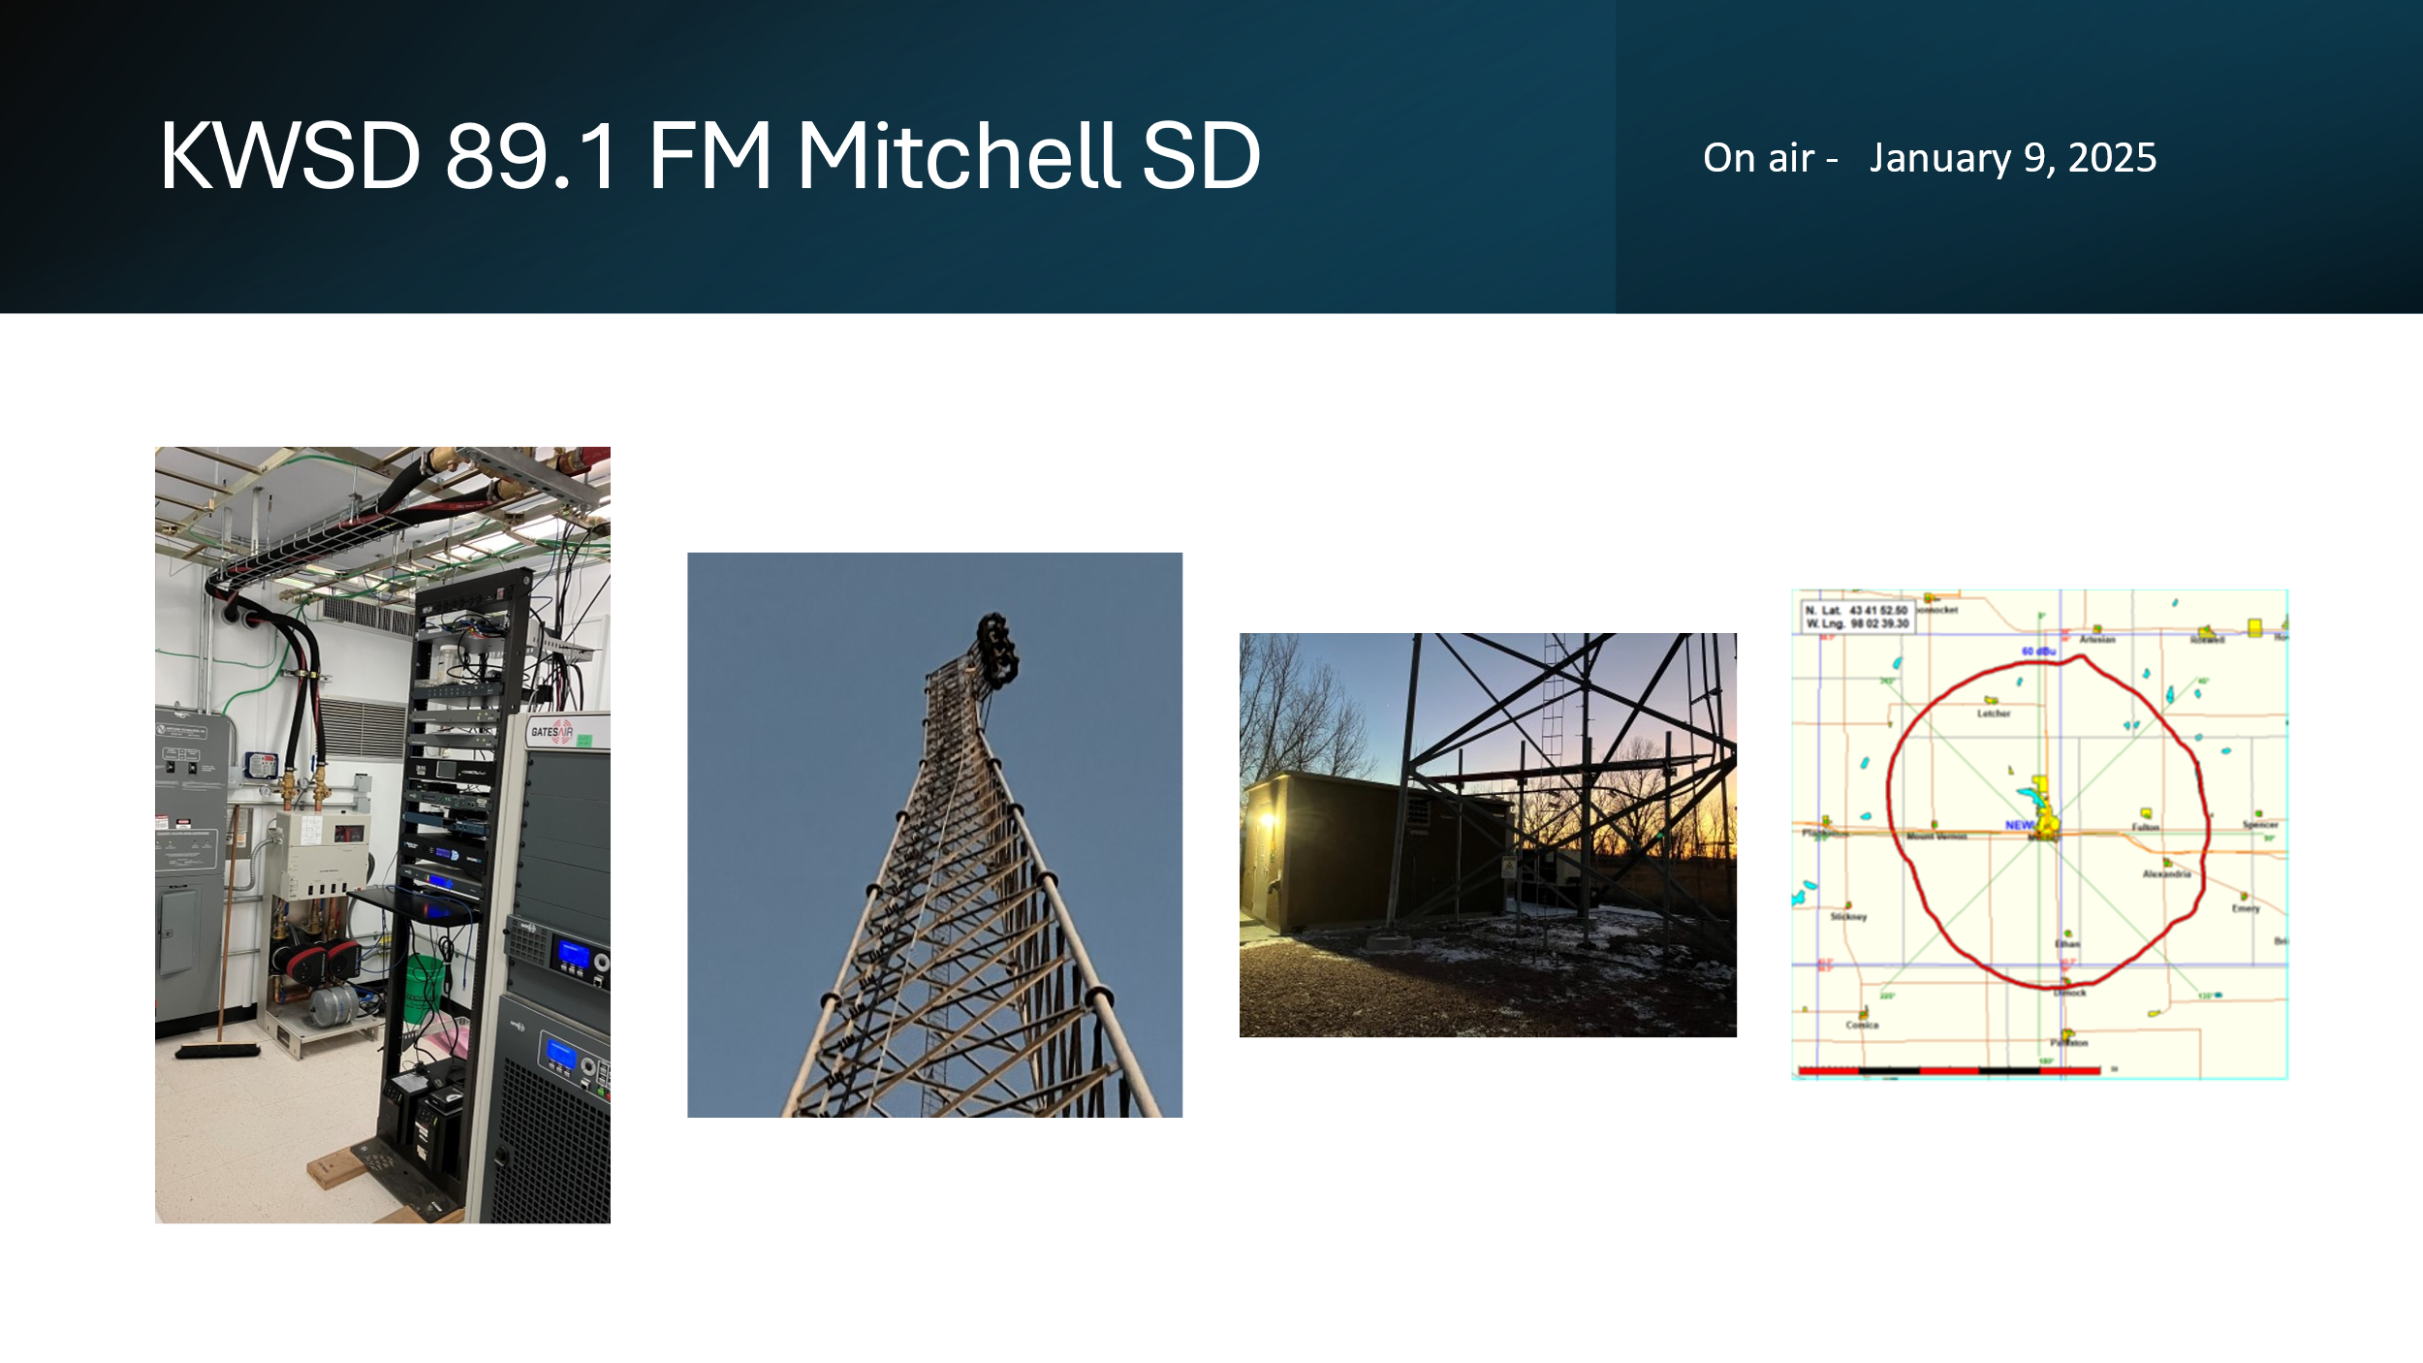

(Jerry Oster—We were under by 11 days)

**Over the Air Television Broadcast FORMAT CHANGE**: On March 03rd SDPB Switched to **4 x 720p HD** instead of **1 x 1080i HD + 4 x 480i SD**, improving picture quality across all channels, making them consistently HD rather than a mix of HD and outdated SD. The **motion clarity** in 720p is better, especially for sports and fast-moving scenes, compared to 1080i, which can have slight blur. This change also makes **better use of available bandwidth,** delivering a sharper, more modern viewing experience for all audiences. SDHSAA Basketball coverage on SDPB-2 and SDPB 3 will see great improvements.

Switching from one HD channel with 3 low-quality SD channels to four HD channels will provide a better and more modern viewing experience for all audiences.

* Sharper Picture: Instead of outdated standard definition (SD), all channels will be in HD, looking much better on modern TVs.
* Smoother Motion: 720p improves motion clarity, especially for sports, news, and action content compared to 1080i.
* Better Use of Resources: This setup maximizes available broadcast space, ensuring all channels look good without wasting bandwidth.
* Future-Ready: As TV technology advances, this move keeps SDPB competitive and prepared for the next generation of broadcasting.

Overall, it ensures our station stays competitive and future-ready while improving viewer satisfaction.

**SD.NET Live** streaming and archiving the 100th Session of the SD Legislature continues to go well. Laura and my time is spent scheduling, monitoring, archiving, and marking daily meetings.

A quick comparison of last year to this year as of Legislative Day 29:

* 2024 Streaming and archiving an average of 14.57 hours/day, 1217 live viewers/day
* 2025 Streaming and archiving an average of 16.55 hours/day, 1596 live viewers/day

Additionally, as of LD29 there are 116 full video files on YouTube comprised of Appropriations hearings, House and Senate floor activities, and press briefings from party leaders and the Governor. As of LD29 that playlist has had 14,239 views for a total of 3,520.8 hours watched.

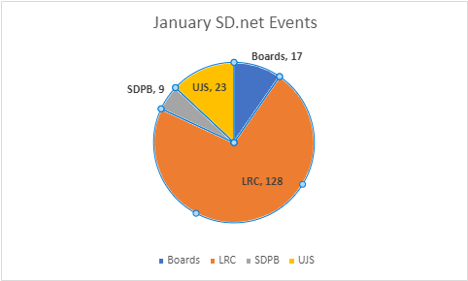

**NGWS is the Next Generation Warning System**. CPB received a STOP WORK ORDER for processing grant funds. Julie will include updates in her report.

Engineering and Finance are working through the remaining capital assets funds to prioritize critical systems that cannot wait for the NGWS grant funding.

*As of March 3rd 2025 - We are still waiting for the official Grant contract.*

*Round one of the grants will allow.*

* *Adding local EAS alerting at all 9 Television Broadcast transmitters. That will connect directly to the FEMA Integrated Public Alert & Warning System (IPAWS)* 
  + *In FY24 SD Joint Appropriation funded the EAS equipment for the 11 FM broadcast stations.*
* *The microwave interconnection system will include Uninterrupted Backup Power supply systems, dehydrator systems, microwave antennas, transmission lines, and high-definition signal processors between SDPB Vermillion Main Studio, KUSD TV/FM Beresford, KCSD TV/FM Sioux Falls, KESD TV/FM Brookings, and KDSD TV/FM Pierpont/Aberdeen.*
* *New HD FM Transmitter in Mitchell, SD.*
* *New Digital FM radio translators at Aberdeen, Huron, Pierre, Lead, Mt Coolidge, Hot Springs, and Edgemont.*
* *Network Operations Server room air conditioner.*

Network Operation Center Vermillion: It is my pleasure to introduce you to Alyssa Ogstad, our newest Member of the Network Operations Center team



Alyssa monitors 12 transmitter sites, 20 microwave sites and keeps us on the air 24/7.

Alyssa is a 2016 graduate of Yankton High School and a graduate of Mitchell Technical College’s Medical Coding Program. Alyssa is also a part-time phlebotomist at Avera Hospital in Yankton, South Dakota.

Alyssa enjoys archery and heavy metal rock n roll. Alyssa has her motorcycle and enjoys cruising whenever she gets the chance. Alyssa is a very good team player, and we are glad she joined the Broadcast Operations Center team at SDPB

Respectfully submitted:

SeVern Ashes

SDPB Director of Engineering and Operation

**South Dakota Board for Educational Telecommunications**

**Programming & Communications**

**March 2025**

**Branding Progress Report:**

* External signage has been installed in Sioux Falls and Vermillion. Communications issues continue to dog our efforts in Rapid City
* Fresh Produce was the recipient of two Silver awards, one Gold award, and a Best of Class award for their design work of the SDPB logo.

**Programming**

Television:

* Local productions that aired December 2024 through February 2025 included: SDHSAA events – Wrestling Duals, Individual Wrestling; Christmas Vespers programming from Mount Marty and Augustana University; Gov. Noem’s Budget Address and State of the State Address; Legislative coverage of the House and Senate; Gov. Rhoden’s Inauguration and Grand March; *Rhoden & Venhuizen: political Brands; Tales from the Hardwood; Chasing Tables;* as well as new episodes of *On Call with the Prairie Doc, South Dakota Focus, Dakota Life,* and *Dakota Life Detours.*
* Forthcoming programs and documentaries include a documentary from France titled *Wibaux Wanted* about a French immigrant who settled in Montana and established a successful cattle operation, and a successful gold mine in South Dakota, *Dakota Life Detours, SD Focus, On Call with the Prairie Doc*; *Dakota Life*; SDHSAA Girls & Boys Basketball, Gymnastics, All-State Band and Jazz Band, Track & Field, Softball.
* Nationally, the TV schedule from PBS premiered new programs: Masterpiece’s *All Creatures Great & Small, Miss Scarlett, Vienna Blood, Finding Your Roots, Antiques Roadshow, American Masters, Independent Lens*.
* Syndicated fare will continue to evolve as some programs come to end of rights and we replace them with newer programs. Doc Martin will come to an end May31, 2025.

Radio:

* The radio broadcast schedule on weekdays and weekends has remained stable.

**Marketing**

* We continue working with Friends and Outreach on events by providing materials and support.
* The FY24 Local Content and Community Service Report was successfully completed and submitted to CPB.

**Other**

* Attended training from PBS and NPR, and reviewed procedures, regarding acceptable Underwriting scripts. The language in our underwriting announcements that air on TV and Radio are subject to certain rules and regulations. We have followed those rules and continue to work diligently to ensure our UW spots follow the realities and spirit of the law.

**ET Board Report – February 2025**

**J Team –Cara Hetland**

**December Highlights:**

* Live coverage of the governor’s annual Budget address and follow up stories looking at proposed cuts and new programs being funded. We covered this in newscast, features, and conversations on In the Moment.
* Spanish interpretation offered of budget address and analysis.
* SDPB News Instagram followers have grown to 1,283

**January Highlights:**

* Live coverage of the governor’s annual state of the state address and follow up interviews. Live Spanish Interpretation
* Analysis and reaction to the speech on In the Moment
* In the Moment Statehouse weekly television show began Jan. 23 and airs weekly

**February Highlights:**

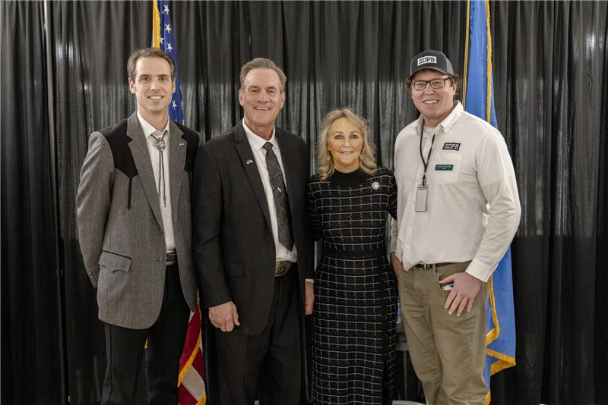Coverage of the 100th legislative session remains our priority – we brought you coverage of the swearing in of Gov. Larry Rhoden, his first address to a joint session of the legislature, the naming of Tony Venhuizen as Lt. Gov., the inauguration and grand march. Plus, the reporting on legislation and it’s impacts on South Dakotans, a one-on-one interview with the new governor, and coverage of weekly press conferences.

*Pictured with the governor and his wife are SDPB’s politics and public policy reporter Lee Strubinger (left) and news director Josh Chilson (right).*

News Instagram followers has grown to 1,335

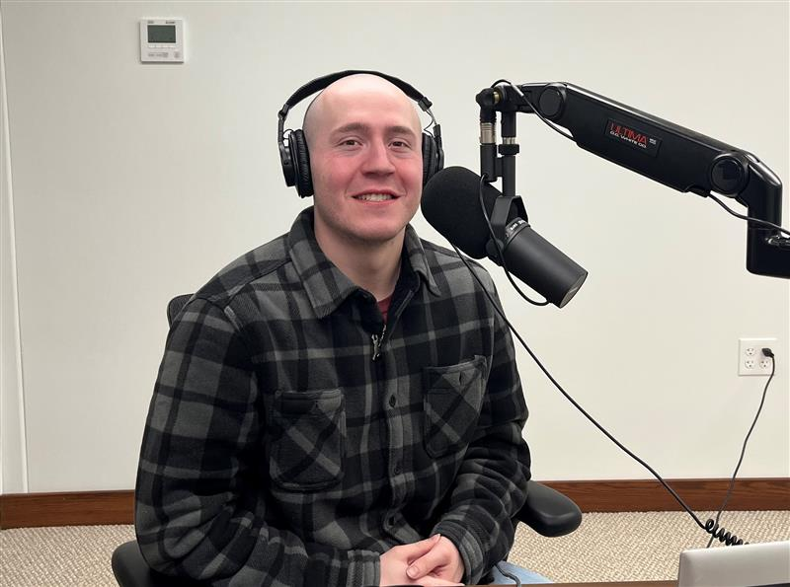**Staffing Changes** – we said goodbye to Evan Walton and Ryan Bozer. Krystal Miga moved to host Morning Edition and Patrick Williams was hired as our host of All Things considered. Patrick is a graduate of Montana State- Billings and he enjoys anything outdoorsy from hunting to hiking in a forest. He is a former collegiate placekicker and punter at Rocky Mountain College also in Billings, Montana.

Intern Jackson Dircks can fill in the gap for us with Evan’s departure. We will look to fill that role permanently after legislative session concludes.

Jackie Hendry and Cara Hetland have been selected to participate in Poynter’s Covering Child Welfare six-month intensive online course.

ET Board Report March 2025

**Digital – Byron Pillow**

Department Projects - A good portion of December and January was spent on my own part in onboarding, learning operations and procedures, and meeting personnel involved across departments in the relevant areas of work that SDPB does. Once settled into the role, it was time to begin building. Current priorities for the department include establishing data collection procedures, creating tools to evaluate digital performance, refining department policies and procedures, and defining a formalized strategy for the coming FY.

Much work is currently underway toward improving operational infrastructure for the department, particularly regarding data collection and digital platform management.

A new data handbook and collection policy is in draft, and mechanisms for continuous monthly collection of platform metrics and digital performance have been implemented for CY25. Additionally, more granular tools for examining performance of specific programs and events are being developed for implementation for FY26 as part of a new Integrated Digital Plan.

Across our platforms, including our primary CMS, Meta, and Google, accounts have been reviewed, updated, consolidated and revamped to best support our work and maintain proper access and record keeping.

In the area of public events and outreach, we have worked with colleagues and Friends of SDPB to develop new tools and standards to better digitally market our public events via our social channels and have made updates to the website to allow patrons more immediate access to event resources.

Small changes are systematically being introduced across our social and web platforms to better integrate News, Entertainment, and Education content as part of a holistic SDPB image and presence. Conversations are ongoing with these departments to determine which specific goals, and strategy can be productively included in the Integrated Digital Plan to better examine the impact of our local programming, journalism, and educational endeavors across our digital ecosystem. Event-specific metric tracking has as of now been implemented across two content areas: SDHSAA livestreams, and Statehouse special event livestreams. Statehouse Coverage -

During the Legislative Session, public-service content and featured statehouse streams are a prominent part of SDPB’s digital content calendar. Alongside the full legislative coverage available on SDNet, we also integrate live web streams of various statehouse special events such as the Inauguration and State of the State across other digital platforms and increased our PR/awareness support around that content on social platforms this year. Those supplemental broadcasts reached an audience of over 15,000 unique users who streamed over 3,000 hours of special statehouse coverage, above and beyond the standard legislative coverage on SDNet.

SDHSAA Digital Content - A variety of SDHSAA events have taken place since the last board meeting, and the numbers for our live web streaming continue to show strong use and interest. Our digital audience streamed over 75,000 hours of live SDHSAA activities across our digital platforms, with ~175k users logging over 500k views of individual event streams.

The inaugural SDHSAA ESports tournament, held on Feb 14-15 and streamed exclusively on SDPB’s YouTube channel, saw ~2500 users view over 800 hours of live content in this exciting new area. Adding to our existing presence, we have begun rolling out a new strategy of paid advertising across Meta platforms to drive users to the livestream and event pages for SDHSAA content. The initial sets of this effort have put direct access to SDPB/SDHSAA in front of over 30k users, a large percentage of which do not already follow SDPB.

Education and Telecommunications Board Report

March 2025

**Entertainment Group—Brad Van Osdel**

***SDHSAA***

February is the kickoff of the winter events for SDHSAA. The one-act play contest was the first event covered for the month; during the three-day event, SDPB took over 600 photos, which have been viewed over 5000 times on the SDPB Flickr page. Three state tournaments were held the same weekend on February 14th and 15th: the state dual wrestling championship, the state gymnastics championship, and the first-ever state e-sports championship. SDPB crews were on location at all three tournaments. For e-sports, we produced video packages for social media highlighting the new state event. These stories have received 5,000 views on Facebook. SDPB also streamed live one of the tournament games all day Friday and the semi-finals and finals of three games on Saturday; these streams have been watched 4,000 times since the tournament. For the second year, we streamed all the apparatus from the state gymnastics meet, and these streams were viewed 77,000 times on SDPB’s webpage. We also produced a highlight program for the state meet that will air in March. At the State Dual Wrestling championships, we streamed all four mats for the preliminary bouts and the championships were broadcast live on SDPB TV on both days of the two-day tournament. The streams for all eight mats and the championships have been viewed 14,000 times on the SDPB YouTube page. The state individual wrestling tournament was held the last weekend in February, and after the first day of preliminary matches, the eight live streams had been watched 118,887 times on YouTube. SDPB streamed all eight mats for the preliminary and semifinal bouts and broadcast and streamed the championship rounds on March 1st.

***Dakota Life***

The December Dakota Life community was Britton. The premiere was held early in December, and 40 people were on hand to watch the program. The stories highlighted the local mayor, the movie theatre, which is a gathering point for the community, a story of first-grade sweethearts that reconnected, married, and again call Britton home, and a story about the football tradition in Britton and how a tragedy turned into a message of strength that spread across South Dakota We take in the Buckhorn rodeo a time-honored western tradition in Britton. We experience the Amherst Pie Auction, a fundraiser for the American Cancer Society. These stories have been viewed 45,000 times on Facebook with 487 likes, shares, and comments. The half-hour episode has been viewed 7,000 times on Facebook.

Elk Point was featured in the January episode of Dakota Life 80 community members were on hand for the local premiere in early January. This episode was viewed over 6.900 times on SDPB's Facebook Page. The episode highlighted several aspects of the community. We visited a home basketball game to see how the school is not just the hub of a small community; it has brought together the towns of Elk Point and Jefferson, and activities teach students lessons they can't learn in a book. We meet a local antique dealer and learn about her adventures playing and coaching bridge at a world-class level. Darts are a classic bar game, but in Elk Point and other communities around South Dakota - they have become a way to pull the community into fundraising for families while they fight cancer. Taking over a farm is a tall task for anyone, but it was just the beginning for 4'11" Thelma Kalstad. We trace the evolution of this farm for over 100 years; with technological advances and through its sale, a future that Thelma would have never dreamed of is now Fleursh Farms. A new concept for a South Dakota farm - an Instagram-friendly you-pick flower farm that has attracted tourists like butterflies from all over the state and garnered national attention. We also dive into the history of Elk Point and tell you how the Missouri River and Agriculture shaped this community. These stories have been viewed on SDPB Facebook over 22,000 times.

Garretson was featured in the February episode of Dakota Life. Forty community members were on hand for the local premiere in early February. This episode was viewed over 3,600 times on SDPB's Facebook Page. For this episode, we talk to a local painter inspired by horses, learn about Jessie James’s famous jump over Devil's Gulch, the history of Garretson and its connection to the railroad, and take a boat tour of the Palisades. We meet a man who has dedicated his model train set to his wife at the local museum, and the crew takes in some goat yoga at a local farm. These stories have been viewed over 17,000 times on Facebook.

The entertainment group continues producing Dakota Life Detours for this season. We produced a special episode for February titled The Highline of the Black Hills. This documentary tells the story of one of the longest-operating rail lines in the Black Hills. We learned about this story during the engagement meetings for the community of Hill City in the Summer of 2024. Meg Warder, the owner of the Black Hills Central Railroad, which operates the 1880 train, brought us interviews she recorded in the early 2000s to preserve the story of the Highline rail line. SDPB partnered with the black Hills Central Railroad to include these interviews in the documentary, which was the project's primary focus. A screening was held in Hill City to premiere the documentary to the community, and 115 people were on hand for the viewing. Since its release on Facebook, it has received 4000 views and an additional 1,200 views on YouTube.

As we continued to connect and share stories from all the past communities, our crew took a trip back to Burke to experience their Christmas celebration and a visit with Santa Claus about the power of small towns and communities. This story has been viewed 10,000 times on Facebook and has been liked/shared and commented on 120 times.

***Tales from the Hardwood***

We continue our “Tales From” series with Tales from the Hardwood for 2025. The four stories produced represent the people of South Dakota's love of basketball and the importance of community and family in high school athletics. Pine Ridge head boys’ basketball coach Casey Means has twice brought the Thorpes to the state tournament in the past five years. While he’s considered a ‘players-coach,’ he brings a sense of emotion, mixed with intensity, to the job. However, his story goes much deeper than the court as he coaches his players. The connections between first-year Aberdeen Central girls’ basketball team coach Paiton Burckhard and her predecessor…and what it’s like to coach her younger sister. Kobee Sherman, diagnosed with cancer in high school, which ended his prep basketball career, started a foundation to raise money for pediatric cancer families. His foundation, Midwest Miracles Foundation, was the beneficiary of Viborg-Hurley’s basketball event to raise money for Kobee’s foundation and help raise awareness for pediatric cancers. High school basketball is a family affair for the Neuendorf family in Hamlin. Todd Neuendorf is the head boys’ basketball coach. His wife Jaime is an assistant coach for the girls’ team. Their daughters Addison and Paxton play on the girls’ team, while their son is a senior on the boys’ team. The program was broadcast on February 27th, and the stories will be released individually on social media over March and used during the basketball tournaments as broadcast feature packages.

**South Dakota Board of Educational Telecommunications**

**Education Report-Marcy Drew**

**March 2025**

**Resource Development and Distribution:**

* The new [sheep brain dissection](https://sdpb.pbslearningmedia.org/collection/dissection-videos-for-classroom-use/t/sheep-brain-dissection/) lesson is now available on PBS LearningMedia as part of the Dissection 101 series. The sheep brain is a useful specimen for schools due to its comparability to the human brain and relatively inexpensive price. SDPB developed the Dissection 101 series for many reasons, including reducing the number of specimens needed by a class, increasing the quality of the dissections, and enhancing the learning experience for students.
* Another SDPB educational resource, [Create Your Own Dance Studio](https://sdpb.pbslearningmedia.org/resource/create-your-space-video/create-your-own-dance-studio/), is available on PBS LearningMedia and at <https://www.sdpb.org/learn/dancestudio>. This collection of five videos and lessons teaches elementary-aged students and their teachers and caregivers that any space can be a dance studio! Create Your Own Dance Studio conveys the message that you can dance in whatever space is available: a home, school, gym, or even a backyard. They can follow along with Solange Rodrigues and Madison Elliott, dancers from Headlights Theater, as they show step-by-step how to create a space, warm up, choreograph a dance, and prepare for a performance in an approachable way. This series was created specifically to give children who may not have access to formal dance lessons an opportunity to express themselves through movement.

**Outreach and Professional Development**

The education team provides outreach and professional development to families, caregivers, and educators to share the resources available from SDPB.

* The Lakota Nation Education Conference attracts educators, school staff, administrators, parents, and community members from every tribal community across South Dakota and some regional locations. The 46th annual conference in December 2024 included 488 registered attendees. SDPB Education staff presented four breakout workshops and hosted an exhibit booth with sample lessons and activities, art opportunities, and a special screening of the new PBS KIDS show, *Carl the Collector.* Fifty-two people registered for the SDPB door prize. Those who shared their email addresses will receive activities, lessons, and educational information weekly via SDPB’s education and early learning newsletters.

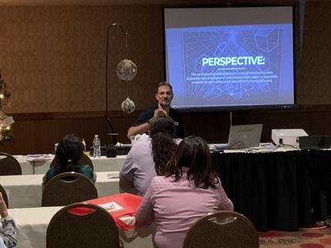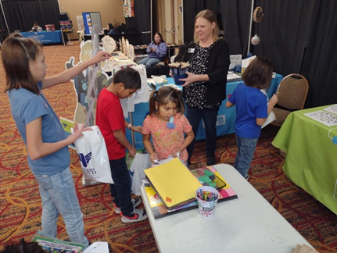

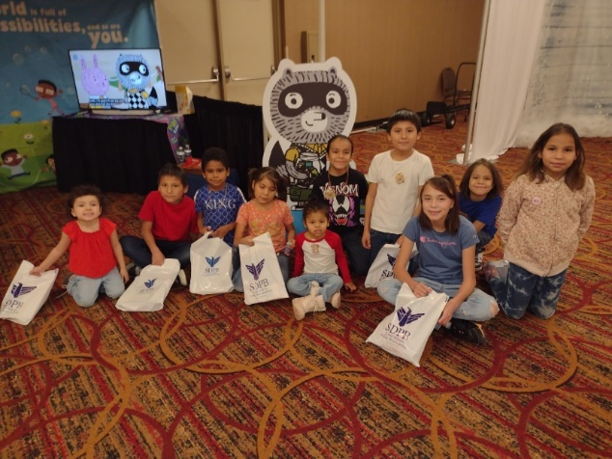

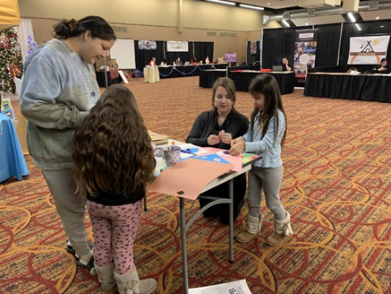

* The student chapter of the Council for Exceptional Children (CEC) at the University of South Dakota (USD) School of Education invited SDPB to their January 2025 meeting to provide professional development. About 20 graduate and undergraduate students from education, physical therapy, speech/language pathology, and psychology majors learned about teaching materials and strategies using resources related to the new PBS KIDS program *Carl the Collector*. The students and faculty in attendance discussed the importance of inclusive environments, calming strategies, using language to describe feelings, and more. The faculty advisor and organization president plan to help SDPB write a proposal to other area universities to offer to bring the session to their pre-service teachers and other interested students.

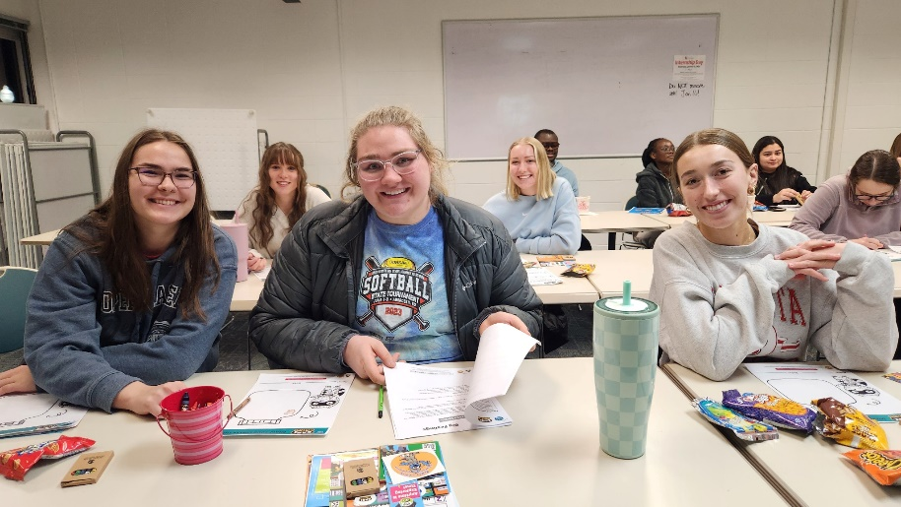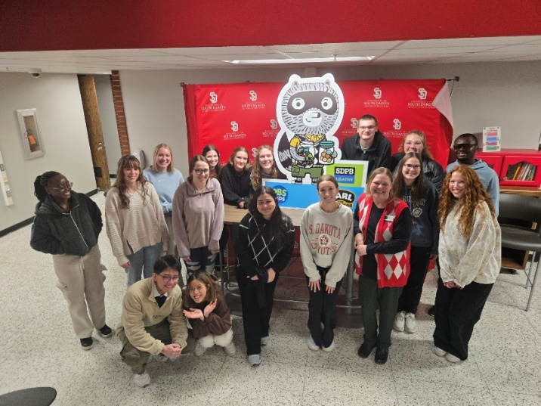

* The West Central School District invited SDPB to share resources at their January all-staff in-service. One session covered art resources from SDPB and PBS, and the second detailed available science resources. Teachers said they were looking forward to using the resources in their classes and that “Steve is a fun and dynamic presenter.”
* SDPB joined several education partners at the United Way of the Black Hills screening of the movie *Sentenced*, a film exploring the impact of illiteracy, followed by a panel discussion about literacy programs and opportunities in the Black Hills.