Educational Telecommunications Board Report
November 2025
Twyla Olson
Director of Content & Assistant General Manager
Sturm und Drang
On July 24th, 2025, the Recission of federal funds for public media from CPB was signed into law, resulting in a $2.2 million loss to SDPB’s budget. Local content was hardest hit, with the greatest loss of staff through layoffs and unfilled positions. Education lost 2 part-time contractor positions, Journalism lost 4 full-time positions, and Entertainment is left with 3 unfilled positions. Digital retains its 2 full-time positions. Through the extraordinarily difficult staffing decisions made, I must commend my team for their professionalism, optimism, and follow-through on all of the hard work accomplished in the ensuing 3 months. I could not be prouder of how everyone handled this crushing blow to the outstanding work we have produced since our 2022 strategic plan. We were knocking it out of the park. Now, we pick up the pieces and move on with our heads held high.
Digital Content
Byron finished a comprehensive dashboard of metrics for our programming on all platforms, a which we will use moving forward to make data-driven decisions.
Each content team was presented with a comprehensive plan of social media deliverables, which will be revisited due to staff reductions.
While we revisit those plans, the Digital Team has been kept busy with the start of the SDHSAA events in September.
Entertainment
The SDHSAA season has been intense, with added coverage by Brad’s team of Cross Country, to fans great approval. We have also continued our growing and successful relationship with All Nations Championships, followed by State Football Championships.
Brad was able to fill one position before the rescission, and he made a wonderful hire with the addition of Jason Andera to his team. Jason brings years of sportscasting experience to the Entertainment Team as well as a longstanding weekly program, which was renamed and launched as Game Time at SDPB. Nate Wek co-hosts with Jason, and it is enjoying a growing audience as it airs weekly on SDPB-1 on Wednesday nights at 10, as well as on YouTube. We also feature outtakes on SDPB radio on Thursday mornings. It’s a great addition to our coverage of SDHSAA activities.
The Tales from series continues with a new addition, Tales from the Net. Its premiere program focused on inspiring stories of Volleyball coaches.
Our Dakota Life season started in Clear Lake with a crowd of about 60 people, then went to Newell in October and Eureka in November. The program takes a break until we go to Centerville in January. Audience numbers continue to grow for this popular series.
Journalism
Cara’s hard work in re-designing Morning Edition to expand local coverage and make up for the loss of staff and programming is in its infancy. We were fortunate to keep Susan Hanson from Programming and bring her back to host Morning Edition, where she provides a friendly welcome to our listeners each morning. We are three weeks in, and everyone is finding their feet with daily 4-minute features in the 6 and 8 o’clock CT hours, and Lori Walsh’s 13+ minute segment in the 7 o’clock CT hour. The next step is to carve out equal time in All Things Considered for these segments, which will help with the overall loss of local programming on radio.
Cara will also expand outreach into our communities with Town Halls in the coming months. In addition, Journalism will host a series of debated in April.
Education
Both our full-time employees in Education were on the layoff list. Due to generous emergency funding from the John T. Vucurevich Foundation, we were able to retain both Marcy Drew and Steven Rokusek. We said goodbye to our part-time contractors, but moved Brittany Neiles, our West River Community Impact Coordinator, into a half-time position with Education. Brittany’s background as an educator is a great addition to this team. We know that they will regroup and do great things together.
Updates on Grants and Special Projects
SDSO Presents Giants in the Earth Opera
Brad and his team completed the opera, and it aired to great acclaim. We premiered the program at The State Theatre in Sioux Falls two weeks before it aired on TV with a crowd of over 100 donors and members and partners. We’ve entered it for a Peabody Award.
Women in Uniform Documentary
We’ve had to put this documentary on hold as we reassess staffing.
Independent Lens Documentaries Grant
In an effort to increase our Outreach and Events during the slower, winter months, and to reach new and younger audiences, we applied for a $5K grant for the 2026 season. Through this grant, we were finally able to purchase additional equipment for our Outreach Team, ensuring that each studio has its own set of tools for screenings. This will save wear and tear on our current set of equipment.
Nathan and Brittany have already planned over 15 events around the 2026 series, with more to come.
Ken Burns American Revolution Grant
We have completed our first round of screenings for this series, with engagement of around 350+ people throughout the state. We will do a second round of engagements when the program airs again in the spring, as we have all of 2026 to celebrate our 250th anniversary.
Last, but certainly not least, SDPB has been invited to participate in the CPB-Funded, NPR Upper Midwest Region Newsroom. We have the MOU in hand and will begin meetings with the other stations shortly.
REGION: NPR Upper Midwest
This exceptional collaboration of public media in Wisconsin, South Dakota, North Dakota, and Minnesota will be working to ensure impactful journalism thrives throughout the region.
MISSION: Groundbreaking enterprise and investigative reporting across the region, while offering training, editorial, and data journalism resources to newsrooms in need. Topic areas may include environment/water, agriculture, native issues, mining, inspirational stories, and new audience development. Offering more robust reporting from this region will serve national audiences in their understanding of America today.
STRUCTURE: MPR News will be the accountable partner to NPR for conducting regularly scheduled editorial discussions, pitch sessions, resource and training opportunities, and delivery of journalism across platforms and stakeholders. Opportunity for participation will be open to all public media outlets (radio, television, digital) within the defined region, with the following leadership team of journalists.
- Deputy Managing Editor: (1 FTE, MPR News)
- Editor: (1 FTE, MPR News)
- Native News Reporter: (1 FTE, MPR News)
- Reporter: (1 FTE, Prairie Public North Dakota)
- Reporter: (1 FTE, SDPB South Dakota)
- Reporter: (1 FTE, Wisconsin Public Media)
NEW PRODUCTS:
- Research/development/implementation of technology for improved content sharing, sponsorship, and revenue generation
- Shared, multiplatform strategy on attracting new, young adult audiences
BUSINESS STRATEGY/SUSTAINABILITY:
- Leveraging additional APM resources, including APM Reports nationwide investigative mentoring experience and the Research Lab data journalism team

- Cultivation of new, young adult audience

- Digital engagement best practices for revenue, including video training and equipment

- Technology and products to implement for new/increased shared revenue opportunities, while providing accessible journalism to the communities we serve

- Leveraging geographic collaboration for matching/additional philanthropic and underwriting opportunities

South Dakota Board for Educational Telecommunications
Engineering, Digital, and Operations
December 2025

FCC Compliance

Federal FCC Filing: SDPB has filed all required filings that were missed due to the 42-day federal shutdown. Thank you to Teri Roetman and Fritz Miller for working with Kasey Salazar with BHR on the EEO Audit and filings. SDPB Engineering filed the ETRS form One readiness data for the 2025 National EAS Test.

FCC Notice of Proposed Rulemaking: - Upper C-band (3.98-4.2 GHz)WT Docket
No 25-59 Oct 30th
The FCC has initiated a rulemaking process to reallocate and auction parts of the upper C-band
(3.98–4.2 GHz)—the spectrum used by broadcasters for national satellite program delivery. This marks the second C-band transition in five years, driven by federal mandates to auction at least 100 MHz by July 2027, with the FCC proposing up to 180 MHz for 5G expansion. NAB and other broadcasters warn that the relocation will be costly and disruptive, seeking guarantees for comparable facilities and full reimbursement. Meanwhile, aviation interests demand protection for radio altimeters. The FCC’s timeline is seen as aggressive and could result in fewer satellite capacity or require retuning, filtering, or replacing earth-station equipment. For SDPB, the upper C-band is vital for PBS, NPR, statewide radio networks, and specific National EAS sources, such as Sirius XM EAS radio and the NPR Squawk channel. Any reallocation could require technical upgrades at SDPB's NOC in Vermillion and possibly at remote sites where wireless point-to-point systems are used. Requiring FY27–FY29 capital planning to ensure ongoing service and SDPB’s role as South Dakota’s EAS State Relay. https://docs.fcc.gov/public/attachments/DOC-415193A1.pdf

South Dakota State EAS Plan: Now that the FCC has reopened, SeVern has reached out to the South Dakota Broadcasters Association and the FCC's EAS technical staff to continue reviewing and approving the plan.

SDPB RF Field Networking

KPSD Faith: The Faith tower lighting faulted in mid-September. The investigation determined there is likely an electrical short on the line feeding the top-level beacon. At this time, it was also determined that the Beacon housings are faded and no longer in compliance. After assessing and consulting with our tower crew and lighting vendors on the repair vs replace. It was clear that a complete replacement is more cost-effective. This route will replace the lighting system to bring it up to the current FAA preferred C5 lighting standard. And a complete removal and installation of 1700 ft. of 55-year-old conduit and electrical feed lines. The Tower crew is scheduled to start the installation on December 1, 2025.

SD.Net: Conversion of legislative meeting rooms to video has gone well. In addition to Steaming to SD.net. We are also streaming each of the rooms in the capital to the SDPB Legislative Channel on YouTube. This will allow legislators and citizens. This workflow enables the meeting archive to be available for review within minutes after the meeting concludes. We are also setting a plan in motion to explore a more Microsoft-centric workflow in the future that would include MS Teams integration that could potentially provide benefits for our partners and SDPB.

The exploration of using AI to create meeting transcripts and summaries has begun. Talks are ongoing with a goal of integrating SD.net backend functions and SDPB’s NOC and Engineering departments.

Respectfully Submitted,

SeVern Ashes

South Dakota Board for Educational Telecommunications
Programming & Communications
December 2025
Programming
The headline in Programming is the savings we have realized from radio and TV programmers. While the defunding of CPB has been terrible, program providers are taking the situation into account and are helping soften the blow.
- PBS reduced our annual dues for FY26 by $105,265.
- NPR reduced our FY26 Core Fee by $59,661 and our FY26 Program Fee by $20,997 for a total savings of $80,658. We also recently negotiated adding another NPR show to the weekend schedule at no added fee.
- NPR received a grant through CPB to cover all stations’ distribution interconnection fees for two years. That means a total savings to SDPB of $25,916 for FY26 and FY27.
- Our Carriage Agreement with APM (American Public Media) was reduced by $14,563. APM provides radio shows like Marketplace, Marketplace Morning Report, On Point, C24 (Classical music on SDPB Radio’s HD2 signal) and BBC News World Service.
- The Create channel (SDPB3 TV) will be FREE to stations in calendar year 2026, a savings of $8,000.
- And in the category of “every little bit helps,” the World channel (SDPB2 TV) is reducing their license fee by $735.
The total program savings due to voluntary and negotiated reductions saves SDPB $235,137. We continue to look for ways to mitigate external programming costs.
Television:
- Local productions that aired August 2025 through November 2025 included: SDHSAA events – Soccer, Cheer & Dance, All State Chorus & Orchestra, Football and Volleyball. SDPB premiered SDSO Presents Giants in the Earth and Discussing Giants in the Earth; Tales from the Diamond; Game Time; Separation of Powers Town Hall; Green Glacier; Dwight in Denmark; Tales from the Gridiron; Game Time; and Tales from the Net. Thanksgiving highlighted West River residents who live with disabilities - documentaries FashionABLE: The All-Abilities Fashion Show and Dominique. We also aired new episodes of On Call with the Prairie Doc, South Dakota Focus, and Dakota Life.
- Forthcoming local/regional programs and documentaries include Our Neighbors in Nehou, Steak Science; and other shows currently in negotiations.
Radio:
- The radio broadcast schedule on weekdays was adjusted to compensate for In the Moment.
Marketing
- The November issue of SDPB Magazine was the last printed and delivered to members. Hannah Wold, our graphic designer, was among those laid off, and the public relations manager job that was vacant won’t be filled; thus, the resources to continue offering the magazine are gone. We are working with Friends to provide a low budget, low impact version of the TV listings that can be distributed to members.
Other
- Promoted Protect My Public Media to encourage our audience, fans, donors, etc. to advocate on our behalf.

ET Board Report
November 2025
Digital Department—Byron Pillow

Department Projects and Updates

It has been a rollercoaster of a few months since our last ET Board Report, and many things have changed in terms of department work and priorities rolling into FY26.

Building on the work of earlier this year, data collection protocols are in full swing and we are well in place to have a full years of clean, systematic digital viewership data for FY26, and metric evaluation through the Data Dashboard continues to be refined. The reports focus on the same core areas as before, with the same focus projects continuing -
- Monthly performance for Social, Video, and Audio platforms, our two web properties, and focused reports for Dakota Pathways, High School Activities, and AppleNews

Digital strategy planning for FY25/26 is being reevaluated in light of the various programming and staffing changes that have taken place, with anticipation of an updated plan being rolled out following SDPB’s larger strategic planning initiatives.

General Metrics

SDPB digital platforms continue to show growth and strong performance across core metrics, keeping up the trends established with our revamped digital strategies in early 2025.

Across 2025, our social accounts have continued to reach nearly 1 million users averaged monthly, with a follower growth of nearly 20k accounts. Total YTD content impressions from social accounts stand at 52 million and growing.

Video viewership across social platforms continues to set records, with total watch time YTD of over 5 million hours, a 30% YoY improvement.

Video streaming platforms also show upward trajectories, with an averaged monthly audience staying near 200k users, with total video views passing 12 million YTD and total watch time over 1 million hours respective.

Audio content, including radio webstreams and podcasts across our owned and NPR platforms, reach an audience of over 15k users who listened to over 500k hours of SDPB audio content YTD.

Our web properties, SDPB.org and SD.net, have delivered nearly 6 million page views YTD from roughly 2 million unique users, with the top performing pages continuing to be the live video streams, podcasts, and high school activities coverage.

High School Activities Coverage

In the digital realm, our coverage of high school sports and fine arts continues to be one of our strongest content pulls.

For the first time in October, the SDPB Sports instagram reached the milestone of over 1 million views in a single month.

Year to date, our livestreaming coverage of high school activities has been viewed over 2.4 million times, by over 400k users for a total running watch time of over 600k hours.

South Dakota Board of Educational Telecommunications
Education Report-Marcy Drew
December 2025

Resource Development and Distribution:
- To best utilize staff time, the Early Learning Links newsletter has been combined with SDPB’s popular Education Update newsletter. Subscribers to the Links newsletter were notified of the change and encouraged to update their subscriptions to continue receiving the same high—quality, standards-aligned resources. Families, child care providers, and educators who subscribe will get valuable lessons and other resources for PreK-12 students delivered to their inboxes weekly during the school year. Everyone is invited to subscribe at this link: https://www.k12.sd.us/MailingLists/SDPBEdServices
- In compliance with rules from the federal government, SDPB’s online education materials are being updated to ensure they are accessible to people with disabilities. Education staff attended training on best practices at the SD School for the Deaf and are working with officials at the state of SD to complete the needed modifications.

Outreach and Professional Development
The education team provides outreach and professional development to families, caregivers, and educators to share the resources available from SDPB.
- On Tuesday, September 16th, Augie Access and FriendsLINK at Augustana University hosted SDPB's Science.
Steve and surprise guest Buddy! Students, staff, faculty, and alumni enjoyed an evening of learning, laughs, and amazing science demonstrations. These programs at AU give adults with disabilities opportunities to attend college and maintain those relationships after they graduate.

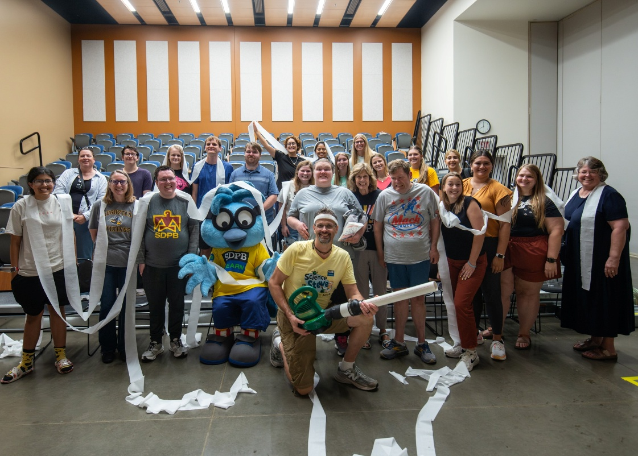

- SDPB hosted its first ever Be My Neighbor Day in Rapid City on September 20 and in Aberdeen on September 27. About 800 people in total attended the events at each community’s public libraries. SDPB was invited to apply and received a grant from Fred Rogers Productions to host Be My Neighbor Day, which promotes the ideas of Daniel Tiger’s Neighborhood and carries on the legacy of Fred Rogers through volunteerism, caring, and kindness. Several community partners provided service activities to help neighbors, including creating first aid kits for homeless people, school supply kits, bookmarks for homebound library patrons, lip balm for children in the hospital, placemats for senior meal programs, and more. Families enjoyed songs and stories with Daniel Tiger, meeting SDPB’s Buddy, and exciting demos from SDPB’s Science Steve.
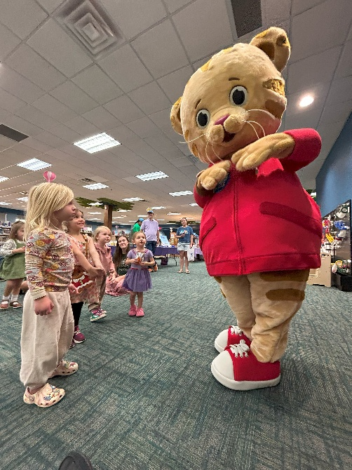
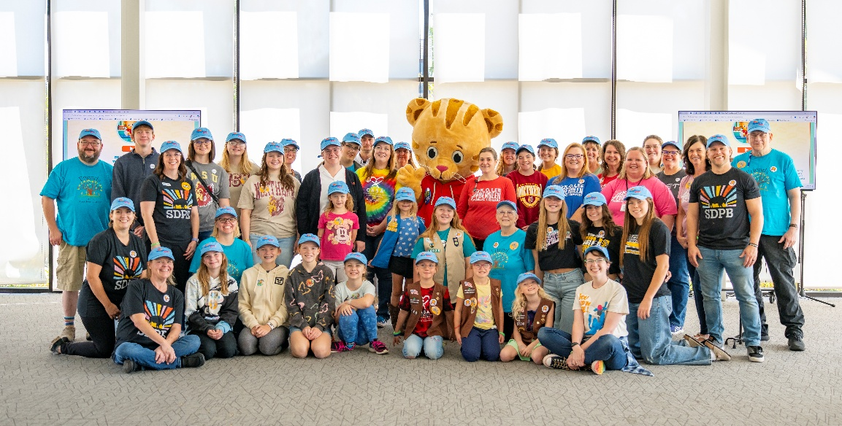

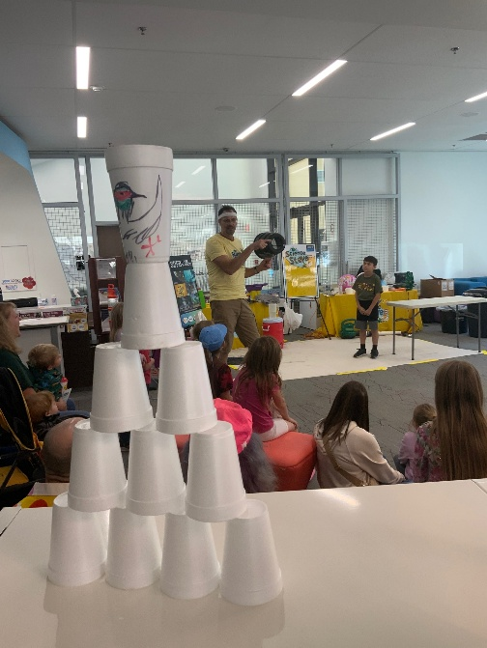

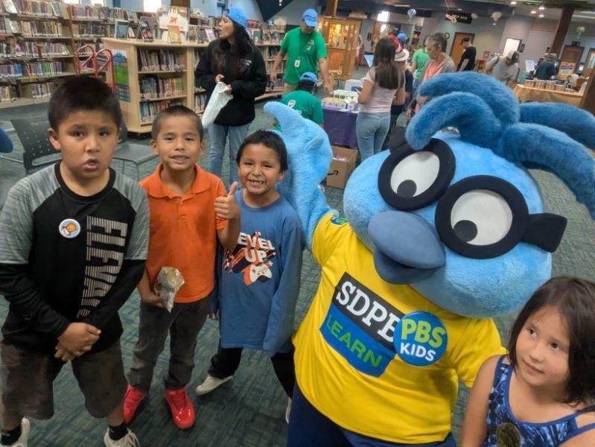
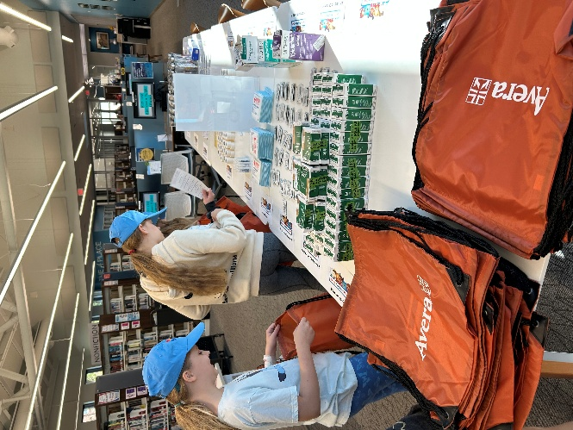

Personnel
- Two contracted consultant positions have been eliminated due to funding reductions. To help fill that gap, SDPB’s west river community engagement coordinator is now assigned to the education team on a part-time basis.

ET Board Report
Jteam-Cara Hetland
December 2025

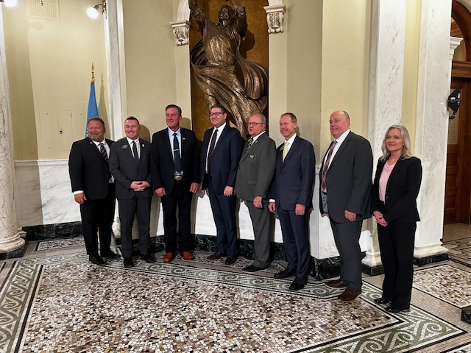
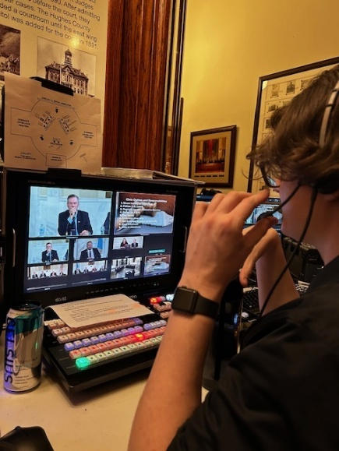
SDPB Jteam partnered with South Dakota NewsWatch, the League of Women’s Voters and the Cheisman Center for Democracy at the University of South Dakota to host a town hall live from the capitol rotunda on the separation of powers in state government. Representatives from each branch of government participated. Gov. Larry Rhoden and Lt. Gov Tony Venhuizen; Supreme Court Chief Justice Steven Jensen and Justice Patricia DeVaney; Republican Rep Scott Odenbach and Republican Sen. Carl Perry, Democrat Rep. Erik Muckey, and Democratic Sen. Jamie Smith were all in attendance for this 90-minute discussion. Initial statistics showed YouTube – 302 views, 6.3k impressions; FB Live – 405 views, 14 reactions, over 60% of views from non-followers; Website – 176 views; Main Facebook feed – 1679 views.
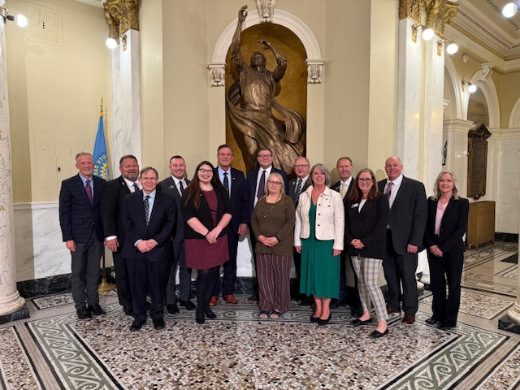
Also in September, In the Moment hosted two live programs around the festival of books with an in studio program featuring children’s authors from our Rapid City studios and a live program from Spearfish from the festival.
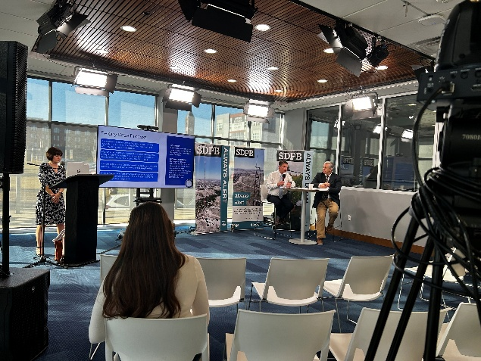
SDPB and SD News Watch hosted a training program for journalists on Oct. 10. This circuit court training had judges and clerks in both our Rapid City and Sioux Falls studios. About 35 people participated either in one of the studios or our online feed from sd.net. There are new computerized programs available to the public to search cases information.
The Jteam is figuring out our new normal. In the Moment is three times a day hour long public affairs program ended Oct. 31. South Dakota focus as a monthly half hour television public affairs program ended Oct 31. We are keeping these brands and developing new ideas around them. In the Moment continues as a daily podcast and longer segment during Morning Edition at 7:34/6:34.
Staffing: The JTeam said goodbye October 10 to Patrick Willliams – he joined SDPB as the All Things Considered Host in December of 2024. Patrick moved to Morning Edition host after Krystal Miga left for personal reasons. Patrick was part of the layoff decisions, and he found work in his home state of Montana. We wish him all the Best.
Also due to layoffs resulting in the loss of CPB money, on October 31, we said goodbye to Ellen Koester, Ari Jungemann, and Jordyn Henderson. Ari and Ellen were producers with the In the Moment daily program. They were both hired in 2022 and helped shape the one-hour program from a live noon hour show to a recorded and well-focused program that aired three times a day. They brought energy and fresh perspectives. Ellen has a love for all things science and endangered species, Ari a love of arts and authors. Ellen accepted a position with SDSU and Ari is with GOED. Jordyn Henderson started as a multimedia videographer in 2020. Based in Sioux Falls, he was key to developing video and social media stories from our In the Moment interviews, statehouse shows, assisting with Dakota Life features, and many more video stories to names. We will miss these three in the Sioux Falls studio and their work.
We celebrate with Josh Chilson on the birth of a baby Rowen Joshua Mateo Chilson was born Aug 21.

SD Board of Directors for Educational Telecommunications
Entertainment Group Board Report—Brad Van Osdel
December 2025

SDHSAA
October was the beginning of SDHSAA tournament coverage. Starting with Class A and AA Golf and Girls Class A and AA Tennis. For these events, the e-group publishes results, takes action, and awards photos. The photos for these four events have been viewed over 4,000 times on SDPB’s Flickr site.
The state soccer tournament was next in mid-October, and the YouTube stream has been viewed 9000 times.
The state Cheer and Dance competition was the following weekend, as well as the state Cross Country meet. The entertainment team took four of the winning cheer and dance routines after the event was completed and shared these highlights on Facebook, where the clips have been viewed over 300,000 times. The team also produced the popular “Coach Cam” video, which shows the reactions of the Cheer and Dance Coaches as their teams perform. This video has been viewed 30,000 times on Facebook.
For the state cross-country meet, the E group aimed to enhance coverage this year and opted to produce individual stories on each of the winners from the six classes. These videos were very successful on Facebook and have been viewed 170,000 times.
The team started the month of November with the Chorus and Orchestra grand concert, which has been viewed over 7,000 times on YouTube after the live broadcast on SDPB1.
The Entertainment team also produced the All-Nations Football Championship, which has been watched on YouTube 11,000 times since the live broadcast. The E group also produced a video that explained and highlighted the importance of the All-Nations Conference to athletes in Native American communities. This video has been viewed 17,000 times on social media.
November 13-15 was the state football championships, and this year, we added a formatted pre-game to our coverage, hosted by Jason Andera, who joined the team in August. Although we have always produced a pre-game show, having a dedicated host to take a deeper dive into the teams enhanced the three-day broadcast. The seven games have been viewed on YouTube 93,000 times. Several memorable plays were released to social media. The halfback-pass from Kain McLeod to Broedan Sales for a 90-yard touchdown for Saint Thomas More was a favorite on Facebook, receiving 67,000 views. Jerren Deal’s Hail Mary pass to Cooper Terrwilliger gave Pierre the lead at halftime of the 11AA championship. This video has been viewed over 200,000 times on Facebook. The E-group also asked players about their favorite Thanksgiving food, and this video has been viewed 22,000 times on Facebook.
The team will conclude the Fall championship season with the state Volleyball tournament on November 20-22 and the State Oral Interp. competition in early December, featuring 12 championship events and broadcasts over a roughly 2-month timeframe.
Game Time
After over 20 years of SDHSAA coverage, the entertainment team felt that we needed to expand our coverage of high school athletics beyond tournament coverage. In August, we launched Game Time, a weekly half-hour program that highlights football, Volleyball, and Boys' and Girls' basketball. Although the content is primarily centered around these sports, the two hosts, Jason Andera and Nate Wek, also delve into high school events and sports beyond football, volleyball, and basketball. The program premieres on YouTube every Wednesday morning with a TV premiere on Wednesday nights at 10:00 PM CT. We have produced 14 episodes of the program and will take a brief break in December, then begin again weekly through the basketball season. The program's success is evident in its over 1,200 weekly views on YouTube, as well as in the interactions with coaches, players, and fans. Nate and Jason began placing football helmets on the set during the broadcast, and coaches who had watched the program started reaching out, offering their teams' helmets to be part of the set.
Tales from Series
The entertainment team continued production of the “Tales from Series” with two additional episodes: Tales from the Diamond, which highlights softball and baseball from around the state, and Tales from the Net, along with Tales from the Gridiron, which brings stories from Wall, Lakota Tech, Brandon, Avon & Mobridge. Tales from the Net dives into stories about Volleyball coaches and players from across the state. This season highlights the leaders who mold our volleyball players in South Dakota - the coaches. Join us as we meet Chester's Jean O'Hara, Sarah Tucker of Douglas, and Sioux Falls Christian's Darci Wassenaar. Although some may know this trio, their stories extend well beyond the volleyball court. The individual stories released to Facebook from these three programs have been viewed 211,000 times. During the upcoming basketball season, the team will produce Tales from the Hardwood. Along with the stories produced for “Tales from Series,” the entertainment team also created other digital content featuring cross-country runners, athletes, and students.
Dakota Life
Dakota Life visited Clear Lake, Newell, and Eurika this past Fall. In Clear Lake, we meet Keith Diekman, our farm collector extraordinaire. Then, we head to the Humble Pig to try some of their smoked meats. We visit one of the best gymnastic studios in our state. We dive into the history of Clear Lake. We also learn about the history of the Crystal Springs Rodeo and visit SoDak Gardens, which just celebrated its 70th anniversary. In Newell, we examine how the irrigation project contributed to the surrounding area's flourishing. Then, we visit with a rancher who explains the pros and cons of raising sheep. We dive into the history of Newell. We visit an experimental farm to determine what can be grown in gumbo soil. Eureka was settled by Germans from Russia; it was initially named St. Petersburg. The railroad renamed the growing community, and it was the railroad that helped make it the world's most significant primary wheat market in the late 19th century. And don’t forget the kuchen! More about Eureka – I have found it! – on this episode. The individual stories of all three episodes have been popular on Facebook, with Clear Lakes' stories viewed 94,000 times, Newell's stories viewed 154,000 times, and Eurika's stories viewed 51,000 times.
Buffalo Round Up
In September, the crew traveled to Custer State Park for the 60th anniversary of the Custer State Park Buffalo Roundup. This popular event has been viewed 60,000 times on YouTube, and the social media stories produced have garnered 147,000 views on Facebook. For these two stories, we highlight the 60 years of the round-up and ask attendees how far they traveled to experience this South Dakota tradition.

