South Dakota Board for Educational Telecommunications
Engineering, Digital, Operations
September 2026
FEMA Next Generation Warning System and Public Safety Communications Grant
SDPB, working with the South Dakota Department of Public Safety and the Bureau of Information and Telecommunications, is developing a statewide Next Generation Warning System (NGWS) strategy that would strengthen South Dakota's emergency warning and public safety communications capabilities.
The initiative builds on SDPB's existing statewide broadcast infrastructure, microwave network, television and radio facilities, and 24/7 Network Operations Center. Rather than creating a separate emergency communications network, the project would modernize and leverage infrastructure already operating across the state.
Why Project Matters, South Dakota's geography, presents significant communications challenges. Rural, Tribal, and frontier communities may have limited commercial broadband or cellular coverage, and commercial networks can become congested or unavailable during severe weather, disasters, cyber incidents, or infrastructure failures.
The proposed architecture addresses this vulnerability by establishing two independent communications paths. Commercial IT connectivity provides the normal high-capacity path, while SDPB's state-controlled point-to-point microwave infrastructure provides a secure, non-Internet-dependent redundant path.
Both paths connect to the BIT/SDPB 24/7 Network Operations Center, allowing emergency information from the South Dakota Emergency Operations Center, Division of Criminal Investigation, FEMA/IPAWS, and other authorized partners to be managed and distributed through statewide infrastructure.
Two Public-Safety Functions
The project supports two distinct but complementary missions.
Public Warning / Emergency Alert System (EAS): Emergency information can be distributed through SDPB's statewide television and FM radio networks to reach South Dakota citizens directly. Future ATSC 3.0 capabilities could further support geographically targeted, multilingual, accessible, and enhanced emergency information.
Public Safety Datacasting: The same statewide broadcast infrastructure can provide secure one-to-many delivery of information to public safety agencies. Potential applications include situational awareness, GIS and mapping information, incident imagery, resource coordination, and critical infrastructure information.
This creates an important distinction: EAS warns the public, while datacasting provides operational information to responders and public safety partners.
Role of the SDPB Network Operations Center
SDPB's 24/7 Network Operations Center provides the operational hub for the system. Existing capabilities include statewide network monitoring, transmitter and infrastructure monitoring, alert management, National and State EAS relay, incident response, technical support, and system management.
Under the proposed architecture, the NOC becomes a central connection point between emergency-management partners and the statewide public safety communications platform.

Infrastructure Modernization
The NGWS initiative would modernize several components of the existing system, including:
- Statewide point-to-point microwave transport with secure, encrypted, multi-gigabit capability
- Television infrastructure supporting ATSC 1.0 and future ATSC 3.0 services
- Statewide FM broadcast and translator infrastructure
- EAS/IPAWS distribution and operational integration
- Public safety datacasting capabilities
- Secure interfaces between emergency-management agencies and the BIT/SDPB NOC
The objective is not simply to replace aging equipment. It is to transform existing broadcast infrastructure into a more resilient statewide public safety communications platform.
Strategic Value to South Dakota
The project would provide a Resilient alternative communications path. reduce reliance on commercial communications infrastructure while improving interoperability among federal, state, Tribal, local, and public safety organizations.
Most importantly, it provides South Dakota with multiple ways to move critical information during an emergency. If commercial Internet connectivity is disrupted, state-controlled infrastructure can provide an alternate path for emergency communications.
The result is a system designed to support both sides of emergency communications:
Warning South Dakota citizens and
Providing critical information to public safety responders.

Federal Funding Opportunity
South Dakota is pursuing FY2026 Next Generation Warning System grant funding to support this modernization. Federal investment would allow the state to leverage existing towers, broadcast facilities, microwave infrastructure, operational systems, and technical expertise rather than constructing an entirely new network.
This approach reduces implementation risk, protects previous state investments, and creates a sustainable platform that can support future public warning and public safety technologies.

Board Takeaway: The Next Generation Warning System initiative expands the role of South Dakota's existing statewide broadcast infrastructure as a resilient public-safety asset—providing independent communications pathways, improving emergency warning capabilities, and helping ensure critical information can reach both responders and South Dakota citizens when conventional communications systems are disrupted.

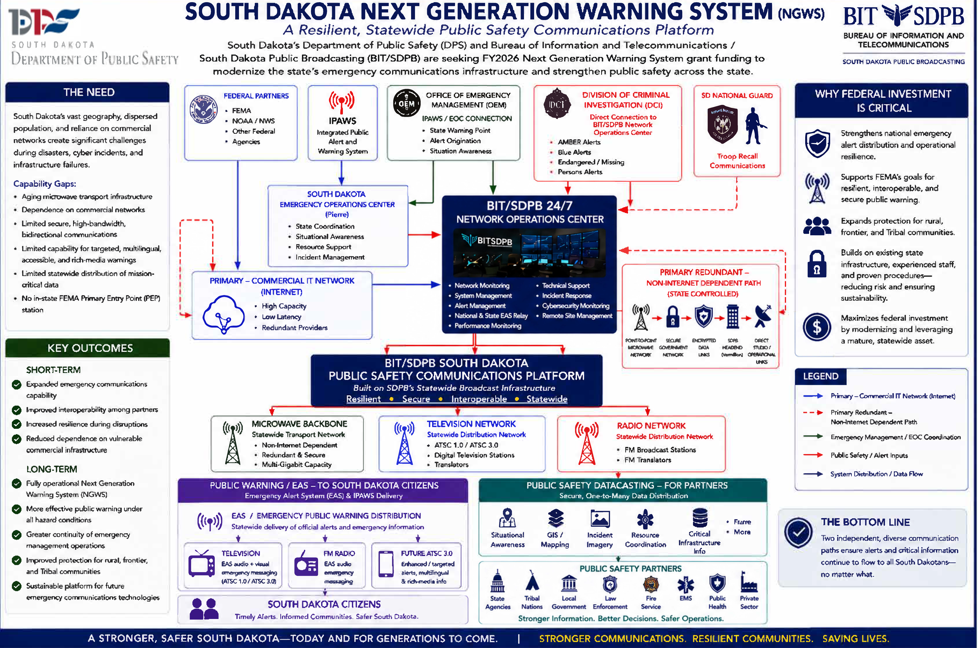
Routine Station and Technical Operations
In addition to work associated with the Next Generation Warning System initiative, Engineering and Operations continued routine maintenance, technology lifecycle replacement, archival preservation, production support, and several major broadcast-system modernization projects.

Broadcast IT and Windows 11 Migration. Continued progress was made eliminating Windows 10 systems from the broadcast environment. Older computers are being replaced with new rackmount hardware where appropriate, while serviceable equipment is being repurposed when it can continue to meet operational requirements. Nine additional computers are on order, with several other systems identified for upgrade or decommissioning.
Archive Digitization Project
The approximately 2,000 videotapes submitted for digitization through grant funding have been returned as digital files and incorporated into SDPB's long-term archive. Low-resolution proxy files allow staff to preview material before requesting restoration of the full-resolution archival file. Only 90 tapes were unrecoverable, representing a strong recovery rate given that the collection spans several decades. This project preserves historically significant SDPB content while making the collection substantially more accessible for future use.
PBS/NPR Interconnect Transition
Progress continues toward moving away from traditional satellite and dedicated MPLS-based program distribution. PBS is transitioning toward redundant public-Internet connectivity, which is expected to replace the significantly more expensive MPLS circuit. PBS is also developing redundant Internet-based program streams as part of its longer-term strategy to reduce dependence on satellite distribution.
Engineering refurbished several components of SDPB's large Andrew satellite antenna to determine whether it could provide improved reception compared with the existing Patriot antenna. Testing showed that the Andrew antenna did not provide the anticipated signal improvement. This work is particularly relevant as Galaxy 16 approaches its expected end of service life in summer 2028 and the industry continues moving toward IP-based content distribution. NPR is similarly developing a low-latency public-Internet stream as an alternative to satellite delivery.
Broadcast Systems Modernization. Engineering continues evaluating replacement television automation systems, with additional vendor proposals and pricing received. Work is also progressing on several other significant infrastructure projects, including the video router replacement and radio Livewire infrastructure upgrade. These projects are intended to modernize core broadcast workflows while improving reliability and long-term supportability.
Production and Operational Support. Staff continued supporting live productions, streaming, audiocasting, track events, jazz band and show choir productions, including an unusually active level of live-production support during July. Routine station maintenance and troubleshooting continued alongside these activities.
Inventory and Asset Management. The ongoing equipment inventory audit continues to make good progress. This effort will improve equipment lifecycle planning, asset accountability, replacement forecasting, and future capital planning.

Overall Engineering and Operations Status
Engineering and Operations continues to balance daily broadcast reliability with several concurrent technology transitions. Current priorities include completing the Windows 11 migration, preserving legacy media assets, preparing for the industry's transition away from satellite distribution, replacing aging broadcast automation and routing infrastructure, modernizing radio networking, and advancing the statewide NGWS/public safety communications initiative.
Together, these projects represent a broader transition from aging and increasingly proprietary broadcast systems toward modern, IP-based, resilient, and supportable infrastructure, while maintaining uninterrupted television, radio, streaming, EAS, and public-service operations.

This gives the Board a much better narrative: NGWS is the strategic initiative, followed by routine operations and modernization work demonstrating that the department is simultaneously maintaining today's network while building the next generation of infrastructure.

Respectively,
SeVern Ashes

South Dakota Board for Educational Telecommunications
Programming & Communications
September 2026

Programming
NPR rolled out a new fee model. It is based on the total households served by stations. Our FY27 total NPR Core and Program fee is $208,207. That amount is $16,019 less due to a couple of program changes SDPB made.

PBS dues will increase 5% from the post-recission FY26 amount. Our FY27 dues will increase by about $38,000 to $795,017.

The World Channel (SDPB2) for FY27 remains at the FY26 rate of $6,615.

The Create channel (SDPB3) for FY27 will remain free, thanks to income from Bob Ross paintings auctioned last year.

Television:
- Local productions that aired since our last meeting in April 2026 include: SDHSAA events – All-State Band, All-State Jazz Band, Track & Field, Girls Class AA Softball, plus the SDHSRA High School Rodeo Championships. SDPB broadcast local documentaries Standing Proud: Women in Uniform, Panorama Part II, Aberdeen’s Pheasant Canteen, The Buffalo of the Northern Plains. SDPB broadcast a candidate forum for the Republican gubernatorial runoff. Using our library of local history documentaries, SDPB put together a schedule of programs that recognized America’s 250th anniversary, culminating with a live broadcast of a reading of the Declaration of Independence by a variety of South Dakota officials. We also aired new episodes of On Call with the Prairie Doc, South Dakota Focus, and Dakota Life.
- Forthcoming local/regional programs and documentaries include coverage of the annual Buffalo Roundup (TV & Radio), a documentary about the Dakota Dome and its place in the hearts of high school athletes who played there, a new season of SDHSAA events, starting with Soccer and the 25th season of On Call with the Prairie Doc, and 29th season of Dakota Life.
Radio:
- As indicated in my April report, the radio schedule was adjusted to accommodate NPR fees. We removed Fresh Air and replaced it with The World. That program change alone saved SDPB about $29,000.
- After the passing of Karl Gehrke, SDPB engaged Matt Weesner to produce local (recorded) episodes of Jazz Nightly while we investigated other program opportunities. We continue to broadcast jazz music Sunday through Friday, and effective Sept. 7 began using a service from WFMT-Chicago.
- Also, effective the week of Sept. 7, the radio broadcast schedule was adjusted to include The Middle live at 8:00pm CT/7:00 MT with a replay Sunday afternoon.
- We will pay tribute to Karl Gehrke with a live concert on April 26.
Marketing
- Developing new workflows for a skinnier Programming-Communications department.
- Working on a communications plan, in concert with initiatives included in the Strategic Plan.

Education and Telecommunications Board Report
September 2026
Brad Van Osdel
Director of Content & Assistant General Manager

Summary
As I’ve transitioned into my new role at SDPB and gained deeper insight into the work happening across our content departments, I’ve developed an even greater appreciation for the scope and impact of SDPB’s service to South Dakotans. This summer showcased strong momentum across our teams, highlighted by the continued evolution of cross-department storytelling and expanded collaboration that enriched statewide engagement. These efforts strengthened SDPB’s statewide presence and have positioned us well for an impactful and ambitious fall season

Leadership Update
I am pleased to share that Kyle Mork has accepted the position of Director of Entertainment Content. Kyle has been a pivotal contributor to Sports and Activities content as well as numerous other major projects. His leadership will help drive the next phase of cross-platform storytelling, live event production, and statewide engagement.

Dakota Life
The Dakota Life initiative continues to evolve into a fully integrated, cross-department production model. Members of the entertainment and journalism teams have collaborated to produce stories for each episode, the outreach team has led community engagement through conversations and premieres, the digital team has expanded the online and on-location storytelling footprint, and the education team has strengthened community partnerships by hosting events tied to Dakota Life locations. Together, these efforts have resulted in enriched local engagement and a deeper connection with rural audiences across South Dakota.

Republican Gubernatorial Runoff Candidate Conversations
The journalism team produced the Republican Gubernatorial Runoff Candidate Conversations leading up to the runoff election. The program provided each candidate an opportunity to share their platforms and plans. The videos shared on social media performed exceptionally well, generating 98,000 views on Facebook and demonstrating strong public interest in statewide political coverage.
Neutrino Days
The education department had a successful summer hosting “Science Steve” events across the state and participated in Neutrino Days in Lead, performing for a large crowd of science enthusiasts. The journalism team ventured deep underground for a special live radio program highlighting the research and experiments happening at the Sanford Underground Research Facility, offering audiences an inside look at the cutting-edge science taking place in South Dakota.

Standing Proud — Women in Uniform
In May, SDPB aired Standing Proud: Women in Uniform, a documentary honoring the women of South Dakota who have served in the armed forces. The program was very well received across the statewide audience. Screening events in Sioux Falls and Rapid City drew strong attendance and fostered meaningful reflection and conversation. Online engagement was also significant, with more than 21,000 Facebook views of the shared content—reinforcing how deeply this subject resonates with viewers. The second episode of Standing Proud is scheduled for release in November.

Declaration of Independence 250th Anniversary
To mark the 250th anniversary of the adoption of the Declaration of Independence, SDPB partnered with State Historian Dr. Ben Jones for a statewide commemorative reading of the document. SDPB delivered comprehensive coverage of this civic event through live streaming, television, and radio, ensuring audiences across South Dakota could participate in this historic moment.
In support of this anniversary, SDPB’s Education Department traveled to conferences statewide to share and promote SDPB’s history resources. These materials were organized to help educators integrate the 250th Anniversary into classroom instruction.

High School Activities Spotlight
This fall, SDPB will launch a new statewide digital series featuring more than 40 stories that highlight students, athletes, musicians, coaches, teachers, and families from across South Dakota. Designed for a cross-platform audience, the series will include content produced for SDPB Radio, digital platforms, Game Time, and for use during live broadcasts of SDHSAA events.
Since its inception last spring, this project has been a fully collaborative effort across SDPB’s Digital, Journalism, and Entertainment departments. The Entertainment team is leading production, while the Journalism team provides editing and editorial support to ensure strong storytelling across all platforms.

Summary
As we move into fall, the content teams are producing an exciting array of projects. Election coverage, Game Time’s second season, the Custer State Park Buffalo Roundup, the release of the second episode of Standing Proud: Woman in Uniform, and Dome Sweet Dome: 45 Years of Memories—a documentary celebrating the experiences of fans, players, and coaches who participated in the Championships at the Dakota Dome—along with daily news coverage, coverage of SDHSAA events and activities, and science programs featuring “Science Steve” at engagements across the state, are all positioned to maintain strong traction across broadcast, radio, local community outreach, and digital platforms

The Digital Department continues to serve as a vital conduit to new audiences, amplifying entertainment, journalism, and education content while guiding viewers and listeners to additional SDPB resources across TV, radio, and online platforms. This quarter, SDPB digital followers grew by 15%, reaching 230,875 total followers, and sdpb.org recorded 1.9-million page views, demonstrating sustained and expanding engagement statewide.
SDPB’s content teams remain committed to delivering impactful programming rooted in community engagement, statewide storytelling, and multiplatform service.

South Dakota Board of Directors for Educational Telecommunications
September 2026
Digital Department Report by Byron Pillow

Department Projects and Updates

Reimagining and improving the function of SDPB’s Open Government services continues to be a primary focus of the department. Since the last Board meeting, we have participated in intensive process mapping activities, established new documentation and protocols, and ensured continuity in workflows even through the departure of both prior Open Government employees. We are working to further consolidate the Open Government tasks and management under the Digital Department and are in the process of hiring a new FTE dedicated solely to Open Government.

Effort continued over the past months participating in the statewide ADA compliance initiative regarding the new Section II / WCAG 2.1 Level AA regulations that go into effect on April 24 for digital content. This effort involves coordination across all SDPB content departments, as well as with Friends where they intersect with SDPB platforms, to ensure that legal requirements are met by SDPB content and SDPB-owned platforms.

General Metrics – 2026 Quarter 2

Q2 of 2026 has already showed consistent YoY growth in digital performance, proof of the excellent work our content teams are doing and our ever-increasing internal collaboration.

Across the quarter, our social media accounts reached an 1.3 million users averaged monthly, with a follower growth of 15.1% YoY to over 230k accounts across platforms. Content impressions for the quarter were over 15.3M, up 29% YoY, content interactions are up 12% YoY to 161K, and total social media video watch time is up 40% to 186K hours.

Video streaming platforms also show upward trajectories, with an average monthly reach hovering over 204k users, with total video watch time up 21% YoY to 339K hours.

Audio content, including radio web streams and podcasts across our own, and NPR platforms, reach an audience of over 13k users monthly who listen to over 169K hours of SDPB audio content.

Our website, SDPB.org, delivered roughly 1.9M page views, from roughly 1.4M unique users.

Q2 2026 returned notable passive ad revenue from both Meta and YouTube properties,
with over $3,800 generated from SDPB content views.

Journalism Team
ET Board Report
August 2026

SDPB and South Dakota News Watch hosted free training for South Dakota Journalists, students and others interested in or concerned about election integrity and newsgathering at the polls on May 8. David Becker, a national election law expert who co-authored the book “The Big Truth” with TV correspondent Major Garrett, was the featured speaker. Sioux Falls Lawyer and legislative lobbyist Justin Smith also joined to discuss state election laws. Forty people participated in the discussion sponsored by SDPB, South Dakota News Watch and the South Dakota Bar Foundation. Also special thanks to Dave Bordewyk, executive director of the South Dakota NewsMedia Association for co-hosting the event. Our next training is partnering with the USD Knudson Law School discussing juveniles in the courts. It is scheduled for October 2.
SDPB was awarded two regional Edward R Murrow awards. In the Small Market Television category, the “South Dakota Focus” team of Jackie Hendry, Delainey LaHood Burns, and Jordyn Henderson won best news documentary for the two-part series on Emergency Medical Services in the state. In the Small Market Radio category, SDPB’s “In the Moment” team of Lori Walsh, Ellen Koester, and Ari Jungemann won for the episode “Meet the black-footed ferret and the people fighting for the species.
Cara Hetland has been accepted to serve on the Knight Journalism Advisory Committee. This group is made up of 10-15 leaders from news organizations across the Knight communities. Members will serve a one-year term with quarterly meetings. The goal is to create a more direct line of communication between Knight and media leaders to better understand emerging challenges and opportunities.
Cara attended the SDNA annual convention in Deadwood. The goal is to create more content sharing partnerships with newspapers across the state. The idea is well received, and more formal agreements are in the works. SDPB has signed three Content Sharing Agreements with True Dakotan (Wessington Springs) and Black Hills Pioneer allow SDPB to rewrite stories for broadcast with credit to the paper, in exchange for all SDPB.org content can be reprinted. We also have formalized our partnership with South Dakota News Watch with election debates, town hall discussions, and journalism training.
The J Team has been focusing on Instagram Reels for regular news content and explaining issues and events in under a minute. Here are some stats on what we’ve been seeing on SDPB NEWS from Quarter 2 2025 to Q2 2026:
- Total views increased 66% YOY
- Follower growth surged past 200%YOY
- Reach up 5% YOY
- Link clicks up 145% YOY
- More than 23 k video views of original news reels

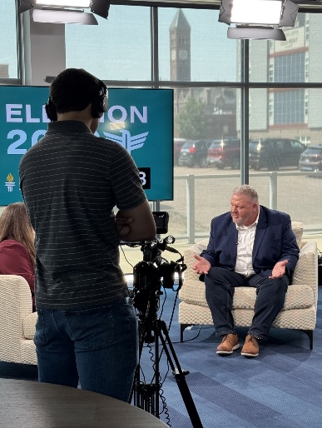
J Team covered primary election the evening of June 2 – with candidate interviews, social media content and newscast and feature material for the next day along with political junkie analysis the day after that. The two runoff candidates did not participate in a debate, but both agreed to a sit down one on one conversation with Jackie Hendry. That 90-minute program aired on SDPB TV on July 16. Special thanks to Design House for the use of the chairs. Also special thanks to the EGroup for assisting in recording and editing the program together.
Upcoming Debates: September 14 – US Senate, September 28 - Gubernatorial, October 1 – US House, October 5 – Ballot Initiatives.

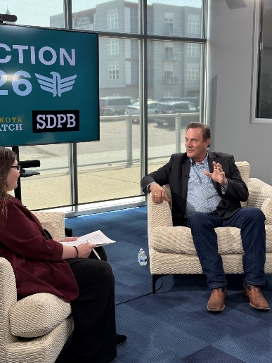
JTeam traveled with Dakota Life to Aberdeen and Agency Village for some interviews about water issues in those communities. And we covered the July 3rd fireworks and presidential visit to Mt. Rushmore.

The Upper Midwest Newsroom content sharing included SDPB feature by Jackson Dircks story on the Grassland Triple Crown – bicycling racing on gravel as a new tourism draw.

August 26, we paid tribute to Karl Gehrke with a live radio broadcast with musicians in both our Sioux Falls and Black Hills studios. 110 people attended. The three-hour program aired on television on Thursday, August 27. Karl’s siblings were in attendance and were moved by the outpouring of support honoring their brother.

SDPB Entertainment Group – Board Report
September 2026 | Kyle Mork
Howard Wood Dakota Relays – New Coverage Initiative (May 1–2, 2026)
The 101st Annual Howard Wood Dakota Relays opened SDPB’s 2026 event season and marked a major milestone for the Entertainment Group, as this was the first year we fully livestreamed the premiere two‑day track and field meet. Although the Relays are a high‑school competition, they are not sanctioned by the SDHSAA and include top athletes from both South Dakota and North Dakota, making it one of the region’s most prestigious spring events. SDPB delivered full coverage of the entire track and field lineup for the first time, offering dedicated single-camera streams for pole vault, high jump, long jump, triple jump, shot put, discus, and javelin, along with a fully produced multi-cam broadcast of all track events.
This inaugural digital rollout produced strong engagement across platforms, reaching 25,150 viewers, earning 74,400 views/plays, and producing 34,450 hours of watch time. These results demonstrate clear audience demand for expanded coverage of the Relays, and SDPB plans to continue this full‑event streaming model for the 2027 Howard Wood Dakota Relays.
May SDHSAA Events – Jazz Band, Show Choir, Tennis, and Track & Field
Following the Dakota Relays, May continued as one of SDPB’s busiest and most productive months. The Jazz Band and Show Choir events were streamed live to SD.net and later broadcast on SDPB‑TV, continuing to draw strong statewide interest. The two tennis championships held during the week of May 19th generated steady digital engagement through stories, photos, and statistics posted throughout the week.
The SDHSAA State Track & Field Championships delivered another standout performance, with 96,540 hours watched, marking a 40.5% increase over last year — one of the largest year‑over‑year gains of any SDHSAA livestream. Building on the success of the Dakota Relays, the team again streamed every field event—shot put, high jump, pole vault, long jump, triple jump, discus, and javelin—while presenting all track events through a fully produced multicam broadcast. Feature stories highlighted record‑breaking performances, light‑hearted athlete interviews, and family traditions, all of which contributed to strong digital viewership across platforms.
June SDHSAA Events – Girls State Softball & Spring Golf
June concluded the SDHSAA season with the Girls State Softball Tournament and Spring Golf. Even with 36 single‑camera streams and only two fully switched productions (Class AA third‑place and championship games), softball delivered one of SDPB’s most dramatic year‑over‑year increases. Views climbed 239.8%, and total watch time jumped 321.1%, demonstrating rapidly growing audience demand for SDPB’s softball coverage.
Spring Golf coverage included results, photos, blogs, and several social videos featuring golfers’ least favorite clubs, favorite professionals, advice for younger players, and standout swings, all contributing to strong digital engagement.
High School Rodeo – Ft. Pierre (June 2026)
The SD High School Rodeo Finals in Ft. Pierre once again proved to be a strong digital performer for SDPB. More than 620 youth athletes competed over four days, and SDPB streamed every portion of the event — beginning with Cattle Cutting and Reined Cow Horse on Wednesday, continuing through two full days of prelims, and concluding with Saturday’s short-go championship, which aired both online and on SDPB-TV. This year’s digital engagement showed solid growth over last year, with the rodeo reaching 9,000 viewers, 21,700 views/plays, and producing 9,630 hours of watch time. With beautiful weather throughout the weekend, the Entertainment team captured several stories that resonated strongly on social media, and state champion interviews continued to roll out through July, contributing to the event’s overall increase in digital reach.
Dakota Life – White River (April 2026)
Dakota Life continued its mission of highlighting South Dakota’s communities with a new episode focused on White River in April. The episode showcased how the community integrates Lakota culture into its schools, supports youth leadership through the Energize group, and preserves local history through a revitalized outpost restored by veterans Clinton and Lisa Rasmusson. It also explored White River’s museum, its annual Frontier Days celebration, and the town’s storied basketball tradition built on generations of state championship success. With the 25/26 season now completed, the Dakota Life team has been traveling throughout the summer to record stories for the upcoming 26/27 season, gathering new content across six communities statewide.
Documentaries – Standing Proud: Women in Uniform (May 2026)
SDPB added a powerful new documentary to its portfolio this year with Standing Proud: Women in Uniform, a half‑hour film that quickly became one of our most well‑received productions. The documentary shares the stories of six women veterans as they reflect on their service, challenges, and achievements — from early training to major world events such as Vietnam, the fall of the Berlin Wall, and 9/11. Their voices reveal how military service shaped their lives, identities, and communities here in South Dakota, creating a deeply personal and resonant narrative that connected strongly with viewers. The production quality, storytelling, and emotional depth of the film were widely praised, reinforcing SDPB’s commitment to elevating local stories with statewide significance. Building on the success of Standing Proud, the team is already planning another half‑hour documentary for release this November to continue exploring and honoring the experiences of South Dakotans through thoughtful, high‑impact storytelling.

Closing Notes
The Entertainment Group continues to expand its reach, deepens community connections, and elevate SDPB’s statewide presence. Our team’s dedication to storytelling and innovation remains central to our mission as we prepare for another strong year of coverage and content creation.

South Dakota Board of Educational Telecommunications
Education Report-Marcy Drew
September 2026

Resource Development and Distribution:
- During the past year, SDPB Learn’s education website saw just over 64,000 individual users and more than 90,000 views. SDPB contributes comprehensive learning resources to PBS LearningMedia for early childhood and K12 educators across the nation. This year, SDPB’s local resources had nearly 86,000 total users, and about 918,000 video streams on PBS LearningMedia alone. On PBS LearningMedia, our Dissection 101 series consistently ranks among the top five most popular science resources in the nation.
- Diligent work continues to update materials to comply with accessibility guidelines and with new requirements from PBS LearningMedia. In the process, we ensure that educational materials remain relevant, up-to-date, and useful to today’s students, families, and educators.
- SDPB Education Update newsletter, emailed weekly during the school year, includes resources, programs, and lessons in all content/developmental areas for parents and educators of students from PreK-12. These resources are aligned with SD Early Learning Guidelines and Content Standards. As of June 2026, this newsletter had 3,613 subscribers.
- Public Media Making History at 250 brings together films, digital series, and educational resources that celebrate American history and identity from stations across the country. SDPB has five educational resources in the collection.

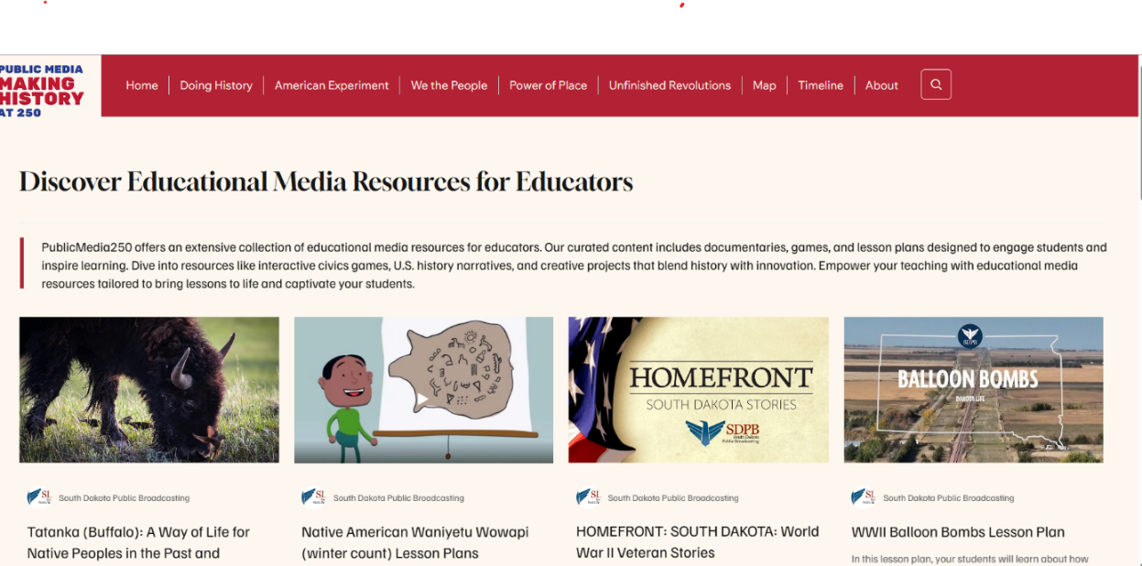

Outreach and Professional Development
- The education team provides outreach and professional development to families, caregivers, and educators to share the resources available from SDPB. In fiscal year 2026, we reached 15,062 people across the state. Direct professional development was delivered to 404 child care and education professionals.
- About 7500 people attended YFS Kids Fair in Rapid City. SDPB was a media sponsor and hosted a character photo booth. Buddy the Bird made several appearances over the course of the two-day event.


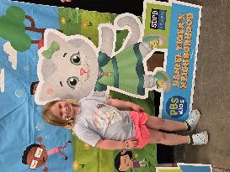

- Children and families from Lower Brule enjoyed a day of celebration at Family Unity Day at the community center. SDPB shared summer activities and more with about 400 attendees. Students at the school learned about hands-on science from Science Steve that morning.

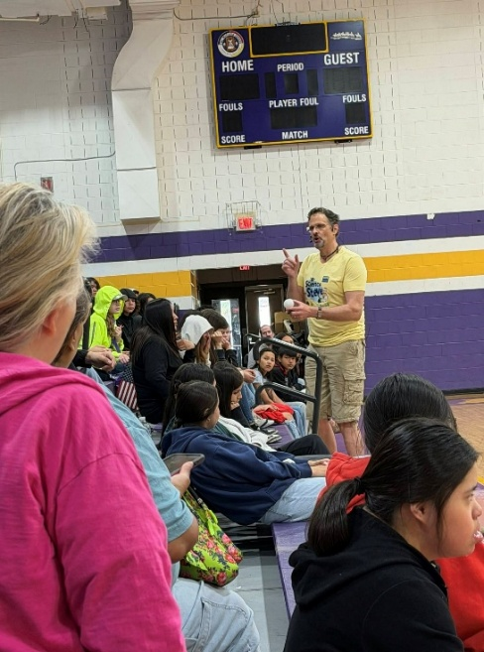
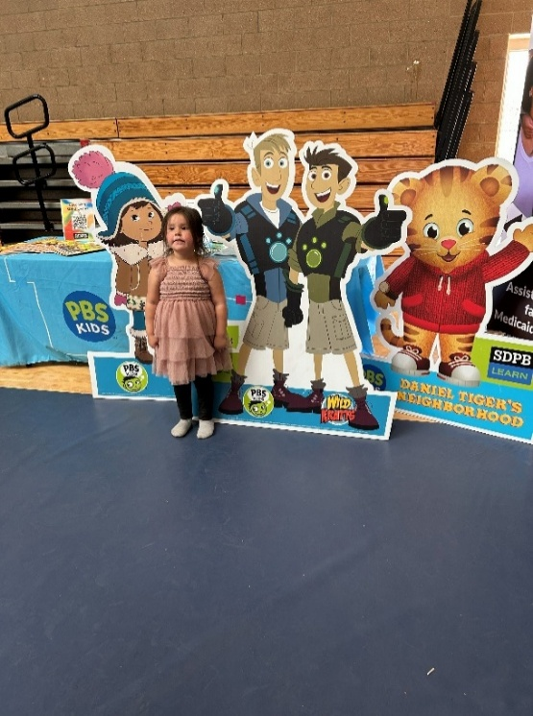

- Science Steve made several additional appearances during the spring and summer. This included the Missouri Breaks Research Symposium in Kyle, where hundreds of students from several area schools attended, USD Head Start families from southeastern SD, approximately 600 homeschool parents and students at the SD Homeschool Conference in Rapid City, and 250 science enthusiasts at Neutrino Day at the Sanford Underground Research Facility (SURF) in Lead.
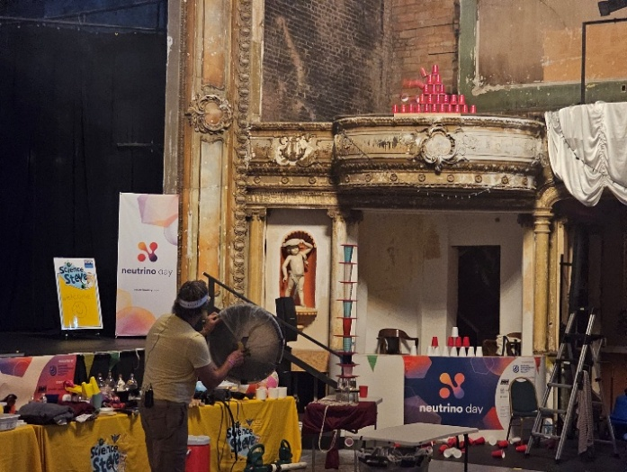
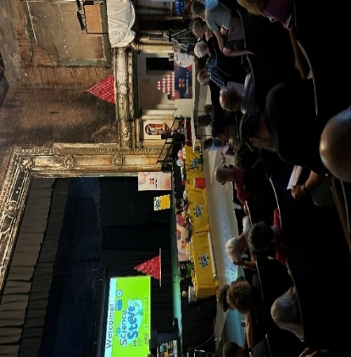

- For the second time, SDPB is part of a nationwide research project measuring learning and engagement in activities based on the PBS KIDS show Work It Out Wombats. As children and families play together, they practice computational thinking or solving problems logically and step by step. SDPB partnered with Siouxland Libraries and Truks N Trykes childcare center to host about 140 people for “Playtime with the Wombats”. Families with children of all ages learned about cause and effect, sorting, matching, and breaking down big tasks to solve problems. Each child took home new box of crayons and a bag full of activities to practice “working it out” at home.

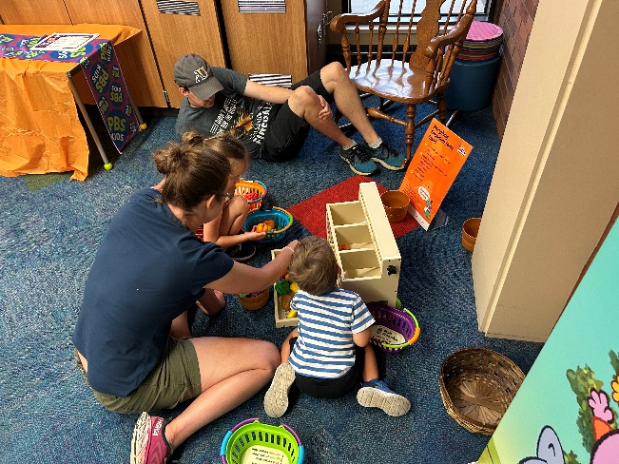
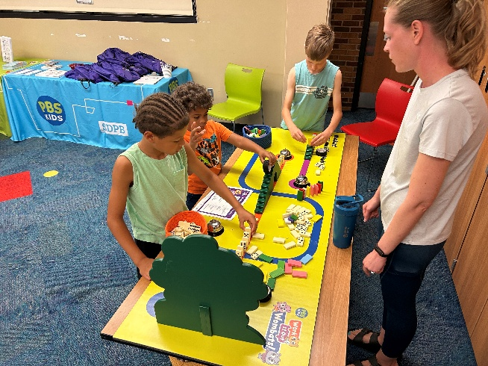
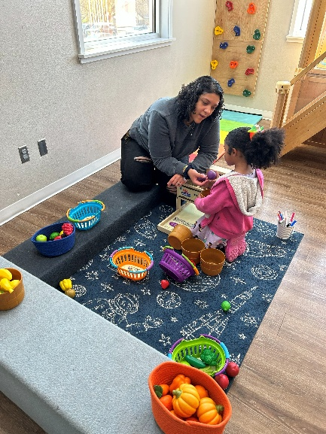

- Professional conferences, school in-services, and guest presentations at schools of higher education provide opportunities to share SDPB’s resources that attendees can use to learn and explore across every content area. This spring and summer, the education team shared resources at the SD Homeschool Conference, Lighting the Way Autism Conference, SD Leadership Conference (school principals and administrators), SD Associated School Board/School Administrators of SD Joint Convention, and Southeast Technical College’s Early Childhood Education program. Featured topics included social studies, particularly related to America’s 250th anniversary, autism, social skills, reading, science, and more.

