Management

Team

Reports

South Dakota Board of Educational Telecommunications
Operations, Engineering & Technology Report
April 2026
The first quarter of 2026 has been highly productive, characterized by successful support for the state legislative session and major sporting events, alongside significant progress on critical infrastructure upgrades. The team provided support for the legislative session and state basketball tournaments. Additional events, including the Young People’s Concert and All-State Band, were also successfully supported.
SDPB Open Government
2026 Legislative Session, as reflected in the online analytics reporting in Byron Pillows April ETV Board report. This project is off to a great start. The switch to video in the legislative meeting rooms has gone well. We're now streaming all the Legislative Committee and Chamber sessions to both www.sdpb.org/open-gov our SDPB Open Government YouTube channel, which is a huge plus for lawmakers and the public. Best of all, this new setup means the meeting recordings are available online just minutes after they wrap up. SDPB digital team is still providing the “official” indexed audio only files back to LRC to attached to each bill.
State Boards and Commission meetings are also being streamed to both www.sdpb.org/open-gov and our SDPB Open Government YouTube channel. The format of most of these meetings is Audio only and streamed with a SDPB Open Government background.
It’s important to note that the official media of record under the Open Government Commission is still audio only. Our team will continue to process audio only files and deliver back to each Board and Commission for archive.
Key infrastructure improvements were completed, most notably the full installation of a new air chiller in the Vermillion NOC server room. This system has a primary and redundant system to ensure adequate temperature & humidity control to safeguard our television, radio automation, EAS activation servers, Open Government streaming encoders and our public safety EAS interconnection delivery system. Fix for the Senate Tricaster video production server. And a new FAA tower lighting system on our KPSD Ch 13/ 97.1 FM 1700 ft tower.
Disaster recovery plan and exercise: Engineering team are reviewing existing recovery plans. To identify existing and new technology to increase system resiliency. Tabletop exercise and fail over drills are being planned for fall of 2026.
Despite these successes, the team faced and addressed several technical challenges. Severe C-band satellite interference on the NPR signal, caused by the new Verizon, necessitated a temporary switch to an internet delivery stream and was later mitigated by changing satellite dishes and installing a new 5G filter; further steps are being taken to reduce future 5G cell interference and enhance signal quality.
PBS Change from Self-Master Control to Outsourced with Encompass, PBS began shadow operation with Encompass on April 1st. They will take turns providing the satellite signal. Eventually the PBS master control/NOC will be decommissioned as they outsource to Encompass based out of Atlanta Ga. With Synchronized disaster recovery site located in Connecticut. Engineering and programming. We are keeping an eye on the quality of service During this transition.

FY27 Capital improvements
The FY27 capital plan prioritizes critical infrastructure upgrades and preventive maintenance to ensure long-term reliability and uninterrupted service across SDPB’s Television, Radio, and Online (Open Government) platforms. It also supports monitoring and compliance functions for tower Maintenance: Conduct scheduled tower inspections and structural repairs across the statewide infrastructure to maintain reliability and regulatory compliance.
- Windows 10 end of life: Replace the remaining backend computers and staff workstations. To bring into BIT compliance.
- Television Signal Processing Upgrades: Continue upgrading signal processing equipment at KTSD, KQSD, and other key television transmitters to improve on-air quality and ensure consistent performance.
- Network Operations Center Modernization: Reconfigure SDPB’s 24/7 Network Operations Center to improve operational efficiency for managing television and radio automation, activating the statewide Emergency Alert System (EAS), and providing real-time remote tower site security monitoring and dispatch for SDPB and State Radio tower systems. This initiative reinforces compliance with FCC, FAA, and site security standards.
FEMA Grant (refresher)
If you recall our plans for FY26, 27,28 were to utilize the FEMA Next Generation Warning System Grant Program (NGWS) grant award to enhance statewide alert and warning capabilities and improve resiliency of emergency alert and warning systems that would improve the timely delivery of public safety information for state and tribal partners. By replacing the SDPB microwave interconnection system will include Uninterrupted Backup Power supply systems, dehydrator systems, microwave antennas, transmission lines, and high-definition signal processors statewide.
Round 1 of the grant would have concentrated on
- The microwave interconnection system will include Uninterrupted Backup Power supply systems, dehydrator systems, microwave antennas, transmission lines, and high-definition signal processors between SDPB Vermillion Main Studio, KUSD TV/FM Beresford, KCSD TV/FM Sioux Falls, KESD TV/FM Brookings, and KDSD TV/FM Pierpont/Aberdeen.

- Adding local EAS alerting at all 9 Television Broadcast transmitters. That will connect directly to the FEMA Integrated Public Alert & Warning System (IPAWS)

- Replacing FM transmitters and translators

Round 2 included

- The microwave interconnection system will include Uninterrupted backup power supply systems, dehydrator systems, microwave antennas, transmission lines, and high-definition signal processors for KUSD TV/FM west to KTSD Reliance, State Capital, New connect into the Office of Emergency Management Command Center in the Mickelson Public Safety Building , Capital complex in Pierre SD. KQSD TV/FM Lowry, KZSD TV/FM Martin, KBHE TV/FM Rapid City, and KPSD TV/FM Faith .

Round 3 included

- ATSC 3.0 NextGen TV ready television transmitters and translators

South Dakota Board for Educational Telecommunications
Programming & Communications
April 2026

Programming

Since our last meeting, where the headline was the savings, we realized from radio and TV programmers, today we sit in a different situation. Post-rescission negotiations realized a savings of $235,137 in TV and Radio programming costs during FY26. As FY27 approaches those savings are not going to continue.

PBS indicates that dues will hold steady.

NPR is rolling out a new fee model. As of this writing, we do not know exactly how the new model will affect our Core Fee and the amount we pay for NPR’s programming.

The Create channel (SDPB3) will remain free, thanks to income from Bob Ross paintings auctioned last year.

Other program costs have yet to be addressed by the providers. It’s suspected that costs might return to the pre-rescission level, but there won’t be a significant rise in cost beyond that. We are keeping our pencil sharp.

Television:
- Local productions that aired since our last meeting in December 2025 include SDHSAA events – Team Duals and Individual Wrestling, Girls and Boys Basketball. SDPB repeated SDSO Presents Giants in the Earth and Discussing Giants in the Earth; Tales from the Hardwood; Game Time; SDPB Election 2026 Gubernatorial Primary Debate; Our Neighbors in Nehou; Steak Science, and live coverage of the legislature, including the State of the State/Tribes/Judiciary addresses. Televised sessions We also aired new episodes of On Call with the Prairie Doc, South Dakota Focus, and Dakota Life.
- Forthcoming local/regional programs and documentaries include Standing Proud: Women in Uniform, Aberdeen’s Pheasant Canteen, The Buffalo of the Northern Plains, and other shows currently in negotiations.
Radio:
- The radio broadcast schedule was adjusted to include The Middle (Fridays at noon). Depending on how the new NPR fee schedule looks, other changes may be forthcoming.

Marketing

- After the demise of SDPB Magazine we worked with Friends of SDPB to create and provide a new version of the TV listings that are distributed to members via email.
- Developing new workflows for a skinnier Programming-Communications department.

Educational Telecommunications Board Report
April 2026
Twyla Olson
Director of Content & Assistant General Manager

Retirement News

Dear ET Board Members,

Serving the people of South Dakota as Assistant GM and Director of Content at SDPB has been a fulfilling experience over the past four-plus years. I am grateful for the opportunity.

But all good things do come to an end. It is time for me to retire.

My last day with SDPB is June 8th, 2026.

Until then, I will work diligently with my successor and the organization to transfer knowledge, responsibilities, assignments, and all pertinent documentation related to my current position.

Working alongside Julie Overgaard during the most challenging years of my career was an honor.

Navigating the winds of change in our industry and funding model was a test that SDPB, with the help of Friends of SDPB and our members and donors, has met with courage and vision.

Despite the challenges we have faced in the past 9 months, the reports you’ll read from my colleagues contain news of growth across all content platforms. I am so proud of them and the incredible work they do each day.

I leave with the knowledge that the right people are in the right positions to lead us into a bright future.

I value the time we have worked together through the many transitions we have seen since my arrival. I look forward to what the next generation does with the great gift that SDPB is to all South Dakotans.

With Respect and Gratitude,

Twyla

ET Board Report
April 2026
Byron Pillow
Digital Department

Department Projects and Updates
Q1 is one of the most eventful for SDPB, and in this includes our digital presence.
Legislative Session runs through almost the entire quarter, and some of our highest-viewed High School Activities events including basketball and wrestling take up multiple weekends across February and March.
A substantial effort has also been spent over the past months participating in the statewide ADA compliance initiative regarding the new Section II / WCAG 2.1 Level AA regulations that go into effect on April 24 for digital content. This effort involves coordination across all SDPB content departments, as well as with Friends where they intersect with SDPB platforms, to ensure that legal requirements are being met by SDPB content and SDPB-owned platforms.
In the final stretch of 2025 into early 2026, we completed a substantial migration and rebranding of our open government coverage from the legacy SD.net website into the primary SDPB website and YouTube channels under the “SDPB Open Government” branding. This also marks the first session for which all Boards and Commissions had the ability to stream video as well as audio to SDPB for citizens to watch on our website and YT channel. The migration was a seamless success and has already yielded increased viewership numbers.

General Metrics
Though full numbers are not yet available for all platforms, Q1 of 2026 has already shown to be the strongest overall digital performance quarter yet, proof of the excellent work our content teams are doing and our ever-increasing internal collaboration.
Across the quarter, our social media accounts have reached almost 1.25 million users average monthly, with a follower growth of over 8k accounts. Content impressions for the quarter are already over 28 million, up 26% YoY, content interactions are up 51% YoY to 297k, and total social media video watch time is up 37.7% YoY to 540.6k hours.
Video streaming platforms also show upward trajectories, with an average monthly reach hovering over 250k users, with total video watch time up 20% YoY to 872.3k hours.
Audio content, including radio web streams and podcasts across our owned and NPR platforms, reach an audience of over 15k users who listened to over 110k hours of SDPB audio content YTD.
Our website, SDPB.org, has delivered nearly 3 million page views YTD, from roughly 1.2 million unique users.
Q1 2026 also set a record high for passive ad revenue from both Meta and YouTube properties, with over $5,000 generated from SDPB content views.

High School Activities Coverage
Q1 of High School Activities has been a powerhouse, on our website, streaming video platforms and social platforms.
On the SDPB website, high school activities / sports pages saw nearly 1 million page views in Q1, from over 270k unique users.
SDPB Sports social media accounts reached nearly 600k users a month, generating over 9.8 million impressions up 88% YoY, 210k interactions up 84.5% YoY, with over 2.1 video views and 3.1k net follows.
Livestreaming digital coverage of HSA events in Q1 set new records across the board, with over 330k users tuning in (up 29% YoY), over 4.4 million impressions (up 14% YoY), over 2.2 million views (up 11.5% YoY), and a total watch time of over 590k hours (up 38% YoY).
Legislative Session / Open Government
Following the rebrand and platform migration to SDPB Open Government, 2026 sets a new baseline for metrics and practices for open government performance.
On our streaming coverage, over 60k people tuned into Open Government broadcasts, watching over 14k hours of live legislative and government content.
On the SDPB Open Government web pages, over 42k users generated over 281k page views with an average duration of over 5 minutes.

Educational Telecommunications Board Report
April 2026
Entertainment Group
Brad Van Osdel
SDHSAA
February marks the start of winter events for SDHSAA and SDPB. The month began with the one-act play contest, during which SDPB captured over 600 photos, viewed more than 6,000 times on SDPB Flickr. The month also saw three major state tournaments—dual wrestling, gymnastics, and e-sports—all held on February 14th and 15th, with SDPB crews covering each location. Photos, result blogs, and stories from every event were shared on SDPB’s Flickr page, social media, and website.
For e-sports, SDPB produced a social media story featuring a father and son quiz, streamed Saturday tournament games, and broadcast semi-finals and finals of three games on the second day. These streams have accumulated 6,200 views since the tournament.
For the second year, we streamed all apparatus from the state gymnastics meet, and these streams were viewed 11,726 times on SDPB’s website. The team also produced a social media story asking athletes what they have learned from being a gymnast. This story has been viewed 12,000 times on Facebook.
At the State Dual Wrestling championships, we streamed all four mats for the preliminary matches, and the championships were broadcast live on SDPB TV on both days of the two-day tournament. The streams for all eight mats and the championships have been viewed 14,000 times on the SDPB YouTube page.
The state individual wrestling tournament was held last weekend in February, and after the first day of preliminary matches, the eight live streams on day one has been watched 114,000 times on YouTube. SDPB streamed all eight mats for the preliminary and semifinal matches and broadcast and streamed the championship rounds on March 1st.
The basketball state championship weeks were a huge success and a favorite event for the staff. The Entertainment team again brought all 6 championships live to the viewers of South Dakota. The total views for the girls' tournament were 680,000 for the three girls' tournaments, and the views for the boys tournament were 589,000 for the three boys tournaments. The crew also told many stories and produced video packages highlighting the people attending and participating in the tournaments. Just a few of the videos produced were Dunk Cam, which showed all the dunks from the boys' tournament. This video was viewed over 40,000 times on Facebook. Can you guess this town by emoji, and an SDPB favorite match the mascot to the town? These videos were viewed on Facebook over 90,000 times. The team produced player profiles, coach interviews, and daily recaps of the scores and highlights from the games. These posts on Facebook have been viewed over 600,000 times.
The All-State band was held last weekend in March, and the concert was streamed live and recorded for a later broadcast in April. The Entertainment team was also on hand for the State Visual Arts competition in April to take photos.
Game Time
Game time, SDPBS’s weekly sports program, continues to gain momentum with our audience. The program averages 1200 views on YouTube each week, and clips from the show have been very successful on social media. As the hosts of the program ask for input on outstanding players, teams, and extraordinary moments from games each week, the program's audience interaction continues to grow as folks submit statistics and suggested “Game Changers” to profile. During March, the girls' basketball preview episode was viewed over 5,000 times on YouTube, and the boys' basketball tournament preview episode was viewed over 4000 times on YouTube.

Dakota Life
Centerville was the Dakota Life community for January. Among the Independence Day traditions of fireworks and picnics, Centerville has added its own unique celebration: toilet races. Teams of two compete racing homemade commodes down Main Street. It’s one of the stories that gives this southeast South Dakota town a unique personality. The episode has been watched 1400 times on YouTube, and the stories have received over 90,000 views on Facebook. 40 community members were on hand for the premiere in late December.
Edgemont was featured in the February episode of Dakota Life. 100 community members attended the local premiere in early February. The Dakota Life team met with local historians to discuss the settlement of Edgemont. We visited the only covered bridge in the region, a point of pride for the community. We check in on a local fishing derby that helps kids get hooked on fishing. We learned about Bill Bailey, a veteran, rancher, club owner, and one-time hobo who was a staple of the local sale barn. And we visit the Edgemont Theatre company on opening night. This episode was viewed over 3,600 times on SDPB's YouTube page, and the stories have been viewed over 82,000 times on Facebook.

Tales from the Hardwood
We continue our “Tales From” series with Tales from the Hardwood for 2026. For this year’s edition, we meet one of the youngest coaches in state history, visit with a kid who has battled through a lot in his life, meet a gal who is combining two passions into basketball, and take a trip down to Wagner to sit down with standout basketball player Ashlyn Koupal. This episode has been watched 5,900 times on YouTube, and the stories released to Facebook have had 225,000 views.

South Dakota Board of Educational Telecommunications
Education Report-Marcy Drew
April 2026

Resource Development and Distribution:

- Art Basics with Dick Termes: Drawing and How to Draw Using Perspective feature videos, lessons, and demonstrations that take viewers through the steps of learning how to draw from beginners to advanced techniques created by the artist. During the 2024/25 school year, 5.4 thousand users accessed SDPB’s art series with Dick Termes on PBS LearningMedia. Those users streamed the videos 48.4 thousand times. Seventy-four percent of those who visited the resources accessed them on a desktop computer, a likely indication of teachers using them in classrooms with students.

- In compliance with rules from the federal government, SDPB’s online education materials are being updated to ensure they are accessible to people with disabilities.

Outreach and Professional Development

The education team provides outreach and professional development to families, caregivers, and educators to share the resources available from SDPB.

- In a long-standing partnership with the SD Arts Council, SDPB’s Education Department assisted with the annual Poetry Out Loud competition. High school students from around the state submit videos of poetry recitations, from which judges select finalists for the in-person state competition. The winner advances to a national competition.

Sanford Promise’s Teen Science Café engages middle and high school students in hands-on STEM activities. In January, they helped Science Steve design and test a new demonstration for upcoming shows. Students worked together to make an extra-large air-vortex-cannon capable of launching supersized vortex rings.

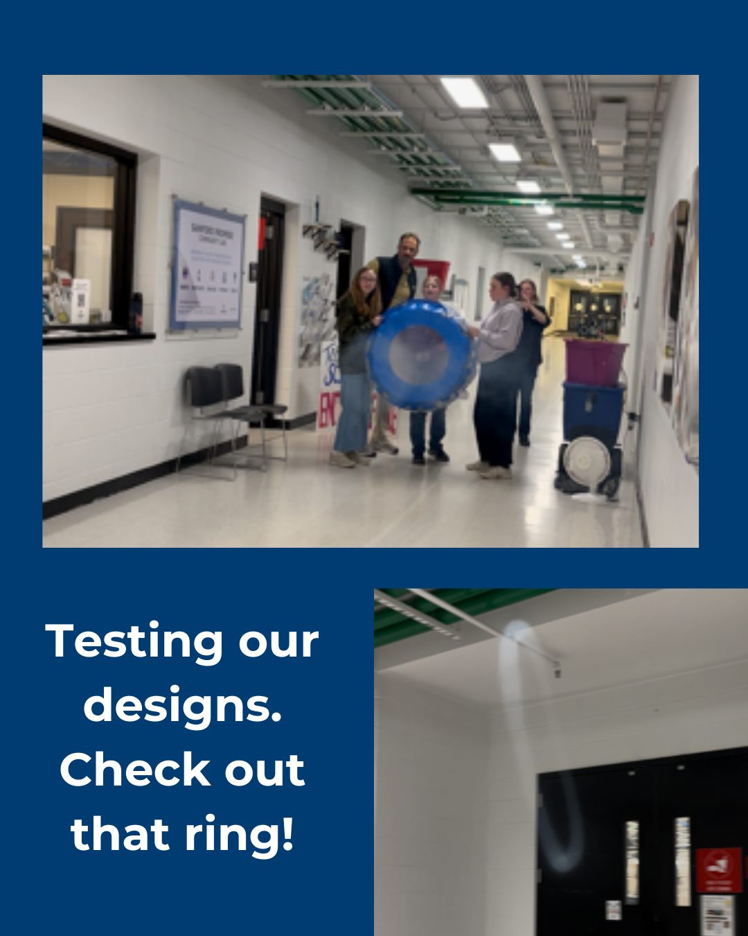
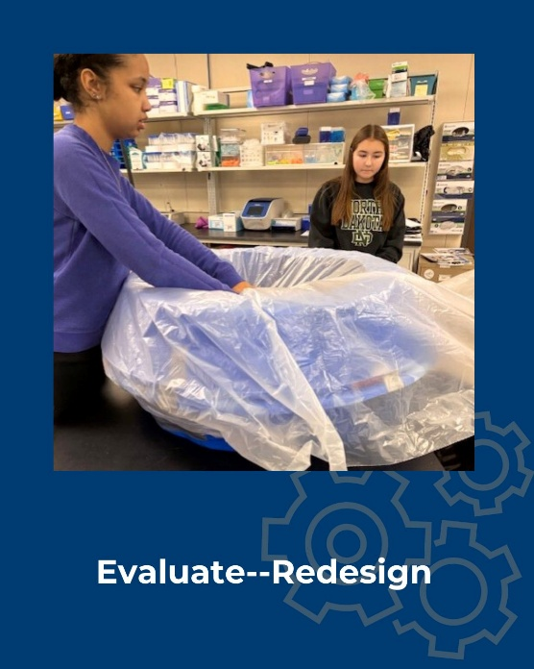

- Nearly 2000 students and teachers learned about hands on science from Science Steve in the first few months of 2026. Appearances included Centerville school, the STEM Ed Conference, the Hill City School science fair, the 71st annual High Plains Regional Science & Engineering Fair at SD Mines, and White River school.
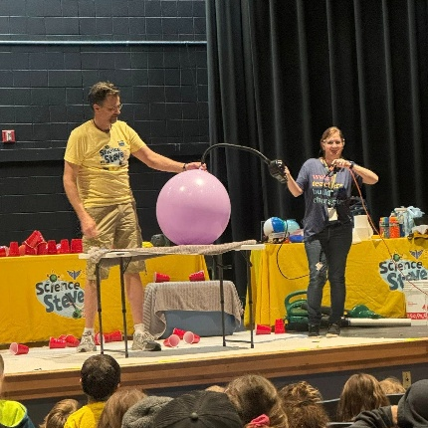

- Truks N Trykes, one of the largest childcare providers in Sioux Falls, invited SDPB to their President’s Day staff in-service. About 60 staff members learned about free, developmentally appropriate resources to help them in their work with early learners.

- The SD Early Childhood Education Conference in Rapid City brought together over 200 early childhood professionals from across the state. The education team shared resources in the exhibitor hall and presented a session called, “Playful and Purposeful Media Use with SDPB.”

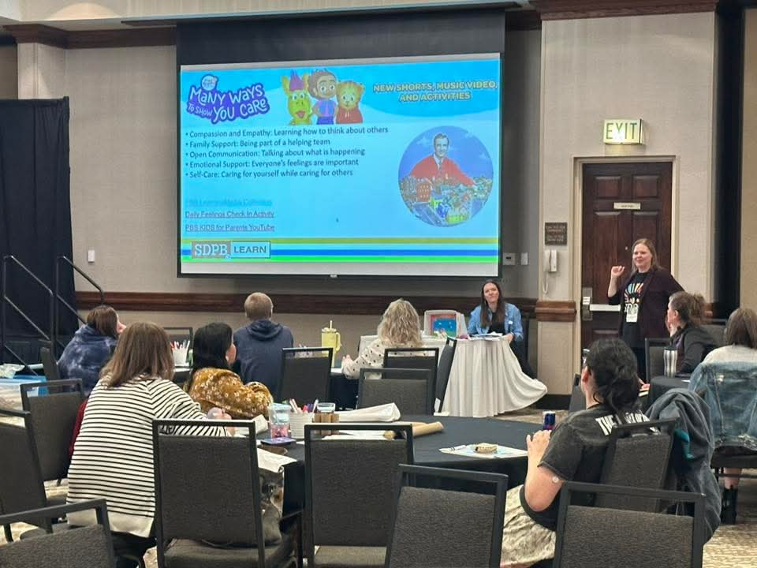

JTeam ET Board Report
April 2025

The SDPB Journalism Team’s first quarter priority was our legislative coverage. Coverage features Governor Rhoden’s State of the State address; manning cameras for the gavel-to-gavel coverage of every house and senate floor session on SDPB 2 and SDPB 3. The team also provided daily newscast material, regular feature stories, interviews with lawmakers, and political junkie analysis each week on radio and podcast. We also produced daily “here’s what’s on the agenda today” Instagram video reels. Weekly “In their Own Words” segments of floor debates around specific legislation. The South Dakota Focus team put together a half hour special looking at data centers. That program aired on March 26, 2026.

Data related to our legislative coverage Q1 2026 over Q1 2025 across socials and on our website:
- SDPB Website: stories under the political beat views are up 5.2% to 76,000 and users are up 4.8% to 53,000.
- SDPB Website: stories under “statehouse” tag views are up 1.5% to 6,500 views and users are up 42.8% to 4,500.
- SDPB News Socials (Facebook, Instagram, X) – 285,000 follows; 31,000 users/month; 370,000 impressions; 3,500 profile visits; 2,200 link clicks; 6,500 content interactions.
- Total watch time for social video content 81 hours, over 21,000 video views.
- SDPB News Instagram - views/impressions up 51.8% to 92,000; Profile visits up 5.5% to 700; net follows up 23.8% to a lifetime total of 1,920 followers.
- SDPB public affairs podcasts (In the Moment/News/Junkies): Total users up 22% to 21,000; total downloads up 4% to 51,000.

We have had profile interviews with candidates for Governor. As of this writing we are preparing for the GOP Gubernatorial Debate on April 13, 2026. All for Republican candidates will appear. We are partnering with South Dakota News Watch. We have a plan for an aggressive next day flood of content on social media, radio, and online.
At the end of April/early May I am presenting at the SDNA Convention in Deadwood. Hoping to form content sharing partnerships with newspapers across the state.
We have joined the Upper Midwest Newsroom with public media from North Dakota, Wisconsin, and Minnesota. CPB funded this collaboration before dissolving. This two-year commitment shares feature stories, a quarterly issues series, and one documentary between the four networks. Jackie Hendry and Jackson Dircks each have contributed stories. The goal is to be full speed by the end of May.

