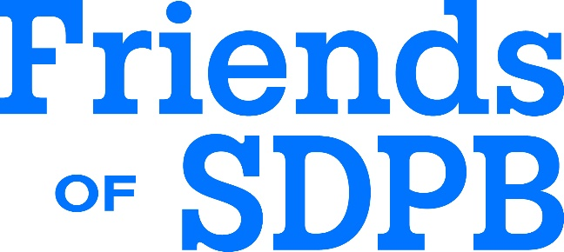

ET Board Meeting Report: Friends of SDPB
Monday, November 24, 2025
Submitted by Ryan Howlett

Friends of SDPB successfully completed the emergency Bison Campaign. We named it the bison campaign because a bison is strong and runs into the storm rather than hiding from it. We felt the campaign, designed by SDPB and Friends of SDPB, did just that, take on the federal funding issue head on. And side notes, 1. We had the logo ready for the Great Buffalo Roundup. We LOVED the logo, so we used it. 2. I refuse to name anything after Bison again, after the NDSU vs SDSU football outcome in the midst of the campaign.
Ultimately, over $2.7 million was raised and pledged with an additional $500,000 gifted to one of our endowments. We have ordered 1,500 of the bison t-shirts! By the numbers, there were seven gifts of six figures, and over 100 gifts of $5,000 or more. While those large gifts are exciting, the sustainer revenue is nearly $350,000. Sustainers renew at nearly 100%, so that is giving lift that we expect to continue annually.
The year over year member count is nearly 15,500, almost 2,000 members higher than this time last year. More donors, giving more is a good thing. We know that the six figure gifts aren’t fully sustainable year-over-year, but some of them may be. The other lift is very sustainable. Donors that went from $1,000 to $5,000 – those gifts can be renewed. They won’t all be renewed, but some will.
Corporate Support is also in the midst of a strong year – they are tracking to hit their aggressive goals. The additional sports projects were helpful and we have seen some disruption due to economy.
Overall, this will be Friends of SDPB’s biggest year. We are going to be watching the January to June 2026 fundraising totals, that will be more predictive of what future years will be, rather than what July to December 2025 were.
Friends is also turning the corner, returning to fundraising for projects directed by SDPB, highlighted by the refresh of the equipment in OSCAR, the SDPB Production Truck. It feels good to be looking at our aspirational goals, rather than plugging a hole.
Friends is managing legislative outreach prior to the 2026 101st SD Legislative Session. We have had a much more manageable process this year focusing on Appropriations Members, newly appointed Legislators, Legislative Leadership, and Legislators with a public safety background. We are encouraged with the results.

