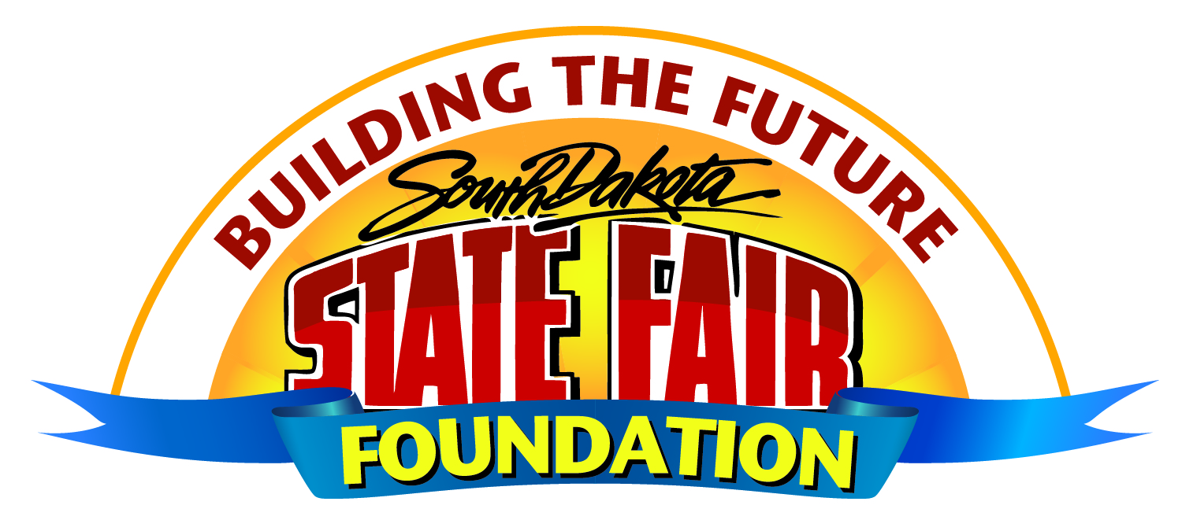
South Dakota State Fair Foundation
Meeting Minutes

1 PM – Tuesday, February 16, 2021
Huron, SD – Nordby Exhibit Hall

- Call to Order: Chairman Barry Mack called the meeting to order.

Members present: Barry Mack, Dusty Anderson, Amanda Stade and via conference call: Loren Noess, Tom Harmon, Denise Muntefering, Erin Yost, Justin Bell, Scott Cordts, and Gary Sharp.

Others present: Staff members Peggy Besch, and Linda Traver.

- Agenda Additions/Changes: Motion to approve agenda was made by Harmon, seconded by Sharp, motion carried via roll call vote.

- Approval of December 29, 2020, Minutes: Motion to approve the minutes was made by Yost, seconded by Noess; motion carried via roll call vote.

- Liquor License Purchase: Besch reported the purchase agreement has been finalized and is in the process of obtaining signatures. The foundation is identified as a ‘Third-Party Consideration Pledgor’ indicating the foundation is paying for the license for the State Fair.

- Registered Agents: Motion was made by Bell, seconded by Harmon; motion carried via roll call vote for the following:
- Authorize representatives Barry Mack, Rodney Freeman, and Scott Cordts to sign financial transactions and legal documents on behalf of the foundation, including the signing of checks.
- Authorize Besch to serve as authorized agent on behalf of the foundation for the purpose of applying for and signing of grant applications, completing annual reports, and other administrative duties. This includes authorization to serve as a second signature on checks.

- The DEX: Senate Bill 99, DEX bill, is expected to be heard by Joint Appropriations the last week in February. Fundraising is going well.

- Adjournment

