DEPARTMENT OF GAME, FISH AND PARKS
Division of Parks and Recreation

Fort Sisseton State Park
11907 434th Ave.
Lake City, SD 57247
605-448-5474

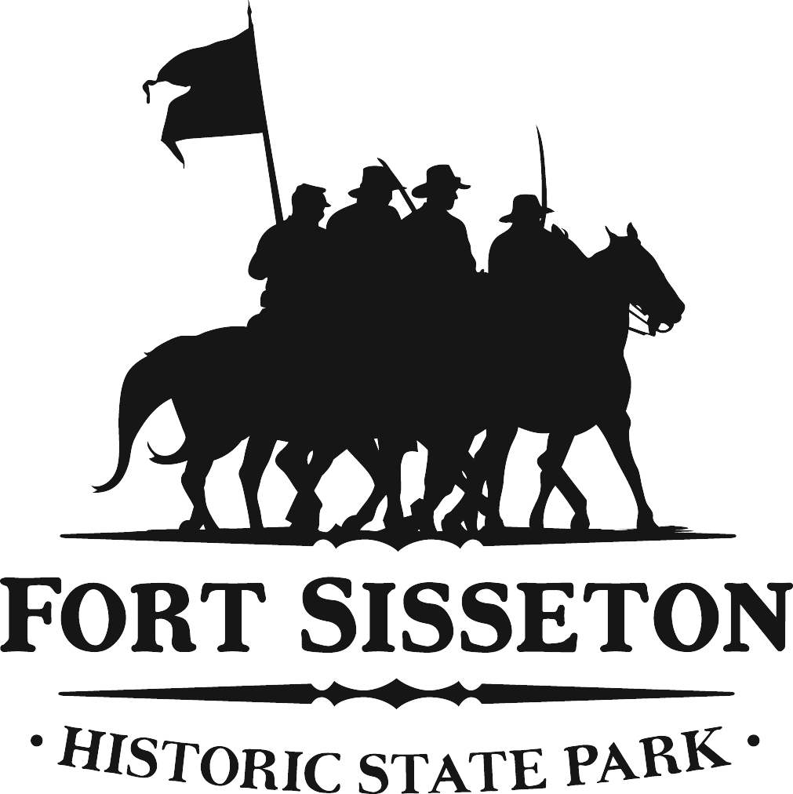

Fort Sisseton Commission Meeting
Agenda
February 15, 2019
Noon-?

Review of Minutes

Introduction of New Commission Members

Foundation Report

Old Business:
- Project/Development update: Ali
  - Geothermal
  - Alarm System
- Marketing/Strategic Planning: Doug
  - Date set for it?
- Past Special Events:
  - Haunted Fort Update: Judy, Eileen(?) and Ali
  - Winter Star Gazing Class: Ali
  - Victorian Christmas Class: Ali
  - Frontier Christmas: Ali
- Upcoming Special Events: Ali
  - Smithsonian Exhibit
    - Dates, expense
  - 60th Anniversary Celebration
    - Baseball Game
    - Exhibit
  - State Parks 100 year anniversary Scavenger Hunt

Public Comment

New Business:
- A/C Unit donated for South Barracks: Judy, Ali and Pam
- Historical Festival updates: Ali
  - Sponsorship
  - Changes to Chuck-wagon

