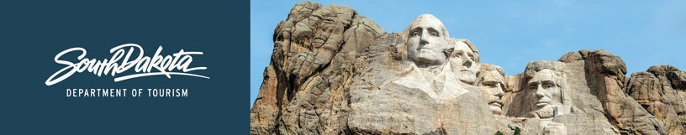

GOVERNOR’S TOURISM ADVISORY BOARD MEETING
Agenda
Wednesday, April 18, 2018, 9:00 am MT
Custer South Dakota

Meeting Location:
Custer Corral/Mount Rushmore Brewing Company
140 Mount Rushmore Road
Custer, SD 57730

9:00 am Call Meeting to Order, President Ivan Sorbel

9:05 am Welcome and Updates from Dave Ressler, Custer Chamber of Commerce

9:15 am Tourism Board Member Reports

10:00 am Regional Director Reports
Karen Kern, South Dakota Missouri River Tourism
Gary Keller, Southeast SD Tourism Association
Rosie Smith, Glacial Lakes and Prairies Tourism Association
Michelle Thomson, Black Hills and Badlands Tourism Association

10:20 am Mount Rushmore National Memorial, Superintendent, Cheryl Schreier

10:40 am Missouri National Recreational River, Interpretation and Education, Dugan Smith

11:00 am Jewel Cave National Monument, Chief of Interpretation, Bradley Block

11:20 am Minuteman Missile National Historic Site, Superintendent, Eric Leonard

11:45 am Wind Cave National Park, Superintendent, Vidal Davila

12:00 pm Break for Lunch

12:30 pm Badlands National Park, Superintendent, Michael Pflaum,

12:45 pm Custer State Park Updates, Visitor Services Program Manager, Kobee Stalder

1:00 pm Update and Report on 2018 Legislative Session, Secretary Jim Hagen

1:10 pm VIA Engagement and Welcome Center Updates, Wanda Goodman, Tourism

1:25 pm Updates on Global Travel and Trade, Alexa Steiner, Tourism

1:35 pm Strategic Plan Update, Secretary Jim Hagen and Wanda Goodman

1:45 pm Global Marketing and Brand Strategy Update, Mike Gussiaas, Tourism

2:05 pm Social Media Update, Stephanie Palmer, Tourism

2:10 pm Global Media and Public Relations Update, Katlyn Richter and Keegan Carda, Tourism

2:20 pm Industry Outreach and Development Update, Kirk Hulstein and Neil Wagner, Tourism

2:35 pm Travel Show and Pheasant Fest, Thad Friedeman, Tourism

2:45 pm Tourism Conference Recap and National Travel and Tourism Week, Natasha Bothun, Tourism

2:55 pm VEP Program, SDVisit.com and TravelSouthDakota.com Updates, Mike Gussiaas and Ann DeVany, Tourism

3:15 pm Research Updates Travel Indicators and Forecast, Kirk Hulstein, Tourism

3:30 pm Secretary‘s Recap, Secretary Jim Hagen

3:45 pm Meeting Adjourned

GOVERNOR’S TOURISM ADVISORY BOARD MEETING
TOURS
Thursday, April 19, 2018, 8:00 am MT
Custer South Dakota Area

8:00 am Depart Hotel

8:30 am Tour Jewel Cave

10:00 am Depart for Crazy Horse

10:30 am Arrive at Crazy Horse

12:00 pm Depart Crazy Horse for home

