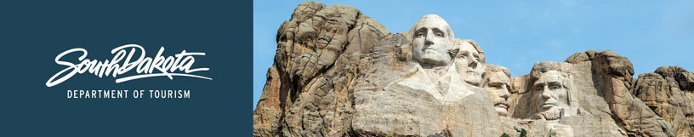

.

GOVERNOR’S TOURISM ADVISORY BOARD MEETING
Agenda
Thursday, August 8, 2019, 9 am
Washington Pavilion
Mary K. Sommervold Hall Stage
Sioux Falls, South Dakota

9:00 am Call Meeting to Order - Vice President Kristi Wagner

9:05 am Welcome and Update from Sioux Falls CVB Director - Teri Schmidt

9:15 am Welcome and Update from Sioux Falls Mayor - Paul Ten Haken

9:25 am Tourism Board Member Reports

10:00 am Global Media and Public Relations Updates – Katlyn Richter

10:10 am Global Marketing and Brand Strategy Updates – Mike Gussiaas

10:30 am Industry Outreach Development and Research Updates – Kirk Hulstein

10:40 am Global Travel and Trade Updates – Cole Irwin

10:50 am Tourism Conference Updates – Natasha Bothun

11:00 am Project Updates -Deputy Secretary Wanda Goodman

11:10 am Project Updates – Secretary Jim Hagen

11:30 am Regional Director Reports
Rosie Smith, Glacial Lakes and Prairies Tourism Association
Gary Keller, Southeast SD Tourism Association
Frank Smith, South Dakota Missouri River Tourism

11:50 am Hot Topics Discussion/Open Forum – Kristi Wagner and Jim Hagen

12:00 pm Meeting adjourns

12:00 pm Lunch

12:30 pm Tour of new updates in Washington Pavilion

