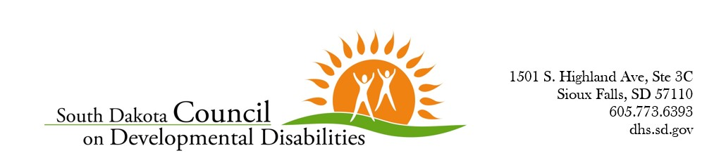

Executive Meeting Notes
May 4, 2026
The Executive Committee of the Council meet on May 4, 2026 via Zoom to discuss the opportunity to sponsor the upcoming Run, Walk & Roll event, which will take place on September 12, 2026, at Elwood Park in Sioux Falls for $500. This sponsorship will mean our logo is on all banners and shirts, getting our name out there even more. The committee talked about the pros and cons of the sponsorship, and ultimately, decided to vote to approve $500 in sponsorship funding to the Run, Walk, Roll event being held by USD Center for Disabilities.
May 14, 2026
A mini-grant application for the Lighting the Way: Autism Spectrum Disorder in our Communities was submitted to the Council on 5/14. Via email, Jessica told the Executive committee members that this is a long-standing partnership we have had with Augustana University in terms of this conference. The Executive Committee voted to approve the mini-grant request for $5000 to support this conference.
May 18, 2026
Jessica was approached by a family requesting Travel Assistance Funds to take their daughter to Miss Amazing in Chicago this summer. Typically, the Travel Assistance Funds are for families wanting to attend conferences and who agree to share information and spread awareness about I/DD. Jessica approached the Executive Committee via email, and asked for their opinion – all voted in favor of having the family submit an application, and approve, if funding is available.

Respectfully submitted,
Jessica Lamb, Executive Director

