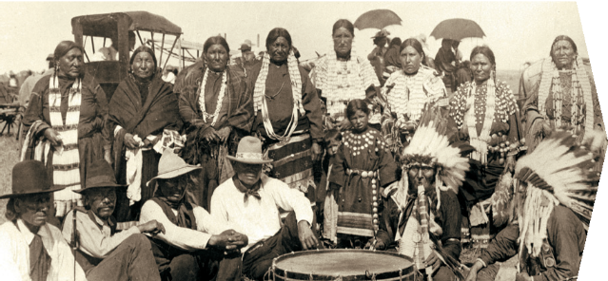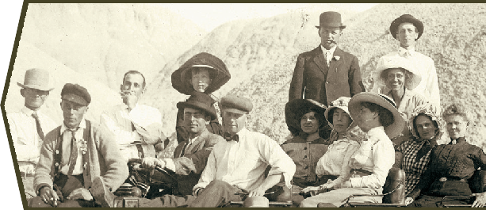

12 September 2025

Joy Beasley

National Park Service

1849 C Street NW

Washington DC 20240

Dear Joy Beasley,

On behalf of the South Dakota State Historical Society Board of Trustees, we are writing to preface the SHPO’s transmittal of the National Register of Historic Places nomination for the former Effting Grocery Store in Sioux Falls, SD.  We appreciate the thoughtful effort that has gone into documenting the property’s history and evaluating its significance.

The Board recognizes that the building underwent a substantial rehabilitation between 2022 and 2024, resulting in the loss of integrity of materials, workmanship, and, to a degree, design. In particular, the replacement of historic masonry and modifications to the fenestration pattern on the south façade have affected these aspects. At the same time, the property continues to retain the essential aspects of location, setting, feeling, and association—those qualities that best communicate its historic role as a neighborhood grocery and its significance under Criterion A. The rehabilitation also restored important design features on other elevations, reopening previously blocked-in windows and doors, and reinstating the building’s characteristic massing, height, setback, and storefront configuration.

The nomination demonstrates that the former Effting Grocery Store holds significance for its long-standing social presence in Sioux Falls and for its associations with women’s work in the early-to-mid twentieth century.  The building’s corner siting and its continued use as a specialty store provide a strong foundation for understanding its place in local history, and for its ability to convey feeling and association.   In light of these considerations, the Board has voted to recommend the nomination be transmitted to the NPS.

We look forward to continued collaboration as this nomination proceeds through the review process.

Sincerely,

––––––––––––––––––––––––––– –––––––––––––––––––––––––––

Tom Hurlbert John Fowler

President Vice President