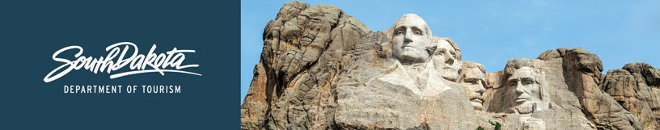

GOVERNOR’S TOURISM ADVISORY BOARD MEETING
Tentative Agenda
September 5 - 6, 2018
De Smet, South Dakota

September 5, 2018
3 p.m. Tours (arranged Ann Lesch)

7 pm Dinner (arranged by Ann Lesch)
Everyone will pay for their own dinner.

GOVERNOR’S TOURISM ADVISORY BOARD MEETING
Tentative Agenda
September 5 - 6, 2018
De Smet, South Dakota

Meeting Location:
De Smet Event and Wellness Center
705 Wilder Lane
De Smet, SD 57231

September 6, 2018
8:30 am Call Meeting to Order, President Ivan Sorbel

8:45 am Tourism Board Member Reports

9:30 am Regional Director Reports
Karen Kern, South Dakota Missouri River Tourism
Gary Keller, Southeast SD Tourism Association
Rosie Smith, Glacial Lakes and Prairies Tourism Association
Michelle Thomson, Black Hills and Badlands Tourism Association

9:50 am Opening Remarks, Secretary Jim Hagen

10: 10 am Updates, Deputy Secretary, Wanda Goodman

10:20 am Global Marketing and Brand Strategy Updates, Mike Gussiaas, Tourism
10:40 am Industry Outreach and Development Updates, Kirk Hulstein, Tourism

11:10 am Global Media and Public Relations Updates, Katlyn Richter, Tourism

11:25 am Global Travel and Trade Updates, Cole Irwin, Tourism

11: 35 am Secretary‘s Recap, Secretary Jim Hagen

11:40 am Public Comment

11:45 am Open Forum

12:00 noon Meeting Adjourned

