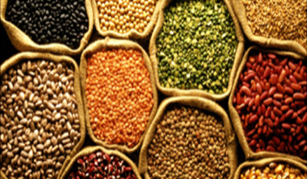
South Dakota
Pulse Crops Council
PO Box 667
Pierre, SD 57501

SD Pulse Council Members:
Chairman Neuharth has called for a conference call on March 13th at 9:00 am central time.

Please call 1-712-770-4010
Code 506975#

Primary discussion will be Specialty Crop Block Grant Information with Dr. Hall, SDSU

Please let me know if you can not attend!

