Department of Executive Management
Bureau of Finance and Management
500 East Capitol Ave. Pierre, South Dakota 57501-5070 Voice: (605) 773-3411 Fax: (605) 773-4711

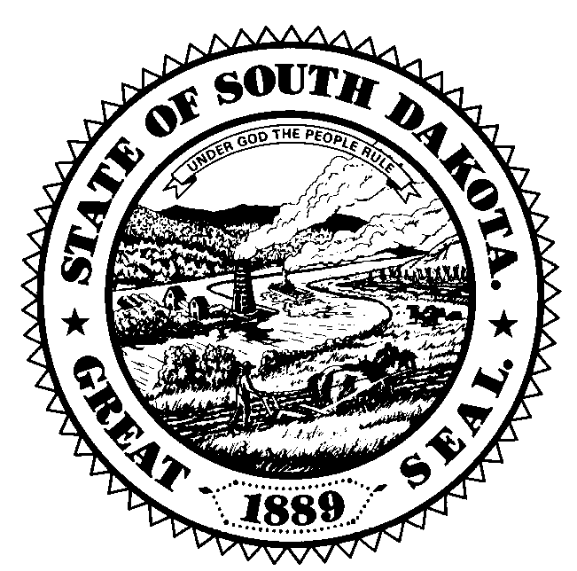

Governor’s Council of Economic Advisors Meeting
January 29, 2020

Governor’s Large Conference Room
Capitol Building
Pierre, SD 57501

11:00 AM – 12:00 PM
Roundtable Discussion of Economic, Business, and Industry Trends

- Council discussion on specific regional areas of the state and how those regions are performing economically, including any possible positive or negative developments that could impact the state economy and the revenue streams for the state in 2019-2021.

12:00 PM – 12:30 PM
Update on Tourism Industry

- Jim Hagen and Kirk Hulstein will present on how the tourism industry performed in 2019 and expectations and trends for 2020

12:30 PM –2:00 PM
Update on most recent US economic forecast/SD economic trends

- Dr. Ralph Brown will present the most recent IHS Economics forecast for the United States economy as well as recent trends in the South Dakota economy including trends in employment, income and various other economic indicators specific to South Dakota.

- Council discussion on agriculture, tourism, manufacturing, financial services as well as other sectors that have a large presence in the state and how those specific sectors are performing or are expected to perform over 2019-2021.

2:00 PM – 3:00 PM
Overview of SD economic forecast and recent tax collection trends

- Jim Terwilliger and Mark Quasney will present the most recent SD specific forecast for specific SD economic indicators from IHS Economics.

- Jim Terwilliger and Mark Quasney will present recent general fund revenue collection trends for major revenue sources that populate the state general fund and how those collection trends compare to the most recent budgeted levels and historical growth rates.

3:00 PM
Other Items
Public Comment
Adjourn

