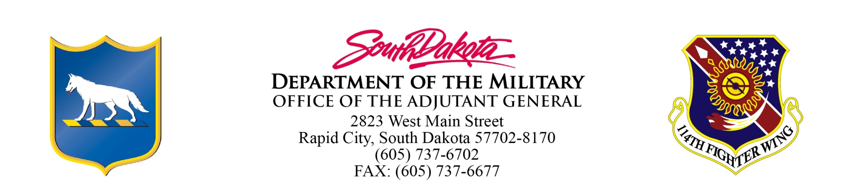

MEETING MINUTES
Board of Military Affiars Meeting
June 13 -14, 2018
Rapid City, SD

DRAFT Unapproved

The Board of Military Affairs (BOMA) convened at Camp Rapid in Rapid City at 3:00 PM on June 13, 2018.

Board Members in Attendance: Al Cornella, Don Goldhorn, Dick Trankle & Kim Vanneman

Military Personnel and Department Staff in Attendance: MG Tim Reisch, Connie Hohn

The meeting was called to order by MG Reisch on June 13, 2018 at 3:00 PM. The minutes from the February 2, 2018 meeting were reviewed. Al Cornella moved to approve, Kim Vanneman seconded the motion. All voted aye.

LTC Brendan Murphy presented the 2018 Golden Coyote Brief being conducted on Camp Rapid, throughout the Black Hills and at Camp Guernsey, Wyoming.

MG Reisch gave a briefing update of the SD National Guard. Topics covered were:

Operational Update
Military Construction Projects
National Awards
Current & Future Deployments
SD National Guard Memorial Plaza Construction.

The meeting recessed at about 5:15 PM with a walking tour of the SD National Guard Memorial Plaza.

Meeting re-convened at 7:30 AM June 14, 2018.

The BOMA members then traveled via Black Hawk helicopter to the Custer State Park training area where they were briefed on the tactical training situation. After returning to Camp Rapid the meeting was adjourned at 11:45 AM June 14, 2018.

