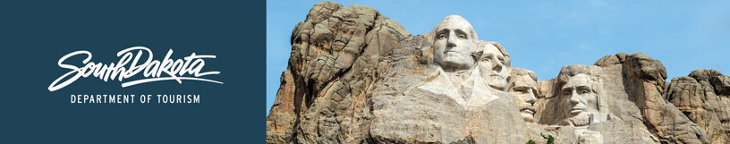

GOVERNOR’S TOURISM ADVISORY BOARD MEETING
Wednesday, March 27, 2019, 9 am
Capitol Lake Visitors Center
Pierre, South Dakota
DRAFT Agenda

9:00 a.m. Call Meeting to Order, President Ivan Sorbel

9:05 a.m. Welcome and Update from Pierre CVB
Lois Ries, Pierre CVB Director

9:15 a.m. Tourism Board Member Reports

9:45 a.m. Regional Director Reports
Gary Keller, Southeast SD Tourism Association
Michelle Thomson, Black Hills and Badlands Tourism Association

9:55 a.m. VIA Update - Don South, President Visitor Industry Alliance (VIA)

10:25 a.m. Project Update - Deputy Secretary Wanda Goodman
- 2019 Legislative Session Update
- Tourism Talks Update
- 2018 Annual Report Overview
- Destination Capitol Hill Update
- Family Travel Association Summit Update
- Strategic Plan Update

10:40 a.m. Industry Outreach, Development and Research Update
- Research Efforts – Kirk Hulstein
- Industry Outreach and Development Efforts – Jacey Jessop
- Online Hospitality Training Update – Jacey Jessop
- Welcome Centers Construction and Season Update – Nate Johnson
- National Travel and Tourism Week Update – Natasha Bothun
- Statewide Hospitality Training Update – Natasha Bothun

11:20 a.m. Global Travel and Trade Update – Calley Worth

11:45 a.m. Break for Lunch

1:15 p.m. State Parks Update – Katie Ceroll, Parks Division Director

1:45 p.m. Global Media and Public Relations Update – Katlyn Richter and Stephanie Palmer

2:00 p.m. Global Marketing and Brand Strategy Update – Mike Gussiaas

2:30 p.m. TravelSouthDakota.com Update – Ann DeVany

2:40 a.m. Project Update from Secretary Jim Hagen
- 2019 Industry Outreach and Marketing Update Overview
- Macy’s Parade Update

2:45 p.m. Hot Topics Discussion/Open Forum – Ivan Sorbel and Jim Hagen

3:00 p.m. Meeting Adjourn

