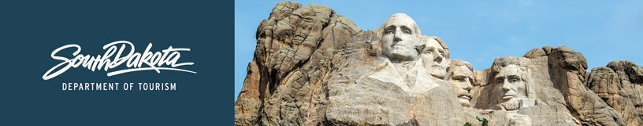

GOVERNOR’S TOURISM ADVISORY BOARD MEETING
Tuesday, January 15, 2019
Ramkota Hotel & Convention Center
Pierre, South Dakota
Agenda

Amphitheater 1

2:00 PM Call Meeting to Order, President Ivan Sorbel

2:15 PM Election of Officers

2:35 PM Tourism Conference Board Duties Briefing,
Conference Chair, Natasha Bothun

2:50 PM Photograph of Board Members and Officers, Chad Coppess

3:00 pm Adjourn

