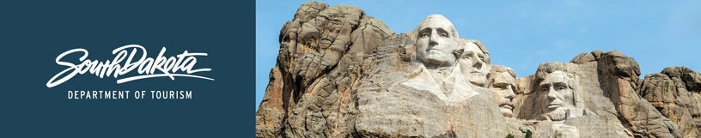
GOVERNOR’S TOURISM ADVISORY BOARD MEETING
Tuesday, January 21, 2020
Ramkota Hotel & Convention Center
Pierre, South Dakota
Agenda

Amphitheater 1

9:30 AM Call Meeting to Order, President Ivan Sorbel

9:35 AM Election of Officers

9:40 AM Tourism Conference Board Duties Briefing,
Conference Chair, Natasha Bothun

9:45 AM Photograph of Board Members and Officers, Chad Coppess

9:50 AM Adjourn

