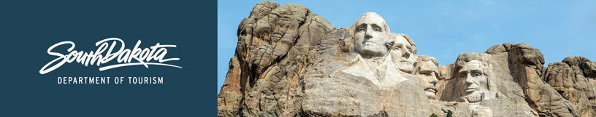
GOVERNOR’S TOURISM ADVISORY BOARD MEETING
Tentative Agenda

April 8, 2021 – 9:00 a.m. to 3:00 p.m., CST
Pierre Ramkota Convention Center – Amphitheater 1
Pierre, South Dakota

9:00 a.m. Welcome - President Kristi Wagner
9:05 a.m. Opening comments and department updates - Secretary Jim Hagen
9:10 a.m. Tourism Board Member reports and regional updates - Tourism Advisory Board
9:40 a.m. Department updates - Wanda Goodman
9:45 a.m. Thoughts and reflections on 30 years in the department and the industry - Chad Coppess
9:50 a.m. State of the travel industry in South Dakota and the nation - Kirk Hulstein
9:55 a.m. Update from Mount Rushmore National Memorial – Secretary Jim Hagen
10:10 a.m. Update from Game, Fish and Parks Department - Emily Kiel
10:20 a.m. Update from Experience Sioux Falls - Teri Schmidt
10:30 a.m. Agritourism update - Jacey Ellsworth
10:45 a.m. Update from the South Dakota Visitor Industry Alliance - Gwyn Wathen
10:55 p.m. Update about the newly revamped Tourism Hospitality Program at Black Hills State
University - Hans Nelson
11:15 a.m. Update on Tribal Tourism - Calvin Bloemendaal
11:25 a.m. Update on Welcome Centers - Nate Johnson
11:35 a.m. Update from Badlands National Park - Superintendent Mike Pflaum
11:45 a.m. Lunch

12:15 p.m. Update from Global Media and Public Relations Team - Katlyn Svendsen
12:30 p.m. Update from Historic Deadwood - Lee Harstad
12:45 p.m. Update from Global Marketing Team - Mike Gussiaas
1:00 p.m. Update on TravelSouthDakota.com - Ann DeVany
1:10 p.m. Update from the Global Travel and Trade Team - Cole Irwin
1:25 p.m. Updates on social media - Stephanie Palmer
1:40 p.m. Update from Industry Outreach, Development and Research Team and
report on the DMO Marketing Relief Program - Kirk Hulstein
1:55 p.m. Update on Spring Hospitality Training and National Travel and Tourism
Week - Bailey Carlsen
2:05 p.m. Update on Industry Outreach Webinar slated for the week of April 19 - Jim Hagen
2:10 p.m. Open forum - President Kristi Wagner and Secretary Jim Hagen
2:45 p.m. Meeting Adjourn - President Kristi Wagner

