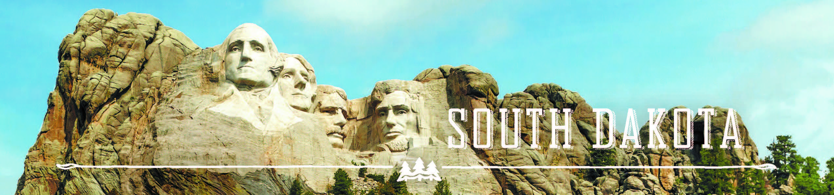

GOVERNOR’S TOURISM ADVISORY BOARD MEETING
Tuesday, January 16, 2018
Ramkota Hotel & Convention Center
Pierre, South Dakota
Agenda

Amphitheater 1

11:00 AM Call Meeting to Order, President Ted Hustead

11:35 AM Election of Officers

11:45 AM Tourism Conference Board Duties Briefing,
Conference Chair, Natasha Bothun

12:15 PM Adjourn

(Photographs of Board and New Officers, Chad Coppess)

