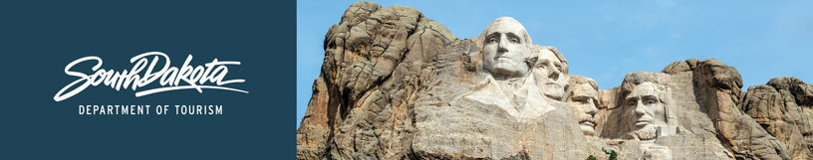

GOVERNOR’S TOURISM ADVISORY BOARD MEETING
Agenda
Tuesday, January 19, 2021, 1 pm CT
Dolly Reed Plaza
Department of Tourism - Creekside Conference Room
711 East Wells Avenue
Pierre, South Dakota

1:00 PM Call Meeting to Order, President Kristi Wagner

1:05 PM Election of Officers

1:15 PM Tourism Conference Board Briefing, Wanda Goodman

1:30 PM Questions and Adjourn

(Photographs of Board and New Officers, Chad Coppess)

