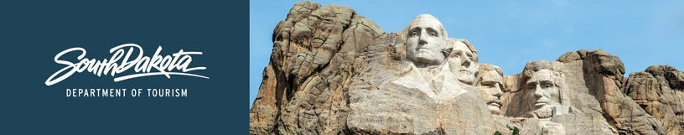

GOVERNOR’S TOURISM ADVISORY BOARD MEETING
Agenda
Tuesday, January 18,2022, 9 am CT
Ramkota Hotel
Amphitheatre 1
920 West Sioux
Pierre, South Dakota

9:00 PM Call Meeting to Order, President Kristi Wagner

9:05 PM Election of Officers

9:15 PM Tourism Conference Board Briefing, Bailey Carlsen

9:30 PM Questions and Adjourn

(Photograph of Board and New Officers, Byron Banasiak)

