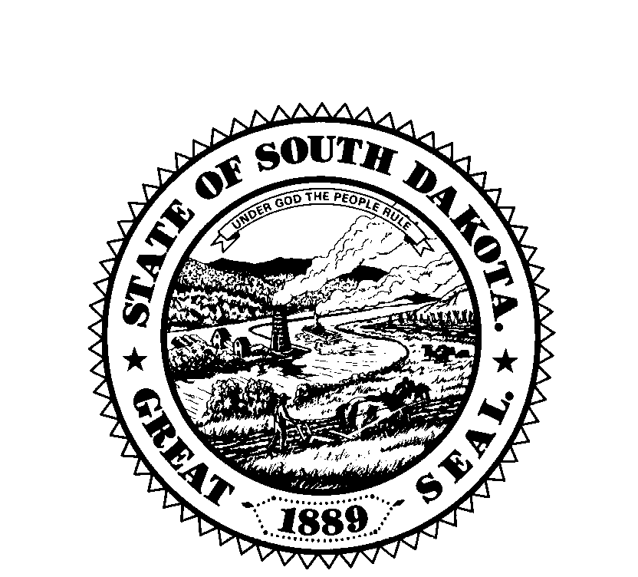
South Dakota Board of Examiners for Counselors & Marriage and Family Therapists
P.O. Box 340, 1351 N. Harrison Ave., Pierre, SD 57501-0340
Ph: 605-224-1721Fax: 1-888-425-3032

E-mail: SDBCE@midwestsolutionssd.com dss.sd.gov/licensingboards/examiners.aspx

SOUTH DAKOTA STATE BOARD OF EXAMINERS FOR COUNSELORS &
MARRIAGE AND FAMILY THERAPISTS
Friday, September 5, 2025 – 9:00 AM CDT
Join Zoom Meeting
https://us02web.zoom.us/j/81719646772?pwd=u880Mwa9v1ke5GW2Fj9qdb9zEVB7F3.1
Meeting ID: 817 1964 6772
Passcode: 930703
Call: 312 626 6799

Proposed Meeting Agenda
- Call to Order
- Approval of Agenda
- Open Forum: 5 minutes for the public to address the Board
- Approval of Board Minutes: May 2, 2025
- Approval of Financial Statement: July 31, 2025
- Executive Session (Pursuant to SDCL 1-25-2(3) for consultation with legal counsel for consideration of proposed contested cases or litigation and contract negotiations
- Old Business
  - Background Check Application Status/Legislation
  - Counseling Compact Updates/Website Page
- New Business
  - Hearing in the Matter of the Application of Hande Briddick for Licensure as a Licensed Professional Counselor
  - Open Meetings Law Overview (required by SDCL 1-25-13)
  - The South Dakota Network Against Family Violence and Sexual Assault Continuing Education Provider Request
  - Artificial Intelligence Standards in Counseling Discussion
- Other Business
  - Office Update
    - Supervisor Expectations Communication
    - Board Appointments/Renewals
    - National Meetings
      - AMFTRB Meeting Delegate – September 2025
      - AASCB Annual Meeting – February 22 – 24, 2026
      - Counseling Compact Annual Meeting – February 22 – 24, 2026
      - NBCC Annual Meeting - TBD
  - DSS Update
- Announcements
  - Next Scheduled Meeting – December 5, 2025 at 9:00 am CT via Zoom
- Adjourn

