Governor’s Snowmobile Advisory Council Meeting Minutes
August 15th 2020 ~ Zoom Meeting due to Covid-19.

Chairman Gary Ulmer called the meeting to order at 9:06 a.m. Council members Scott Erstad, Bruce Hintz, Al Nagel, Dave Kennedy, Todd Sprang and Todd Wilkinson were present.

Game, Fish, and Parks (GFP) members present were Shannon Percy and Ryan Raynor and Scott Simpson.

Agenda Adoption
A motion was made by Wilkinson and seconded by Hintz to adopt the agenda. Motion Carried.

Approval of Minutes
A motion was made by Nagel and seconded by Sprang to approve the minutes of the May 2nd, 2020, meeting as presented. Motion Carried.

Public Comment
No comments were made.

Council Appointment
Raynor recognized Bruce Hintz and Todd Wilkinson for being reappointed by the Governor for another term. Council members serve three-year terms with no limit on the number of terms served.

Operations under Covid-19
Raynor stated it’s been a crazy summer so far and explained some of the department policies related to covid-19 such as socially distancing, wearing a mask when within 6ft of somebody and so forth. Raynor stated it’s his goals to continue to attend club meetings and provide the opportunities of the East River groomer school and other events, even if in a unique fashion but situations may call for over the phone attendance or cancellations. Raynor and Percy made it clear they are taking each meeting or gathering one case at a time as things continue to change and want to make sure this doesn’t disrupt communications with the snowmobile community.

Black Hills Update
Percy reviewed the number of 5-Day Temporary Permits sold during the season showing a comparison from the 18-19 season as well. Wilkinson asked if there was any way, whether statutorily or through internal rules if our residents who buy the temporary permits could somehow be tied to our gas tax? Simpson stated he wasn’t aware of any avenues at this time, but certainly something we would look into. Raynor stated they would have an update for the council at their December meeting.

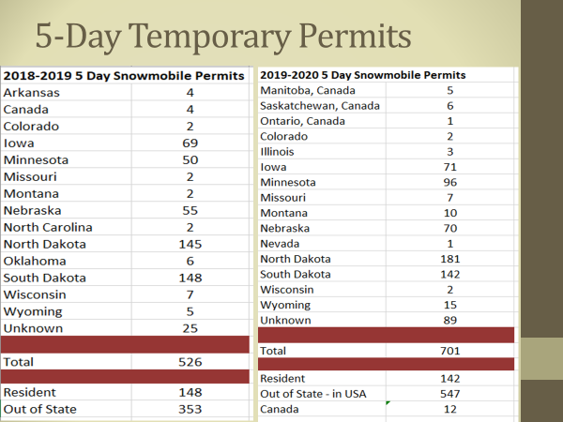

Trail Reroutes
Percy ran through a list of trail reroutes, which included:

Double Vault Toilet – Percy will be installing a new DVT at Trailshead Lodge this fall. Trailshead lodge plans on putting electricity and heat to the vault.

Hwy #385 Corridor – Landowner was going to pull the trail agreement due to OHV traffic in the DOT right of way. SD DOT commission met and closed the short section of the highway right of way from Brownsville road to hideaway road to OHV Traffic. DOT commission has asked GFP, the Forest Service and local area engineer what possibilities there are to resolve the issue. If DOT chooses to place a OHV trail in the right of way, the snowmobile trail would be lost on the adjacent private property.

Trail 8 – This trail was moved due to winter logging which was necessary as a protected plant is located in this area. The Black Hills National Forest Service (BHNFS) requires a foot of snow before logging can take place. Percy stated he still hasn’t heard from the Forest Service on this reroute yet.

Trail #3 – This reroute took place due to a winter removal. Percy will be meeting with the Forest Service soon to discuss the potential reroutes on this trail. This is located in close proximity to Hardy Camp.

July 2020 Tornado – Trail 1,3 and 4 have been directly impacted by the tornado of 2020. The Forest Service is currently salvage logging in these areas. Trail crews will be busy this fall to continue trail cleanup as necessary.

Fat Tire Bike Meeting
Percy stated he and Gary Ulmer did attend a Zoom meeting back in May to review the Fat Tire Bike grooming season. Groups were asked about what positives and negatives came from the season. Percy stated we observed less traffic on our trails. The Fat Tire group stated it was the best snow season ever. Single track trails were heavily used. They also questioned the liability issue, which was mentioned in last year’s meeting. The Fat Tire Bike group would also like to see a multi-use study done on the trails. Things to improve on next year included, signing from the start of the season, reports of bicycles riding down the center of the trail and not wearing bright clothing. Percy states that he still has an issue with the Big Hill parking lot with the 3 groups now utilizing that lot. Snowmobile funds currently pay to plow that parking lot.

The Fat Tire Bike group wants more destinations added next year like Cement Ridge and Savoy. Would like to see a dilution of trail users per mile by adding Custer Peak, Dumont, Steel Wheel and Deerfield.

The FS Road 222 which intersects with trails 1 and 3, is very difficult to ride bicycles on they mentioned.

The group did donate $500 through a go fund me page.

Currently, nobody knows what the future holds due to Covid-19 and a vacant Forest Supervisor Position.

East River Update
Raynor indicated groomer inspections were not conducted this year due to the parks being so busy and Covid-19. He stated he intends on doing inspections of a select few groomers this year to determine which one should be surplused this fall.

A 2016 Sno-Cat with 22,750 miles and 4,060 hours from the Black Hills will be transferred to East River this fall.

Raynor mentioned the oldest groomers in the fleet is a 2006 in Redfield and a 2007 in Miller. Both machines looked to be in good working order with the Miller machine showing some loss of the poly coating on the boggie wheels.

2020-2021 GIA Applications
Grant-in-Aid (GIA) applications totaling $313,203 and includes 1,415 miles of groomed trails and 1,070 miles of signed trails were recommended to the council: The slide below was presented to the council which included all 15 grant applications from snowmobile clubs across eastern SD. Raynor mentioned De Smet and Watertown still have minor reroutes to discuss but due to covid-19 those clubs haven’t been able to meet. Clear Lake showed a minor re-route that would not reflect any changes to their original grant proposal. Lastly, Miller is removing 7 miles of trail that ran north on Hwy 45 and extending the trail from Miller to Wessington springs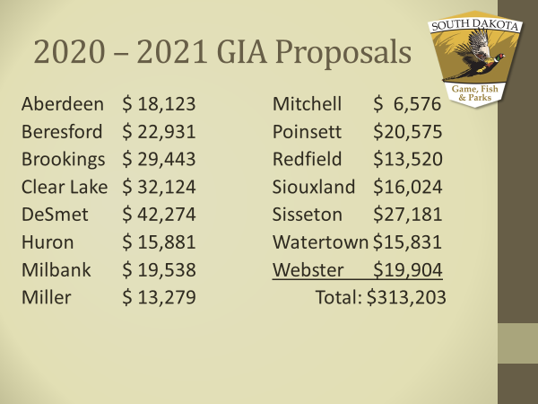

Wilkinson made a motion to approve the 2020-2021 GIA packages, seconded by
Kennedy. Motion Carried.

FY 2020 Budget Review (July 1, 2019 to June 30, 2020)
The snowmobile program spent $870,038 during FY20 and revenue earned totaled $832,104. The snowmobile trails fund dropped from $767,052 to $729,118 as of June 30th, 2020.

Total Revenue Earned in FY20 Included:
Gas Tax: $406,805 (11,623 Registered Snowmobiles)
$10 Snowmobile License: $106,575
3% Registration Tax: $257,995
$40 5-Day Temporary Permit: $ 23,000
Interest: $ 22,709
Charges for Sales/Services: $ 15,020
Other: $ 0

Total Expenditures in FY20 Included:
Salaries & Benefits: $315,038 Travel: $ 35,103
Contractual Services: $ 94,304 Supplies & Materials: $180,432
Grants: $124,080 Capital Assets: $121,081

Capital Assets Purchased:
Raynor shared with the council the slide below to remind them what was purchased under capital assets and what RTP dollars were spent. Including in this same slide are FY21 projected and FY22 requested capital asset purchases as well.

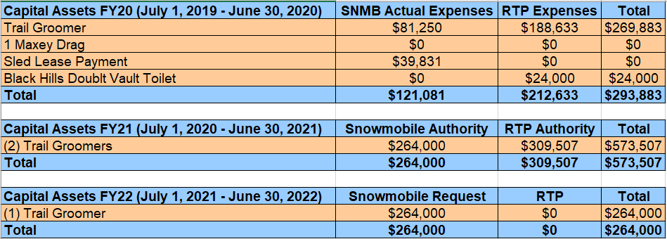

FY 2021 Budget Preview (July 1, 2020 to June 30, 2021)
Projected revenue for FY20 is $845,415 while $1,386,351 of spending authority is budgeted. The 10,869 snowmobile registrations account for $380,415 received through the gas tax reimbursement. This revenue is based on the number of registered snowmobiles as of July 1st, x .28 cents in gas tax, x 125 gallons of fuel.

Projected Revenue:
Gas Tax: $380,415 (Actual)
$10 Snowmobile License: $108,000
4% Registration Tax: $265,000
$40 5-Day Temporary Permit: $ 23,000
Interest : $ 18,000
Charges for Sales/Services: $ 15,000
Other: $ 35,000

Projected Expenses:
Personnel Services: $426,553 Supplies: $184,750
Travel: $ 54,754 Grants: $312,500
Contractual Supplies: $143,794 Capital Assets: $264,000

Projected Capital Assets:
Raynor stated the RTP council in June approved the full 30% of motorized dollars to the snowmobile program. With these funds, the snowmobile would match around $200,000 to the RTP funds approved which is $309,507. Percy told the council the intent of these funds is to purchase two groomers this year. Percy reminded the council how he kept track of groomer downtime last winter and it added up to over 1,100hrs. This is the same amount of time as one groomer running all day long. With that being said, the Black Hills grooming operation will increase from 6 groomers to 7, with the 7th groomer being a backup to groomers that breakdown for extended periods of time.

FY 2022 Budget Recommendation (July 1, 2021 to June 30, 2022)
Projected revenue for FY21 is $855,000. Raynor told the council that all revenue projections from FY20 were brought over to FY21, except for the Gas Tax which seems to fluctuate every year. Specific categories are mentioned below.

Projected Revenue:
Gas Tax: $390,000
$10 Snowmobile Licenses: $108,000
3% Registration Tax: $265,000
$40 5-Day Temporary Permit: $ 18,000
Interest : $ 18,000
Charges for Sales/Services: $ 35,000
Other $ 35,000

Projected Expenditures:
Personnel Services: $426,553 Supplies and Materials: $184,750
Travel: $ 61,754 Grants: $312,500
Contractual Supplies: $136,794 Capital Assets: $264,000

Projected Capital Assets:
Listed above.

Wilkinson made a motion to approve the FY2022 Snowmobile budget as proposed by Raynor. Motion was seconded by Erstad. Motion Carried.

Raynor shared the following slides with the council which depicted the number of registered sleds and gas tax monies brought in over the last ten years.

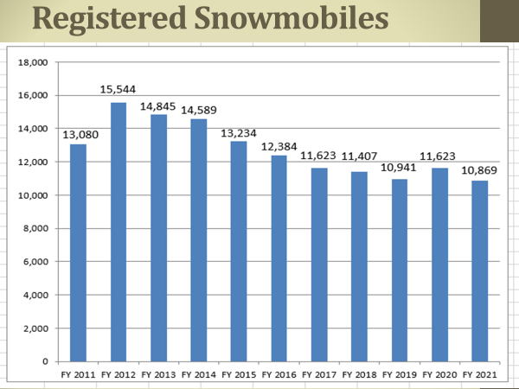

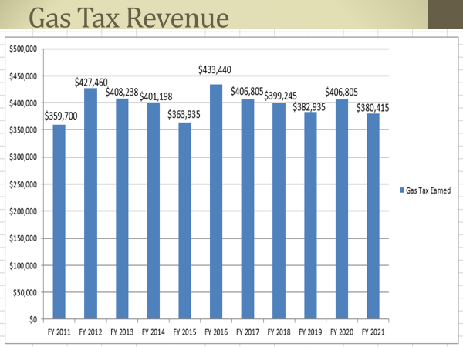

Letter to Rental Businesses
In May, Raynor reported that 80% of the snowmobile accidents were on rental sleds. Kelly Weaver asked GFP if there was a way to help reduce that number as many sleds that are rented, are probably first time or novice riders. GFP told the council this message would come better from SDSA. The council was fine with this change but asked that they were mentioned in the letter. GFP will provide the businesses and addresses to SDSA who can forward the letter with their letter head.

Election of Officers
Dave Kennedy moved into the Chairman position while Bruce Hintz was voted into the Vice Chairman position. A motion was made by Wilkinson and seconded by Sprang. Motion Carried.

Next Meeting
The next meeting is scheduled for 10:00 a.m. on Friday, December 4th, 2020, in Rapid City. This meeting is held in conjunction with the SD Snowmobile Association Association’s Annual Convention and could be held via Zoom again.

Adjournment
A motion was made by Hintz and was seconded by Erstad to adjourn at 10:37 a.m. Motion carried.

