Governor’s Snowmobile Advisory Council Meeting Minutes
August 14th 2021 ~ Hybrid Meeting.

Chairman Dave Kennedy called the meeting to order at 9:03 a.m. Council members Scott Erstad, Bruce Hintz, Al Nagel, Dave Kennedy, Todd Sprang and Todd Wilkinson were present.

Game, Fish, and Parks (GFP) members present were Shannon Percy and Ryan Raynor.

Agenda Adoption
A motion was made by Nagel and seconded by Wilkinson to adopt the agenda. Motion Carried.

Approval of Minutes
A motion was made by Nagel and seconded by Wilkinson to approve the minutes of the May 15th, 2021, meeting as presented. Motion Carried.

Public Comment
No comments were made.

Council Appointment
Raynor recognized Gary Ulmer and Scott Erstad for being reappointed by the Governor for another term. Council members serve three-year terms with no limit on the number of terms served.

Black Hills Update
Percy ran through a list of trail reroutes, which included:

Trail #6, located by O’Neill Pass, had private property concerns that forced us into looking at other options. We are now getting off Boles Canyon Road onto Forrest Service Property. GFP is still waiting on approvals from the USFS.

Trail #7, by Steelwheel, is still an unknown how this will look, Percy stated. We are still actively looking for a reroute around all the private property.

Trail 5, by Recreational Springs Resort, has had some progress over the past few months but still waiting on some things to come together Percy stated. GFP went out and worked with Kaschmitter to find a new corridor through this development. GFP will have to install a barrier fence where they agreed the trail can go. Percy stated they did push some sections of the trail out into the ditch, into the DOT right of way, but he is still waiting on approvals through DOT.

East River Update
Raynor was briefly approached by Simpson about the possibility of purchasing or leasing a bay at the new shop at Pelican Lake. This shop was built to help support parks and wildlife operations in the Watertown area. Raynor stated this would have to be a purchase or a lease for snowmobile funds to buy out the federal funds used. The council agreed they would need more information than what was provided. Raynor stated he will let the division directors know.

Raynor indicated groomer inspections were completed this year between himself and Brian Nelson from the Black Hills Trails Office in Lead. He shared an updated equipment hours and miles slide which can be seen below.

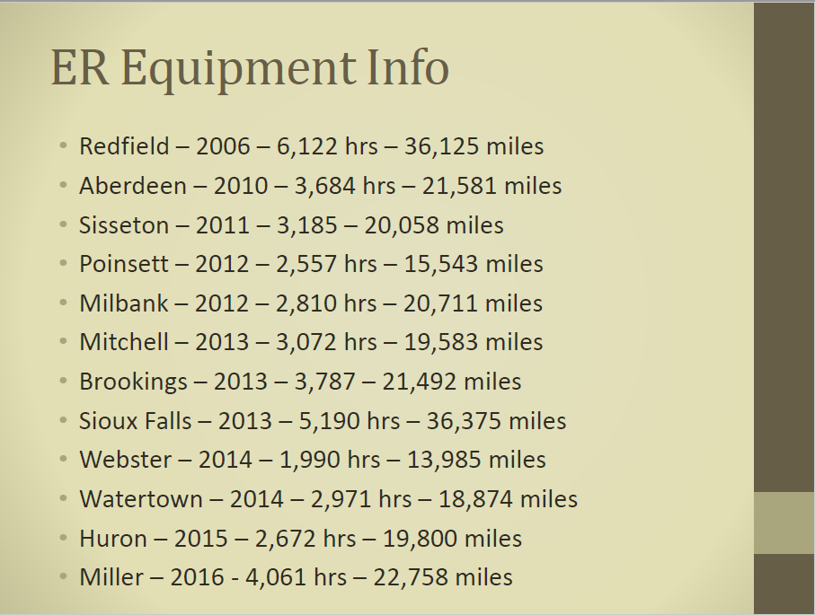

Raynor stated the groomer that would transfer east river has had some issues where it would just shut down and then start right back up again. After trying to trouble shoot with Tucker and other local mechanics, Tucker ended up coming out and replacing a master switch hoping this would resolve this issue. At this time, the plan is for staff from the Black Hills to take this groomer out on long trips this fall to make sure they have this issue resolved. If not, GFP would try and trade in this groomer instead of transferring it east river.

Trail Signing Equipment
Back in May, the council approved the purchase of rotary hammer drills for each club participating in the GIA program. This drill, along with a rebar attachment being built by a club member in Beresford, will help club members drill rebar signs in the ground during dry, and frozen conditions. Raynor stated all drills have been delivered to the clubs and is waiting to hear back about status of the rebar attachment.

2021-2022 GIA Applications
Grant-in-Aid (GIA) applications totaling $310,632 and includes 1,400 miles of groomed trails and 998 miles of signed trails were recommended to the council: The slide below was presented to the council which included all 14 grant applications from snowmobile clubs across eastern SD. Raynor reminded the council that the Redfield club chose to no longer participate in the GIA program due to lack of help to maintain the trail system.

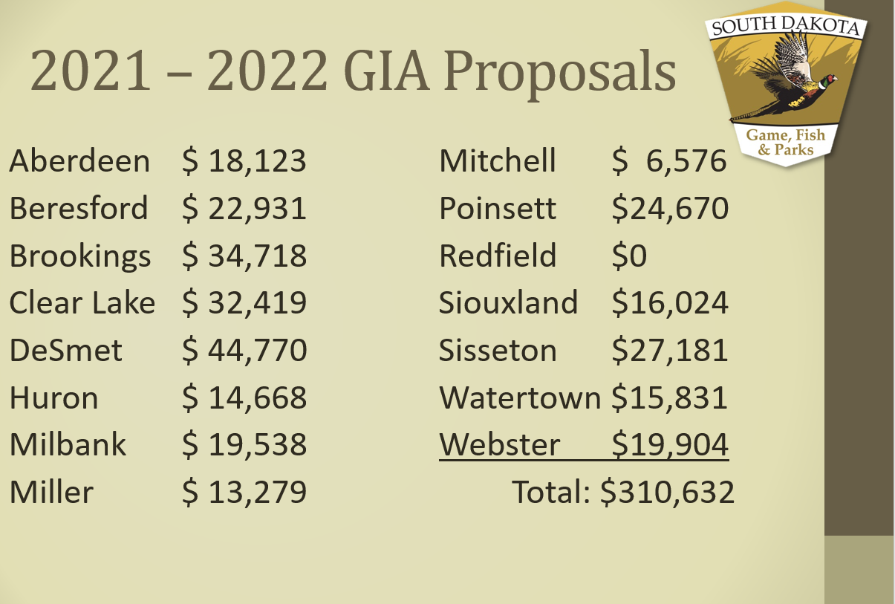

Wilkinson made a motion to approve the 2021-2022 GIA packages, seconded by
Erstad. Motion Carried.

FY 2021 Budget Review (July 1, 2020 to June 30, 2021)
The snowmobile program spent $856,725 during FY21 and revenue earned totaled $915,113. The snowmobile trails fund increased from $729,118 to $744,579 as of June 30th, 2021.

Total Revenue Earned in FY21 Included:
Gas Tax: $380,415 (10,869 Registered Snowmobiles)
$10 Snowmobile License: $ 92,552
3% Registration Tax: $319,348
$40 5-Day Temporary Permit: $ 40,840
Interest: $ 25,345
Charges for Sales/Services: $ 48,908
Other: $ 7,705

Total Expenditures in FY21 Included:
Salaries & Benefits: $324,645 Travel: $ 49,641
Contractual Services: $ 56,754 Supplies & Materials: $163,275
Grants: $101,106 Capital Assets: $204,231

Capital Assets Purchased:
Raynor shared with the council the slide below to remind them what was purchased under capital assets and what RTP dollars were spent. Including in this same slide are FY22 projected and FY23 requested capital asset purchases as well.

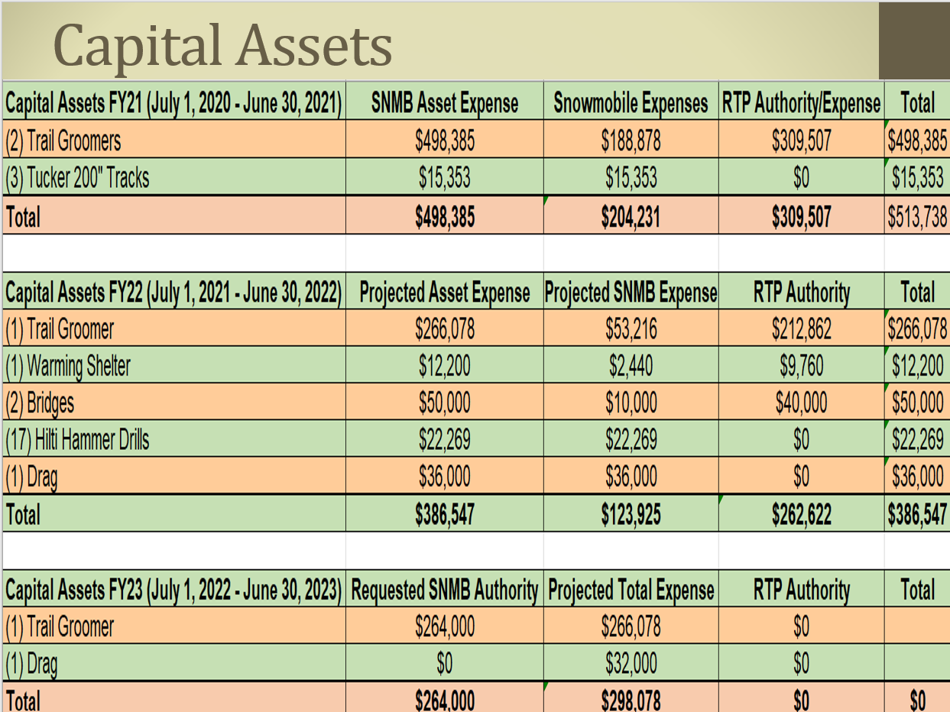

FY 2022 Budget Preview (July 1, 2021 to June 30, 2022)
Projected revenue for FY22 is $856,725 while $1,386,351 of spending authority is budgeted. The 9,735 snowmobile registrations account for $340,725 received through the gas tax reimbursement. This revenue is based on the number of registered snowmobiles as of July 1st, x .28 cents in gas tax, x 125 gallons of fuel.

Projected Revenue:
Gas Tax: $340,725 (Actual)
$10 Snowmobile License: $ 98,000
3% Registration Tax: $319,000
$40 5-Day Temporary Permit: $ 23,000
Interest : $ 25,000
Charges for Sales/Services: $ 16,000
Other: $ 35,000

Projected Expenses:
Personnel Services: $426,553 Supplies: $184,750
Travel: $ 61,754 Grants: $312,500
Contractual Supplies: $136,794 Capital Assets: $264,000

Projected Capital Assets:
Raynor stated the RTP council in June approved the majority of the 30% motorized dollars to the snowmobile program. With these funds, the snowmobile would match around $125,000 to the RTP funds approved which is $262,622. Percy told the council the intent of these funds is to purchase a groomer, warming shelter and rebuild 2 bridges located on the designated snowmobile trail.

FY 2023 Budget Recommendation (July 1, 2022 to June 30, 2023)
Projected revenue for FY23 is $856,000. Raynor told the council that all revenue projections from FY22 were brought over to FY23. Specific categories are mentioned below.

Projected Revenue:
Gas Tax: $340,000
$10 Snowmobile Licenses: $ 98,000
3% Registration Tax: $319,000
$40 5-Day Temporary Permit: $ 23,000
Interest : $ 25,000
Charges for Sales/Services: $ 16,000
Other $ 35,000

Projected Expenditures:
Personnel Services: $426,553 Supplies and Materials: $184,750
Travel: $ 61,754 Grants: $312,500
Contractual Supplies: $136,794 Capital Assets: $264,000

Projected Capital Assets:
Listed above.

Erstad made a motion to approve the FY2023 Snowmobile budget as proposed by Raynor. Motion was seconded by Hintz. Motion Carried.

Raynor shared the following slides with the council which depicted the number of registered sleds and gas tax monies brought in over the last ten years.

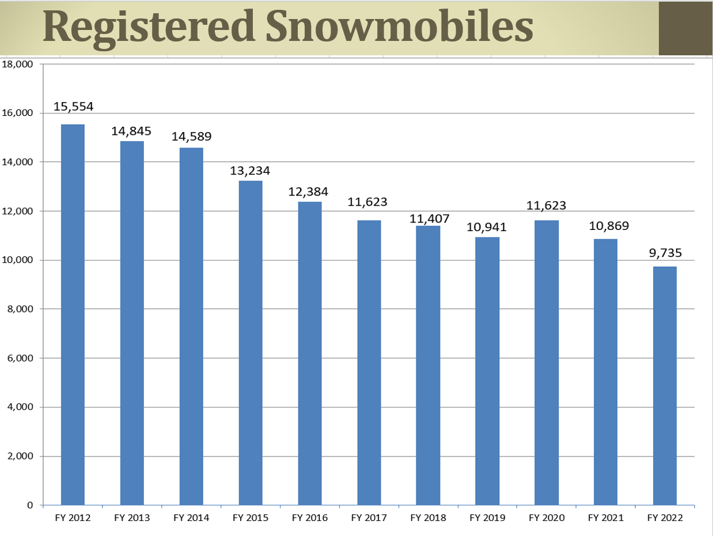
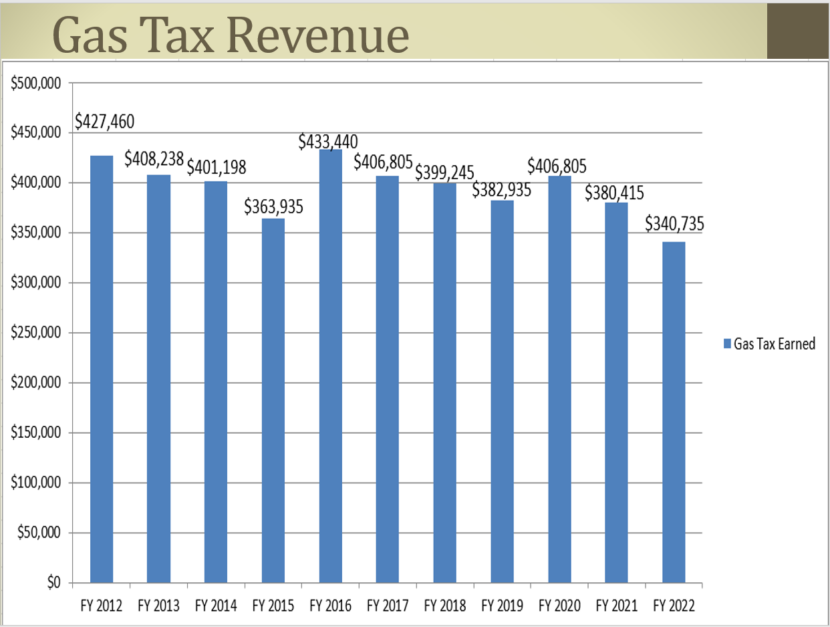

Election of Officers
Dave Kennedy stayed in the Chairman position while Bruce Hintz stayed in the Vice Chairman position. A motion was made by Erstad and seconded by Wilkinson. Motion Carried.

Next Meeting
The next meeting is scheduled for 10:00 a.m. on Friday, November 5th, 2021, in Mitchell. This meeting is held in conjunction with the SD Snowmobile Association Association’s Annual Convention.

Adjournment
A motion was made by Hintz and was seconded by Erstad to adjourn at 10:45 a.m. Motion carried.

